**ELECTRIC CHARGE, FORCE, AND FIELD**

**Exercises**

**Section 20.1 Electric Charge**

**13. Interpret** We'll estimate the charge your body would carry if the electron charge slightly differed from the proton charge.

**Develop** Since the human body is about 60% water, let's assume that the number of protons/electrons per kilogram in your body is the same as that of a water molecule. Water is 2 hydrogen atoms (with one proton and one electron each) and one oxygen atom (with 8 protons and 8 electrons). If the charges on the electrons and protons are different by one part in a billion, then the net charge on a water molecule would be



The mass of a water molecule is the mass of two hydrogens and one oxygen: 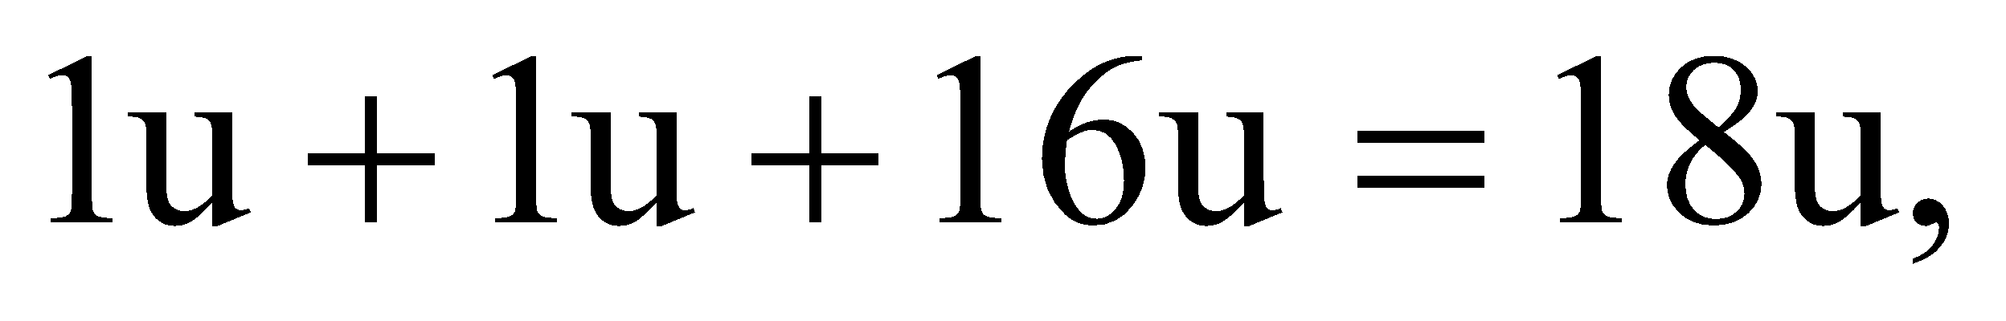 where 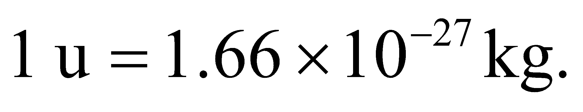Therefore, the net charge to mass ratio for a water molecule would be:

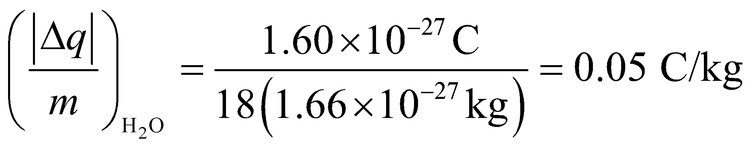

**Evaluate** We'll assume your mass is 65 kg. If we approximate this mass as pure water, then the total charge on your body would be approximately

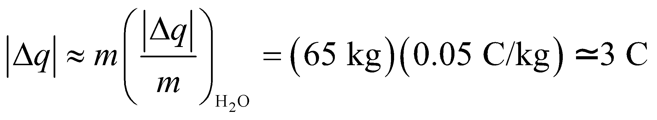

**Assess** This is a huge amount of charge. Imagine half of the charge was in your head/chest and the other half was in your legs, about a meter away. Then the magnitude of the force of repulsion between the upper and lower parts of your body would be

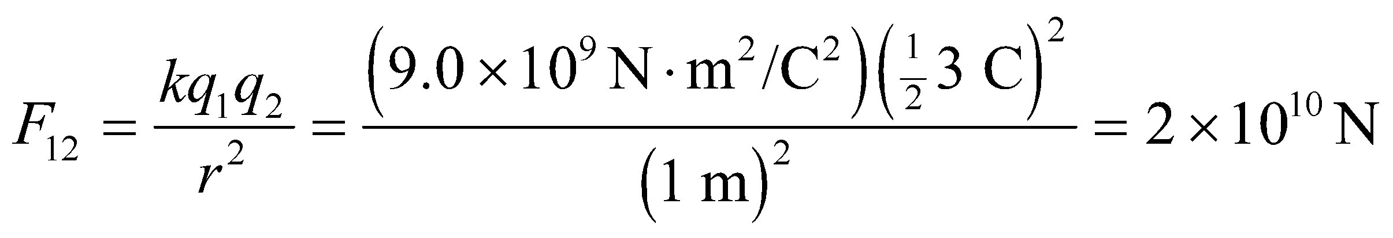

This would rip you apart!

**14. Interpret** This problem deals with quantity of charge in a typical lightning flash. We want to express the quantity in terms of the elementary charge *e*.

**Develop** Since the magnitude of elementary charge *e* is 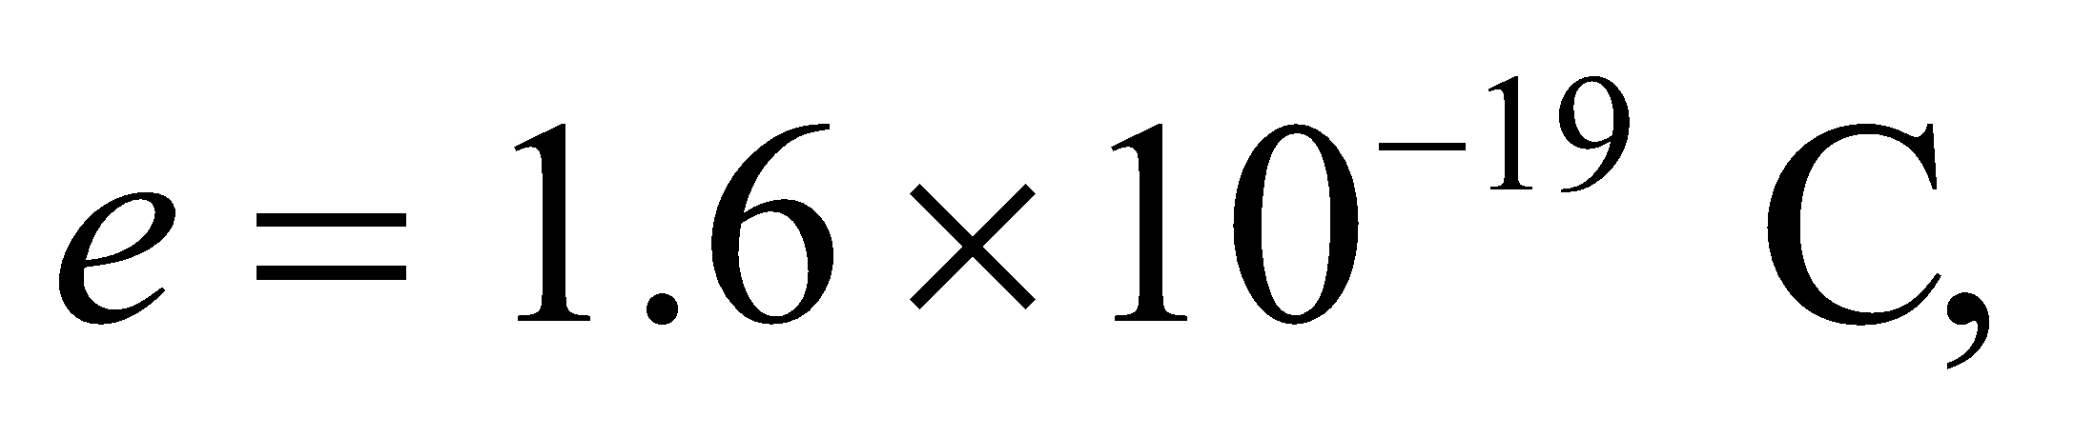 the number *N* of electrons involved in the lightening flash is given by *N* = *Q*/*e*.

**Evaluate** Substituting the values given in the problem statement, we find

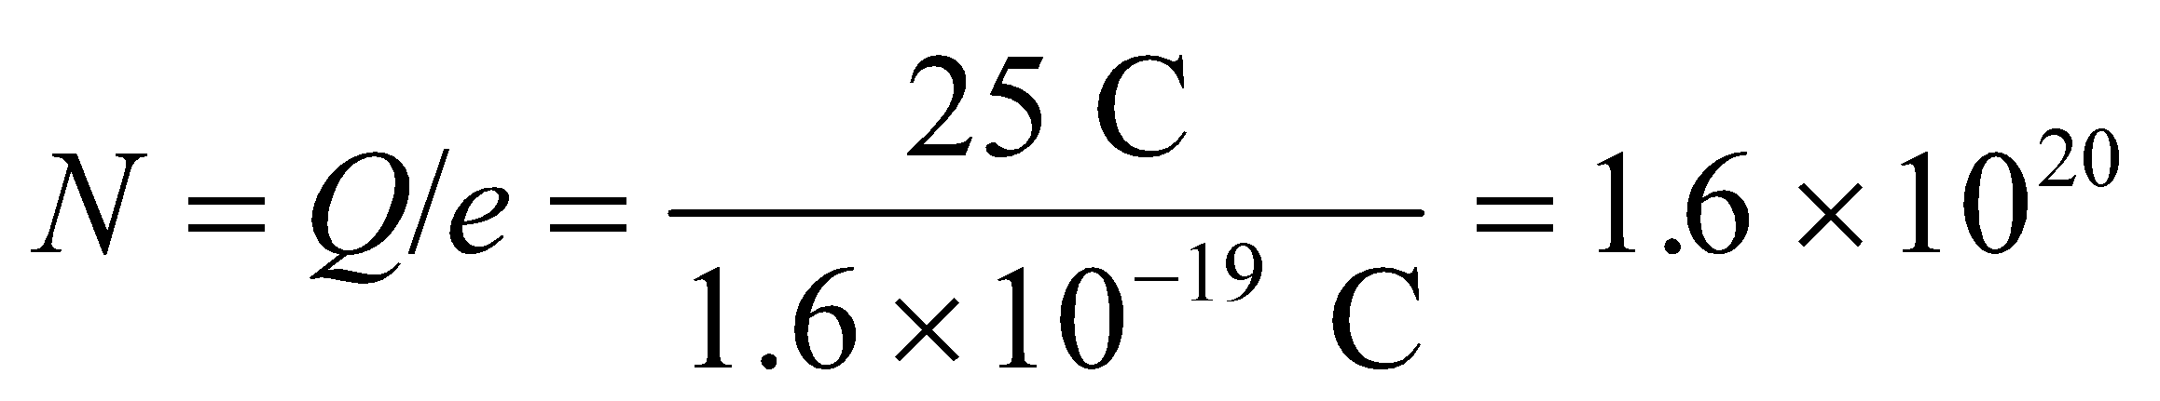

**Assess** Since 1 coulomb is about 6.35 × 1018 elementary charges, our result has the right order of magnitude.

**15.** **Interpret** This problem asks us to find the combination of *u* and *d* quarks needed to make a proton, which has a positive unit change *e*, and a neutron, which has zero charge.

**Develop** The *u* quark has charge 2*e*/3 and the *d* quark has charge −*e*/3, so we can combine these so the charges sum to unity (for the proton) or zero (for the neutron).

**Evaluate** (a) Two *u* quarks and a *d* quark make a total charge of 2(2/3) − 1/3 = 1, so the proton can be constructed from the quark combination *uud*.

(b) Two *d* quarks and a *u* quark make a total charge of 2(−1/3) + 2/3 = 0, so the neutron can be constructed from the quark combination *udd*.

**Assess** Because of a phenomenon called color confinement, quarks can only be found in hadrons, of which protons and neutrons are the most stable examples.

**Section 20.2 Coulomb’s Law**

**16.** **Interpret** The electron and proton each carry one unit of electric charge, but the sign of the charge is opposite for the two particles. Given the distance between them, we are to find the force (magnitude and direction) between these particles.

**Develop** Coulomb’s law (Equation 20.1) gives the force between two particles. For this problem, 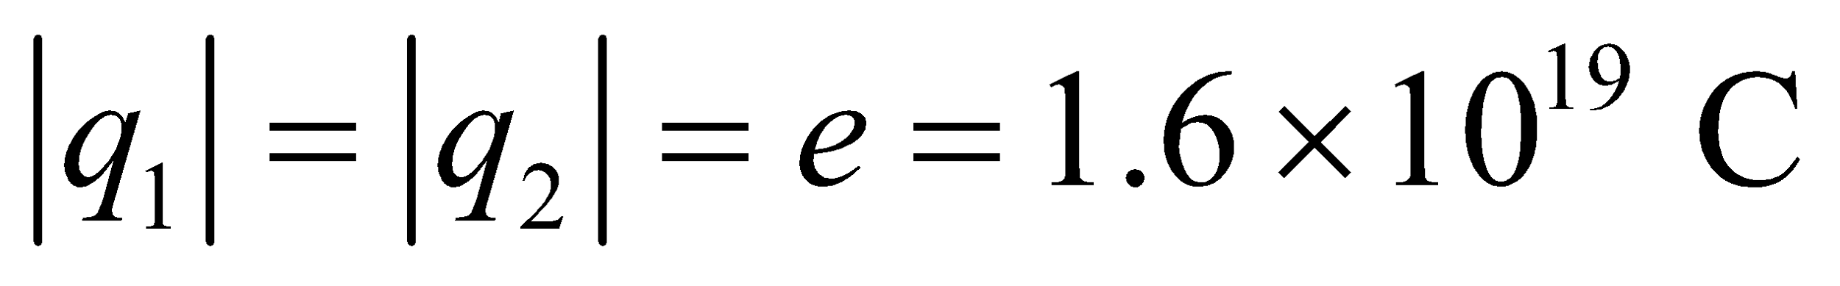 and *r* = 52.9 × 10−12 m. Because the charges have opposite signs, the force will be attractive.

**Evaluate** The force between these particles is attractive and has the magnitude

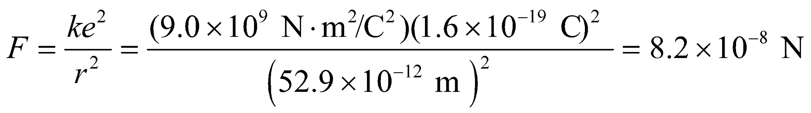

**Assess** Because the electron is much less massive than the proton, the electron does most of the accelerating in this two-particle system.

**17. Interpret** We want to know how far a proton must be from an electron to exert an electrical attraction equal to the electron's weight on Earth.

**Develop** The force between a proton and electron has a magnitude given by Coulomb's law (Equation 20.1): 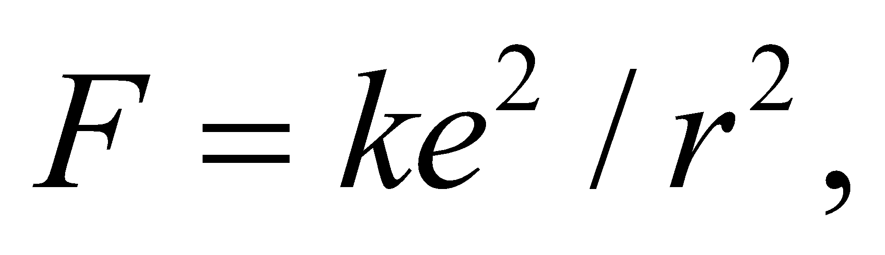where 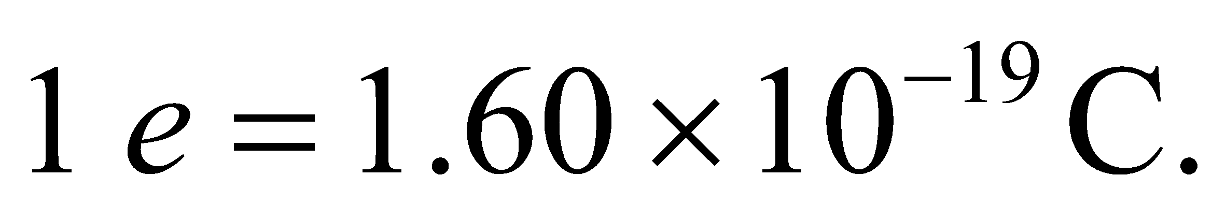We'll solve this for the distance, *r*, at which 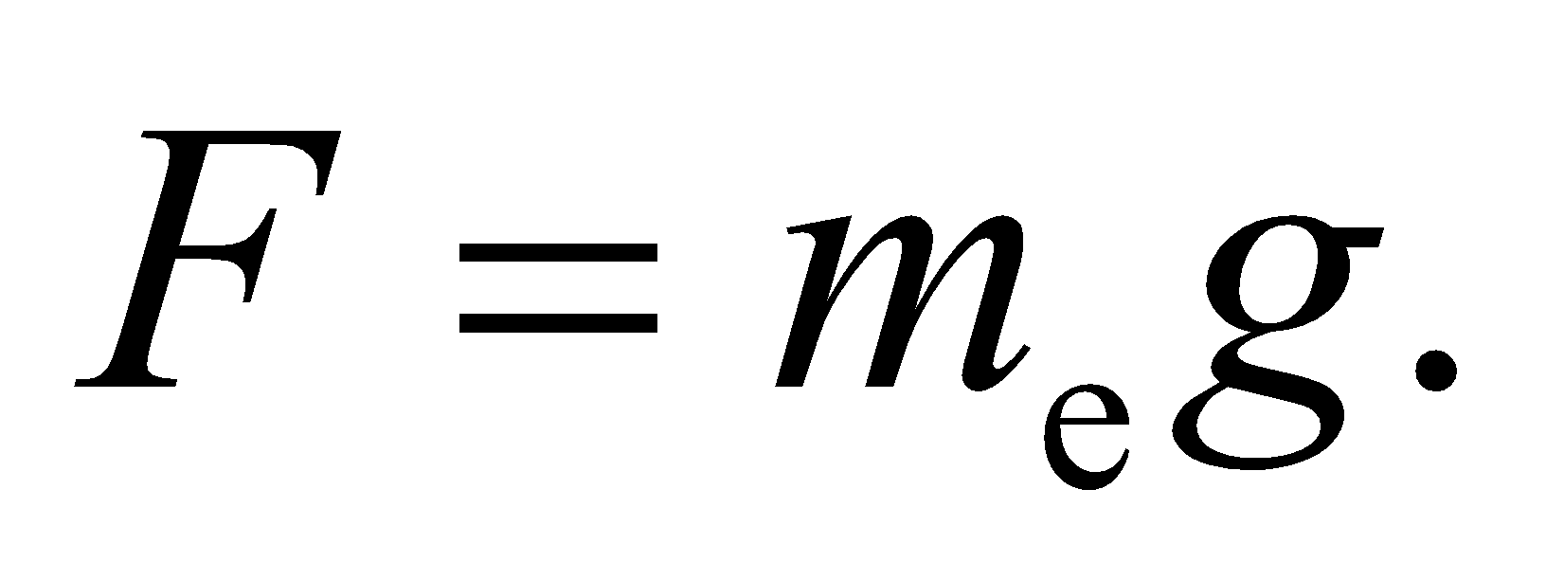

**Evaluate** The distance at which the electrical force is equal to the gravitational force is

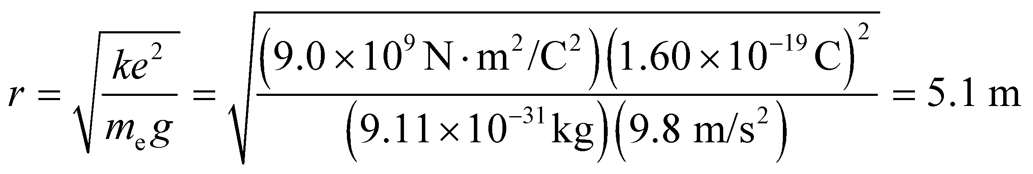

**Assess** On the molecular scale, protons and electrons are roughly 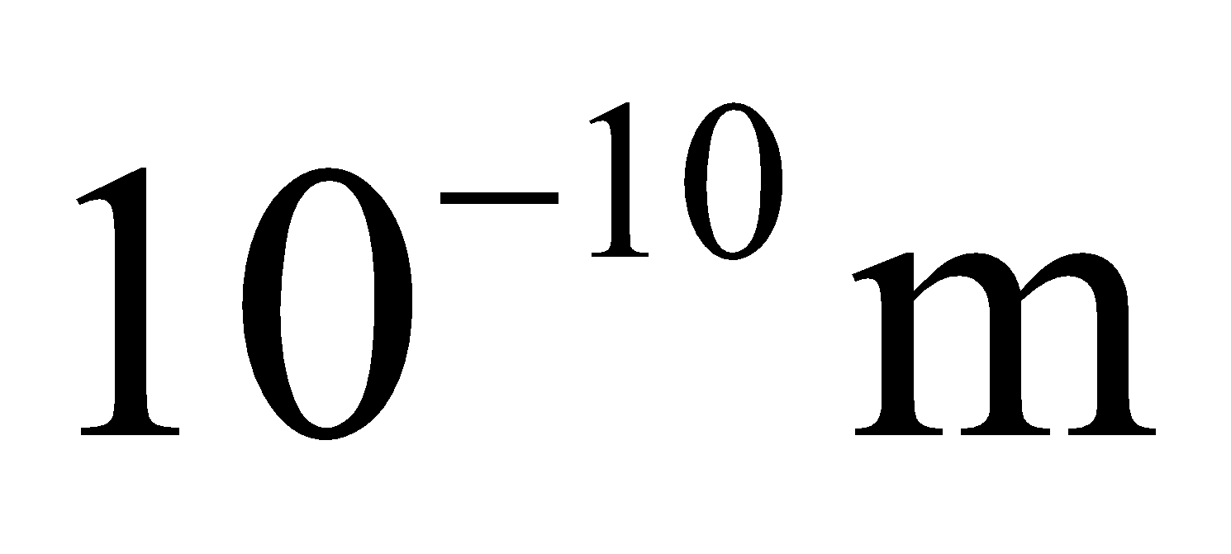apart. Since the Coulomb attraction scales as 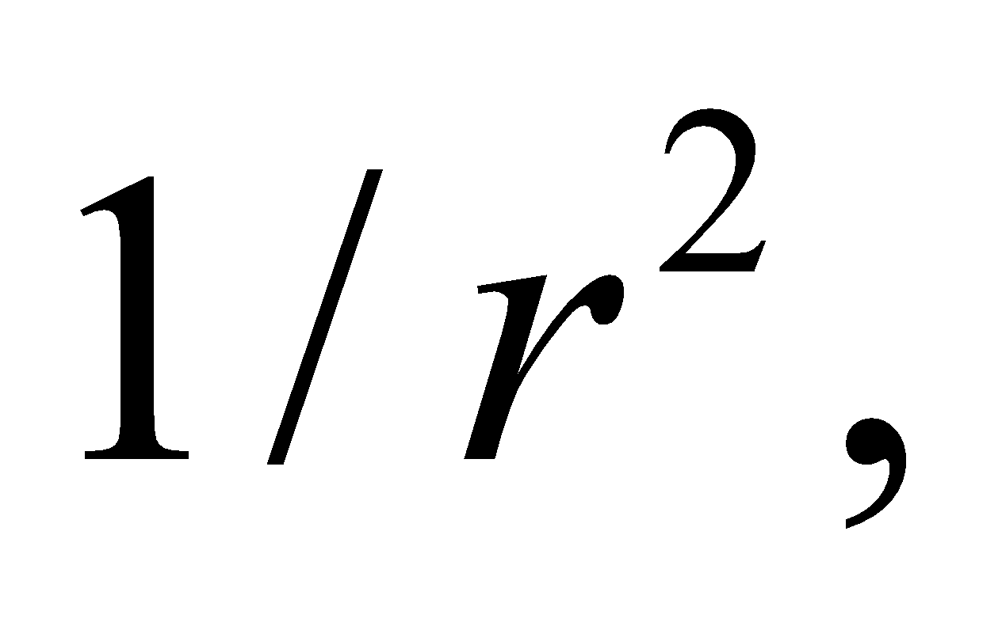electric forces will clearly overwhelm any gravity effects.

**18. Interpret** The problem is to calculate the charge on tiny Styrofoam pieces.

**Develop** Since the charges are equal, the repulsion force at the given distance is 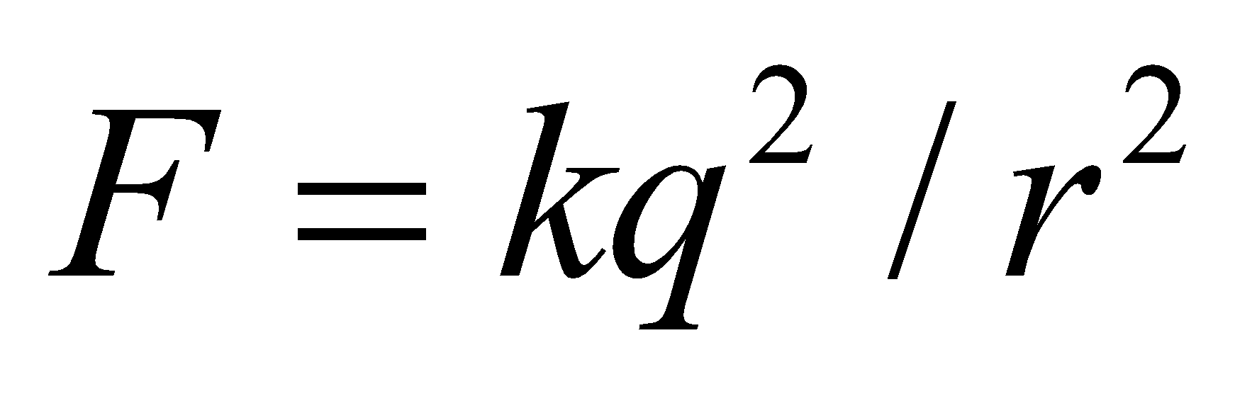 (Equation 20.1).

**Evaluate** Solving for the charge in Coulomb's law gives

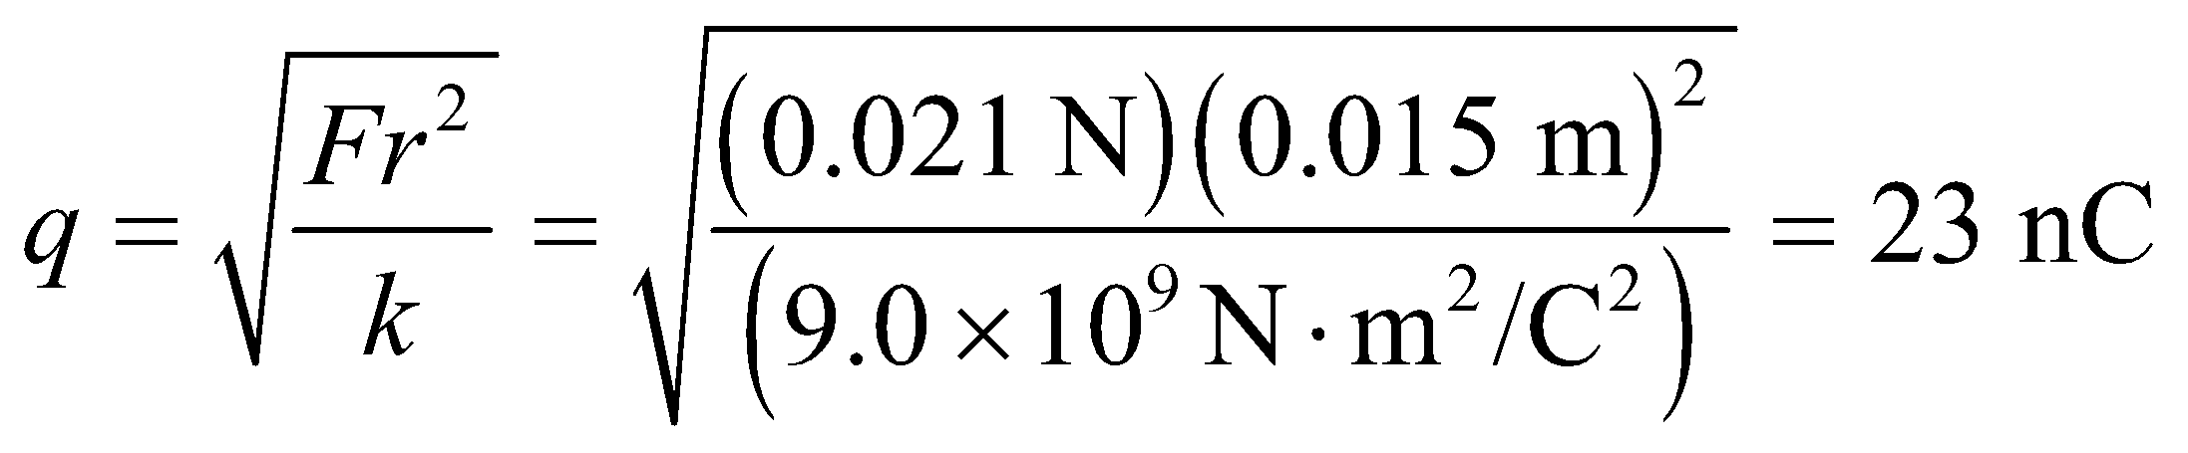

**Assess** This seems reasonable for small charged objects.

**19. Interpret** This problem involves finding the unit vector associated with the electrical force one charge exerts on another, given the coordinates of the positions of both charges.

**Develop** A unit vector from the position of charge *q* at 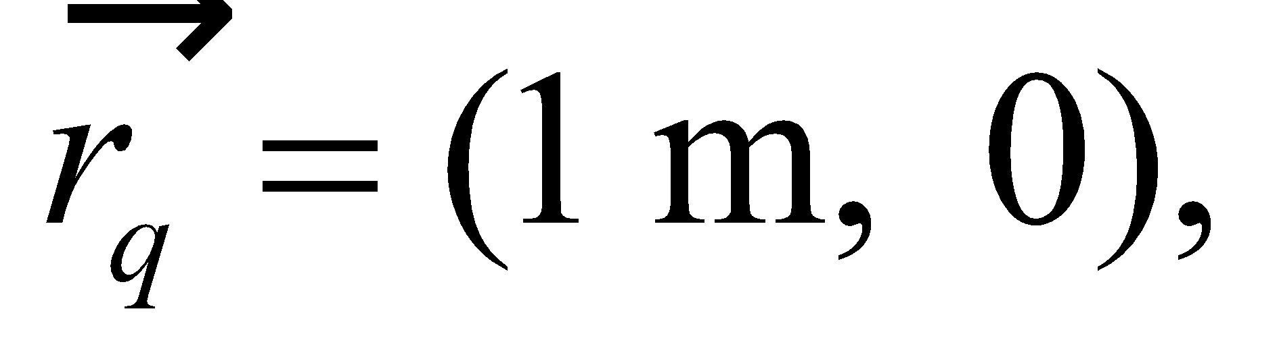 to any other point 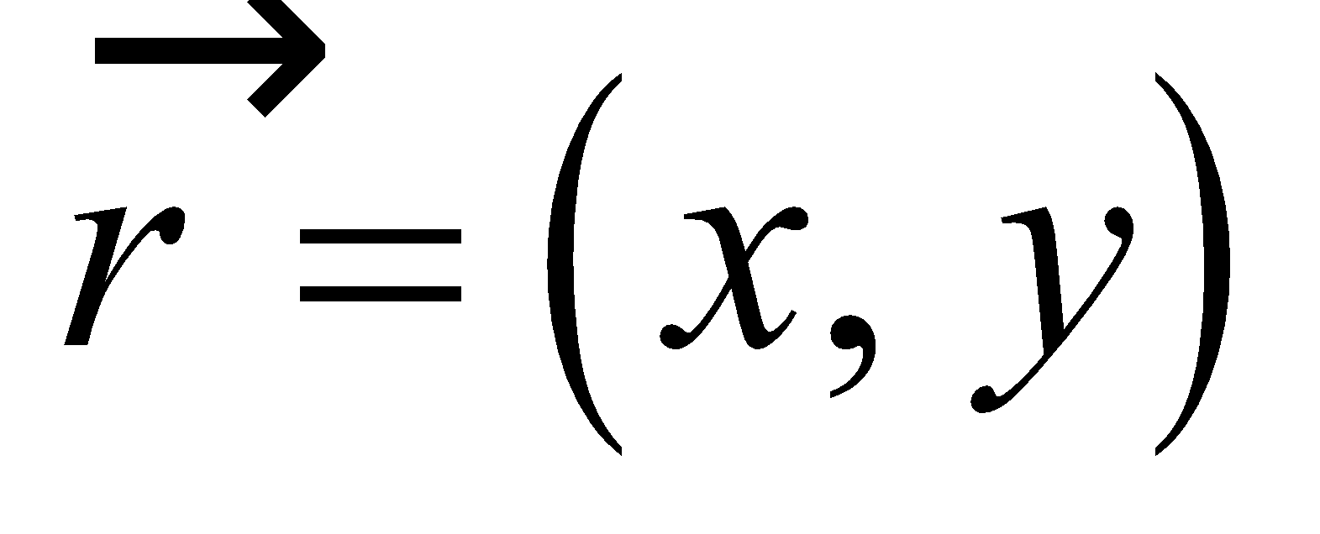 is

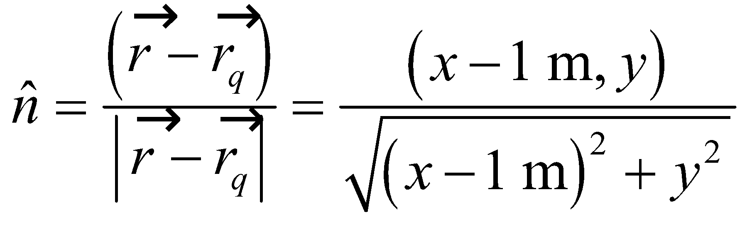

**Evaluate** **(a)** When the other charge is at position 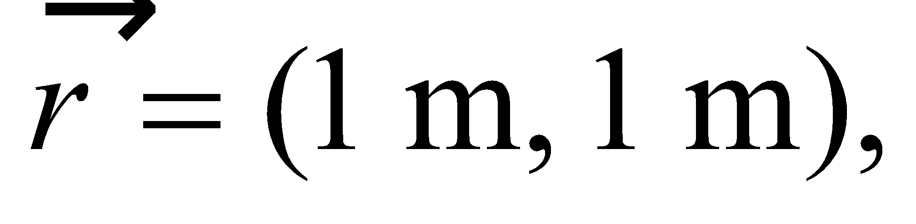 the unit vector is

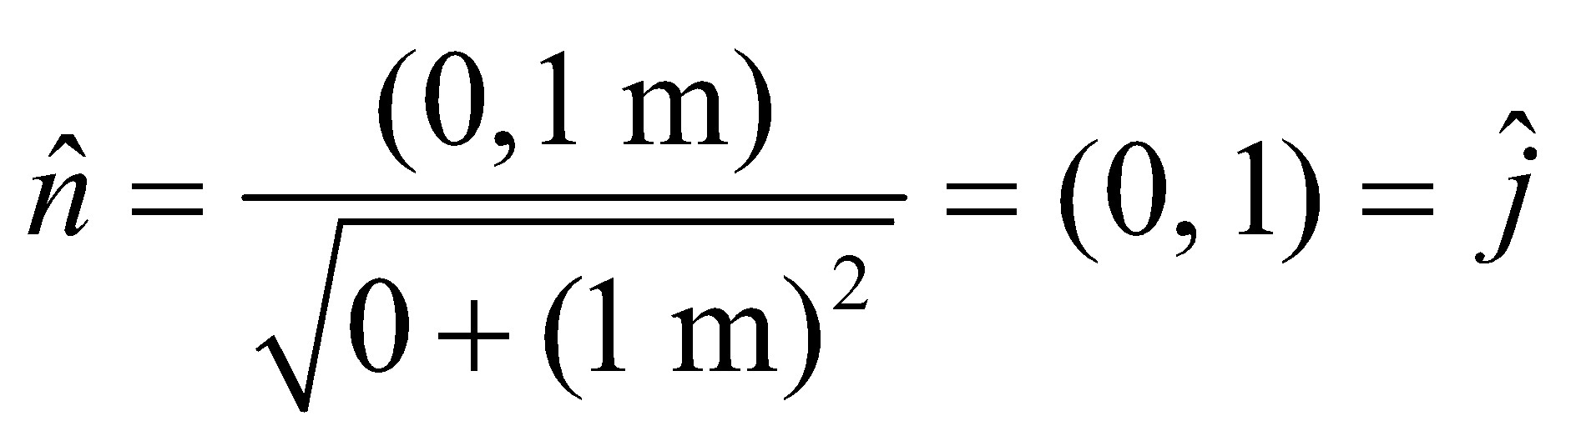

**(b)** When 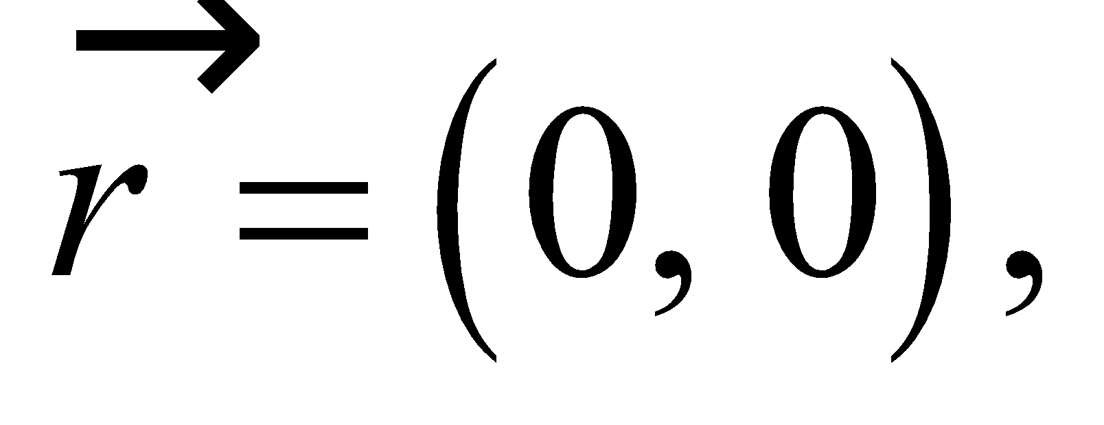

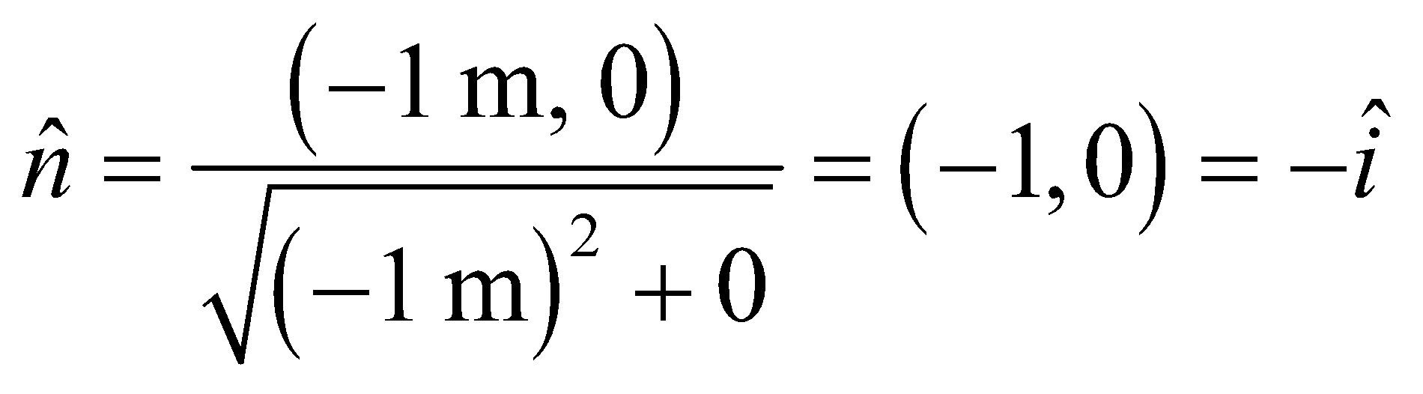

**(c)** Finally, when 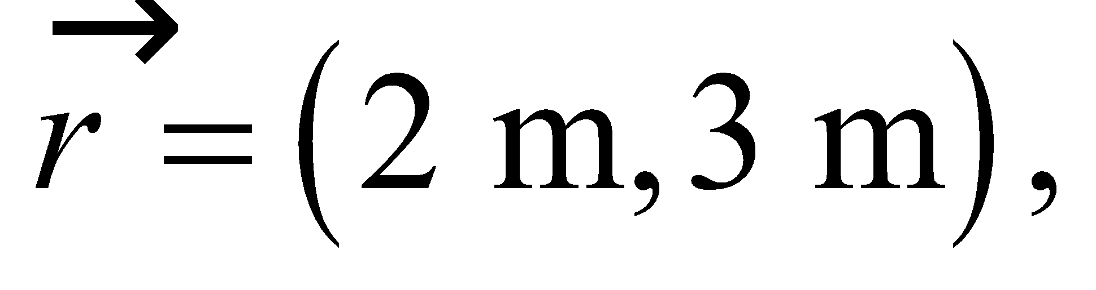 the unit vector is

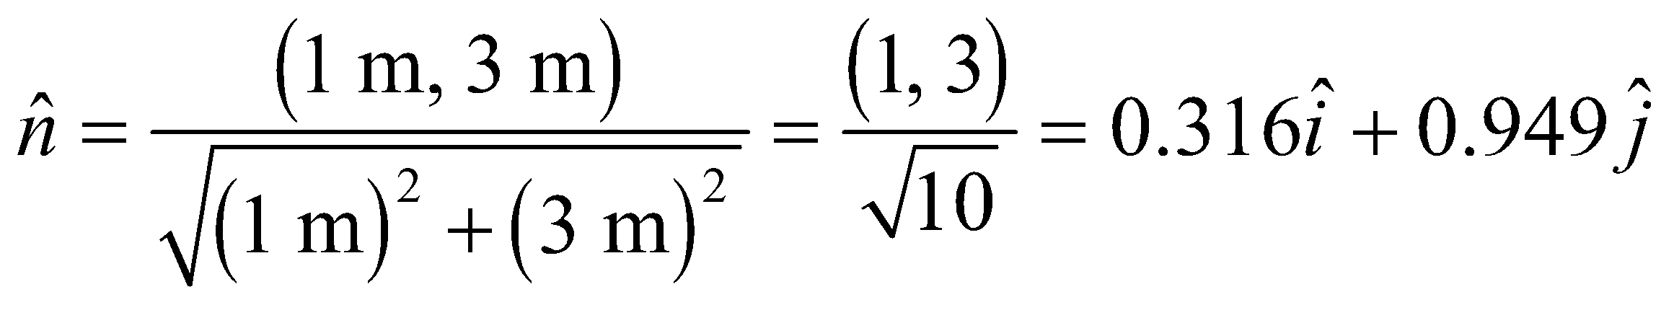

The sign of *q* doesn’t affect this unit vector, but the signs of both charges do determine whether the force exerted by *q* is repulsive or attractive; that is, in the direction of 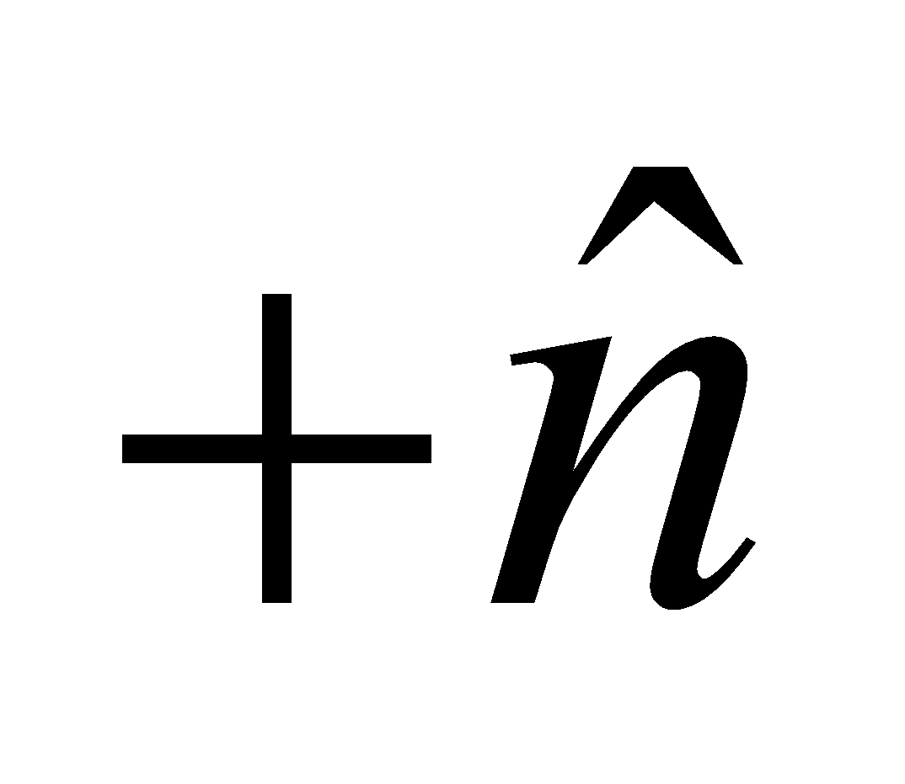 or 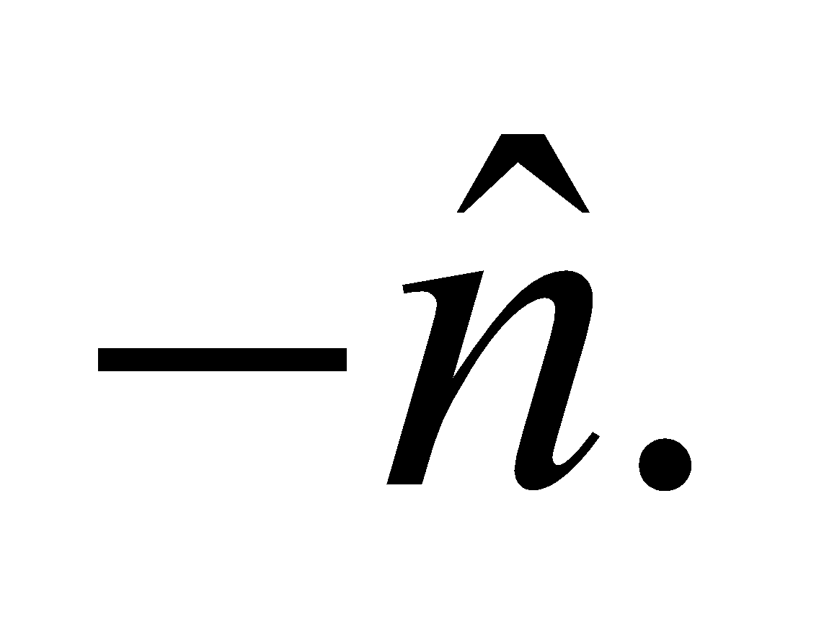

**Assess** The unit vector always points away from the charge *q* located at (1 m, 0).

**20.** **Interpret** This problem requires us to find the force acting on a proton due to an electron, given the positions of the two particles.

**Develop** Use the result of the previous problem to find the direction of the force acting on the proton. The relevant quantities are 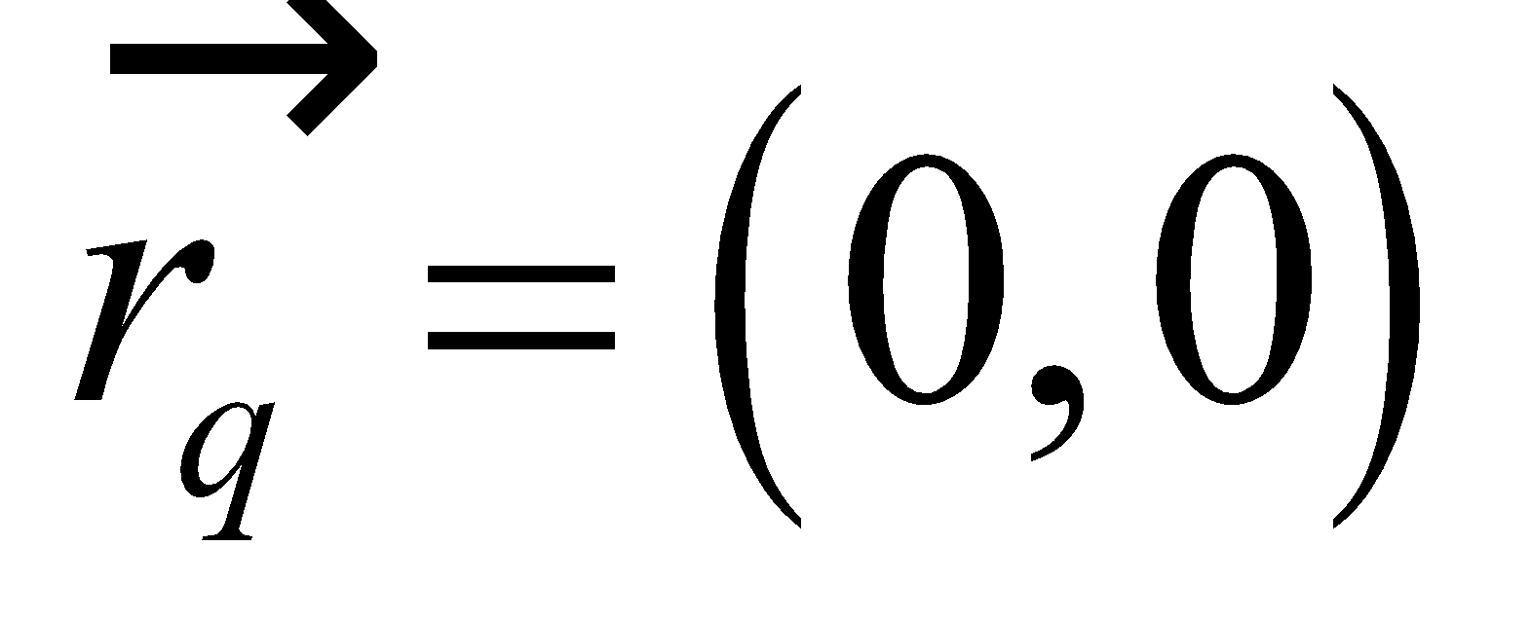 for the proton and 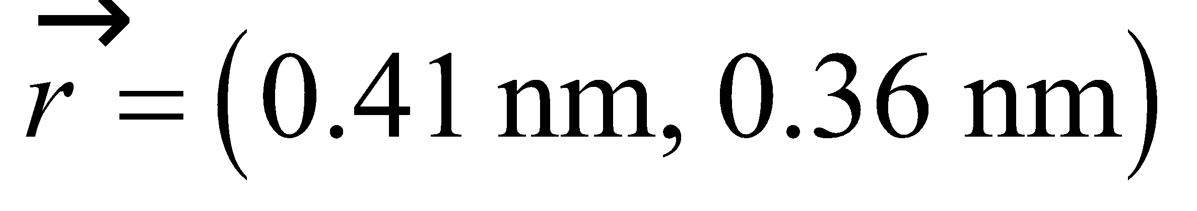, so the unit vector indicating the direction of the force is

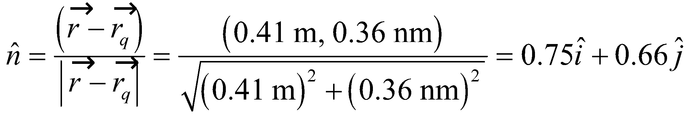

Because the charges are opposite in sign, the force will act in the positive 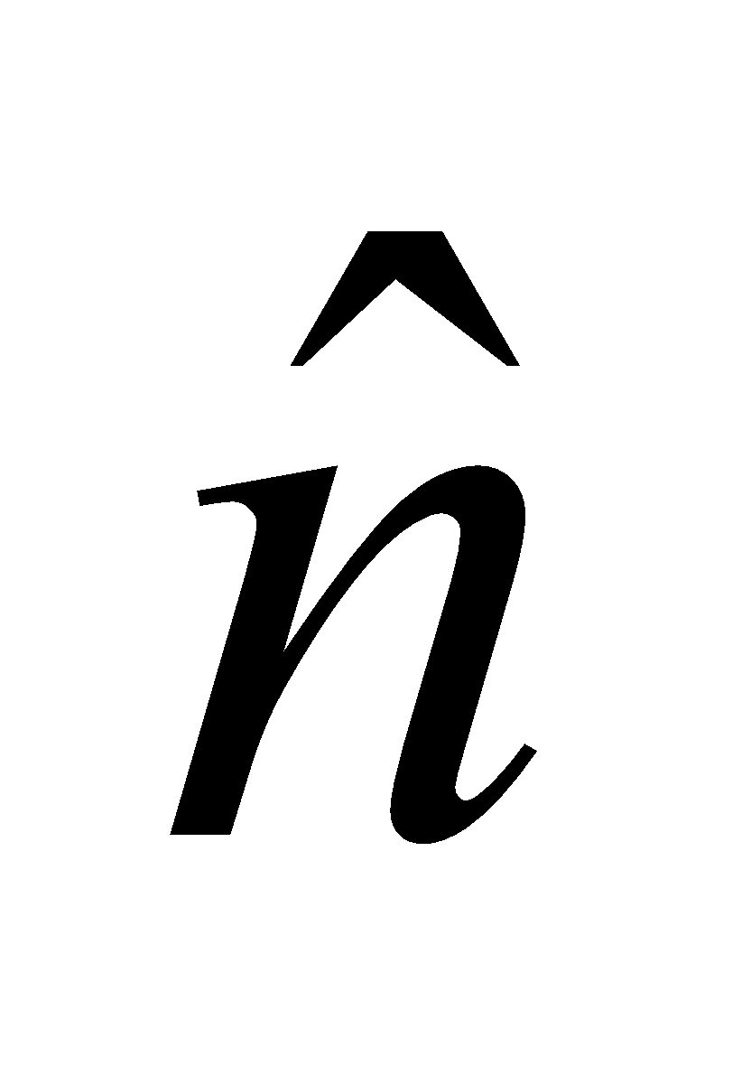 direction. The magnitude of the force may be found using Coulomb’s law (Equation 20.1).

**Evaluate** The magnitude of the force is

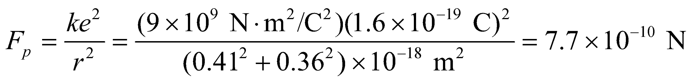

so the complete (i.e., vector) force is 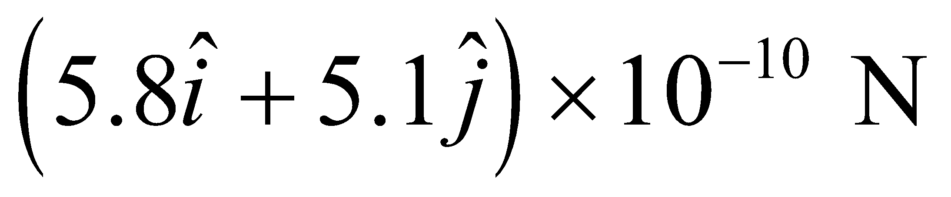

**Assess** This force is two orders of magnitude less than the force between the electron and proton in a hydrogen atom. The direction of the force is 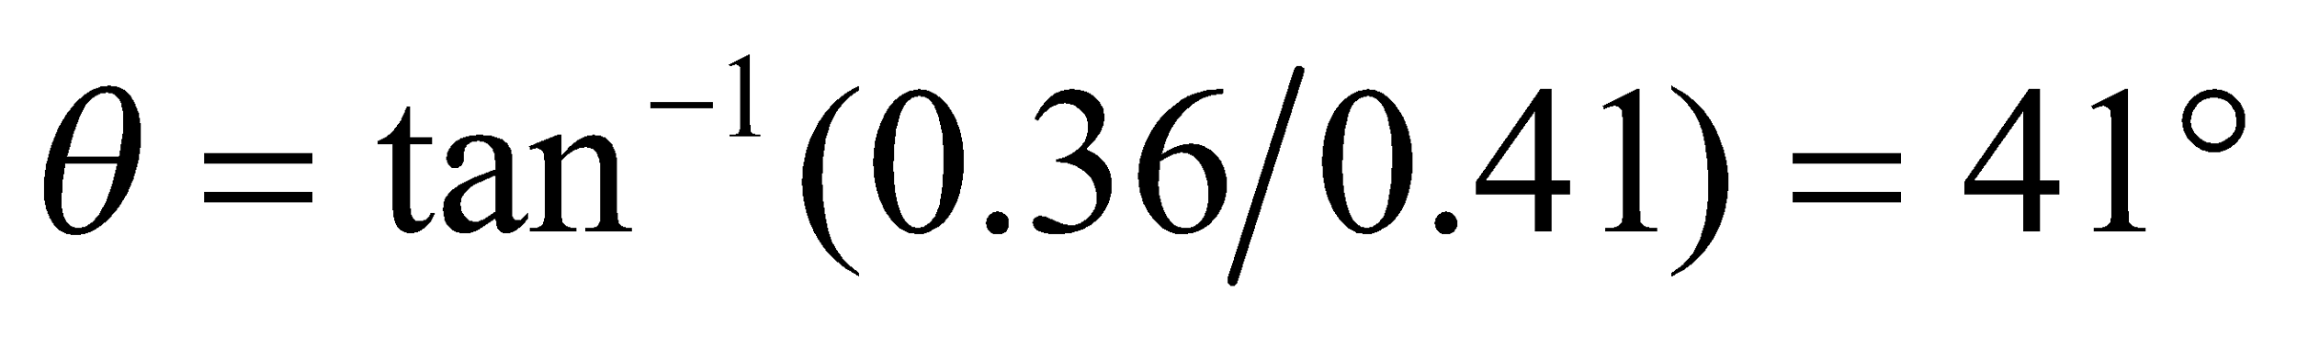 above the *x* axis.

**Section 20.3 The Electric Field**

**21. Interpret** This problem is about calculating the electric field strength due to a source, when the force experienced by the electron is known.

**Develop** Equation 20.2a shows that the electric field strength (magnitude of the field) at a point is equal to the force per unit charge that would be experienced by a charge at that point: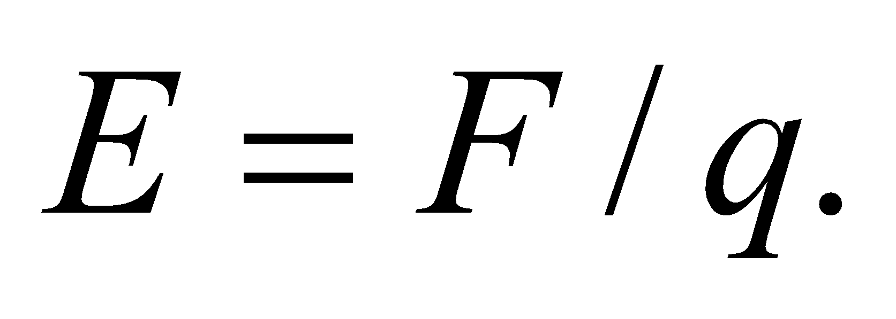

**Evaluate** With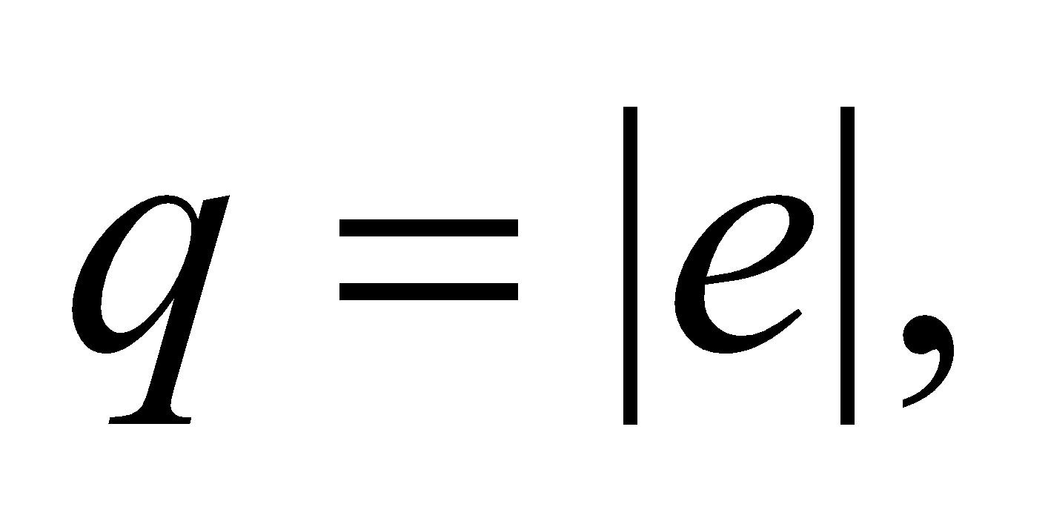we find the field strength to be

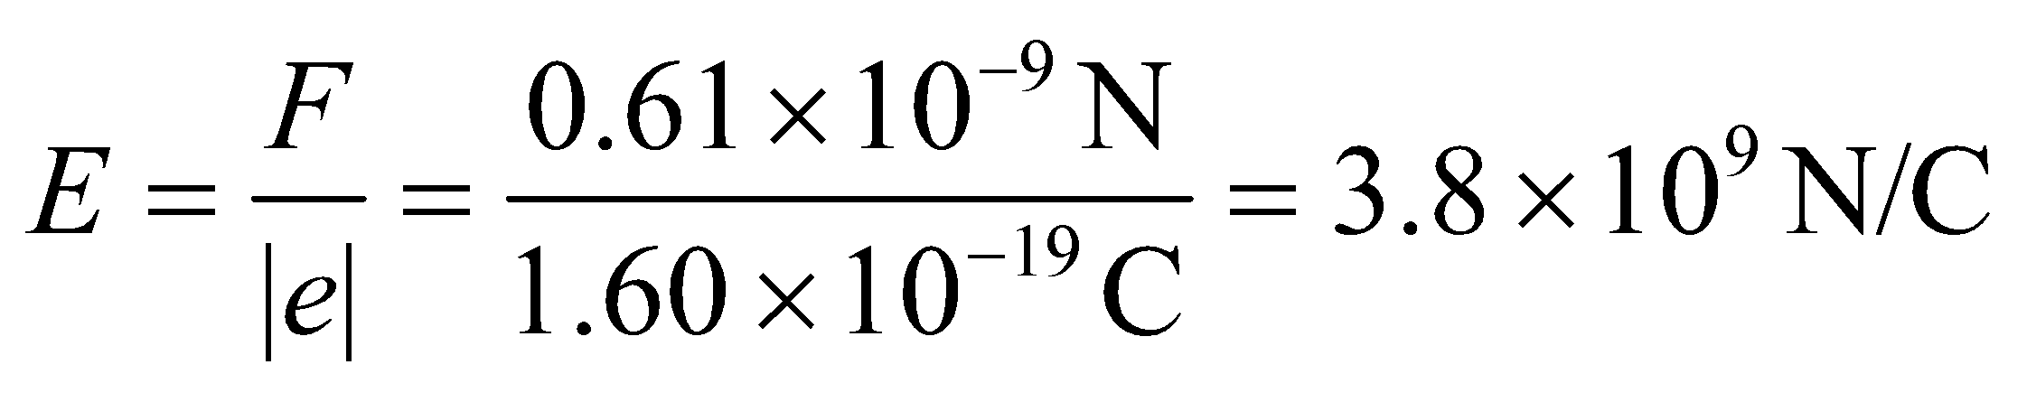

**Assess** Since the charge of electron is negative, the electric field will point in the opposite direction as the force.

**22.** **Interpret** This problem asks us to find the magnitude of the force on an electric charge that is placed in an electric field of the given strength.

**Develop** The electric field is the force per unit charge, so we multiply the magnitude of the charge by that of the electric field to find the force (see Equation 20.2b).

**Evaluate** The magnitude of the force is 

**Assess** The direction of this force will be in the same direction as that of the electric field because the charge is positive.

**23. Interpret** This problem involves calculating the electric field needed to produce the given force on the given charge, and then find the force experienced by a second charge is the same electric field.

**Develop** Equation 20.2a shows that the electric field strength (magnitude of the field) at a point is equal to the force per unit charge that would be experienced by a charge at that point:

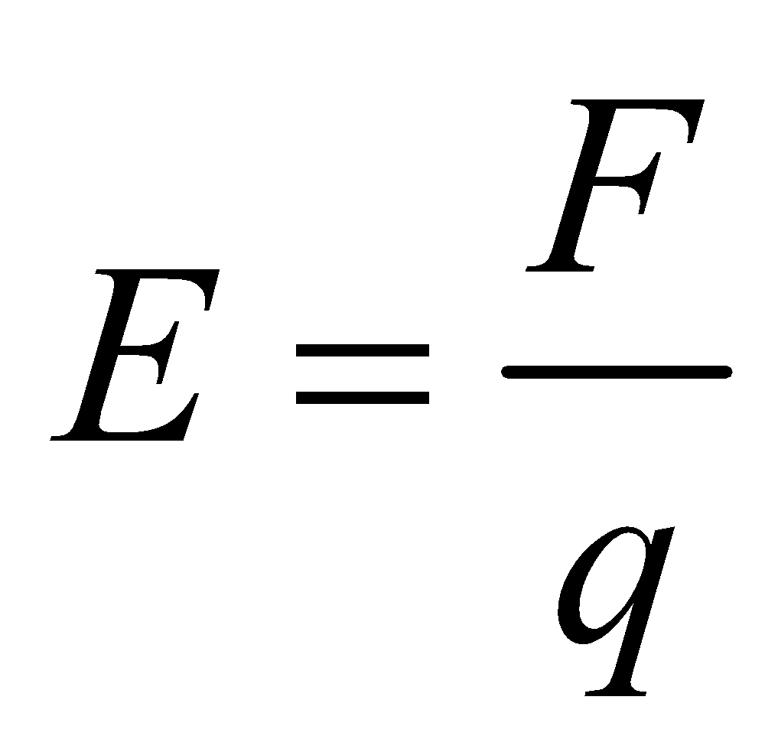

The equation allows us to calculate *E* give that *F* = 150 mN and *q* = 68 nC. For part **(b)**, the force experienced by another charge *q*′ in the same field is given by Equation 20.2b: *F*′ = *q*′*E*.

**Evaluate** **(a)** With 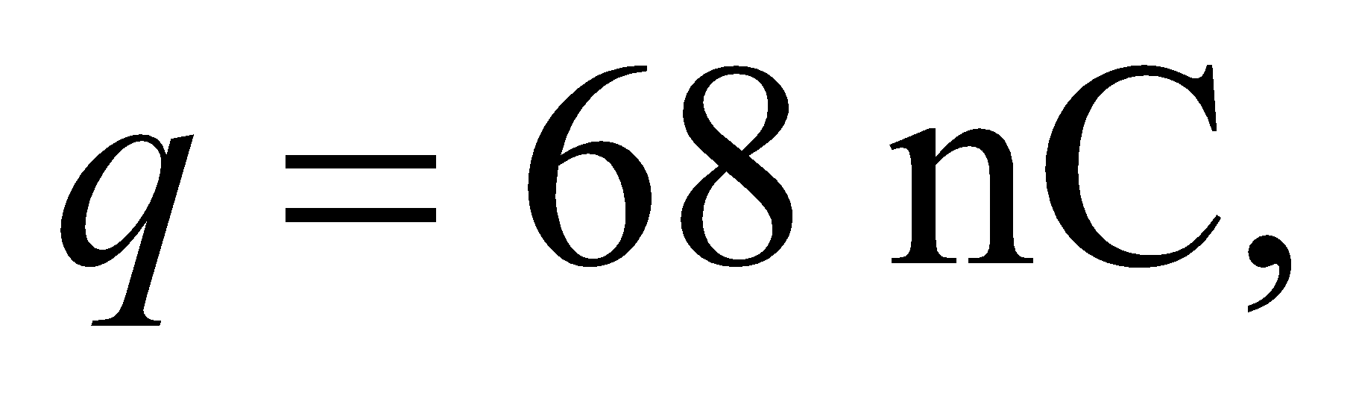 we find the field strength to be

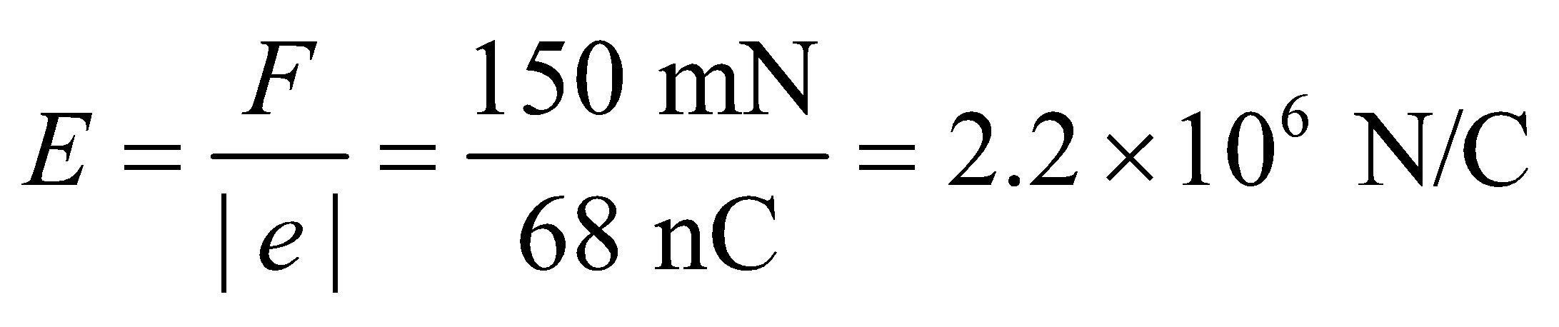

**(b)** The force experienced by a charge *q*′ = 35 μC in the same field is

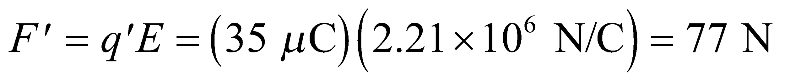

**Assess** The force a test charge particle experiences is proportional to the magnitude of the test charge. In our problem, since 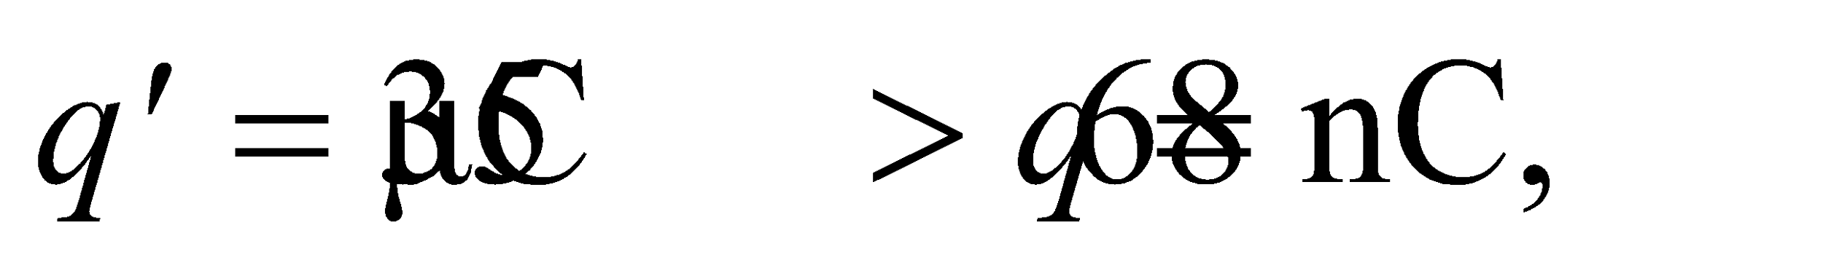 we find *F*′ > *F*.

**24. Interpret** We want the force on an ion inside a cell with an internal electric field.

**Develop** A singly-charged ion has a charge of so the magnitude of the force will be 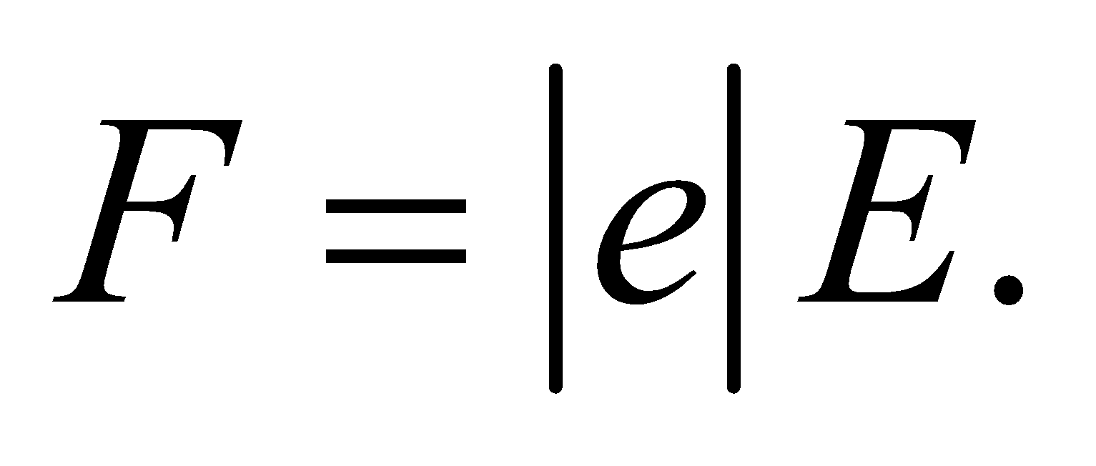

**Evaluate** The force on the ion in the cell is



**Assess** Although a pico-Newton is very small, it is a significant force at the molecular scale.

**25.** **Interpret** This problem is similar to Problem 20.23, in that we are given the force exerted on a given charge by an unknown electric field, and we are to find the force exerted by this field on another charge (a proton, in this case).

**Develop** Apply Equation 20.2b 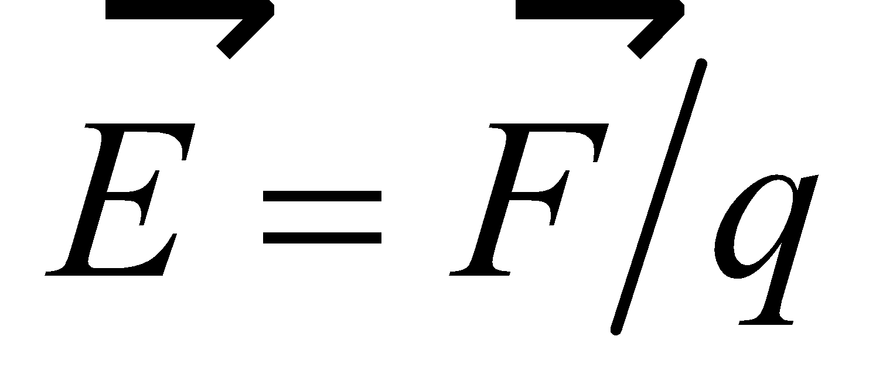to find the electric field, with *q* = −1 μC. The force on the proton (*qp* = 1.6 × 10−6 C) is given by Equation 20.2a, 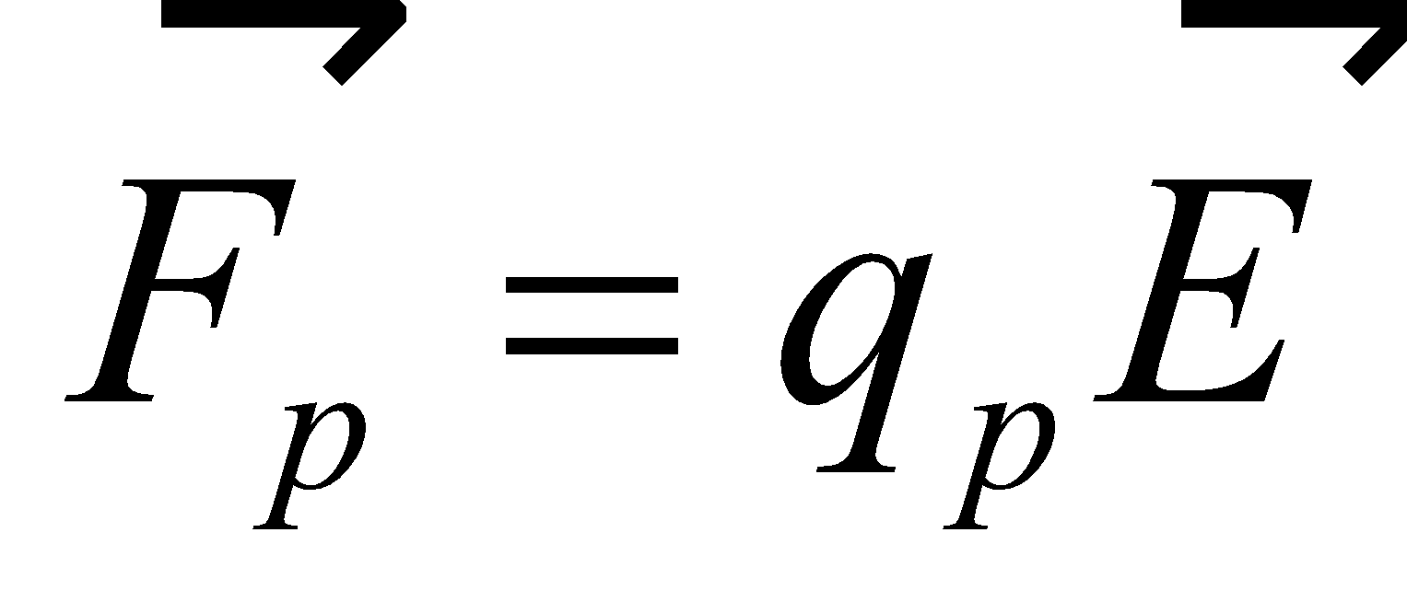. Inserting the result of Equation 20.2b gives

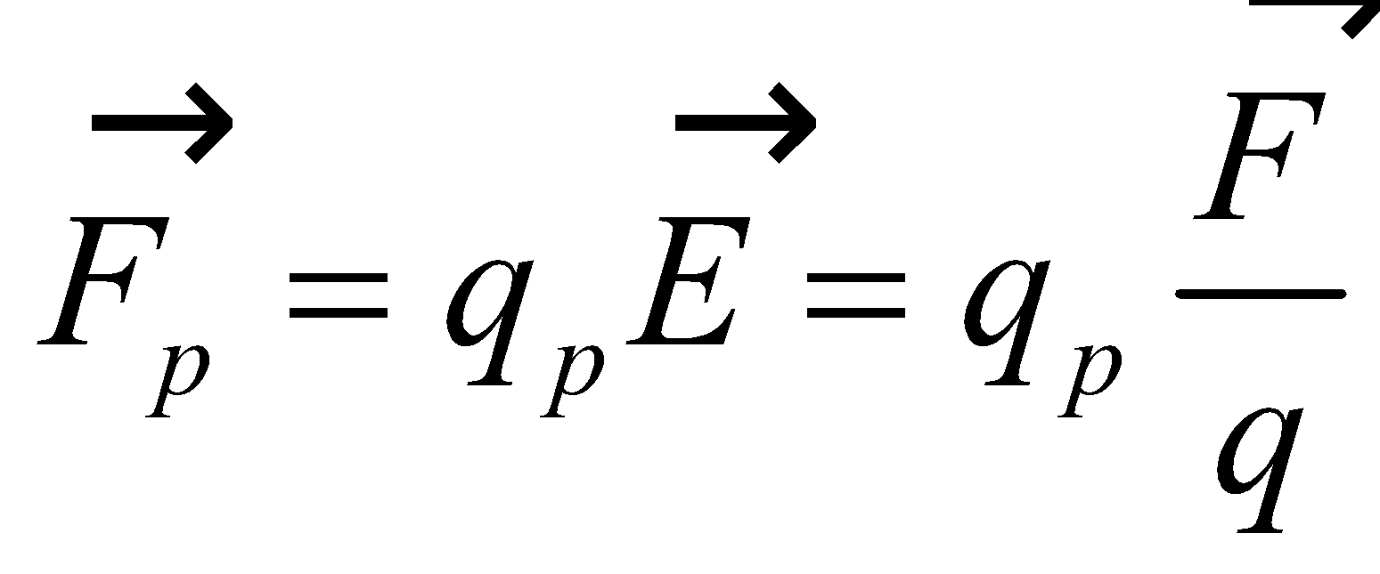

**Evaluate** Inserting the given quantities into the expression above for the force on the proton gives

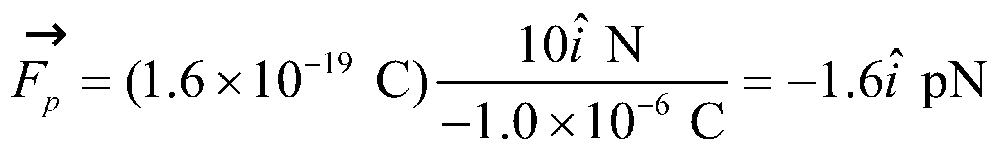

**Assess** The force on the proton acts in the opposite direction compared to the force on the original charge, because the two charges have opposite signs.

**26. Interpret** For this problem, we are to calculate the electric field strength due to a positive point charge—the proton.

**Develop** The electric field strength at a distance *r* from a point source charge *q* is given by Equation 20.3:

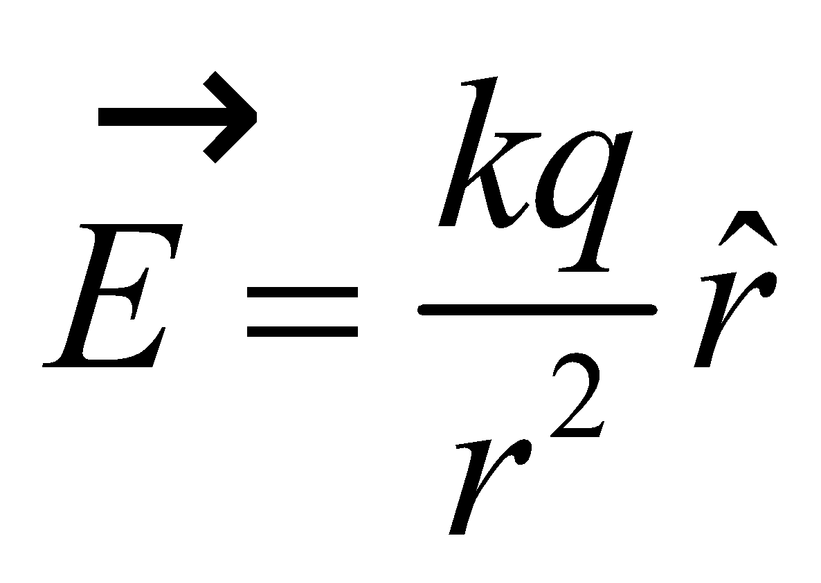

The proton in a hydrogen atom behaves like a point charge, so we can apply this equation to find the electric field of the proton. The charge of the proton is *q* = +*e* = 1.6 × 10−19 C.

**Evaluate** At a distance of one Bohr radius (*a*0 = 0.0529 nm) from the proton, the electric field strength is

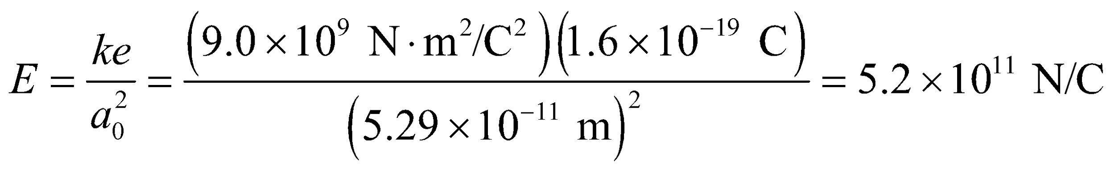

**Assess** The field strength at the position of the electron is enormous because of the close proximity.

**Section 20.4 Fields of Charge Distributions**

**27.** **Interpret** For this problem, we are to find the electric field at several locations in the vicinity of two given point charges. We can apply the principle of superposition to solve this problem.

**Develop** Take the origin of the *x-y* coordinate system to be at the midpoint between the two charges, as indicated in the figure below, and use Equation 20.4 to find the electric field at the given points. Let *q*1 = +2.0 μC and *q*2 = −2.0 μC. Let 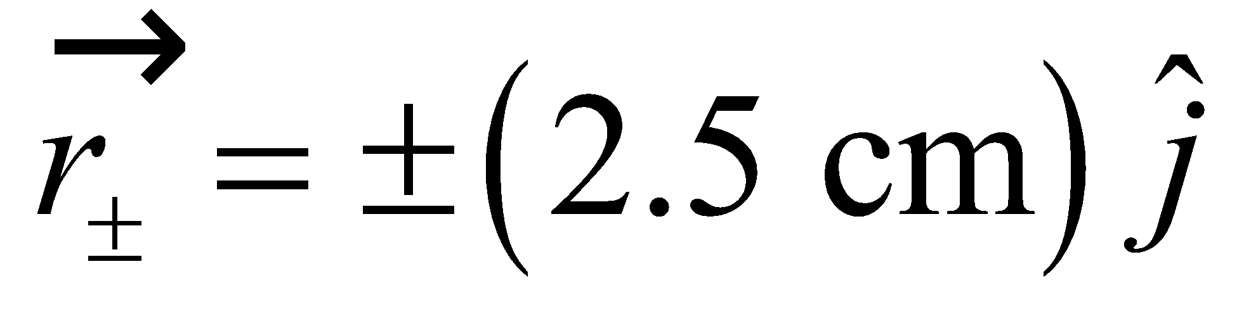 denote the positions of the charges and 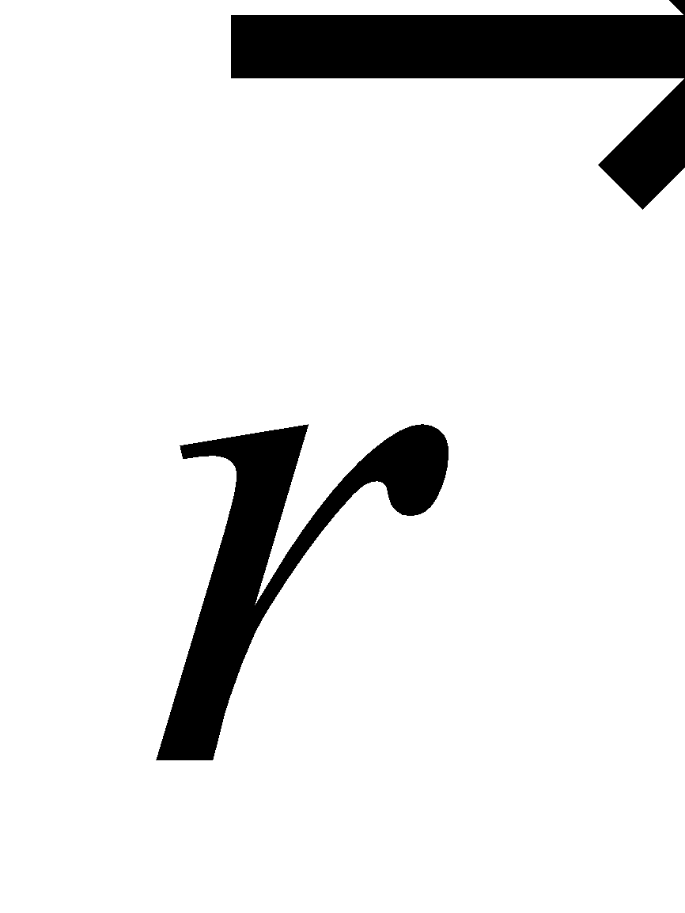 denote that of the field point (i.e., the point at which we are calculating the electric field). A unit vector from charge *i* to the field point is 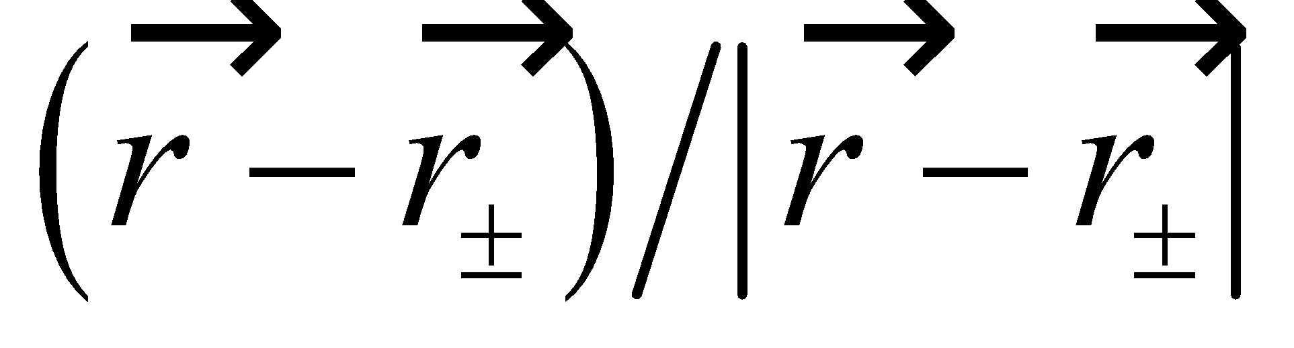 [where the plus (minus) sign corresponds to the positive (negative) charge)]. Thus, the spatial factors in Coulomb’s law are 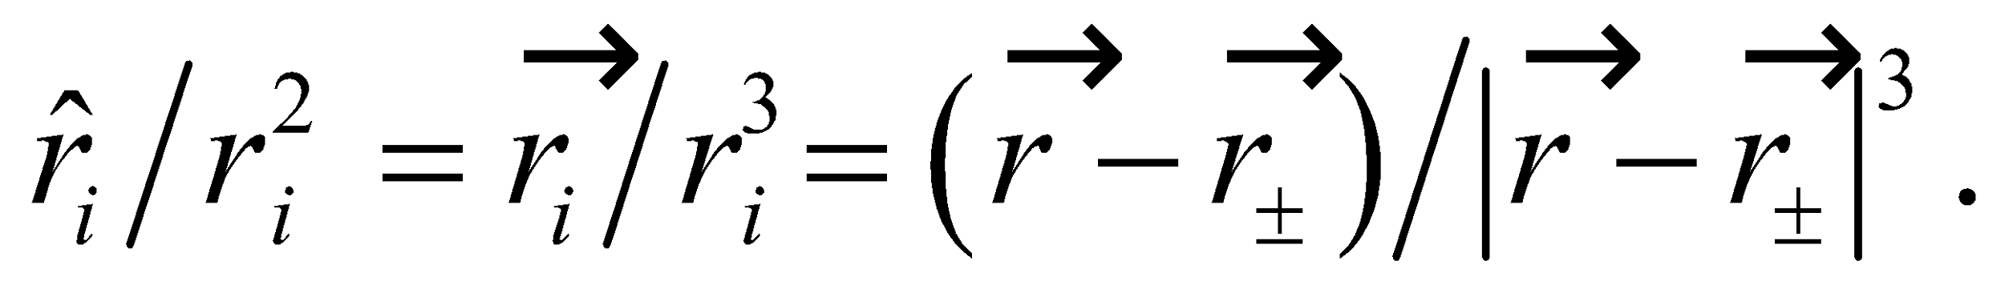 By the principle of superposition (Equation 20.4), the total electric field at any point is

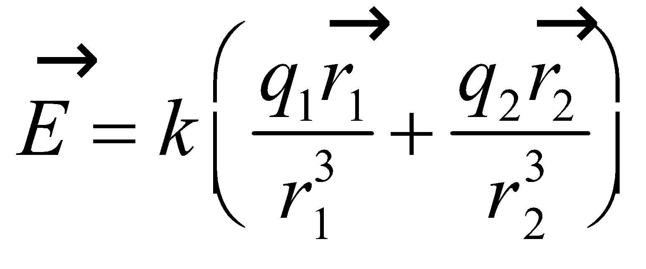



**Evaluate** **(a)** For the point at 5.0 cm to the left of *P*, we have

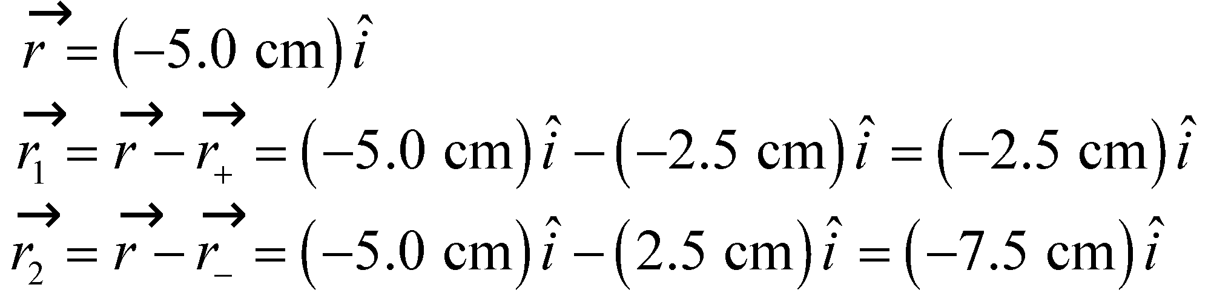

so the electric field is

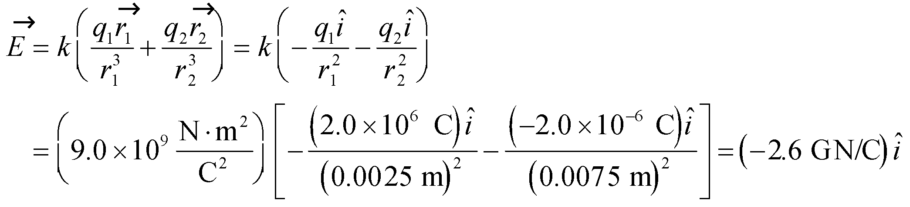

(**b**) For the point at 5.0 cm directly above *P*, we have

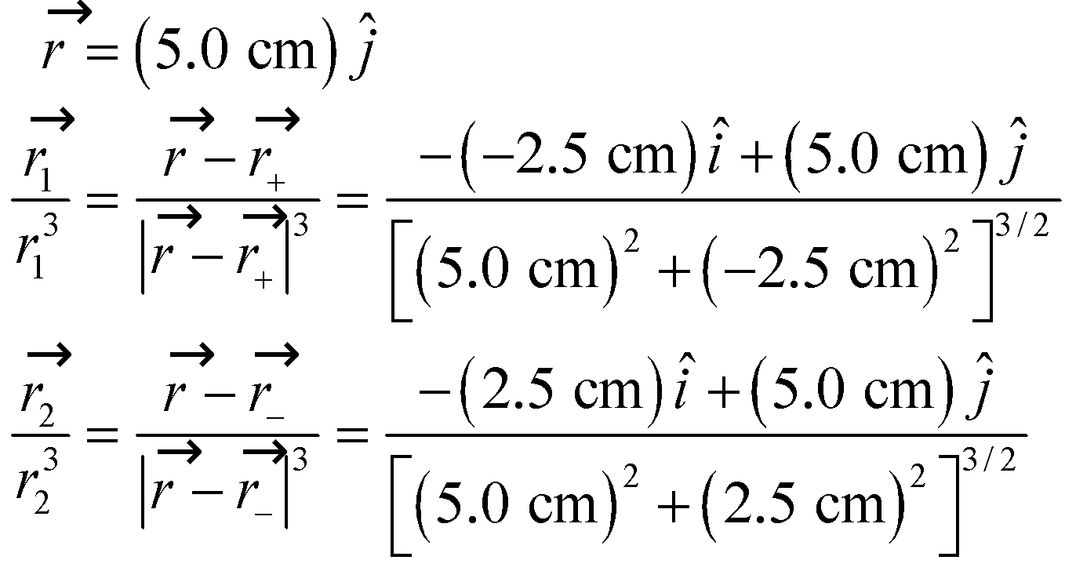

so the electric field is

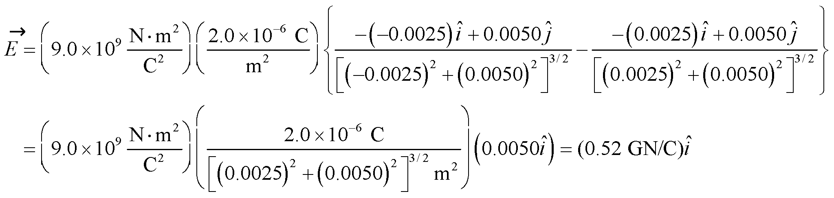

(**c**) For 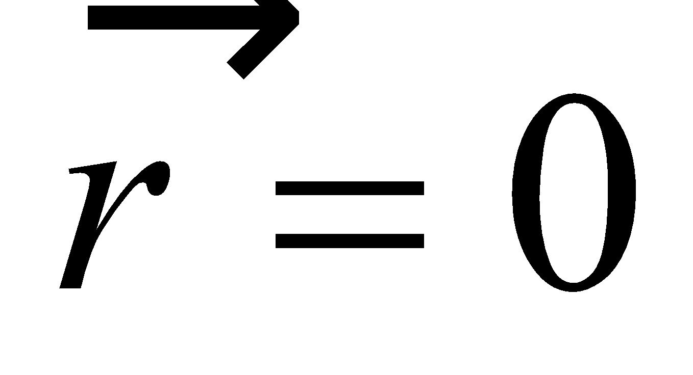, we have

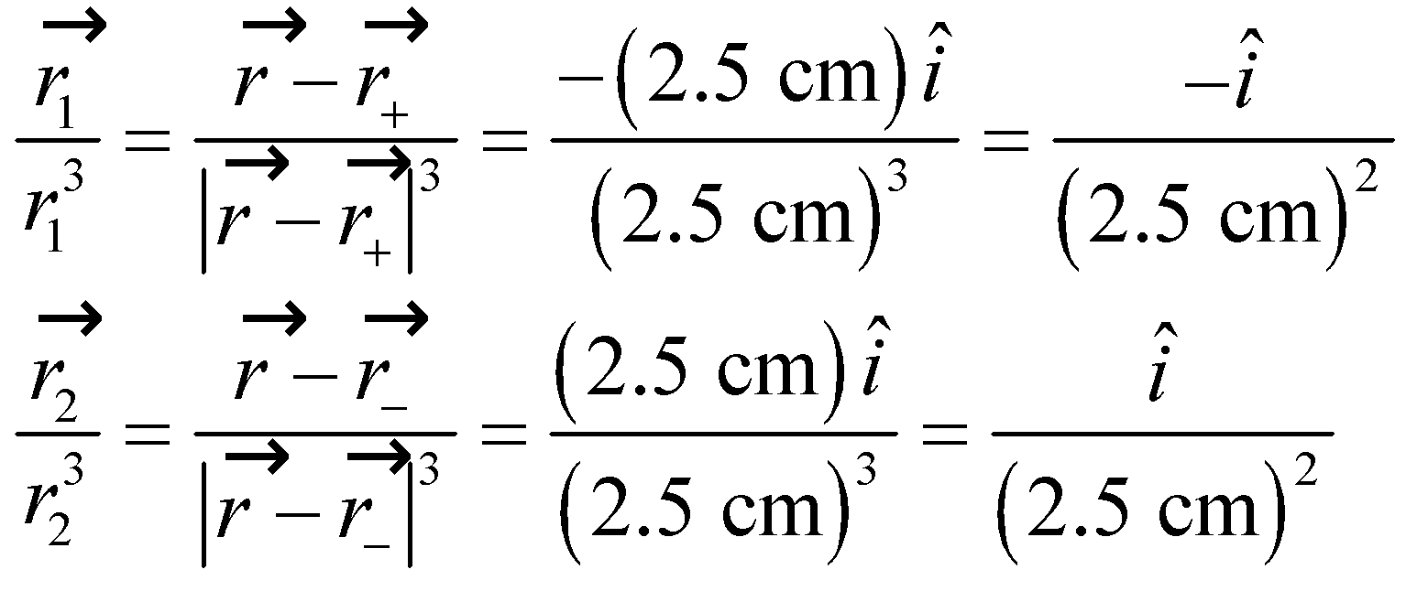

so the electric field is

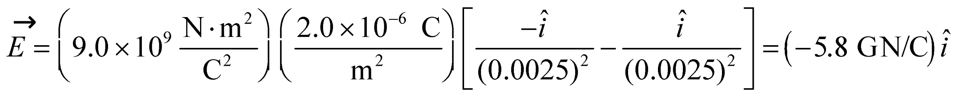

**Assess** The electric field for part (b) is much weaker because the fields from the two charges largely cancel.

**28. Interpret** Given the magnitude of the dipole moment, we are asked to calculate the distance between the pair of opposite charges that make up the dipole.

**Develop** As shown in Equation 20.5, the electric dipole moment *p* is the product of the charge *q* and the separation *d* between the two charges making up the dipole:

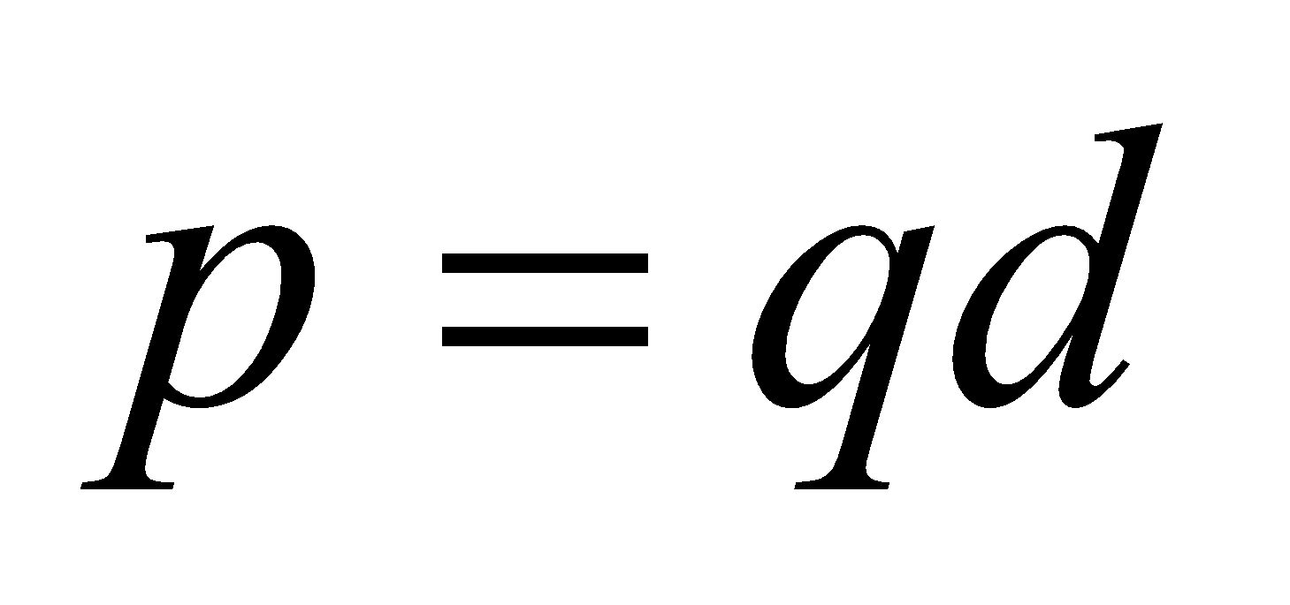

**Evaluate** Using the equation above, the distance separating the charges of a dipole is

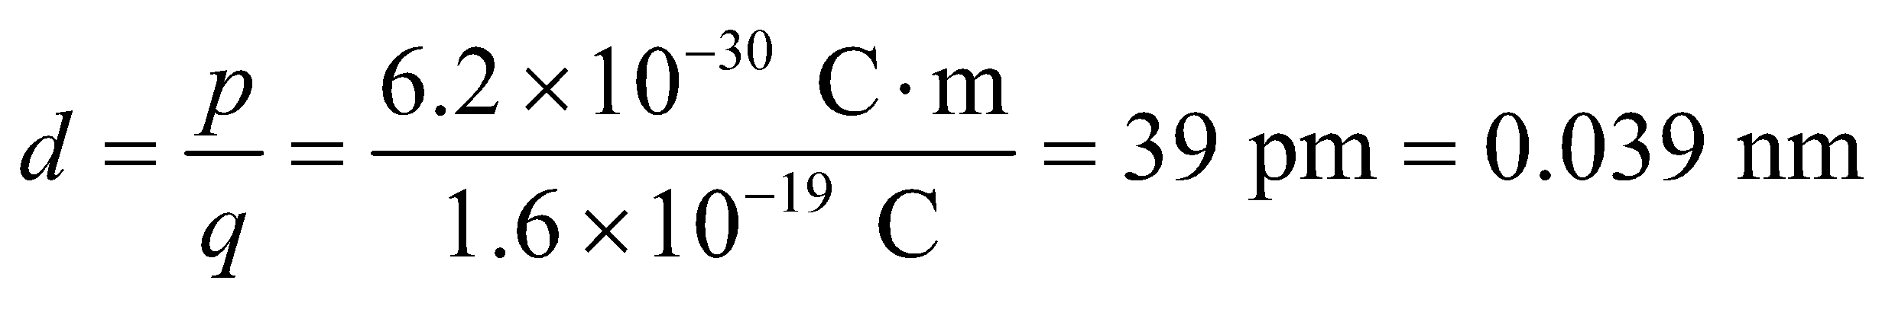

**Assess** The distance *d* has the same order of magnitude as the Bohr radius 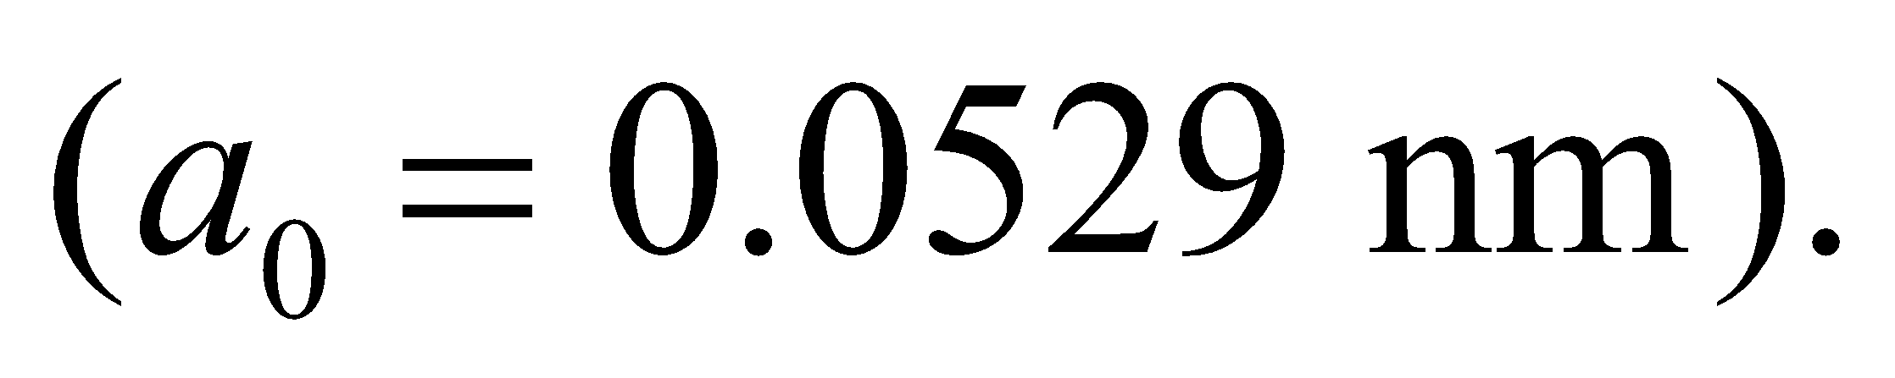

**29.** **Interpret** We are given a long wire with a uniform charge density and are asked to find the electric field strength 38 cm from the wire. We can assume that the wire length is much, much greater than 38 cm.

**Develop** For a very long wire 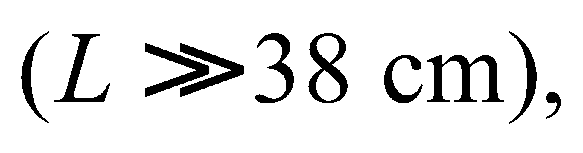 Example 20.7 shows that the magnitude of the electric field falls off like 1/*r*. Therfore, the electic field is simply scaled by the ratio of the distances, or

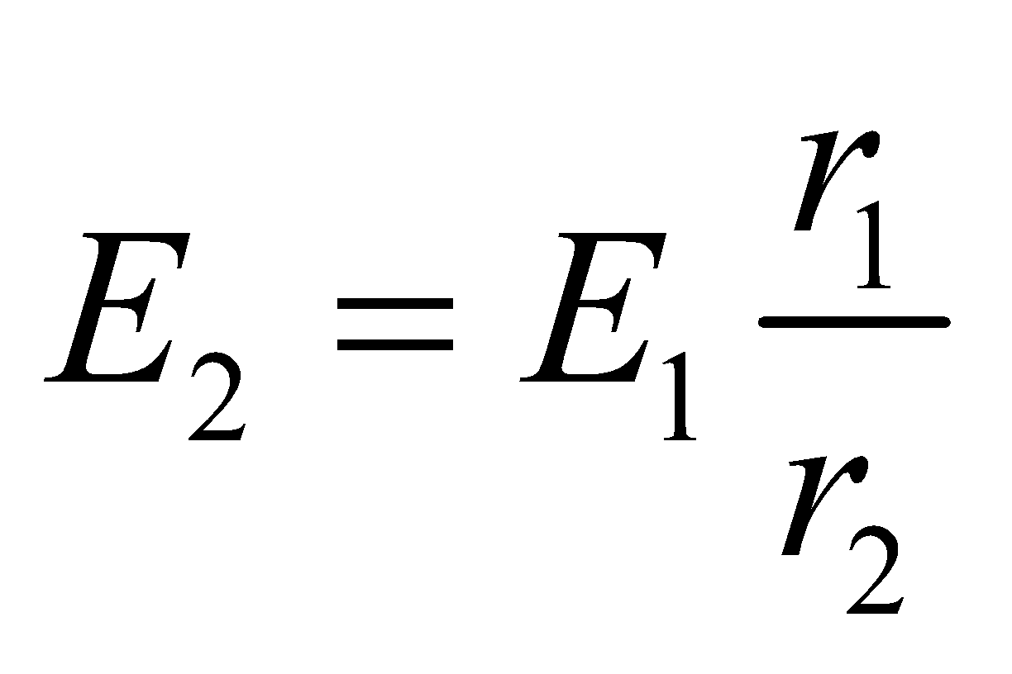

**Evaluate** Inserting the given quantities into the expression above gives

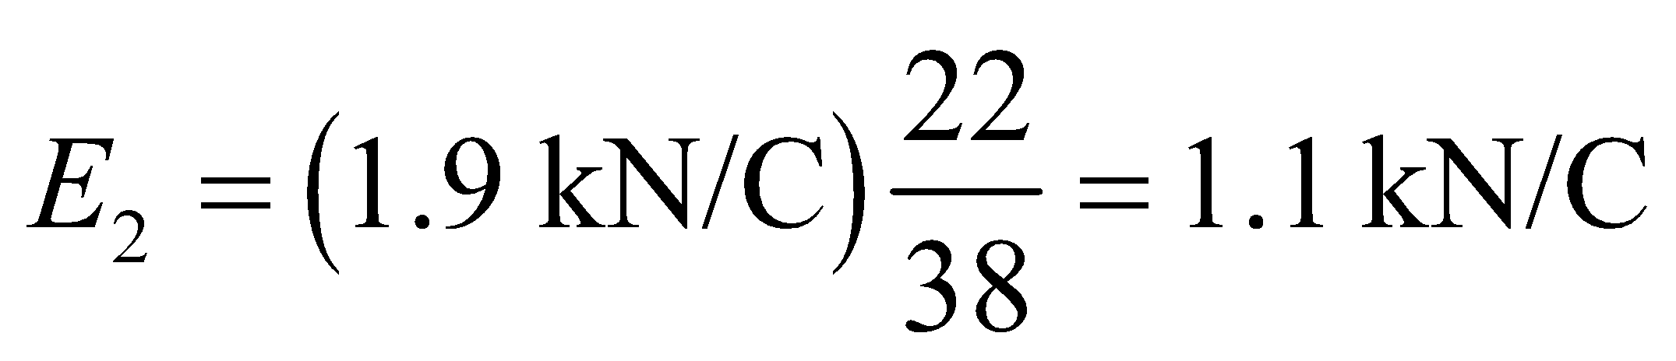

**Assess** The electric field gets weaker the farther we are from the wire, as expected.

**30. Interpret** In this problem we are asked to find the line charge density, given the field strength at a distance from a long wire. We can assume that the wire is much, much longer than the distance involved (45 cm), so that the result of Example 20.7 applies.

**Develop** If the electric field points radially toward the long wire 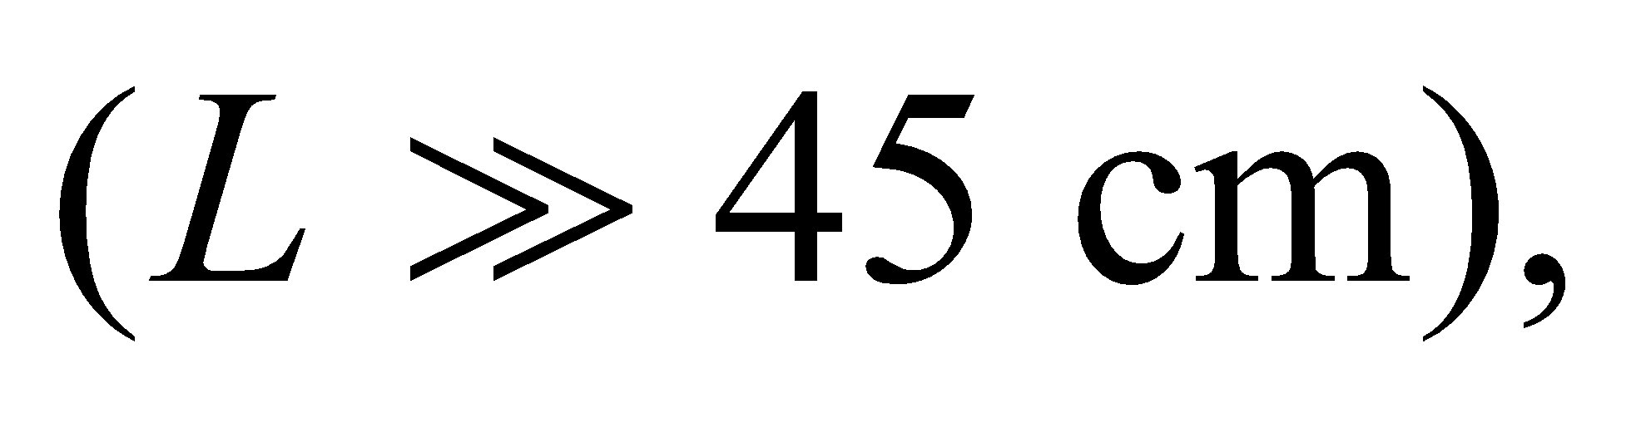 the charge on the wire must be negative. The magnitude of the field is given by the result of Example 20.7,

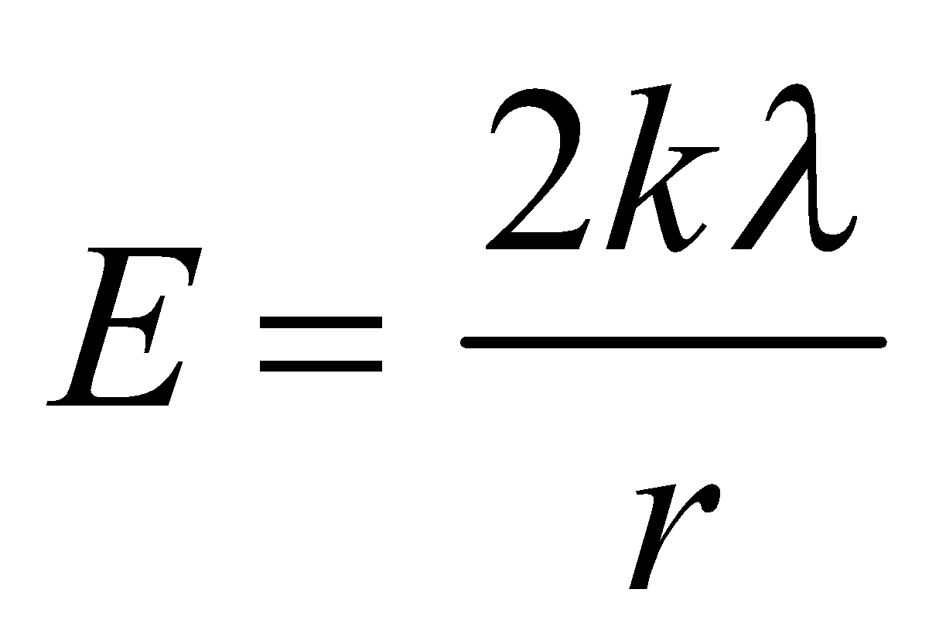

**Evaluate** Using the equation above, we find the line charge density to be

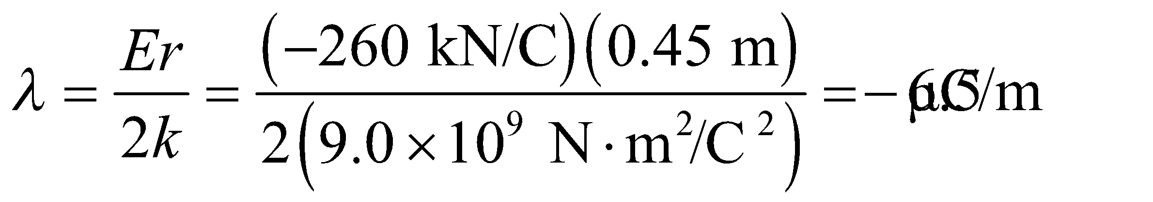

**Assess** The electric field strength due to a line charge density decreases as 1/*r*. Compare this to the 1/*r*2 dependence of the electric field of a point charge.

**31. Interpret** We will use Coulomb’s law and the definition of electric field to find the electric field at a point on the axis of a charged ring.

**Develop** From Example 20.6, which is done for a general distance *x*, we see that

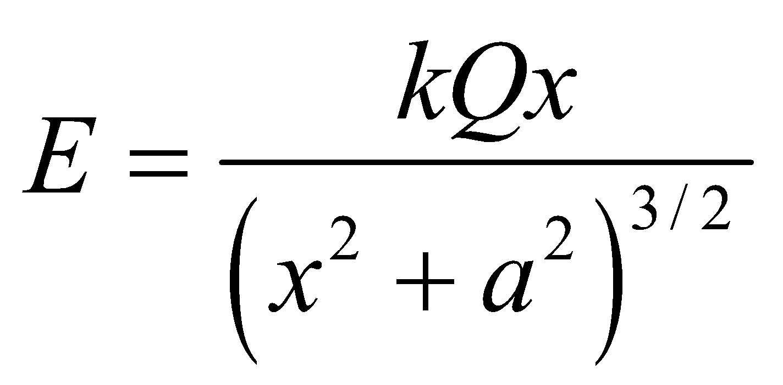

We want to know the field *E* at position *x* = *a*.

**Evaluate** Inserting *x* = *a* into the expression above gives

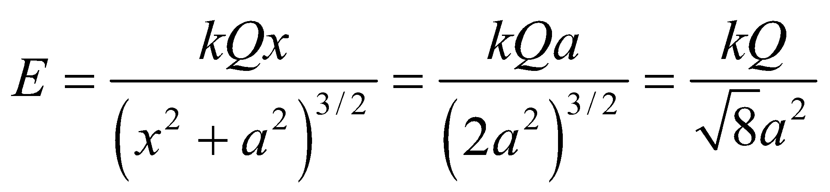

**Assess** The units are *kQ*/(distance)2, which are correct for an electric field.

**Section 20.5 Matter in Electric Fields**

**32. Interpret** For this problem, we are to find the force generated by 10 elementary charges in the given electric field, and calculate the mass that can be suspended by this force in the Earth’s gravitational field.

**Develop** By Newton’s second law, the force due to gravity and the force due to the electric field must cancel each other for the oil drop to have no acceleration. This condition gives

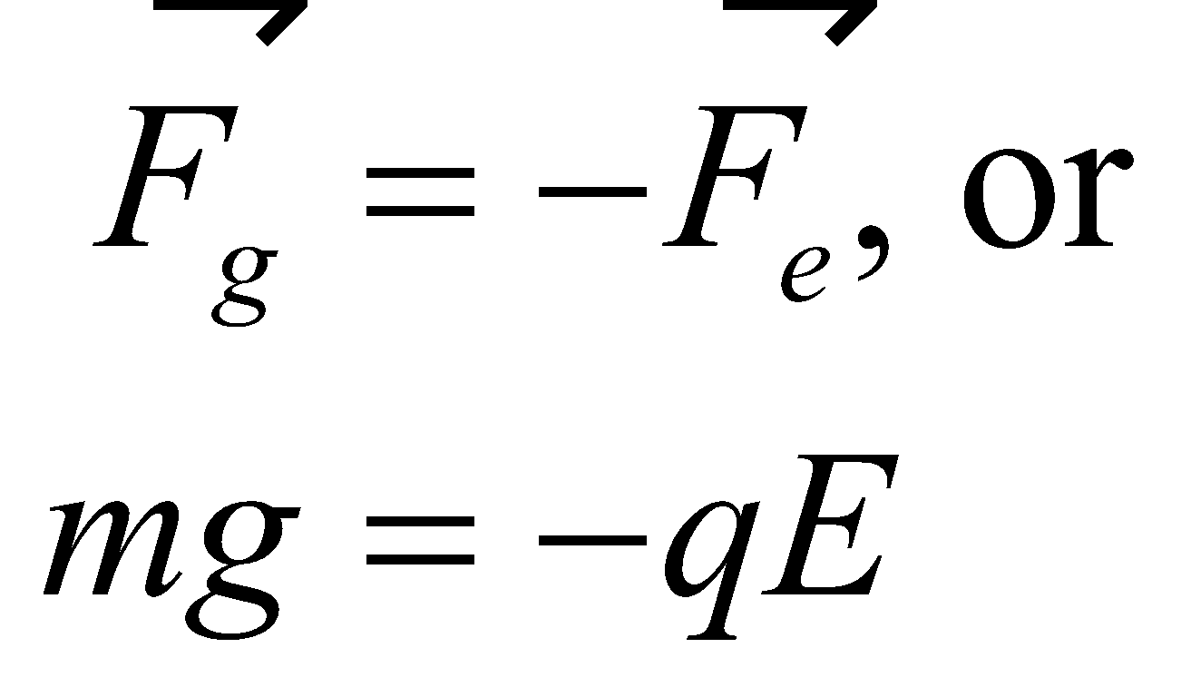

The equation can be used to compute the mass *m*.

**Evaluate** Using the equation above, the mass is

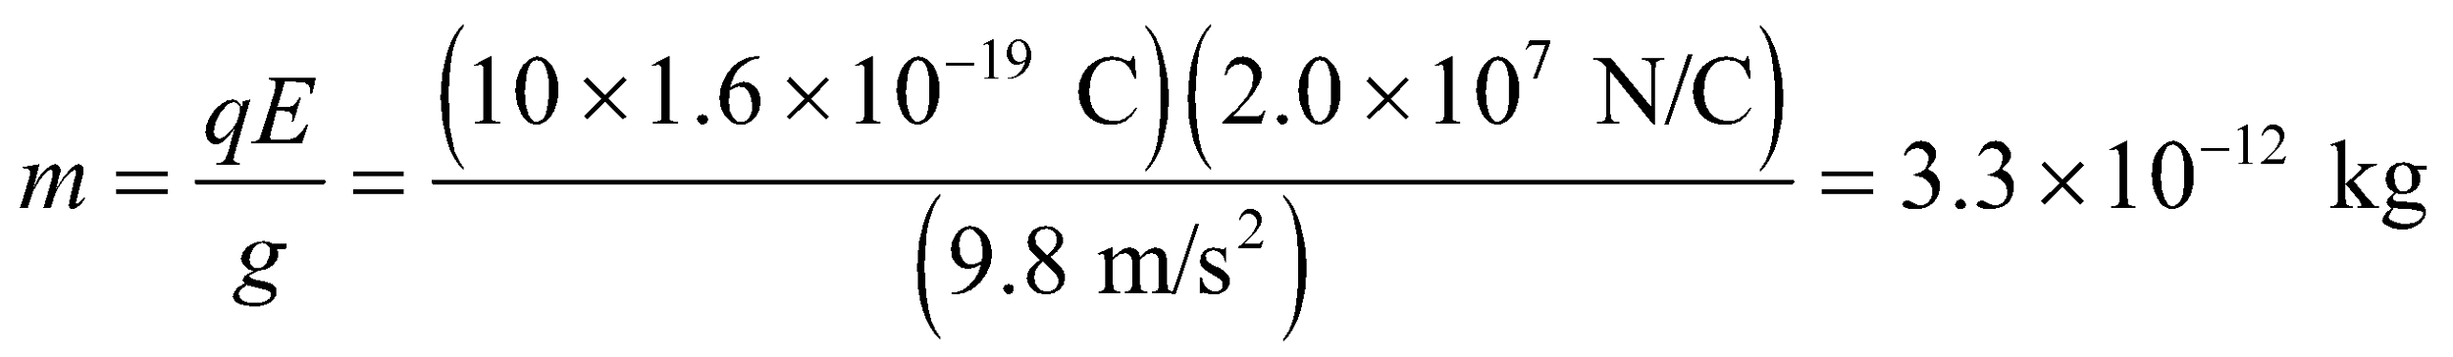

**Assess** Because this mass is so small, the size of such a drop may be better appreciated in terms of its radius, 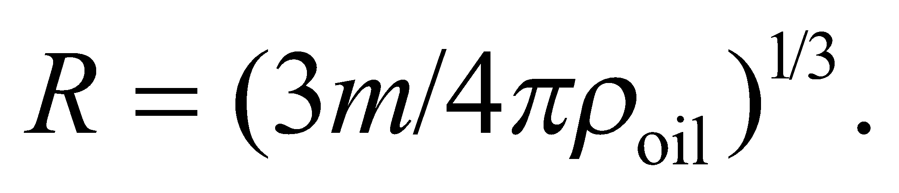 Millikan used oil of density 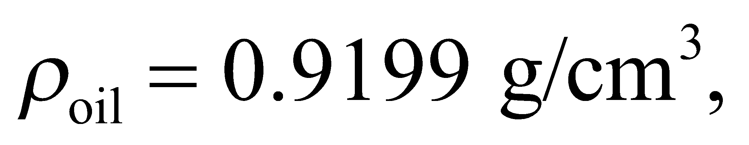 so 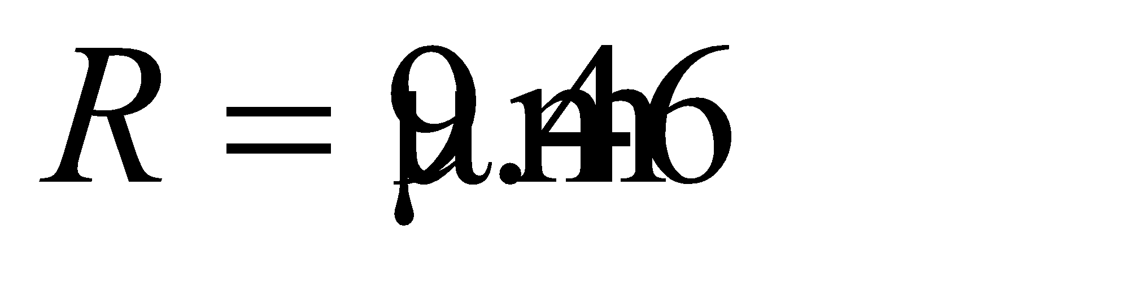 for this drop.

**33.** **Interpret** This problem involves kinematics, Newton’s second law, and Coulomb’s law. We can use these concepts to find the electric field strength necessary to accelerate an electron from rest to *c*/10 within 5.0 cm.

**Develop** If the electric filed is constant in space, the force applied to the charge will be constant, so we can use Equation 2.11, which applied for constant acceleration, to find the necessary acceleration for the electron. This gives

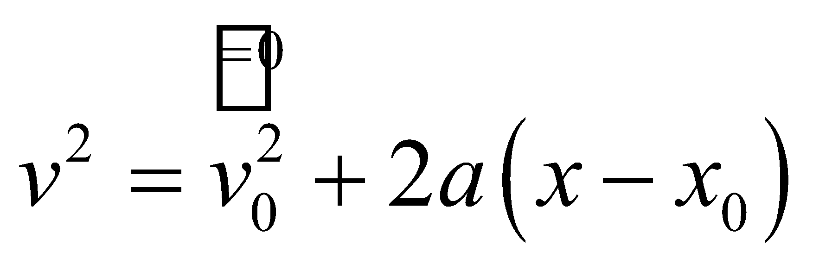

where *v* = *c*/10, *x* − *x*0 = 5.0 cm, and *v*0 = 0 because the electron starts from rest. Thus the acceleration is

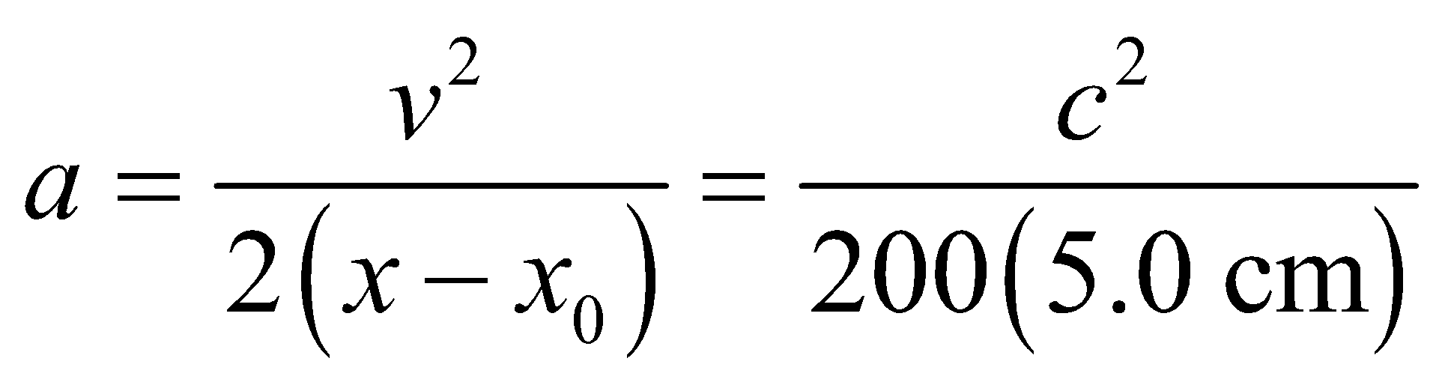

The force needed to provide this acceleration is given by Newton’s second law which, combined with Coulomb’s law, gives

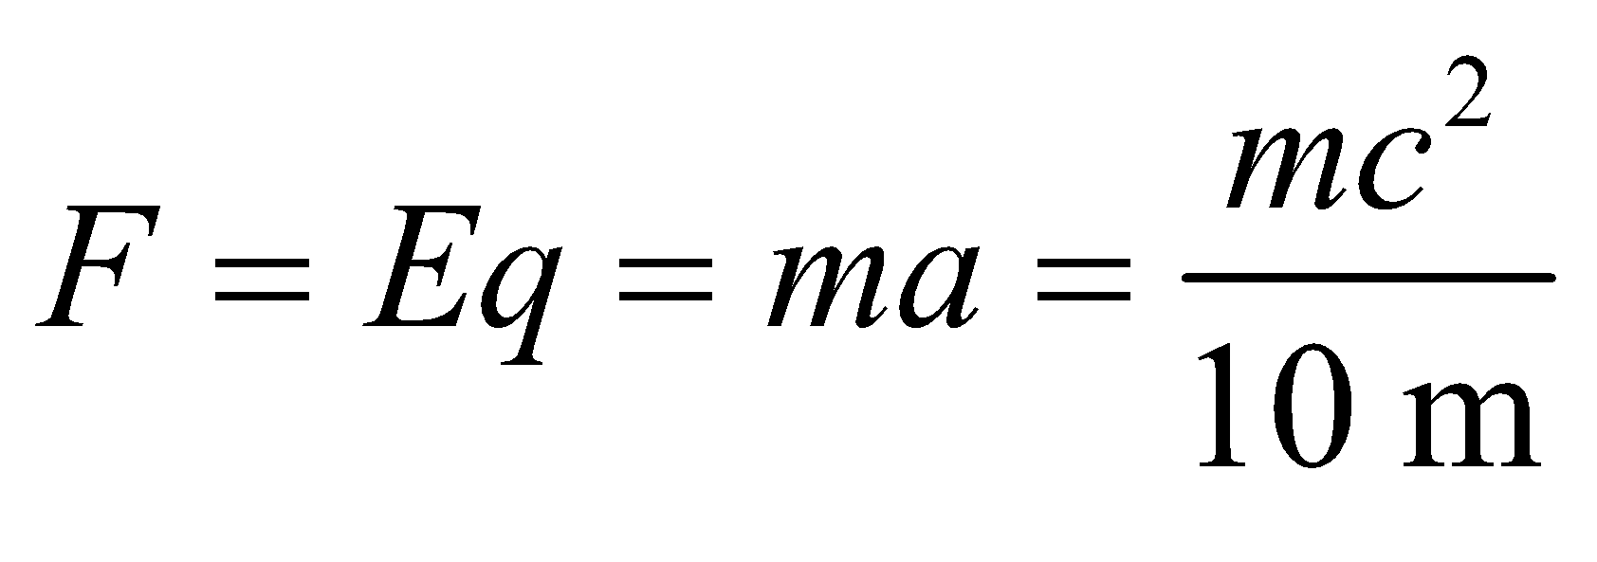

which we can solve for E.

**Evaluate** Inserting |*q*| = 1.6 ×10−19 C for the electron’s charge (since we are only concerned with the strength of the electric field, not its direction), we find

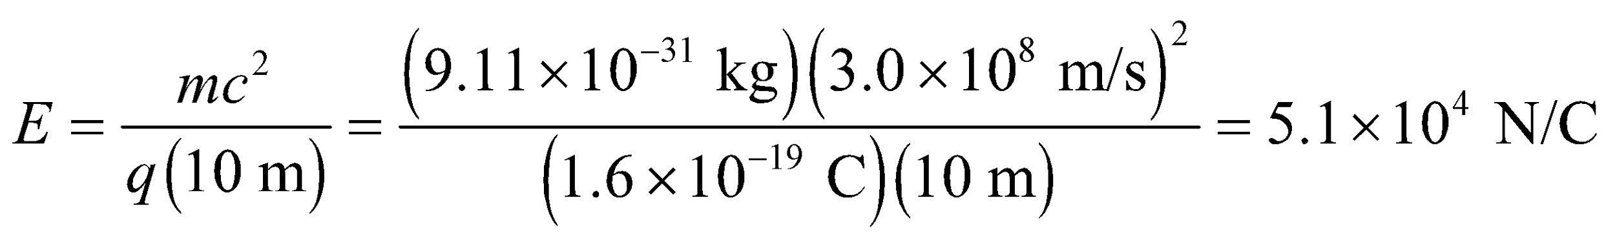

**Assess** Because the electron has as negative charge, it would move opposite to the direction of this electric field.

**34. Interpret** This problem is about the motion of a proton, which has charge +e, in an electric field that points to the left. The proton enters the field region with the given velocity, and we are to find how far it travels in the field before it reverses direction. We are also to describe its subsequent motion. To address this problem, we will use Newton’s second law and Coulomb’s law, and some kinematics from Chapter 2.

**Develop** Choose the *x* axis to the right, in the direction of the proton’s initial velocity, so that the electric field is oriented to the left. If only the Coulomb force (Equation 20.2b) acts on the proton, the acceleration can be found from Newton’s second law (for constant mass: Equation 4.3):

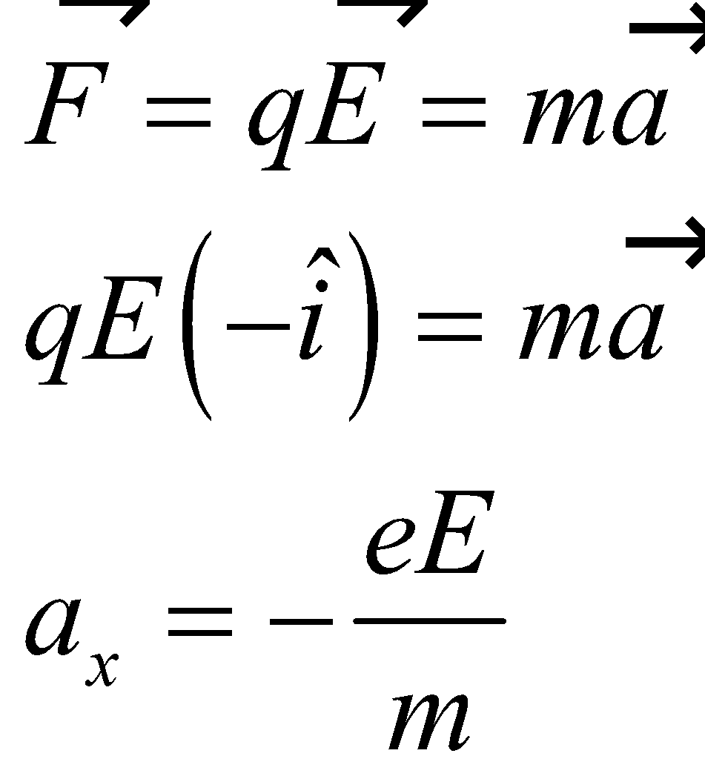

where *a*x is the magnitude of the proton’s acceleration along the *x* axis. The negative sign means that the proton decelerates as it enters the electric field. Because the acceleration is constant, we can apply Equation 2.11, 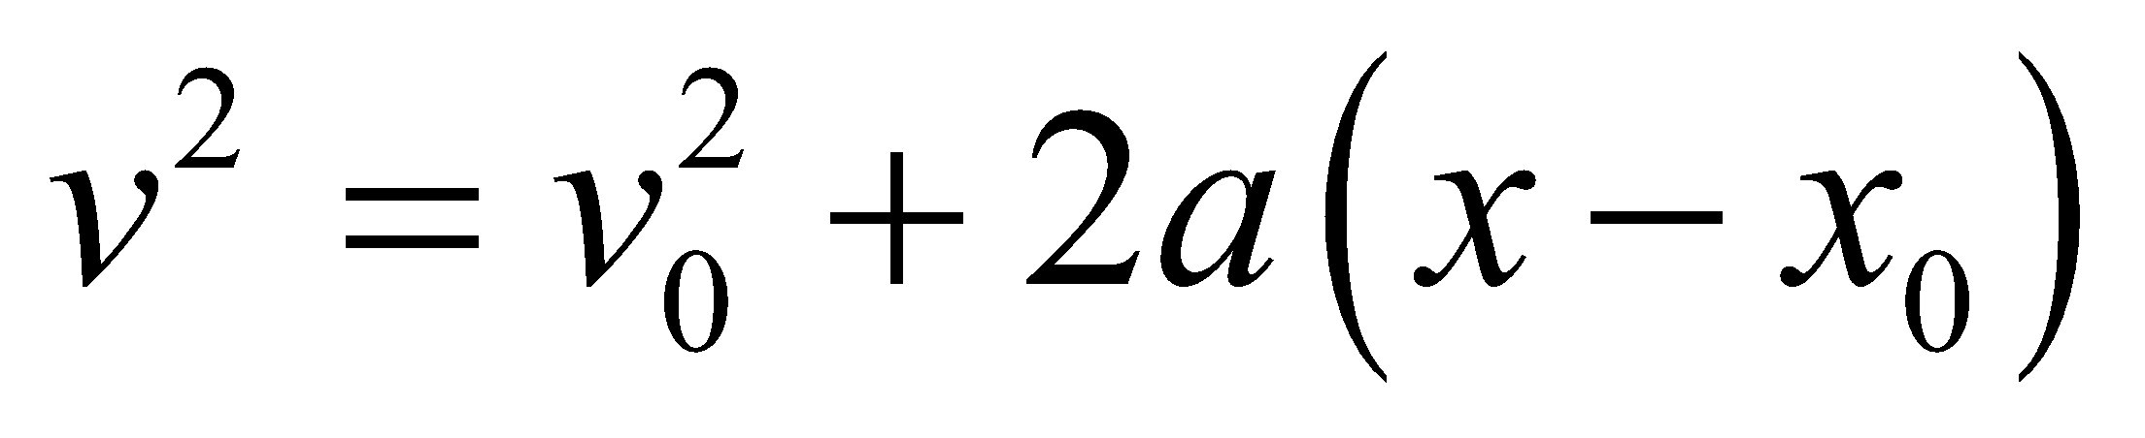. When the proton reverses direction, its velocity *v* = 0 momentarily, so we insert this into Equation 2.11 to find the distance traveled *x* − *x*0.

**Evaluate** **(a)** Using Equation 2.11, with 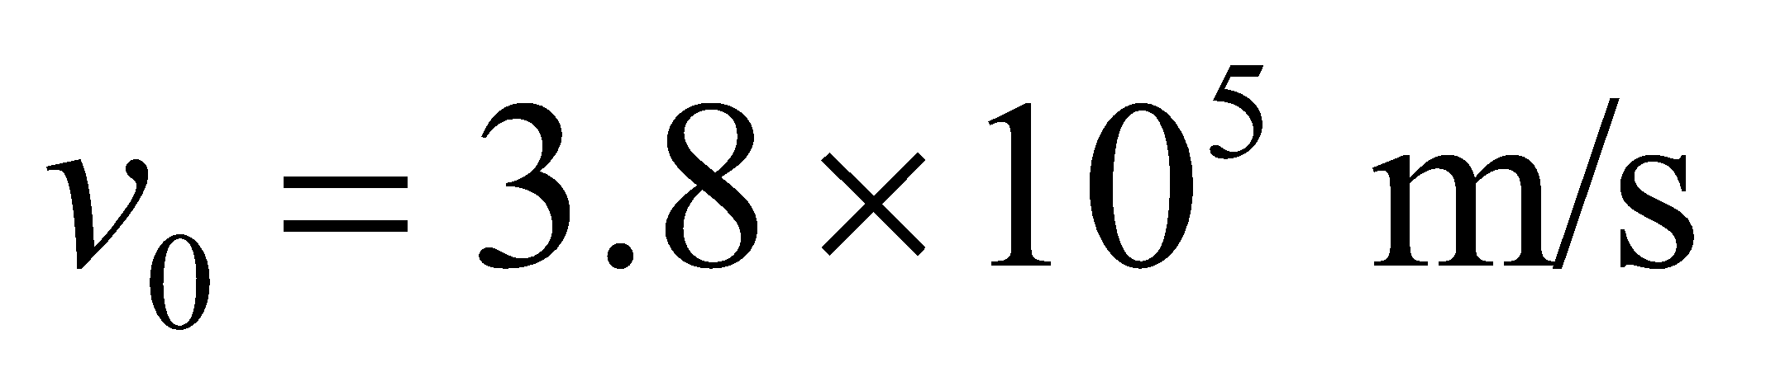, we find the maximum penetration into the field region to be

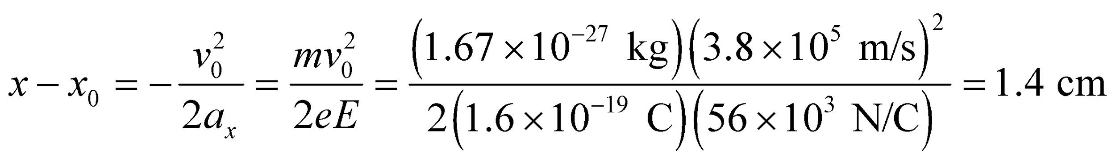

**(b)** The proton subsequently moves to the left, with the same constant acceleration in the field region, until it exits with 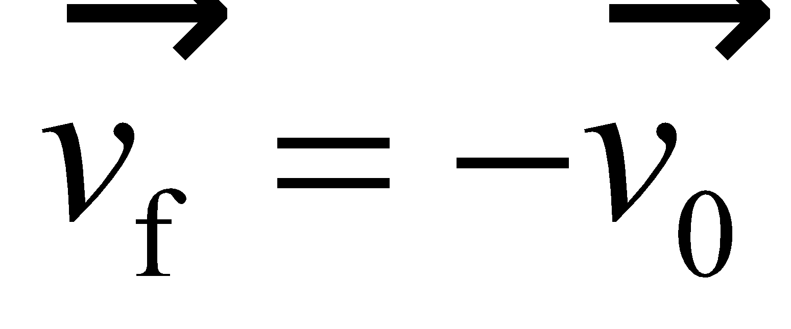.

**Assess** The deceleration of the proton increases with the field strength *E*. Note that it is unrealistic to have an electric field that begins instantaneously in space or time, as we will find in later chapters.

**35.** **Interpret** This problem involves an electrostatic analyzer like that in Example 20.8, so we will use the results of that example. We are to find the coefficient *E*0 in the expression for the electric field strength in the analyzer that will permit protons to exit the analyzer.

**Develop** From the analysis of Example 20.8, we know that the coefficient E0 of the analyzer is related to the particle mass *m*, its velocity *v*, and it charge *q* by

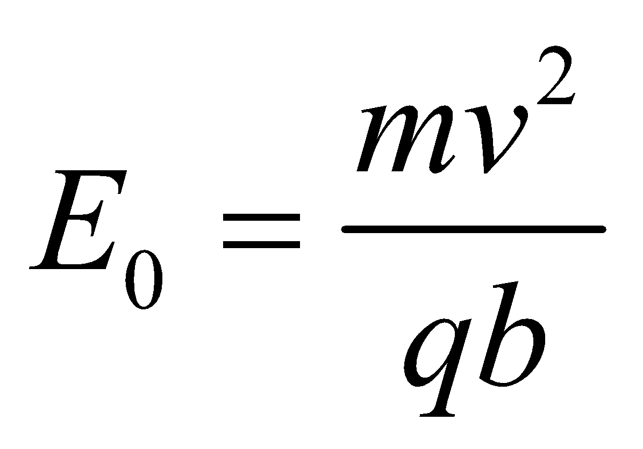

Given that 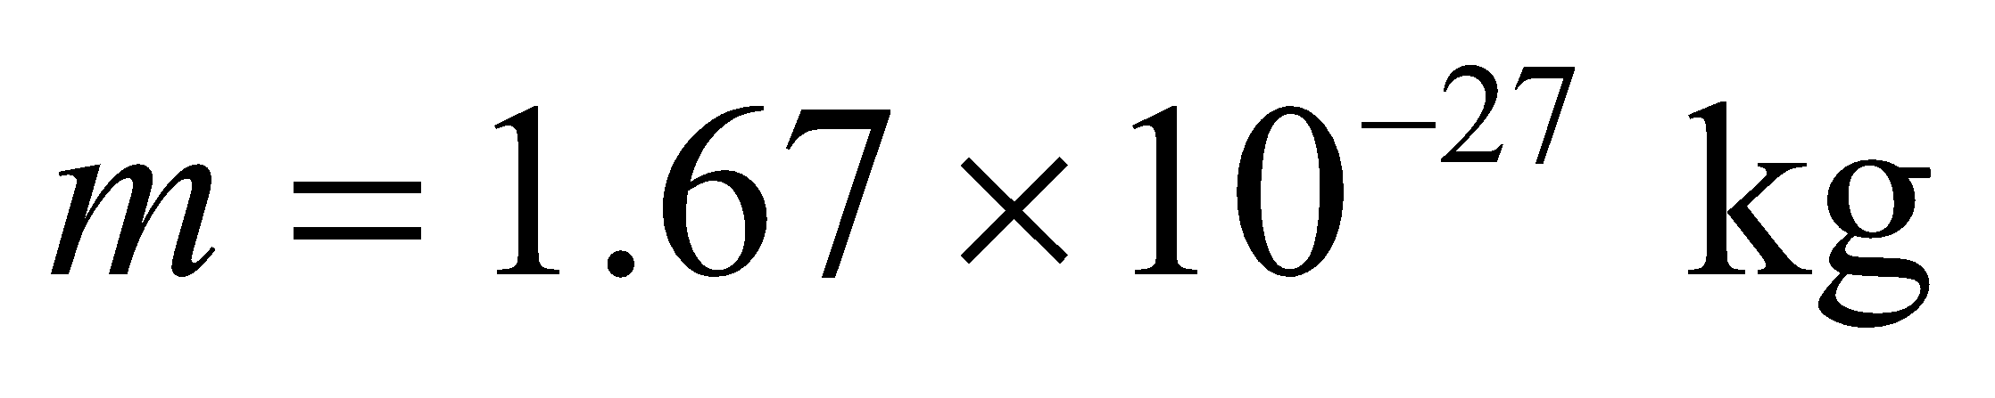 for a proton, 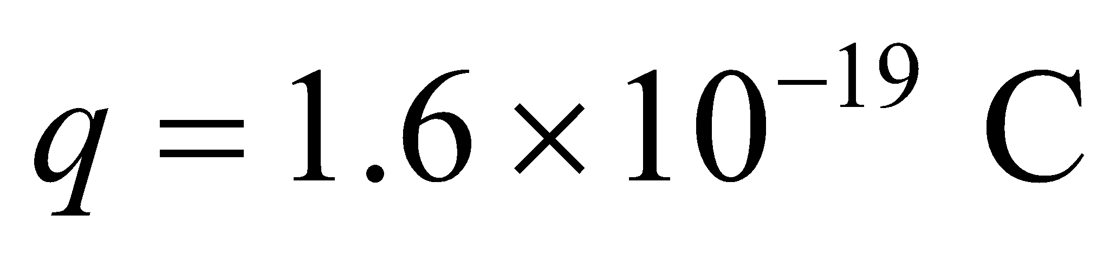, and *v* and *b* are given, we can find *E*0.

**Evaluate** Inserting the given quantities in the expression for *E*0 gives

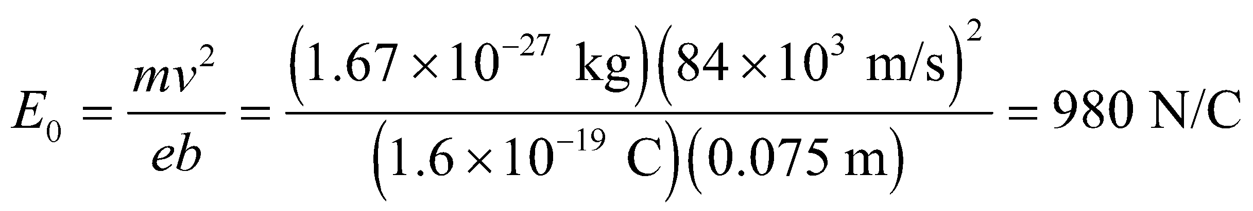

to two significant figures.

**Assess** Note that the proton exits the analyzer with the same speed with which it entered that analyzer, because the force is always perpendicular to the proton’s trajectory (i.e., it’s a centripetal force). Thus, the force does no work on the proton, but the proton’s velocity has changed direction.

**Problems**

**36. Interpret** The problem asks for an estimate of the fraction of electrons removed from a 2-g ping pong ball due to rubbing.

**Develop** Suppose that half the ball’s mass is protons (the other half is neutrons). The number of protons is then

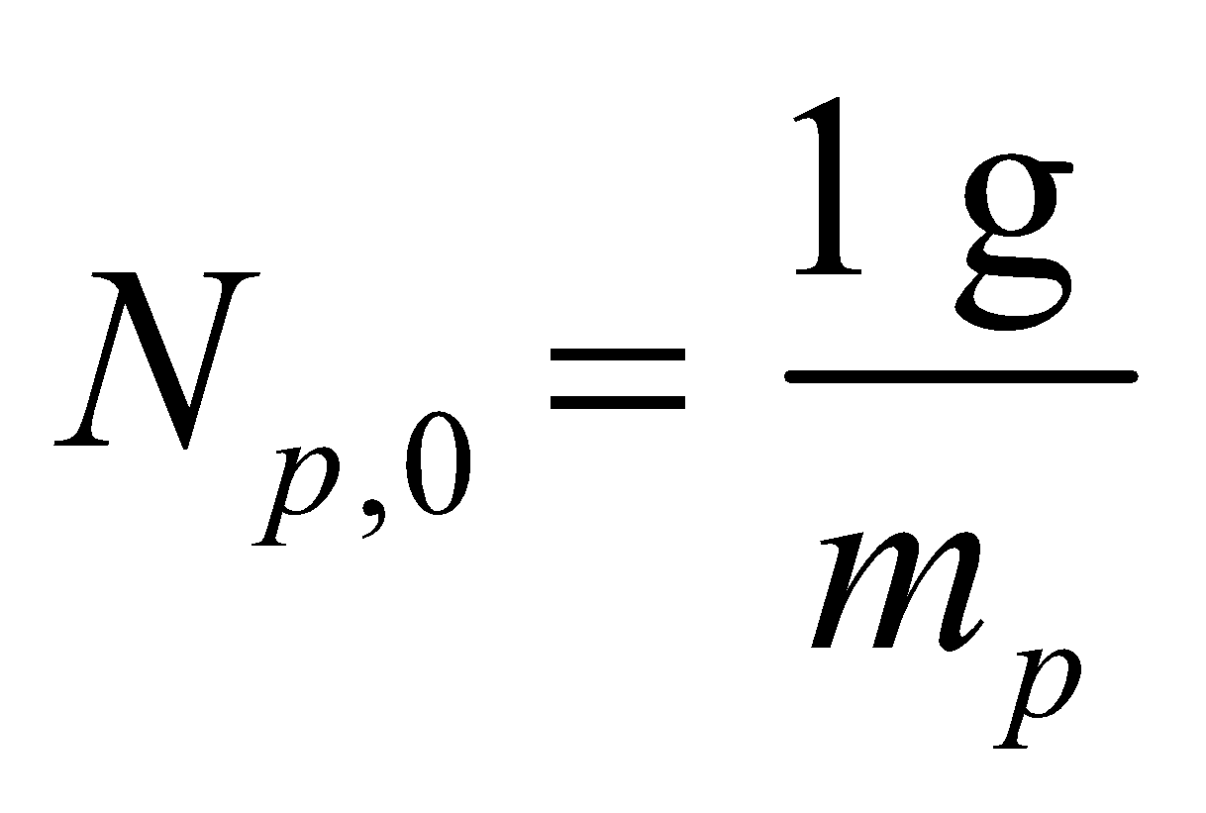

For the ping pong ball to be initially neutral, it must have the same number of electrons *Ne*,0. Therefore, *Ne*,0= *Np*,0. The number of electrons removed is

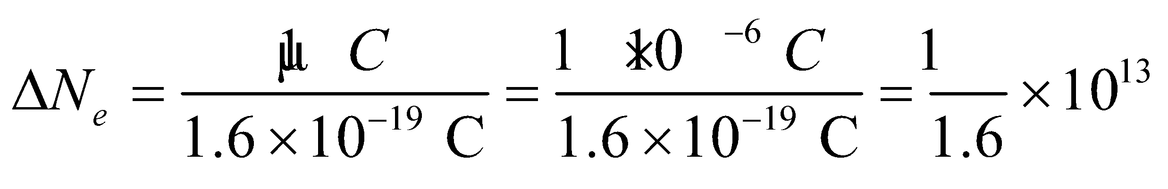

The fraction removed is then *Δ*N*e*/*Ne*,0.

**Evaluate** Inserting the numbers, we find the fraction of the ping pong ball’s electrons that are removed is

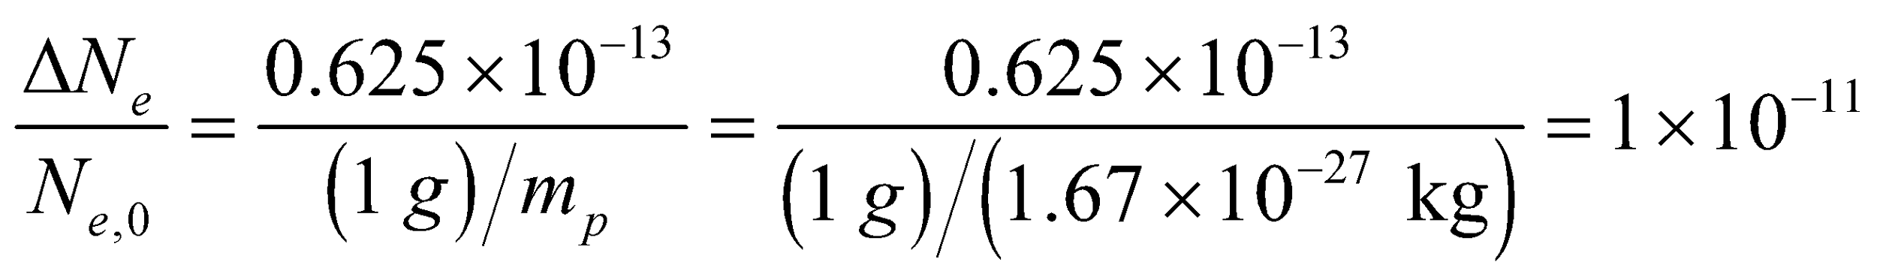

**Assess** The fraction is about a hundred billionth. Thus, although we removed some 10 trillion electrons, it is only a very small fraction of the total number of electrons.

**37.** **Interpret** This problem involves Coulomb’s law, which we can use to relate the force experienced by the two particles to their charges.

**Develop** Coulomb’s law (Equation 20.1) gives the force between charged particles 1 and 2 as

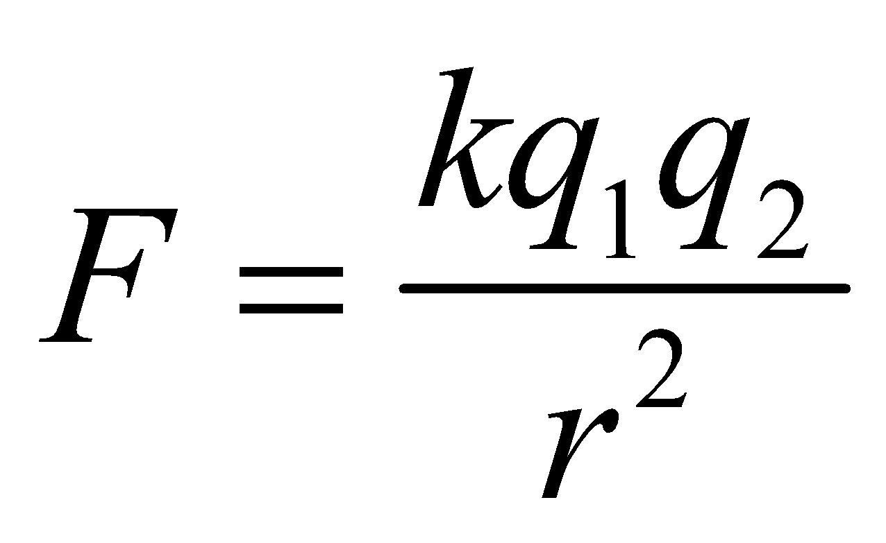

We are given that *q*1 = 2*q*2, and the *r* = 15 cm, so we can solve for the magnitude of the larger charge *q*1.

**Evaluate** Substituting for *q*2 in Coulomb’s law and solving for *q*1 gives

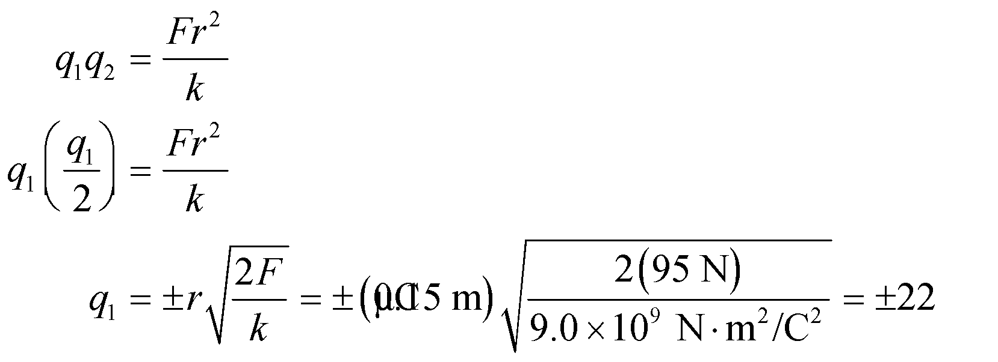

**Assess** Because the force is repulsive, the charges must have the same sign. However, from the information given in the problem statement, we cannot tell whether the sign is positive or negative.

**38. Interpret** In solving this problem we follow Problem Solving Strategy 20.1. The source charges are the proton and the electron, and the charge on which the forces act is the helium nucleus (with charge +2*e*). Using the principle of superposition, we can sum the individual forces to find the total force.

**Develop** Make a sketch of the situation that shows the charges and their positions (see figure below). The unit vector from the proton’s position toward the origin is 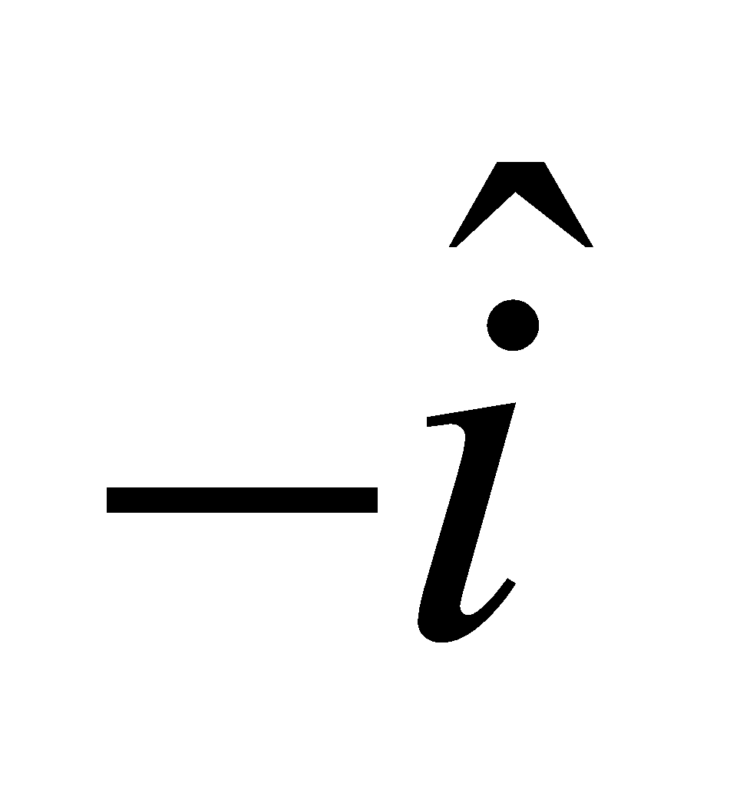. Using Equation 20.1, the Coulomb force exerted by the proton on the helium nucleus is

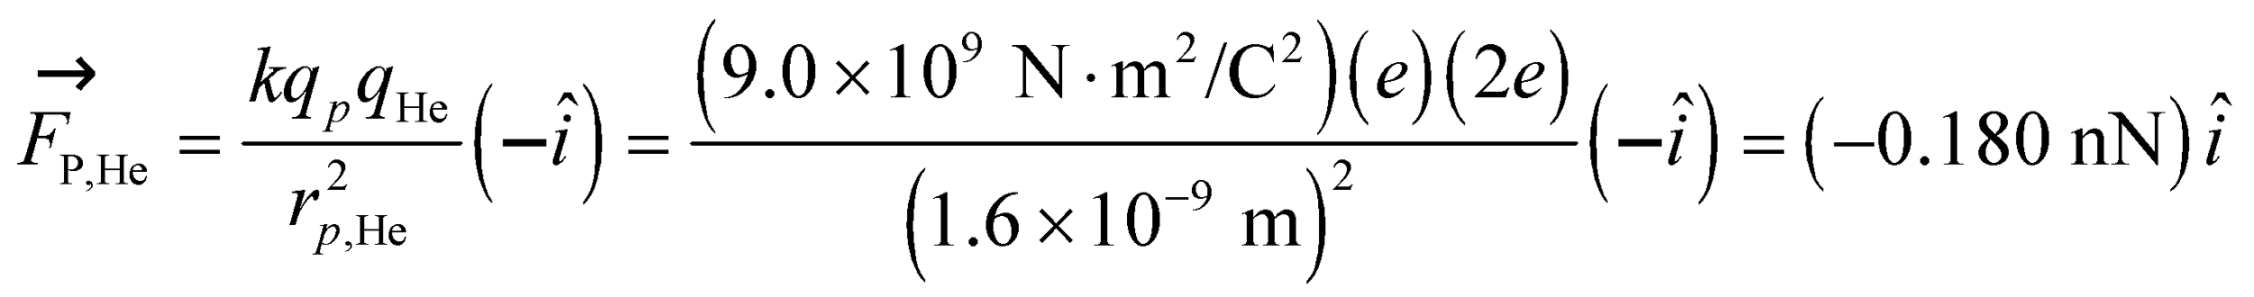

where we have retained an extra significant figure in the result because this is an intermediary result. Similarly, the unit vector from the electron’s position to the origin is 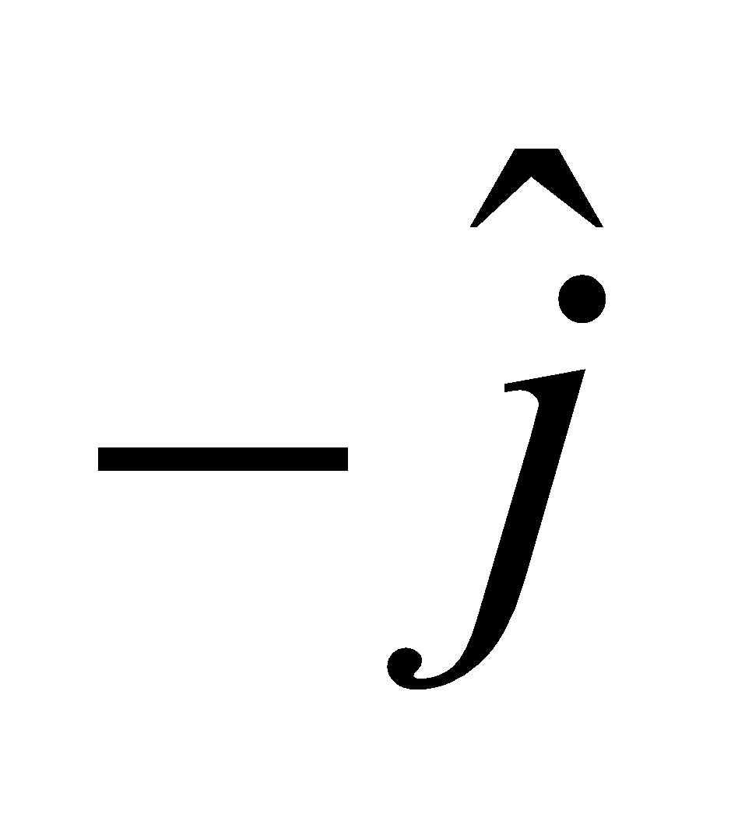, so the force it exerts on the helium nucleus is

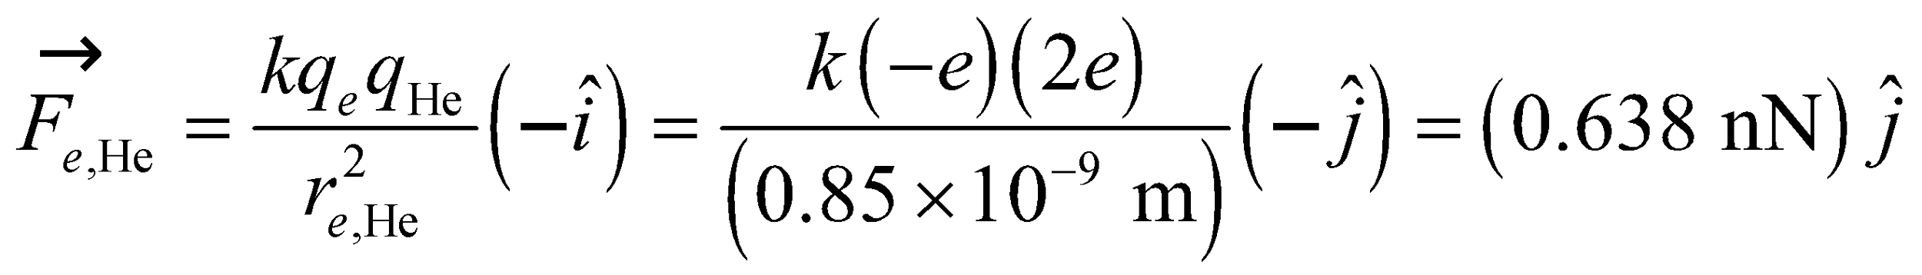



**Evaluate** To two significant figures, the net Coulomb force on the helium nucleus is the sum of these:



**Assess** In situations where there are more than one source charge, we apply the superposition principle and add the electric forces vector-wise. Because the electron is closer to the He nucleus than the proton in this problem (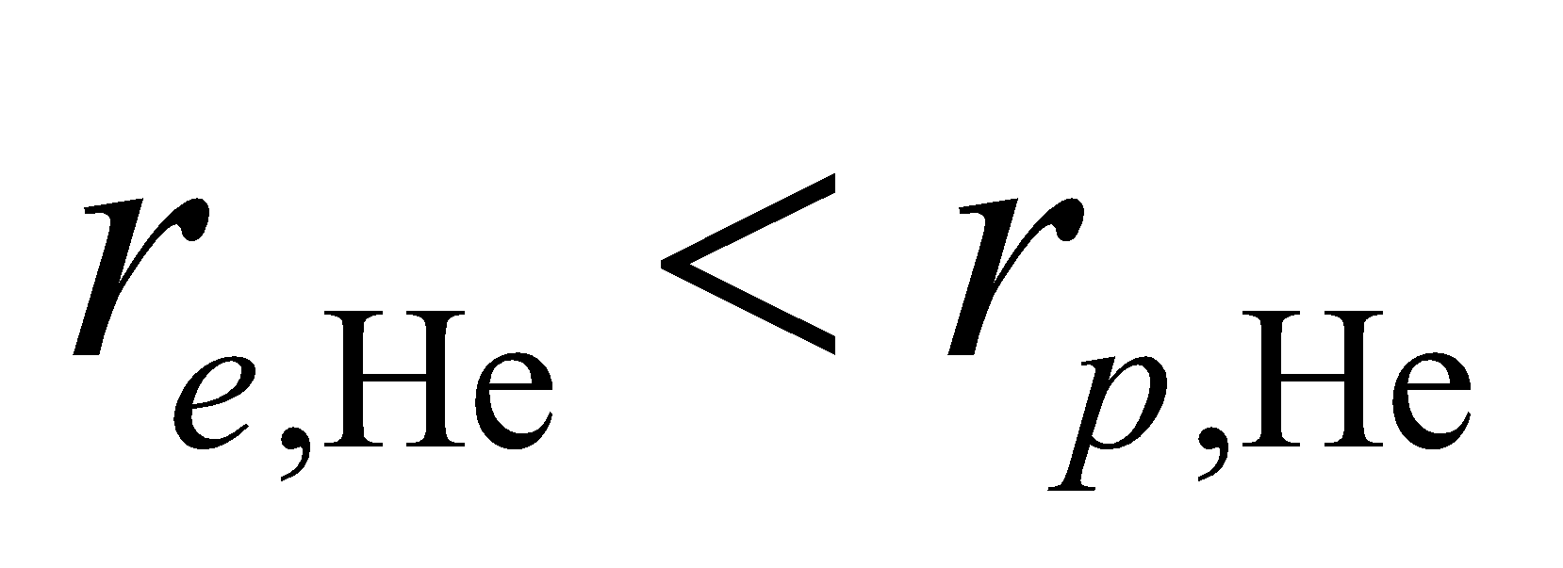), we expect 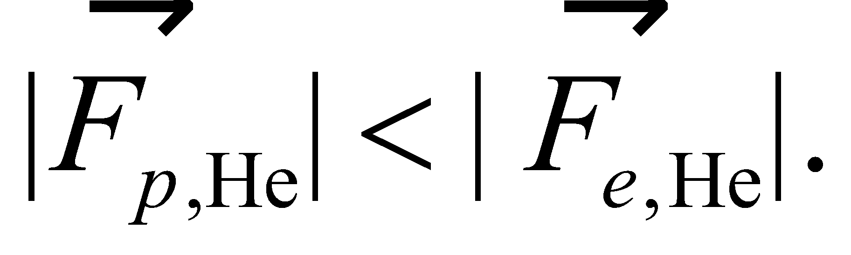 The direction of the force is 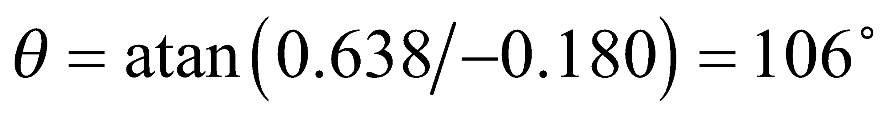 with respect to the positive *x* axis.

**39. Interpret** This involves finding the electric force on one charge from another charge when both are located in the *x*-*y* plane.

**Develop** Denote the positions of the charges by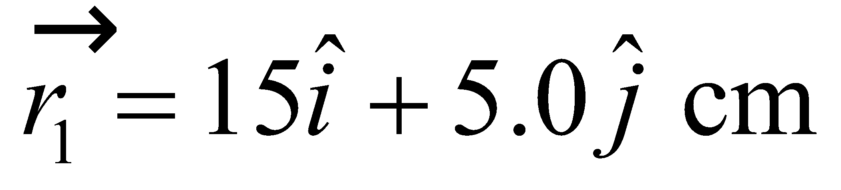 for 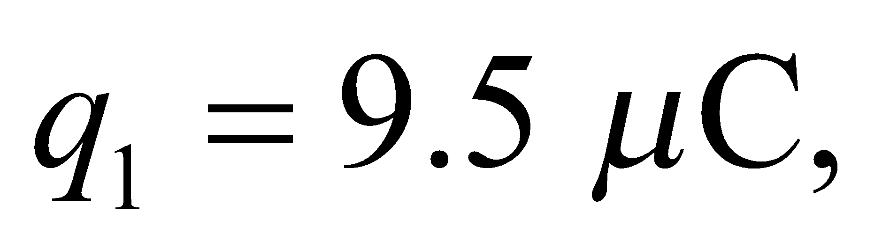 and 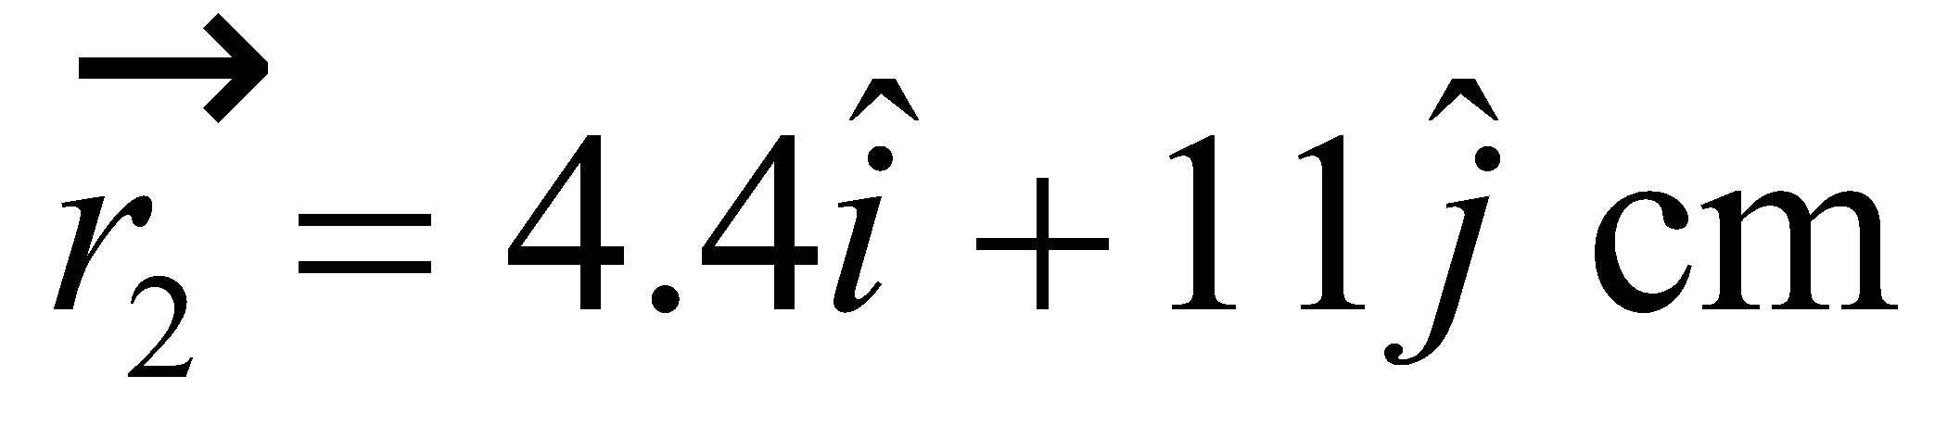 for 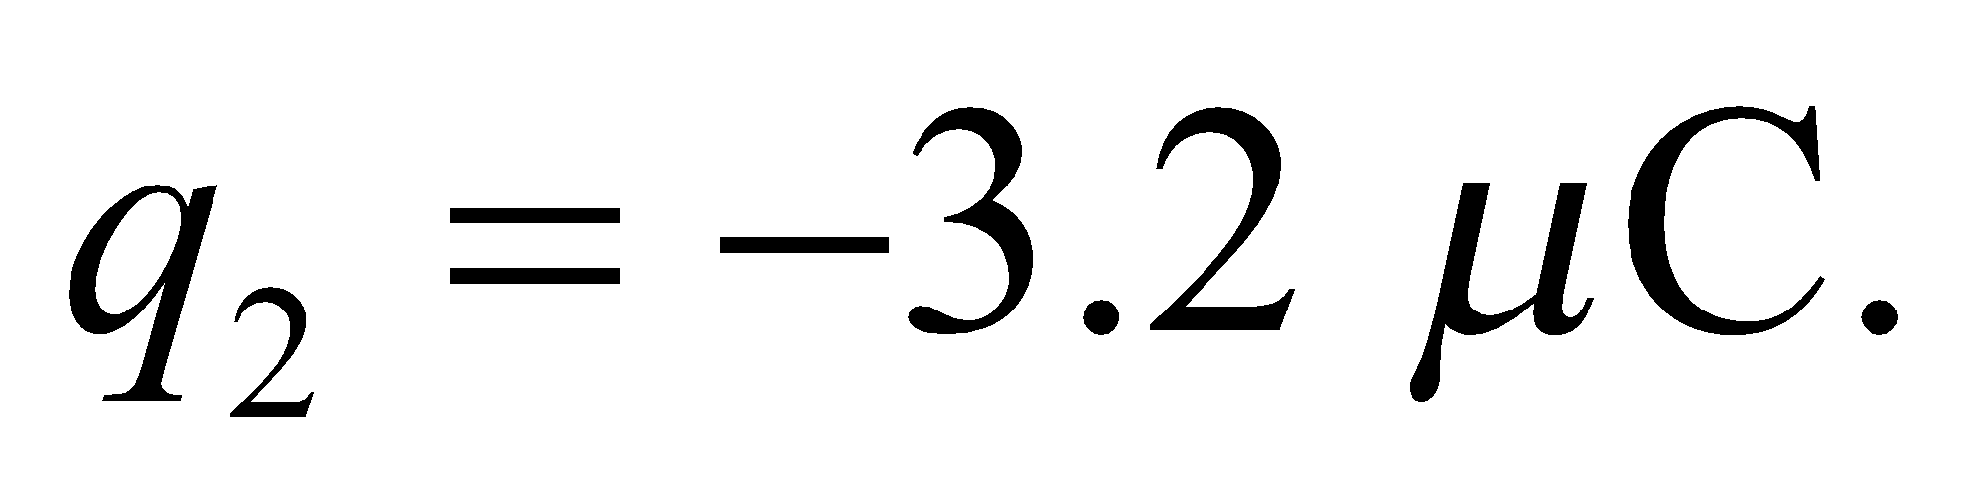 The vector from *q*1 to *q*2 is 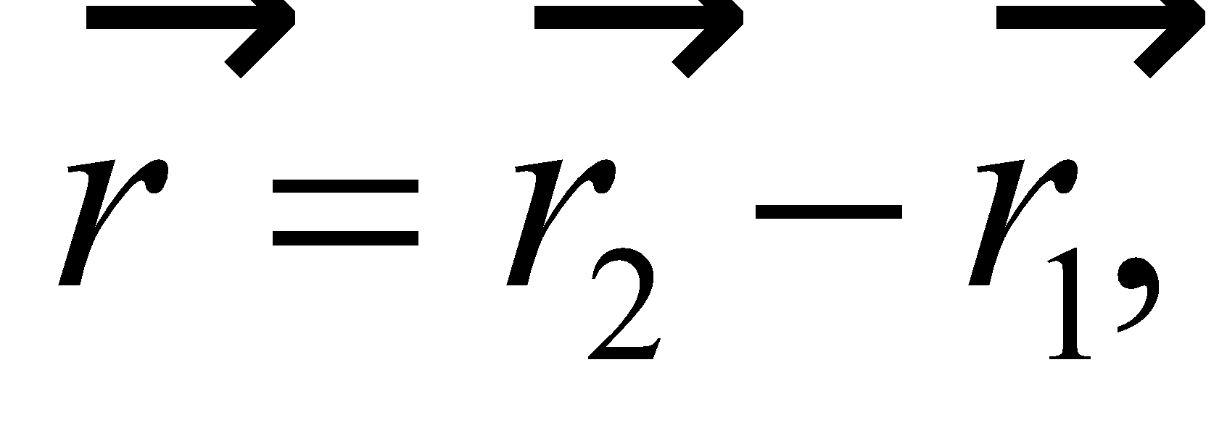from which we can find the charge separation, *r*, that goes into Coulomb's law, 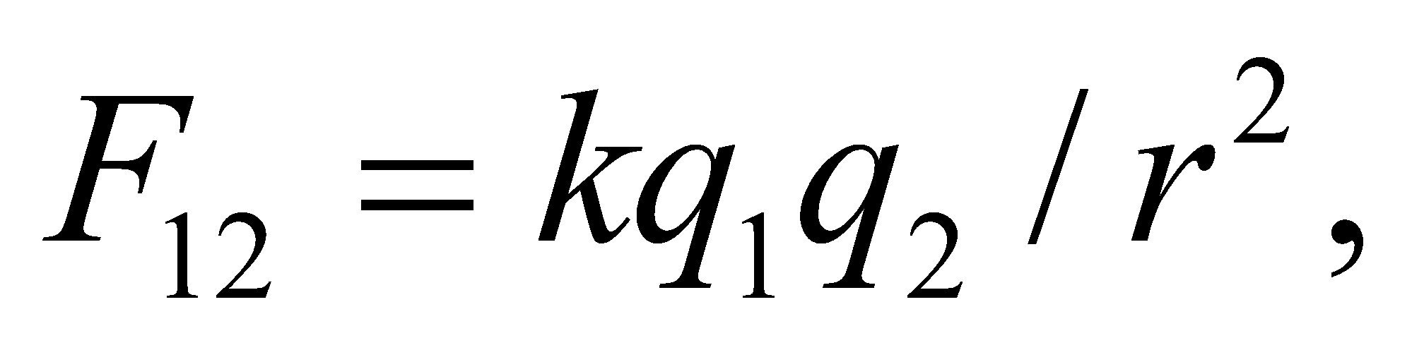 for the force *q*1 exerts on *q*2. The direction of this force can be designated with the unit vector, 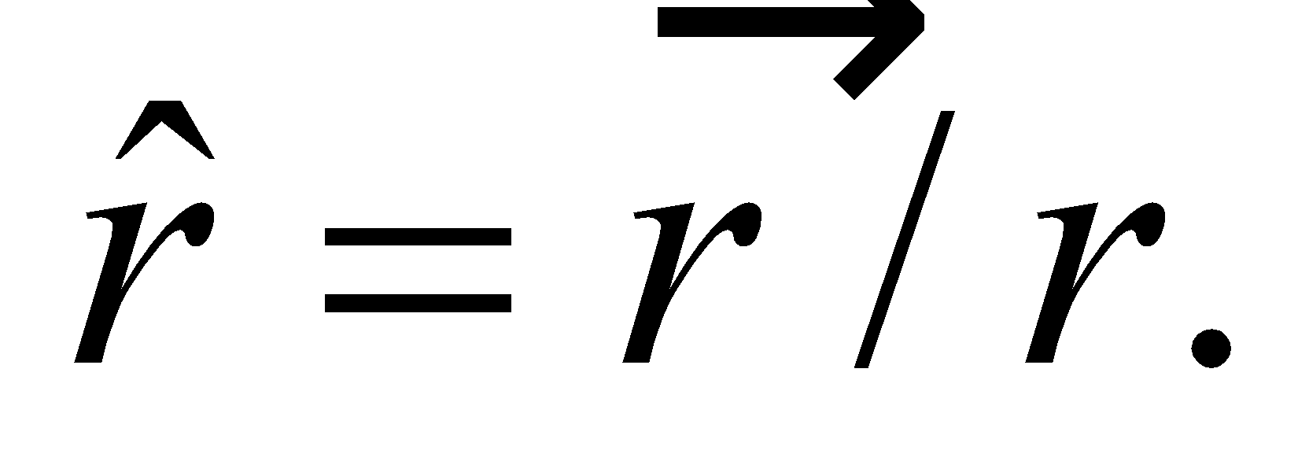

**Evaluate** First, we find the vector displacement:



The magnitude of this vector is 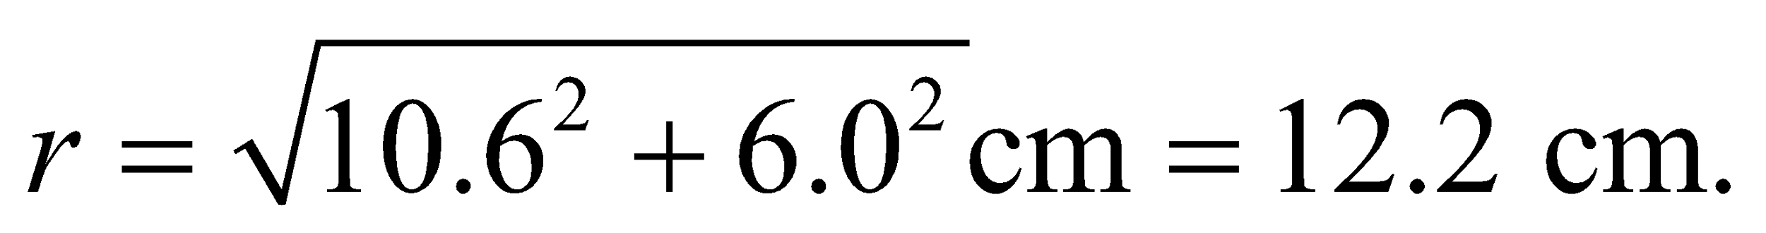So the electric force has a magnitude of

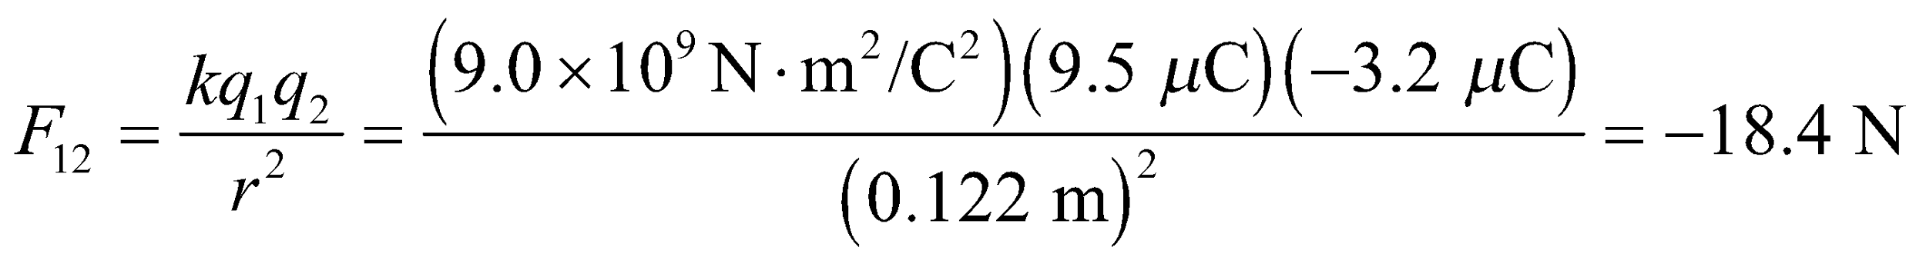

Using the unit vector, we can write the force in component form:

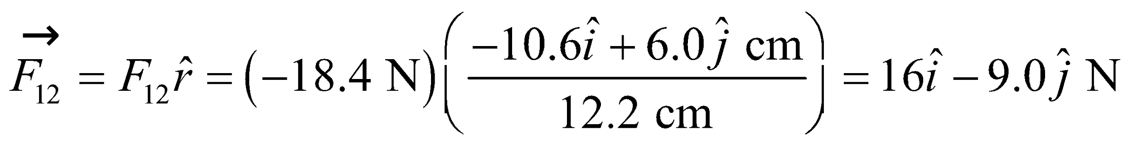

**Assess** Without calculating the exact directions, we can see that points to the left of the positive *y*-axis, whereas 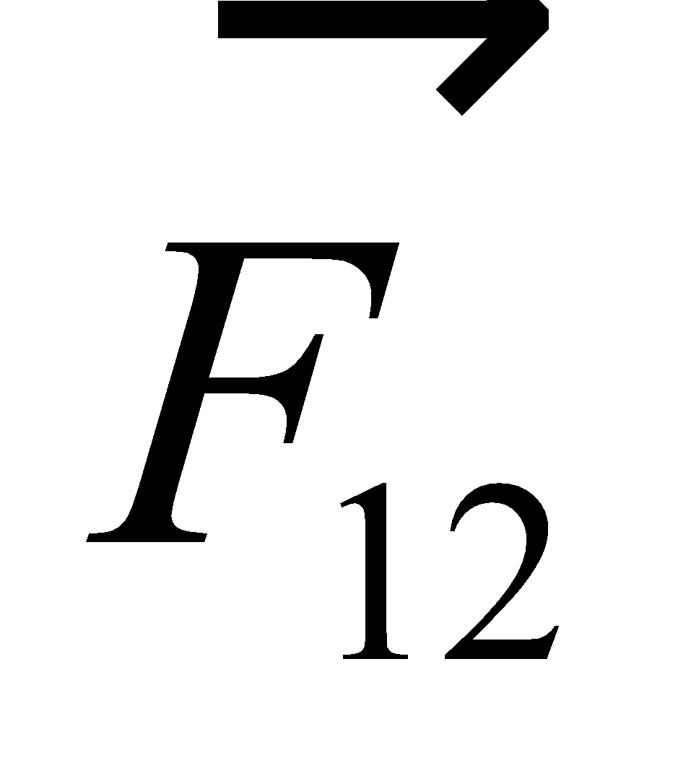 points to the right of the negative *y*-axis. This seems to agree with the fact that the force between oppositely charged particles is attractive, pointing in the opposite direction as the vector that separates their positions.

**40. Interpret** Coulomb’s law applies here. Since more than one source charge is involved, we make use of the superposition principle to find the net force on the test charge.

**Develop** Make a sketch of the situation (see figure below). By symmetry, the test charge must be placed on the axis; if not, it will experience a nonzero force in the 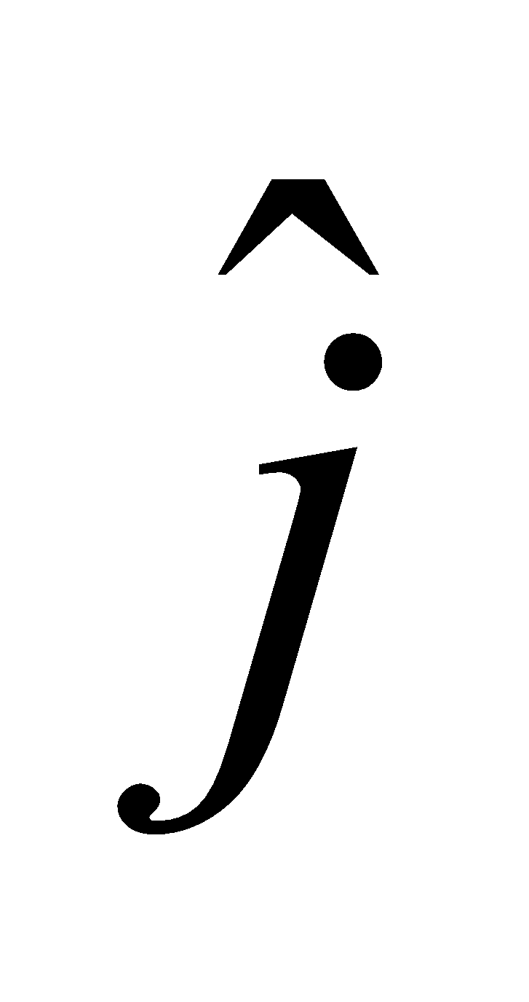 direction. If we place a charge to the left of the origin, it will experience a nonzero force because the charge 3*q* is both larger (in magnitude) and closer than the charge −2*q*, so it will always generate a greater force for all *x* < 0. If we place a positive (negative) test charge between the two charges, the net force will be to the right (left); that is, nonzero in both cases. Thus, the test charge *Q* must be placed on the *x* axis to the right of the −2*q* charge; that is, at *x* > *a*. Using the principle of superposition (Equation 20.4) with Coulomb’s law (Equation 20.1), the net Coulomb force on the test charge is

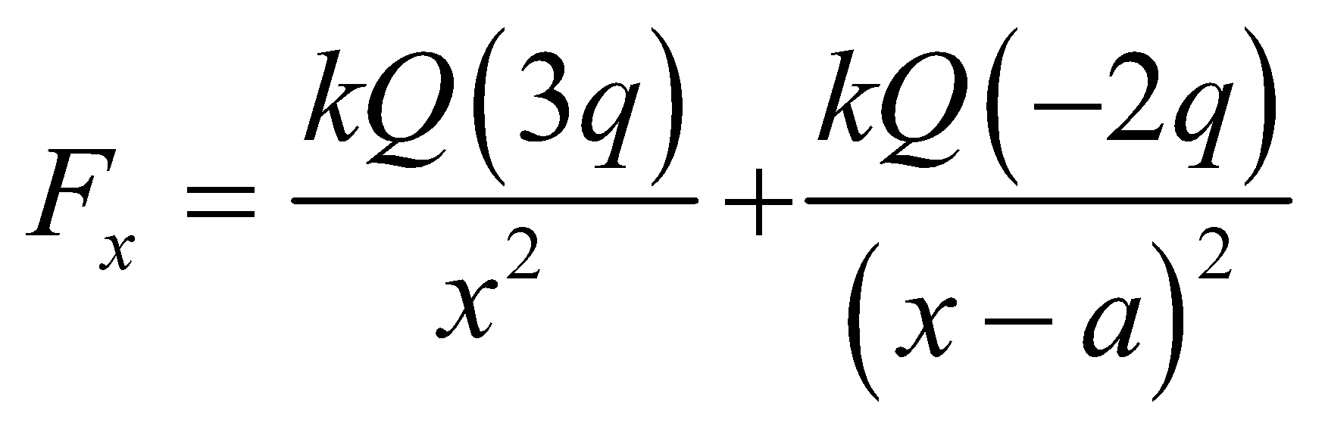

Set *F*x = 0 to solve for *x*.



**Evaluate** The condition *Fx* = 0 implies that 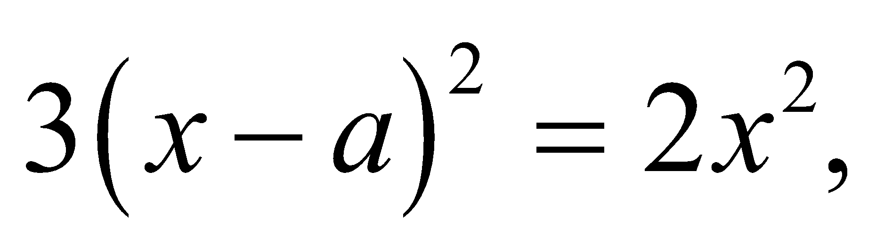 or 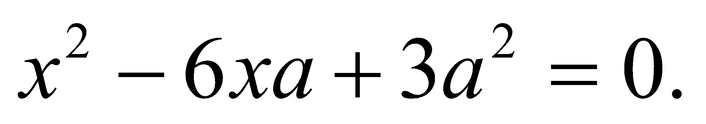 Thus,

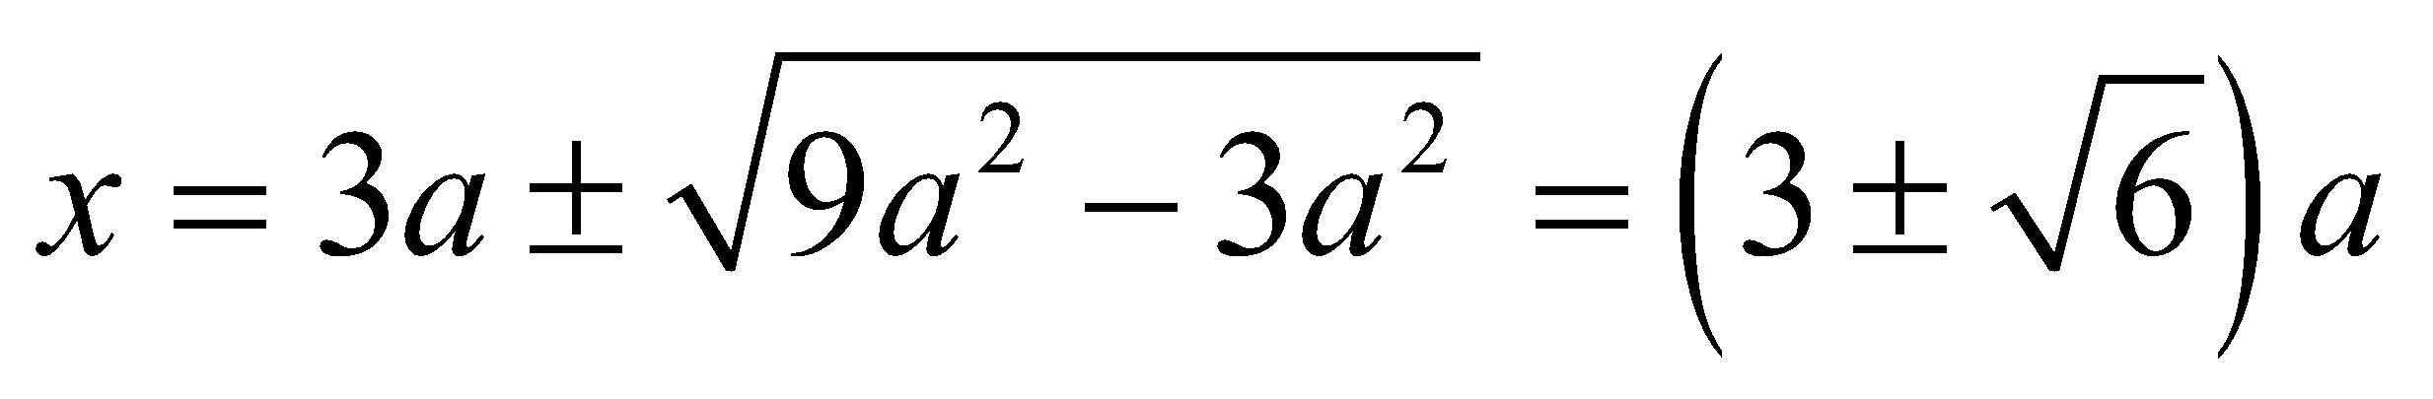

Only the solution 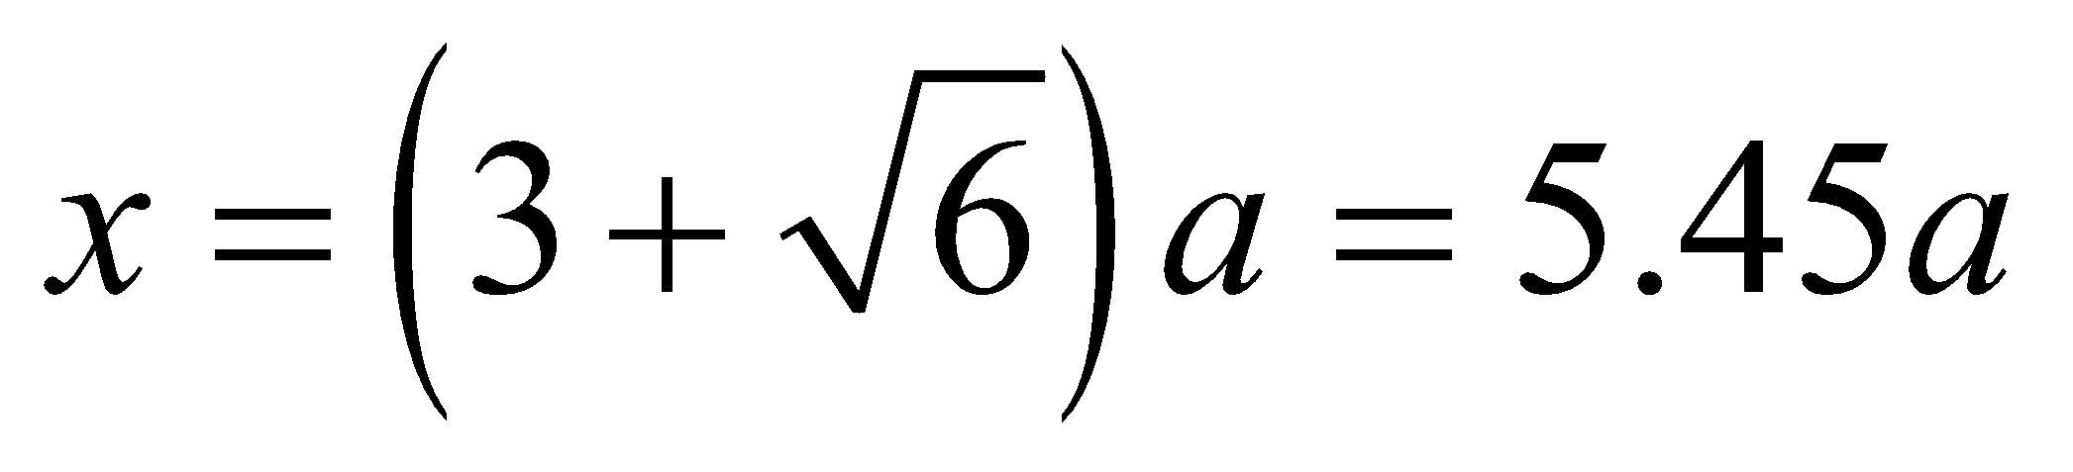 is to the right of *x* = *a*.

**Assess** At 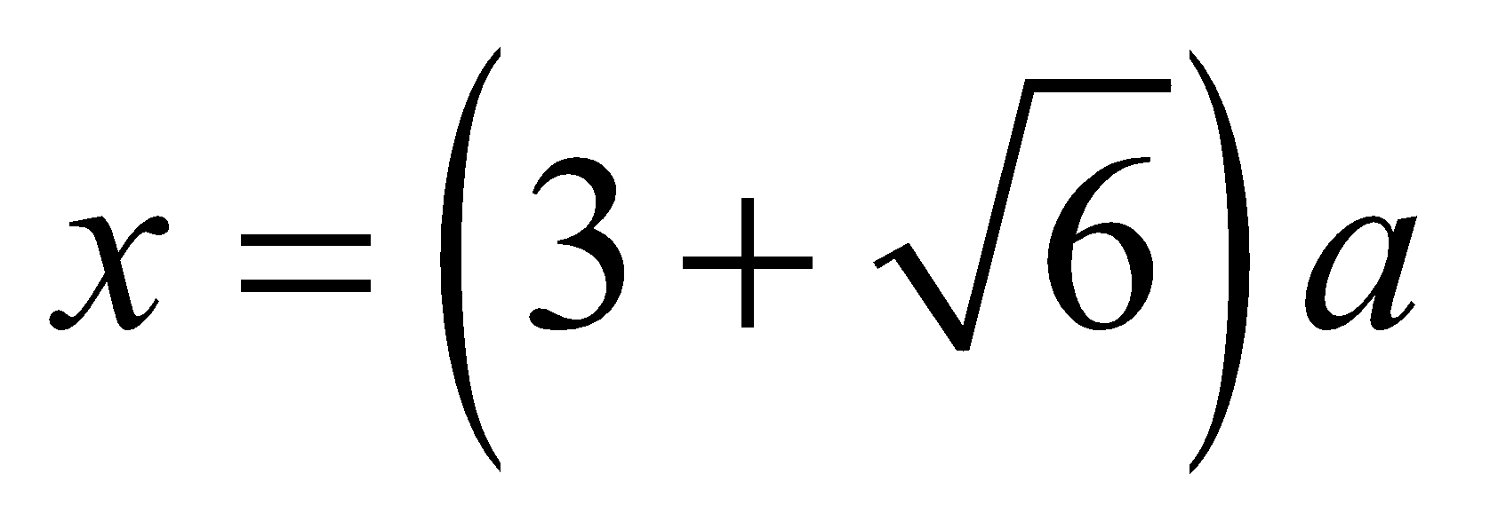 the forces acting on *Q* from 3*q* and −2*q* exactly cancel each other. Notice that our result is independent of the sign and magnitude of the third charge *Q*.

**41.** **Interpret** This problem involves Coulomb’s law and the principle of superposition, which we can use to find the position of the three given charges so that all of them experience zero net force.

**Develop** By symmetry, the negative charge must be at the midpoint between the two positive charges, as shown in the figure below. With this positioning, the attractive force between the −q charge and each +4q charge cancels the repulsive forces between the two +4*q* charges. The −*q* charges experiences no net force because each +4q charge generates a force on it that is equal in magnitude but in the opposite direction.



**Evaluate** To verify that we have the correct positioning, we calculate the net force on the left-hand charge. Coulomb’s law and the superposition principle give

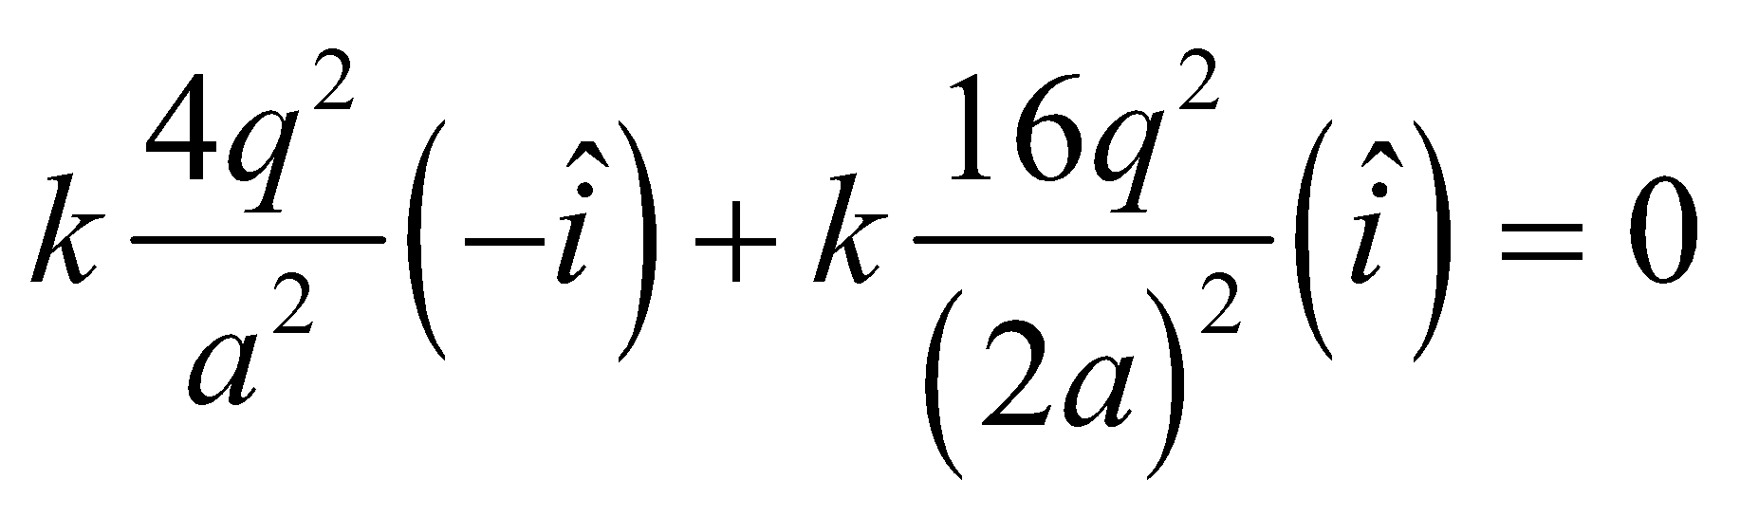

The expression for the force on the right-hand charge is the same, except that the sign of the unit vectors is reversed. The force on the central charge is

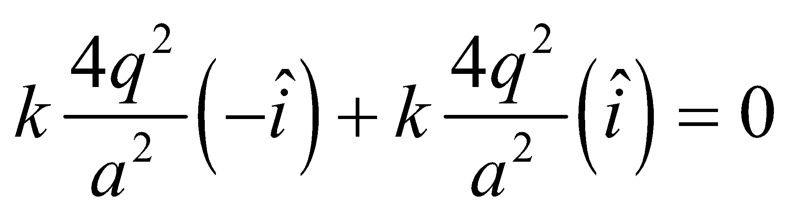

Thus, all three charges experience zero net force.

**Assess** The equilibrium is unstable, since if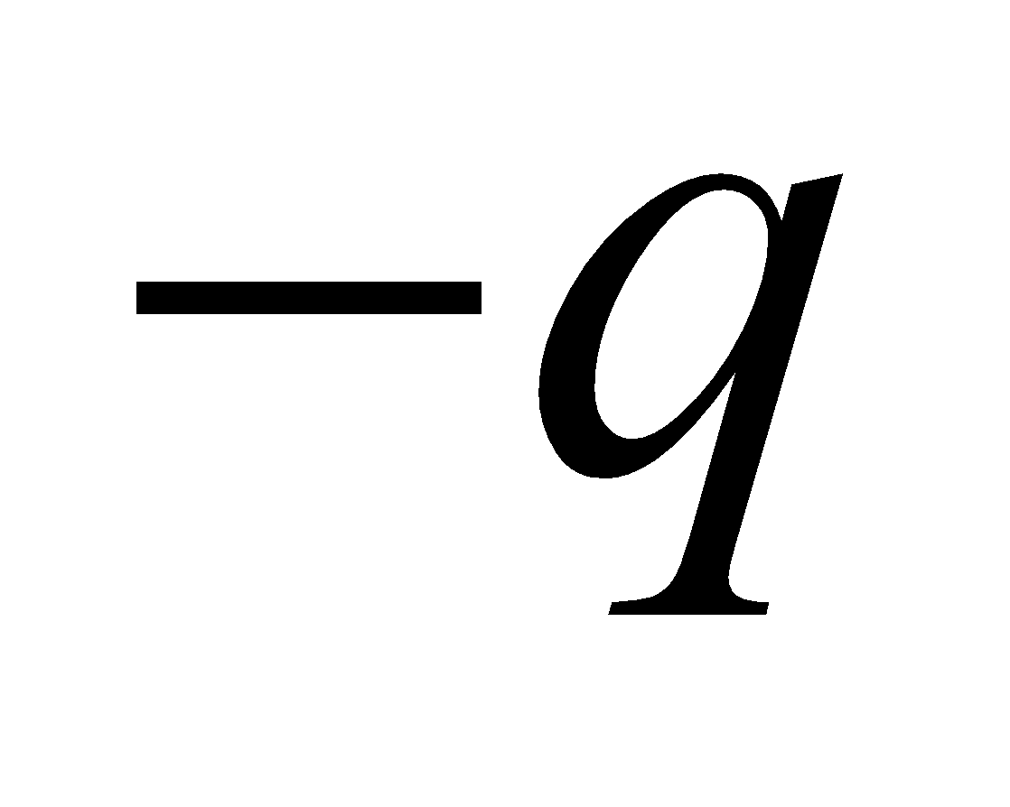is displaced slightly toward one charge, the net force on it will be in the direction of that charge.

**42. Interpret** More than one source charge is involved in this problem. Therefore, we use Coulomb’s law and apply the superposition principle to find the net force on *q*3.

**Develop** We denote the positions of the charges by 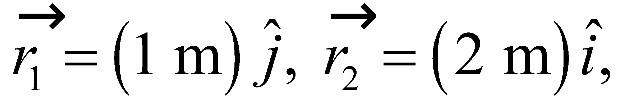 and 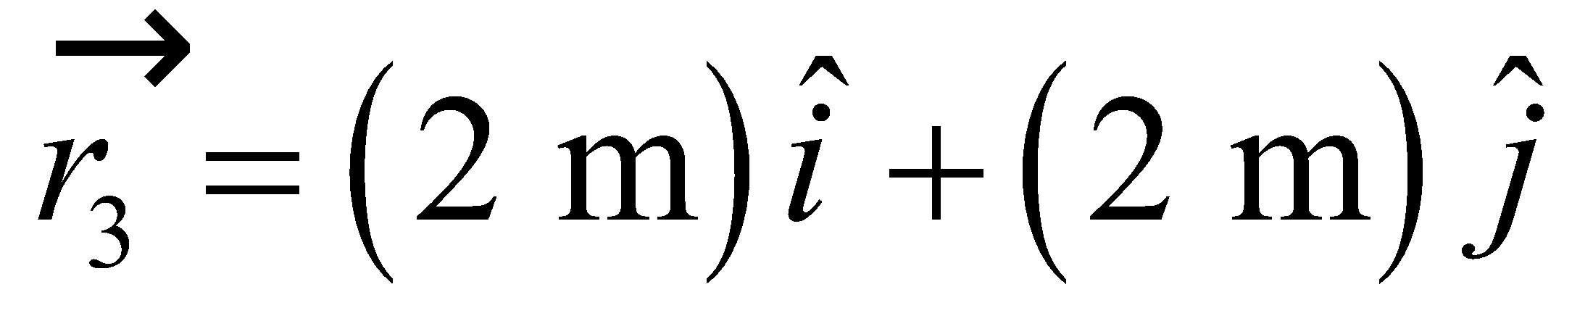 (see figure below). The unit vector pointing from *q*1 toward *q*3 is

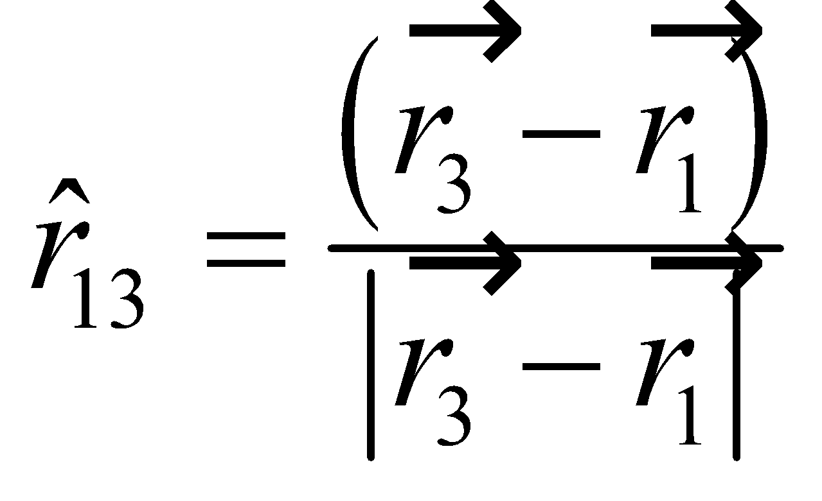

Similarly, the unit vector pointing from *q*2 toward *q*3 is

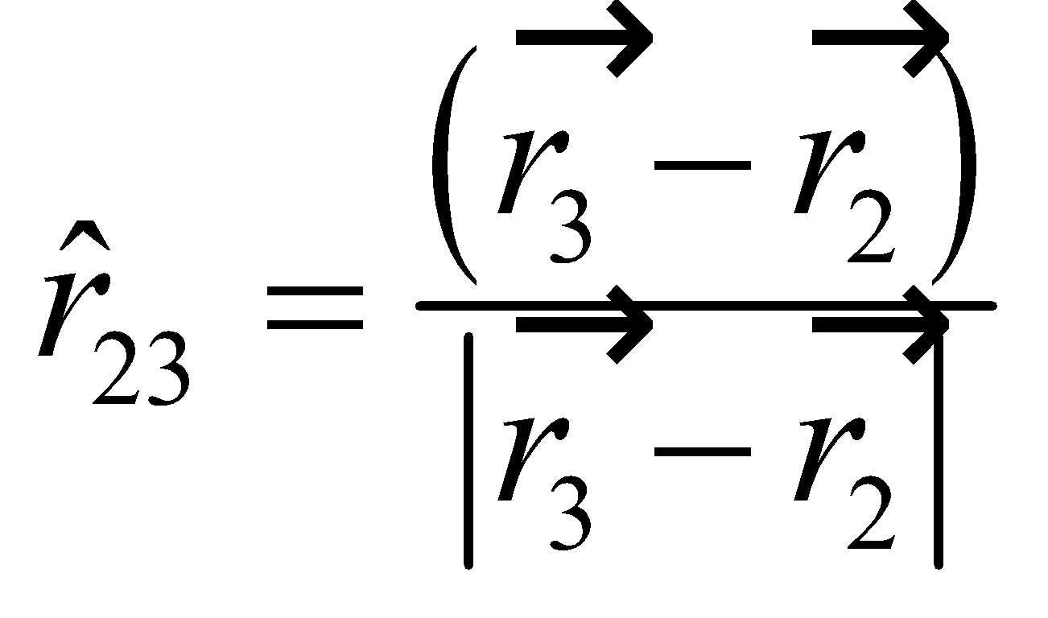

The vector form of Coulomb’s law and the superposition principle give the net electric force on *q*3 as

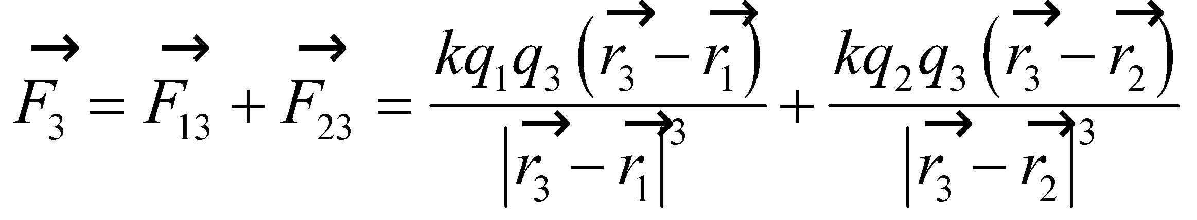



**Evaluate** Substituting the values given in the problem statement, we find the force acting on *q*3 to be

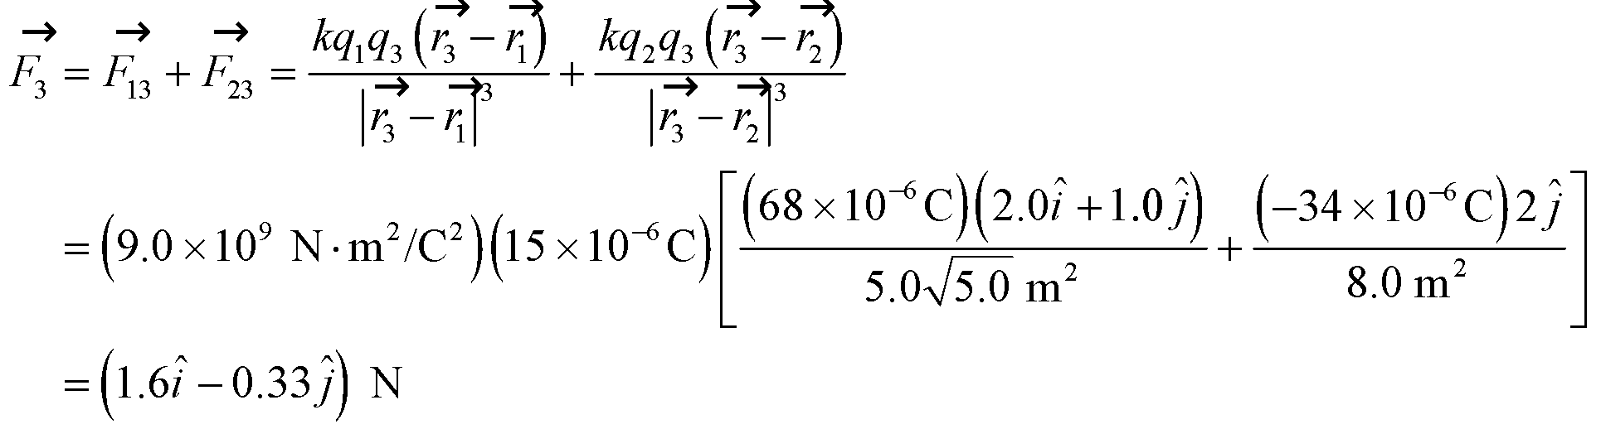

or 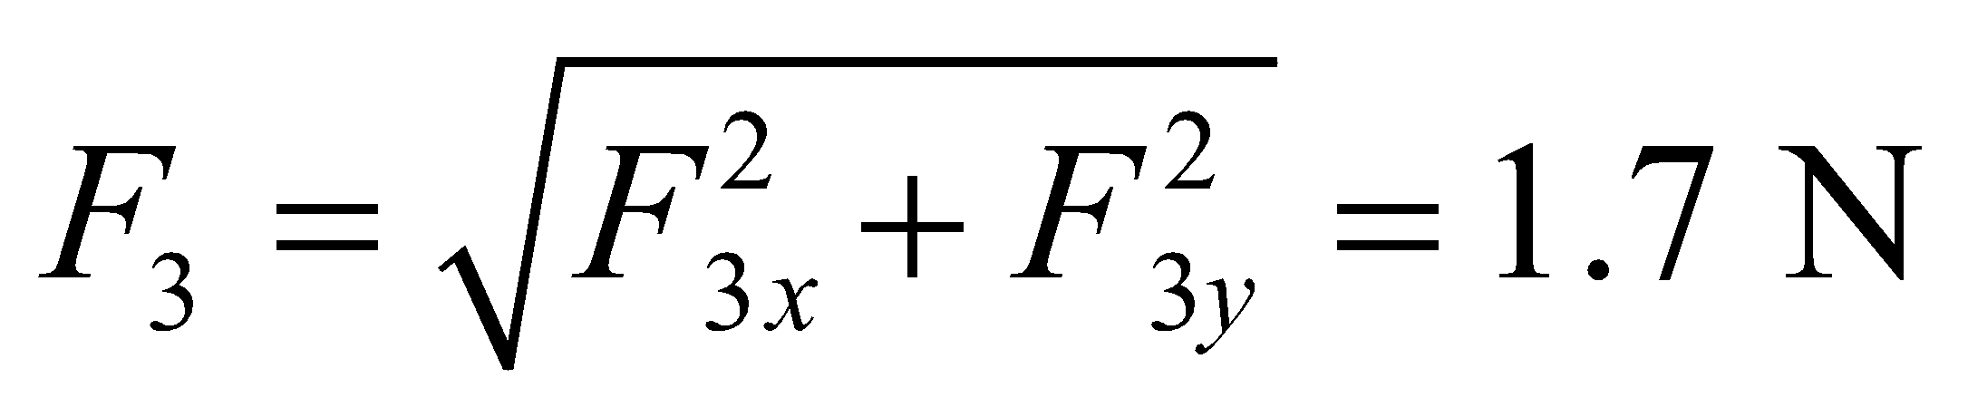 at an angle of 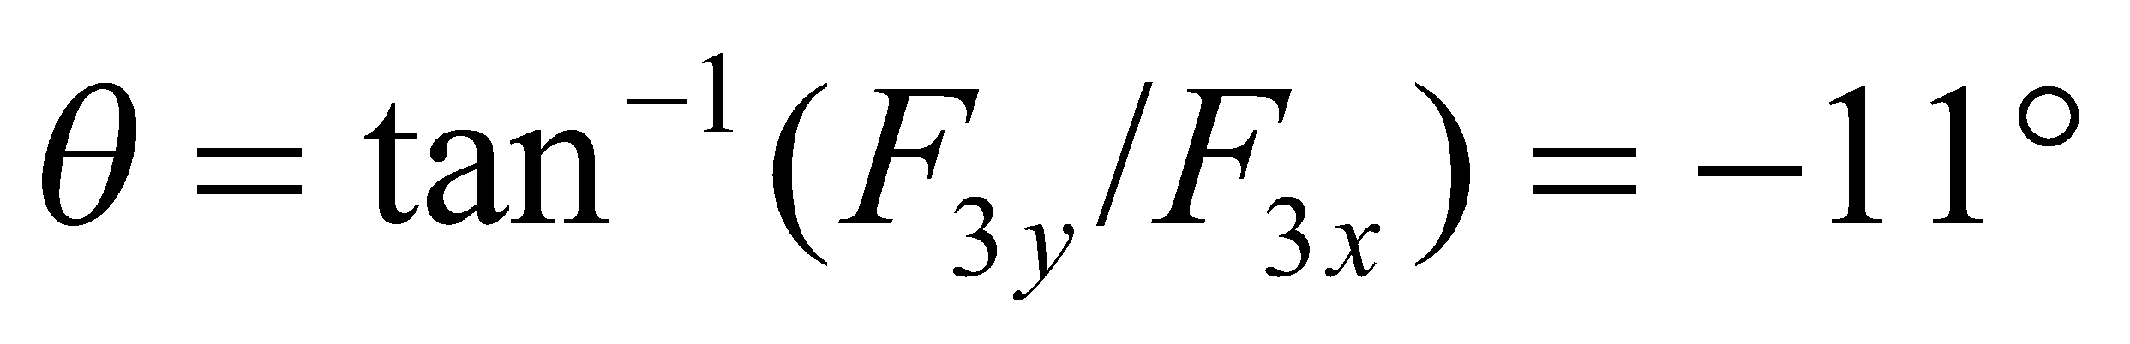 to the *x* axis.

**Assess** The force between *q*1 and *q*3 is repulsive (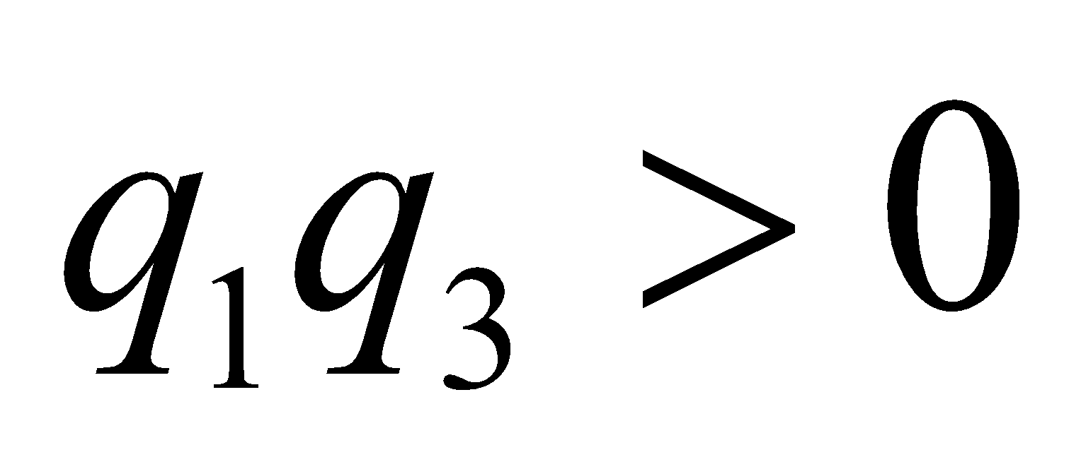) while the force between *q*2 and *q*3 is attractive (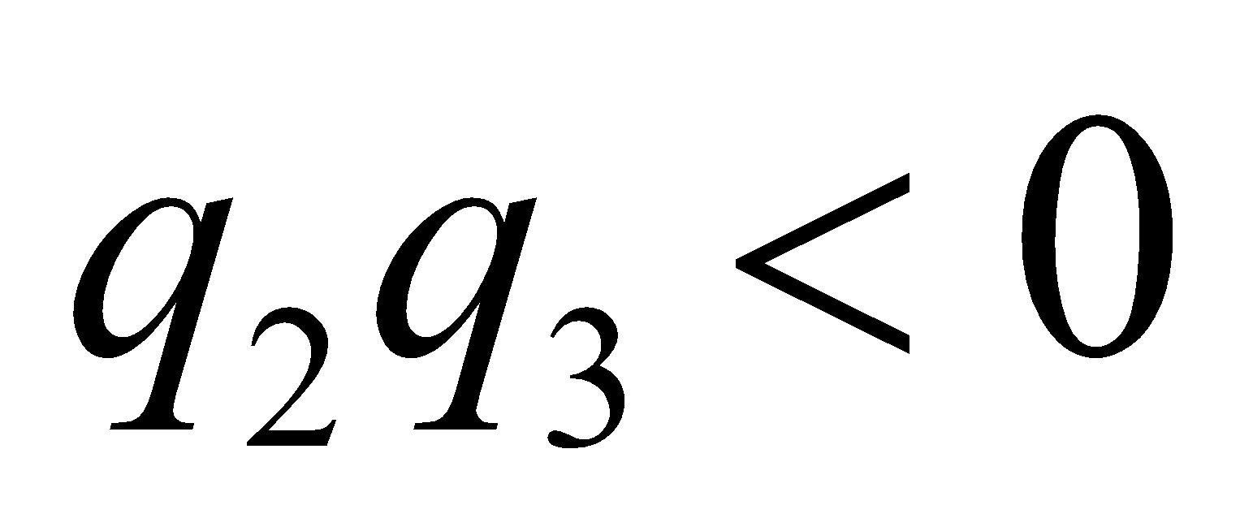). The two forces add vectorially to give the net force on *q*3.

**43.** **Interpret** This problem is similar to the preceding one, only the magnitude of the charges has changed. Therefore, we can use the same strategy to solve this problem.

**Develop**  The position of the charges are again denoted by  and  The unit vector pointing from *q*3 toward *q*1 is

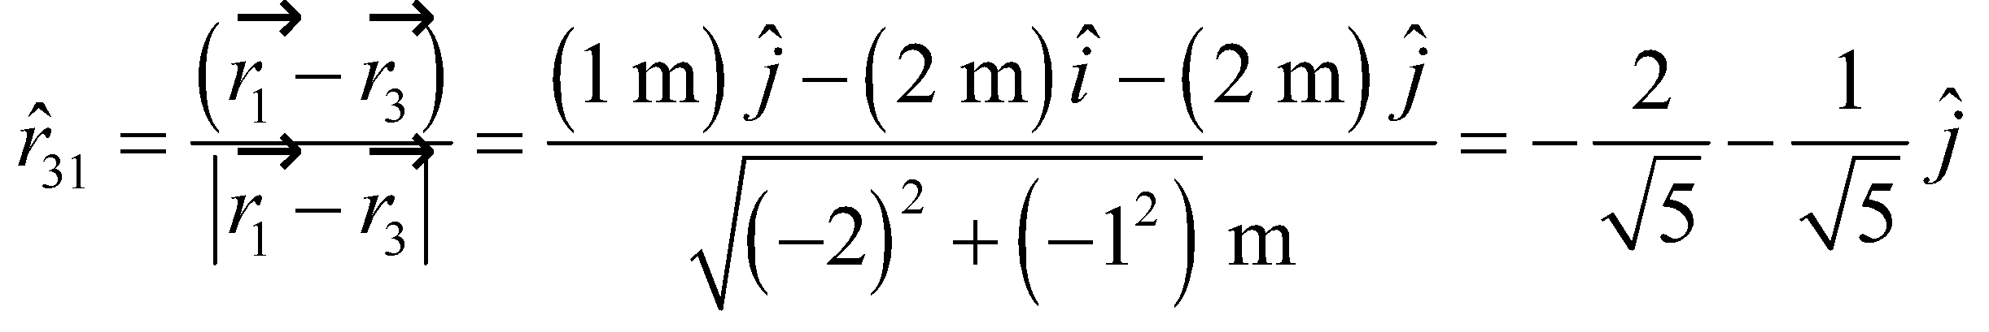

Similarly, the unit vector pointing from *q*2 toward *q*1 is

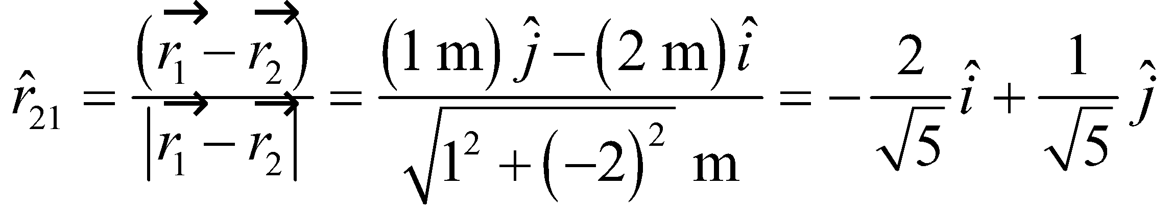

The vector form of Coulomb’s law and the superposition principle give the net electric force on *q*3 as

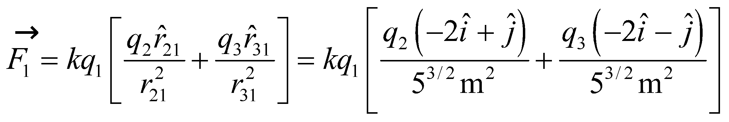

We are told that the force on *q*1 is in the 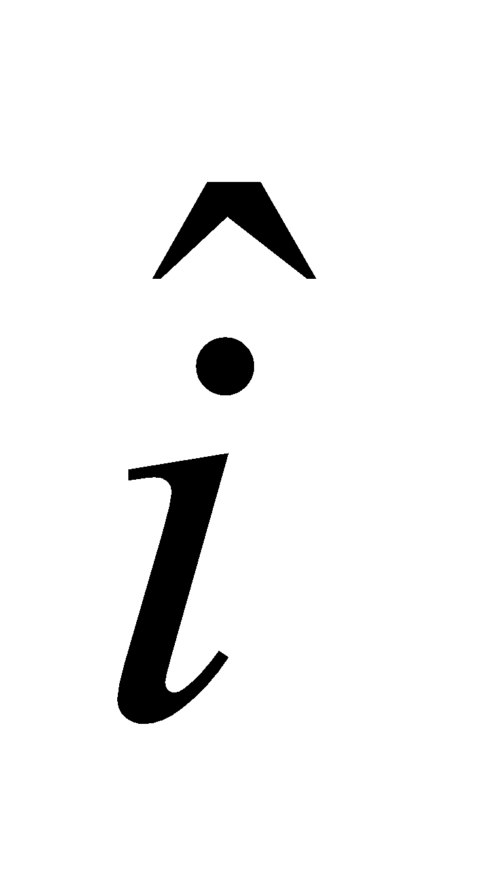 direction, so the  component of 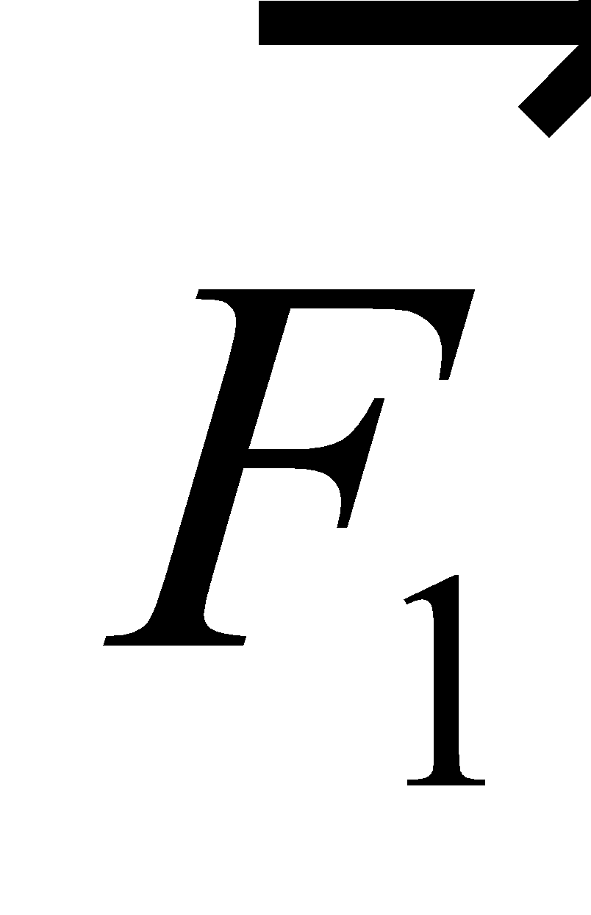 must be zero. This gives

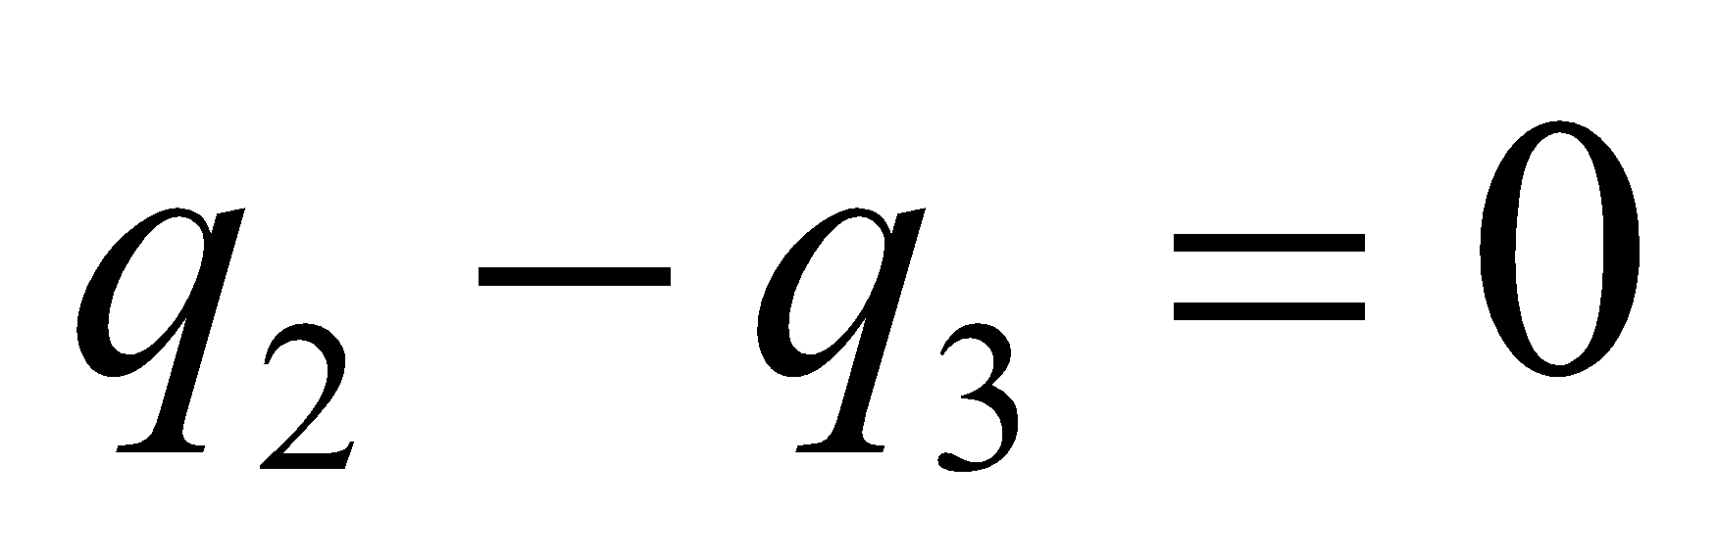

**Evaluate** (a) From the equation above, we find that *q*3 = −*q*2, or *q*3 = 20 μC.

(b) Inserting the result from part (a) into the expression for  gives



**Assess** Because the charges *q*2 and *q*3 are positioned symmetrically above and below *q*1, the result that *q*2 = −*q*3 is expected.

**44. Interpret** This problem requires us to find the force exerted by 4 source charges positioned on the corners of a square on a test charge *Q* positioned at the center of the square. We will use Coulomb’s law and apply the superposition principle to find the force on *Q*.

**Develop** We begin with a diagram of the situation (see figure below). By symmetry, the forces  and 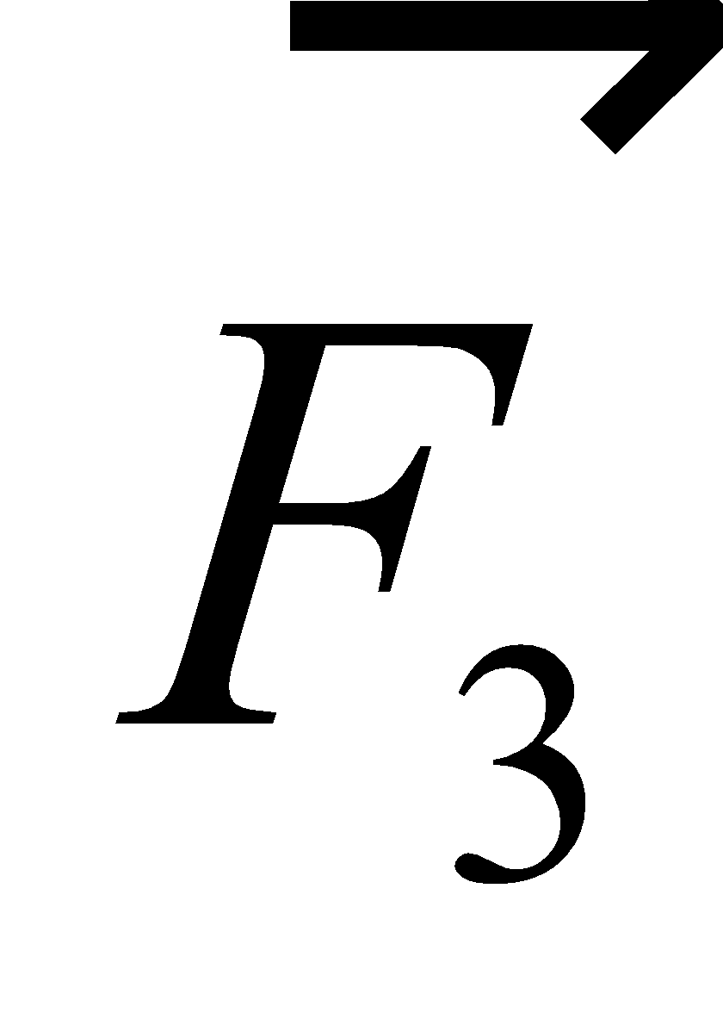 cancel, and the forces 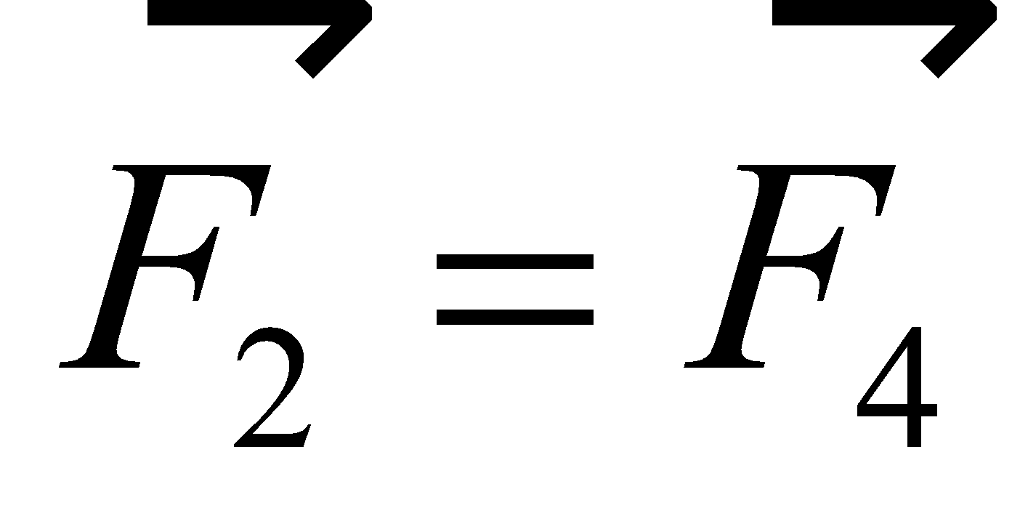. The magnitudes these force on *Q* from is

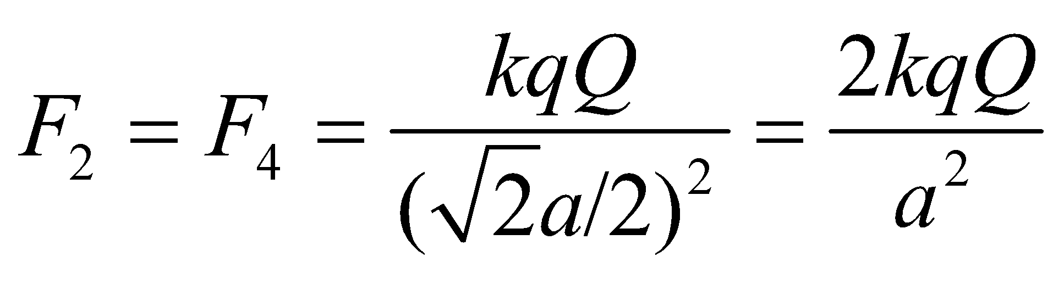



**Evaluate** **(a)** The net force on *Q* has magnitude

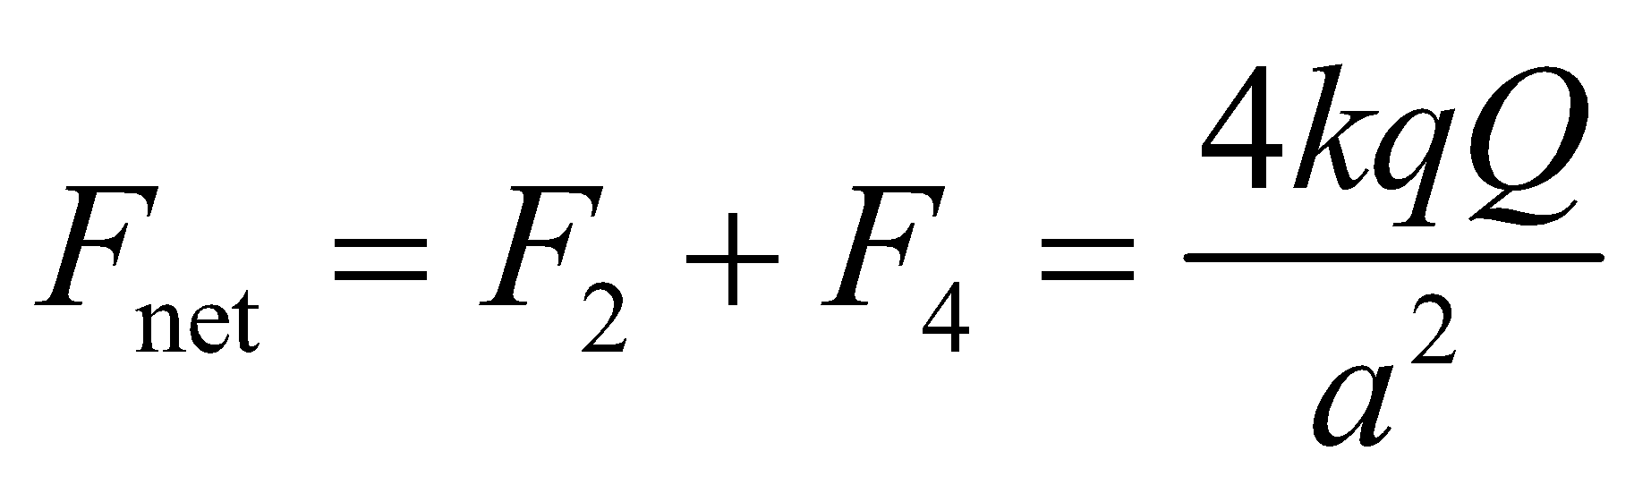

**(b)** The direction of 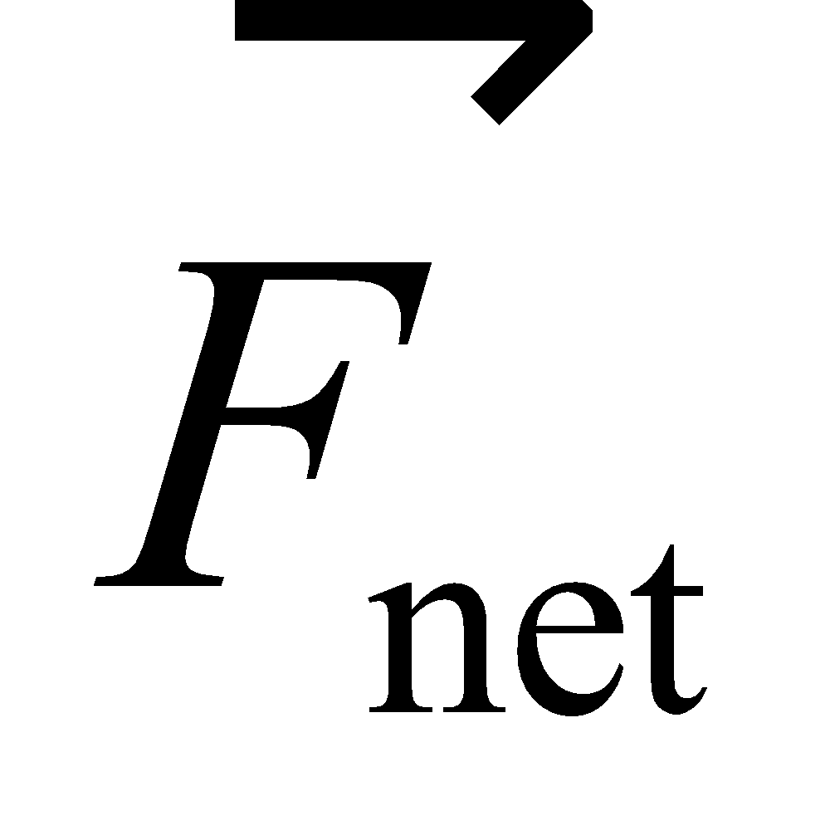 is toward the negative charge for 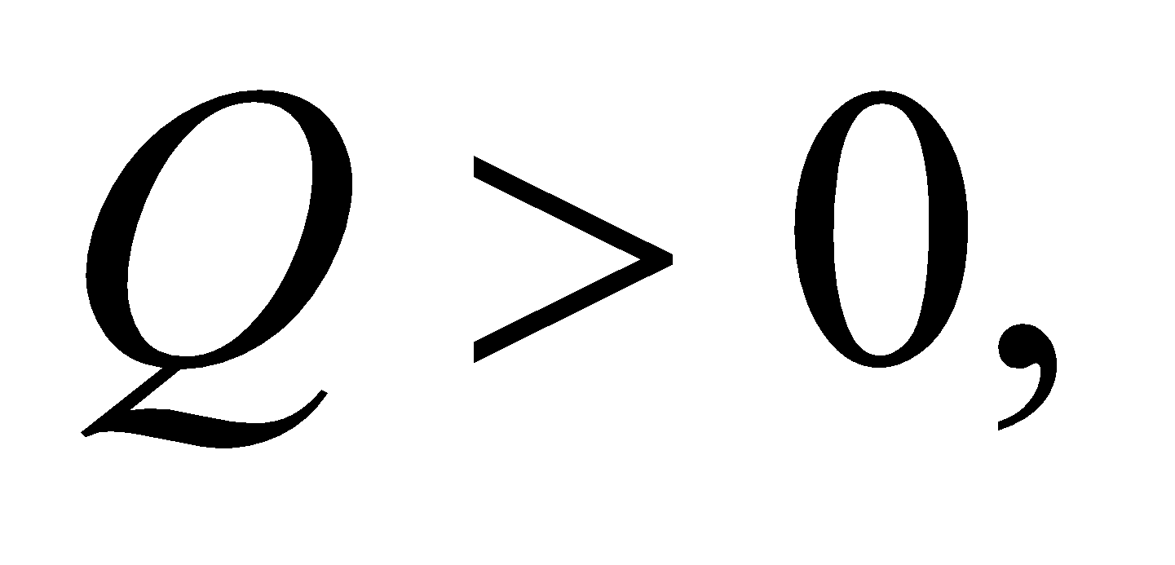 and away from the negative charge for 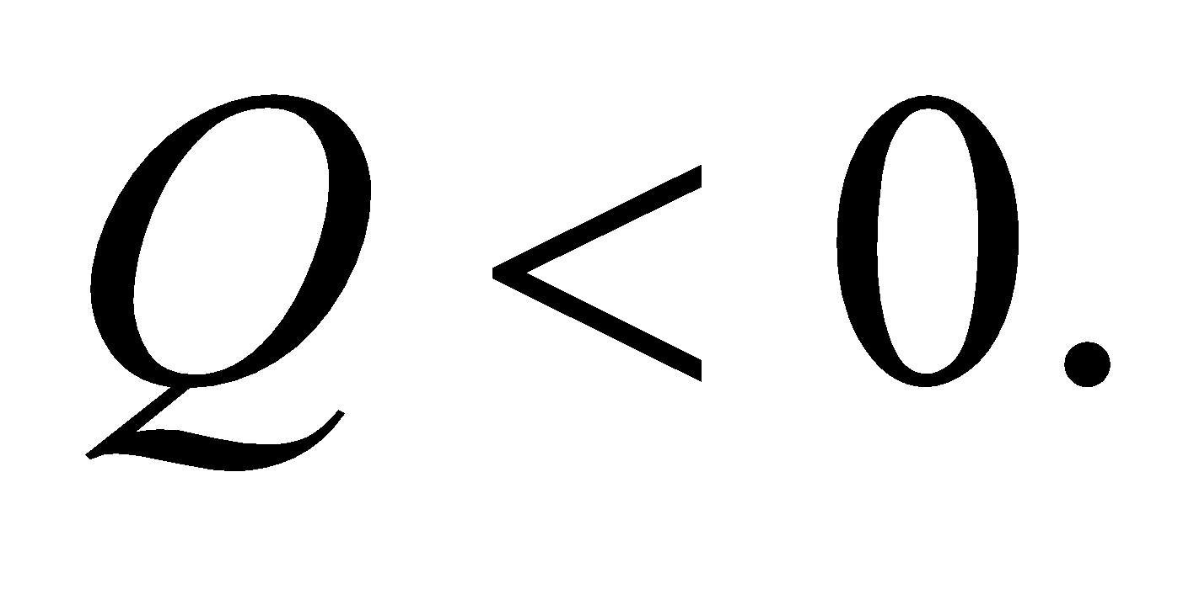

**Assess** Although we have four charges acting on charge *Q*, only two need to be considered. By the superposition principle, the force on a charge placed midway between two identical charges must sum to zero.

**45. Interpret** We're asked to calculate the electric field from a point charge at several locations.

**Develop** The electric field from a point charge is given by Equation 20.3: 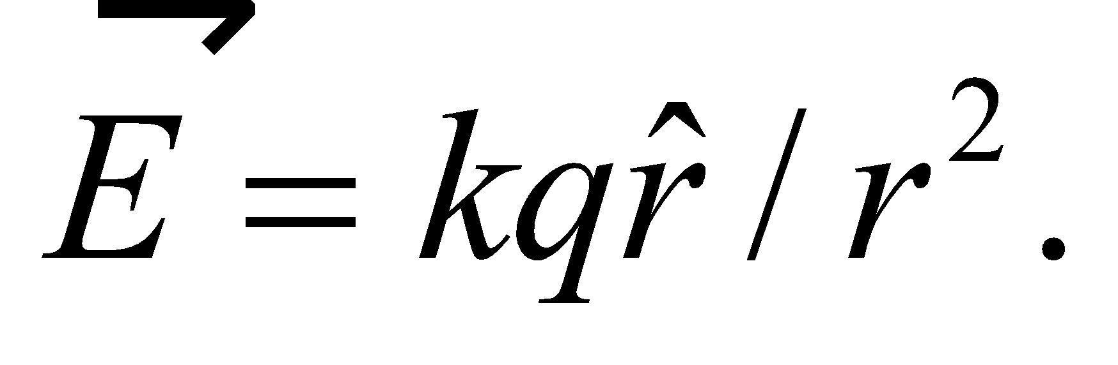 The charge is at the origin, so the vector,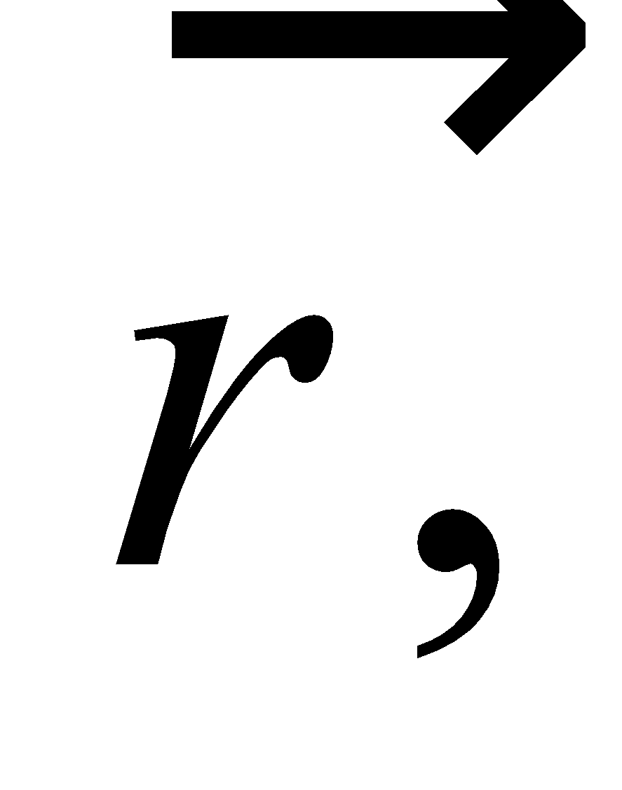 has the same coordinate values as the points in *x*-*y* plane that we're asked to consider. Since the unit vector is 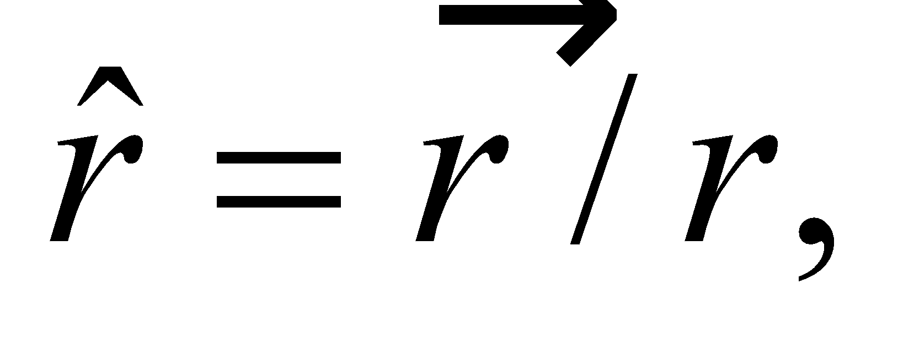we can write the electric field in a more compact form: 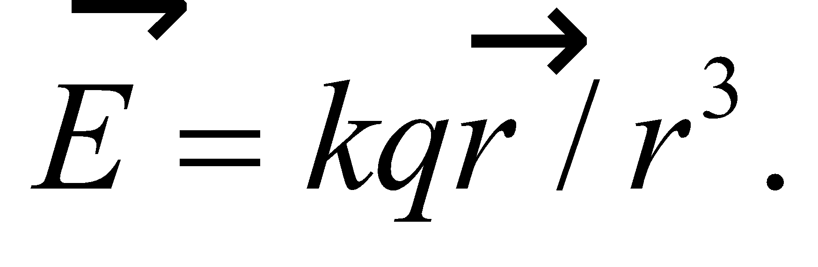

**Evaluate**  (a) At 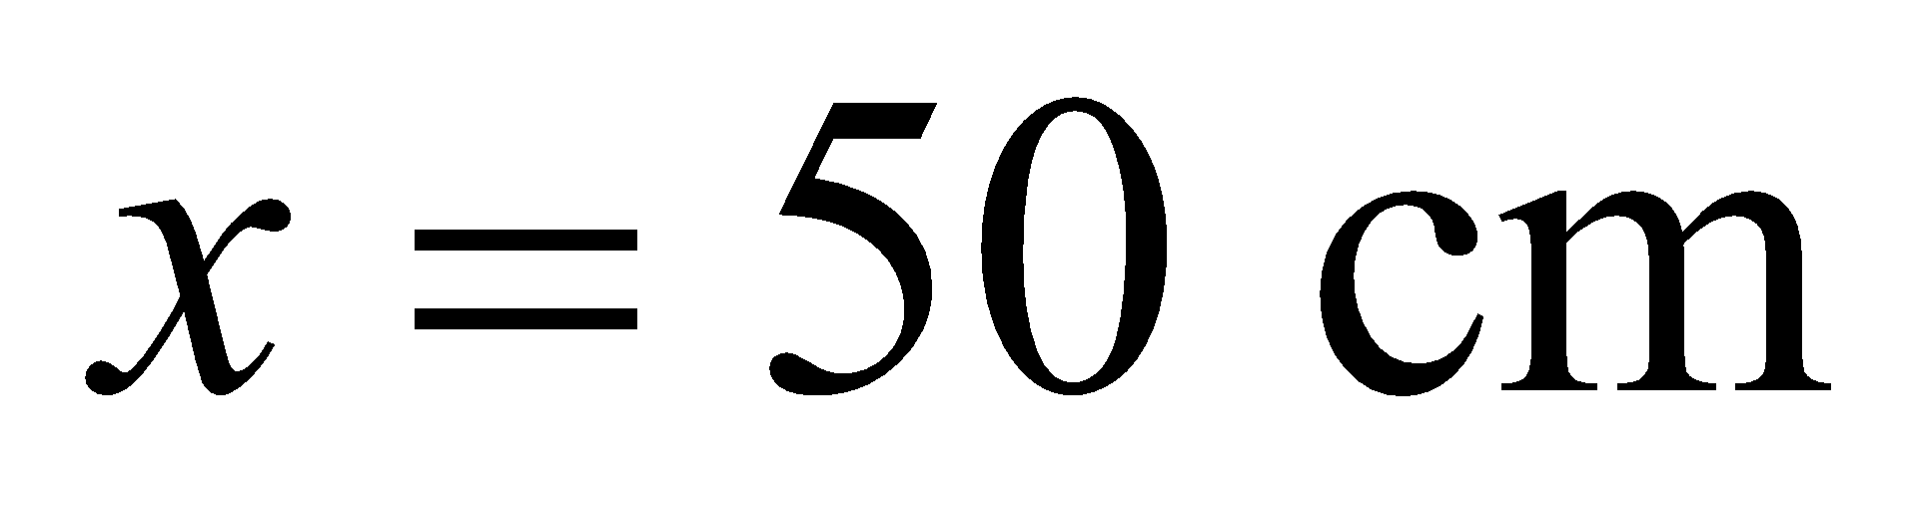 and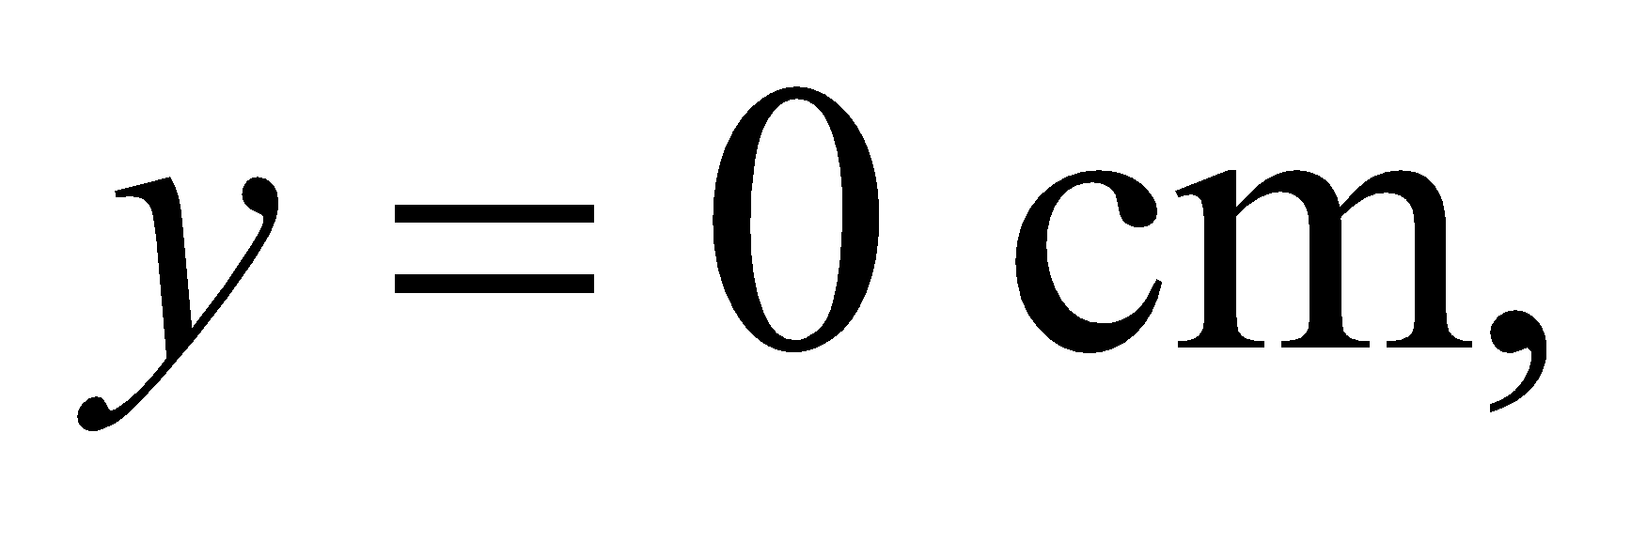the electric field is

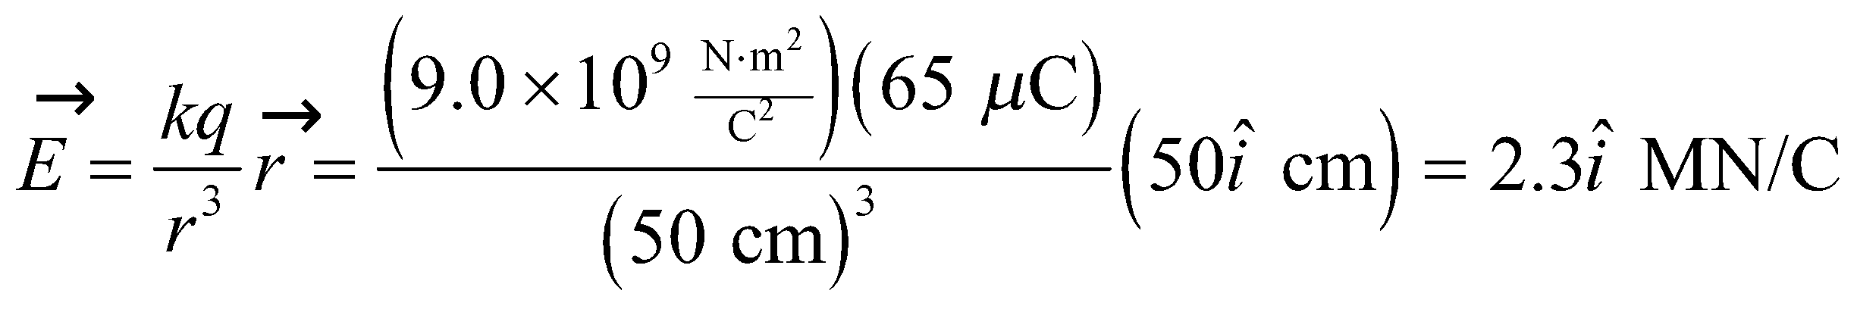

(b) At  and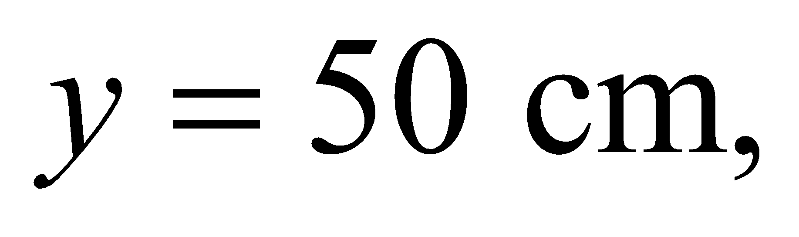the electric field is

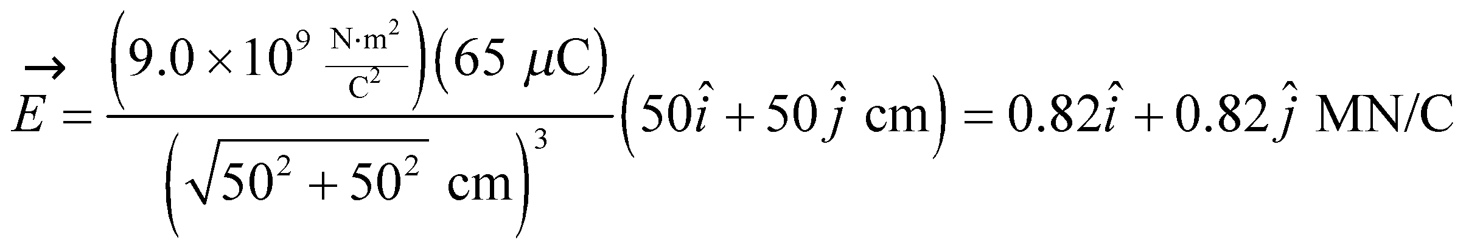

(c) At 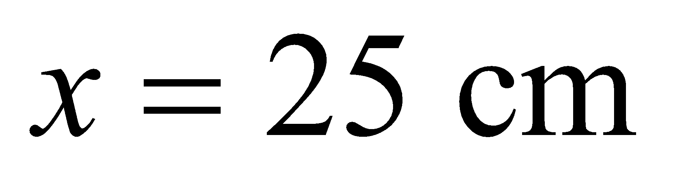 and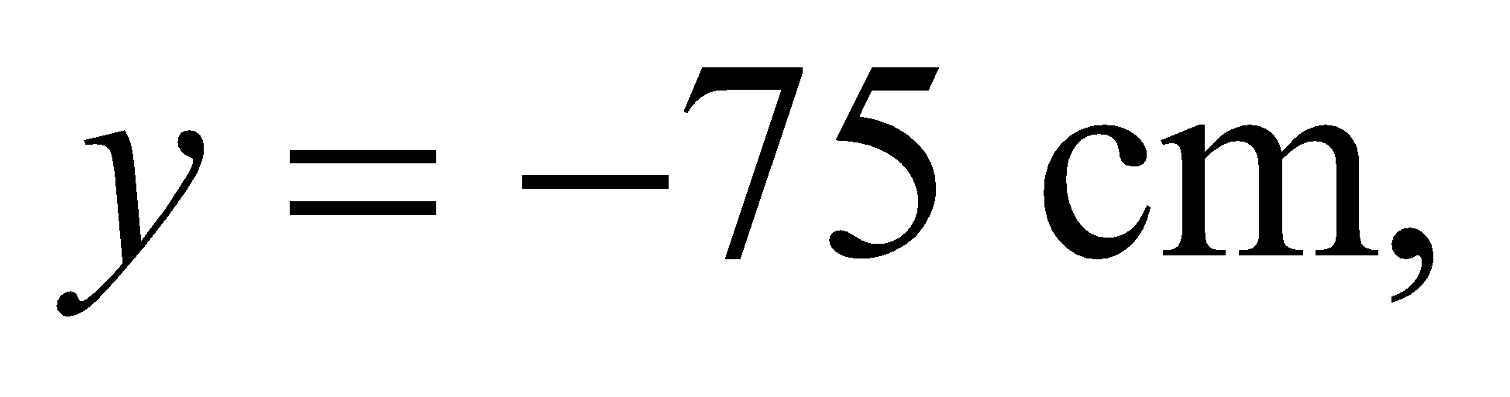the electric field is

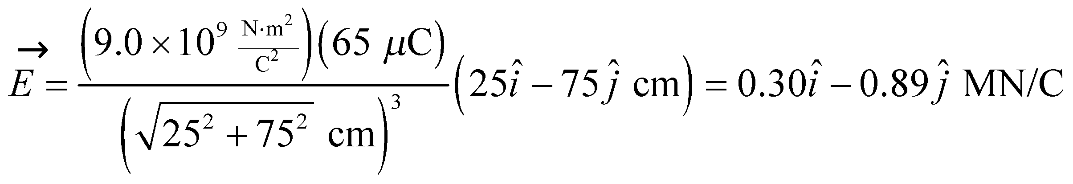

**Assess** The magnitude of the electric field in parts (a), (b), (c) is 2.3 MN/C, 1.2 MN/C, and 0.9 MN/C, respectively. This shows that the field decreases as one moves further away from the point charge, as we would expect.

**46. Interpret** This problem involves Coulomb’s law and, since more than one source charge is involved, the superposition principle. We will used these to find the point where the field strength vanishes.

**Develop** We first note that the field can be zero only along the line joining the charges (the *x* axis). To the left or right of both charges, the fields due to each both have *y* components in the same direction, and so cannot sum to zero. Between the two charges, a distance *x* > 0 from the 1 μC charge, the electric field is

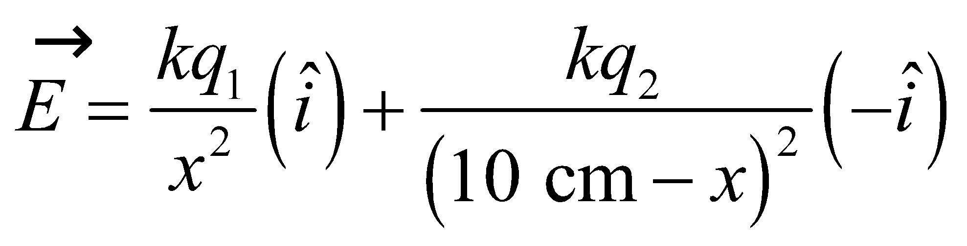

**Evaluate** With 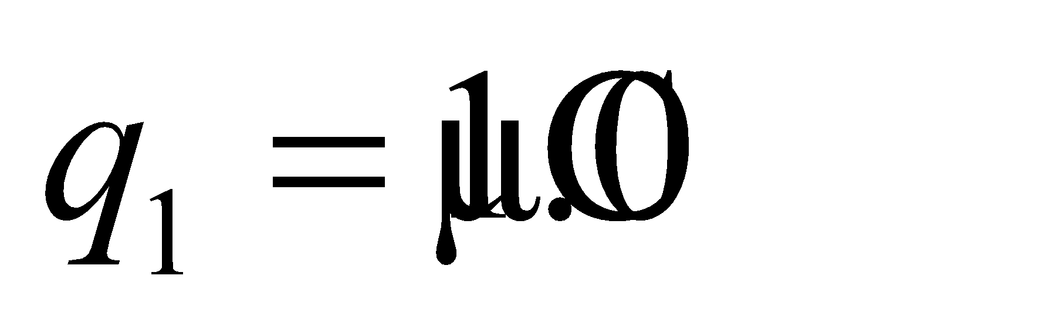 and 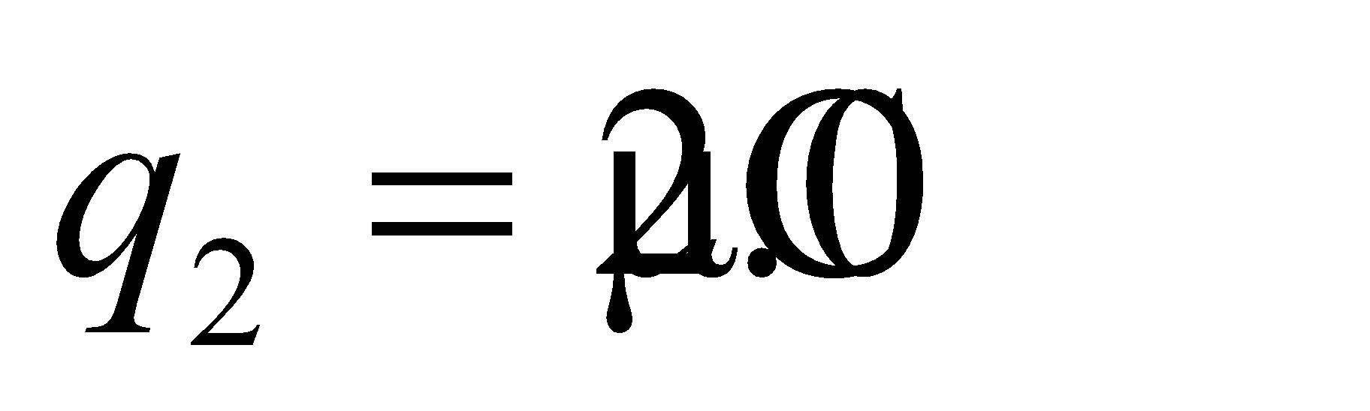, the field vanishes when

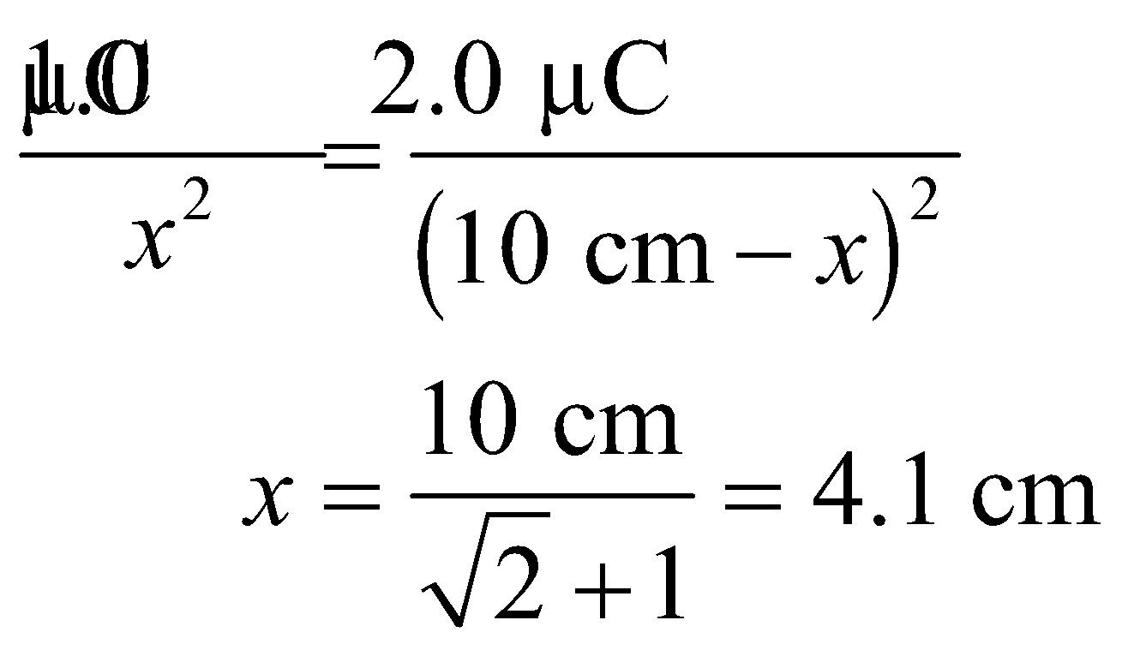

**Assess** Since 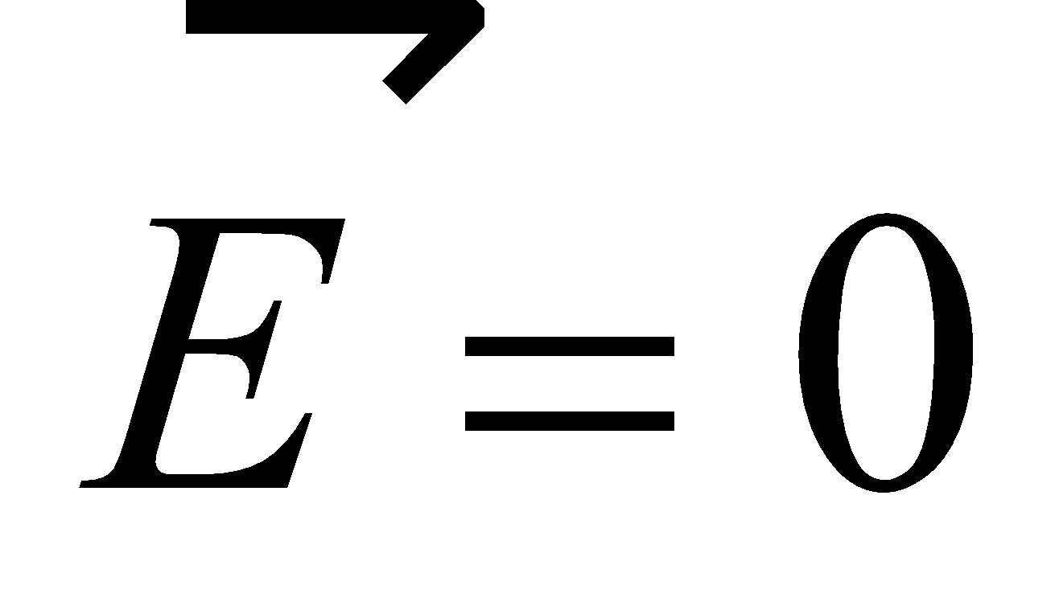 at 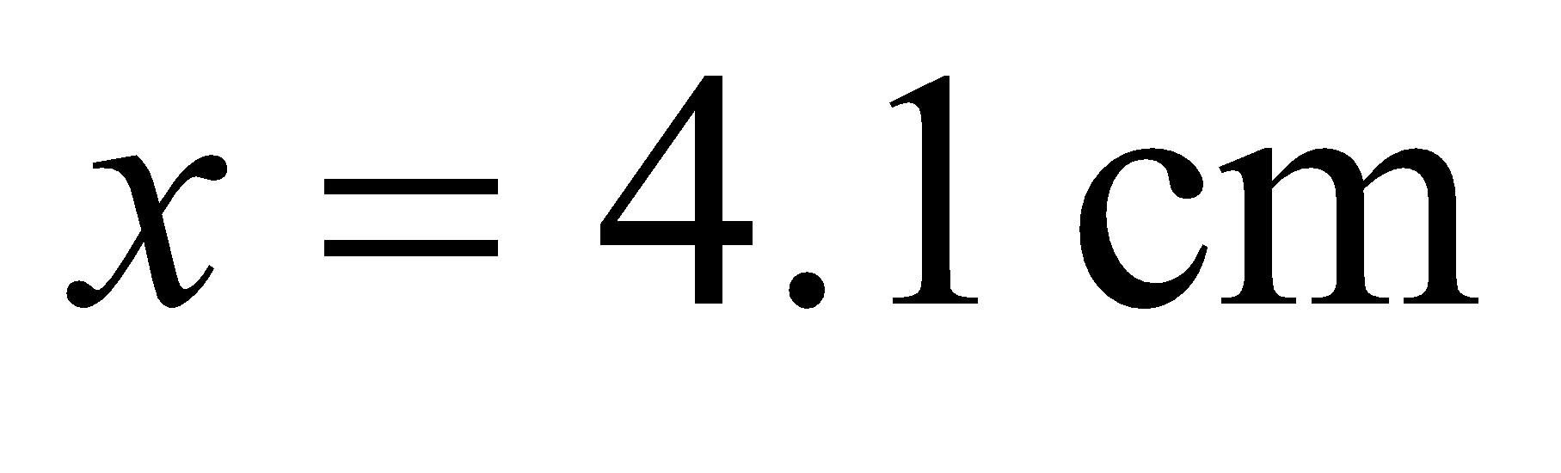 a charge placed at that point does not experience any force.

**47.** **Interpret** This problem involves two source charges, a proton at *x* = 0 and an ion at *x* = 5.0 nm. We can apply the principle of superposition to find the electric field at *x* = −5 nm.

**Develop** The field at the point *x* = −5 nm due to the proton is

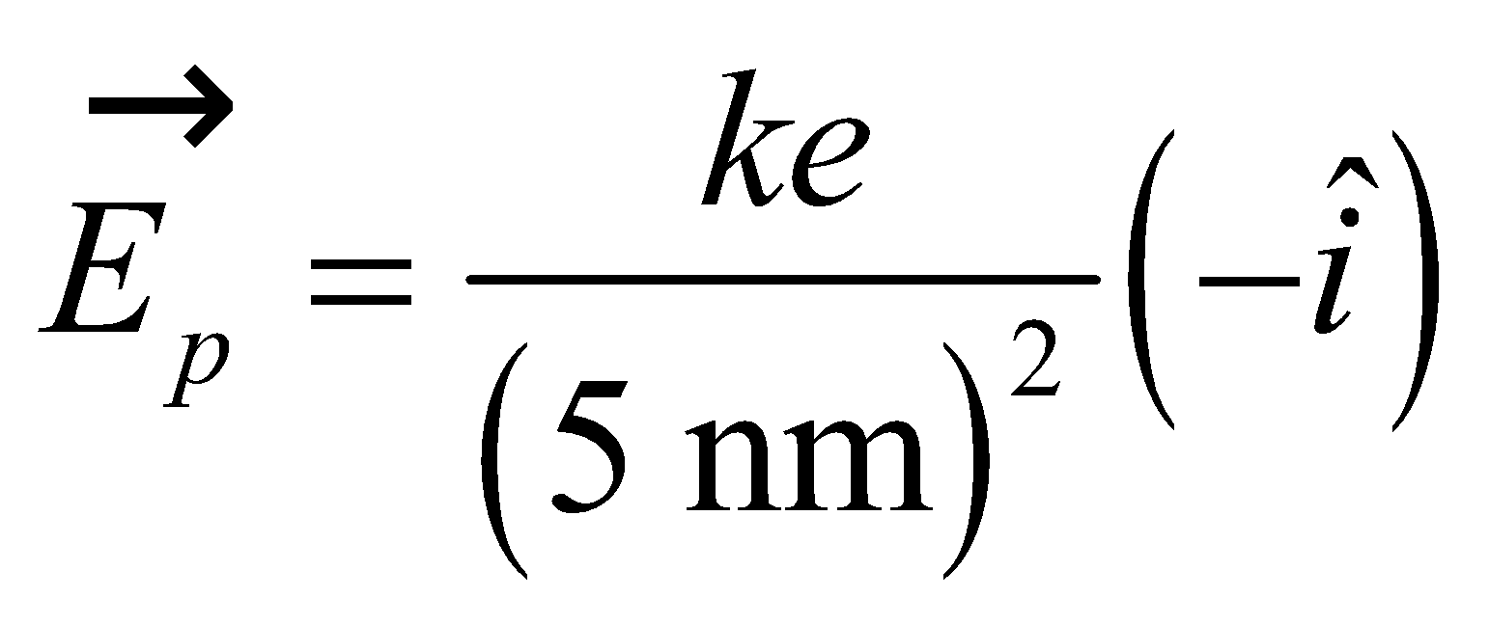

The field at the same point due to the ion is

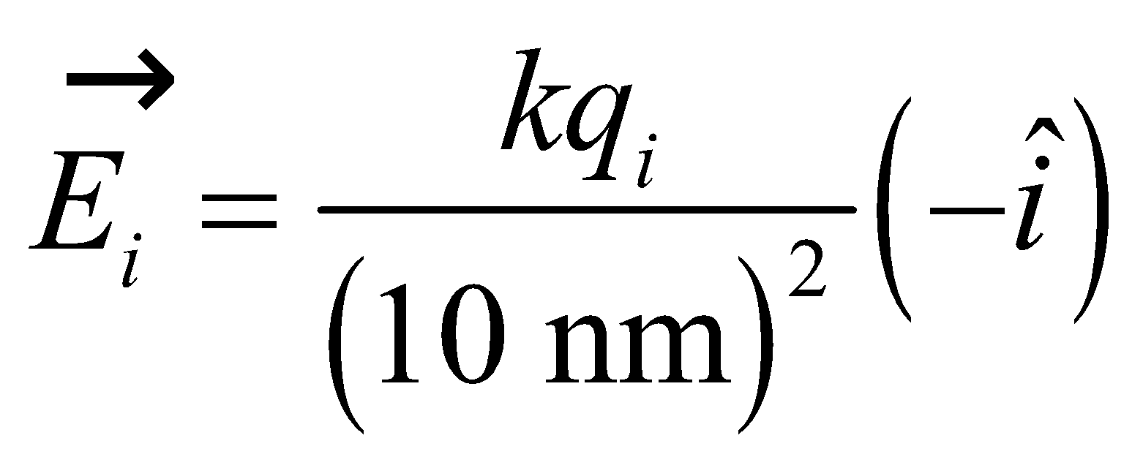

The total electric field is the sum of these two, and is zero at *x* = −5.0 nm, so we can solve for *q*i.

**Evaluate** Solving for the ion’s charge gives

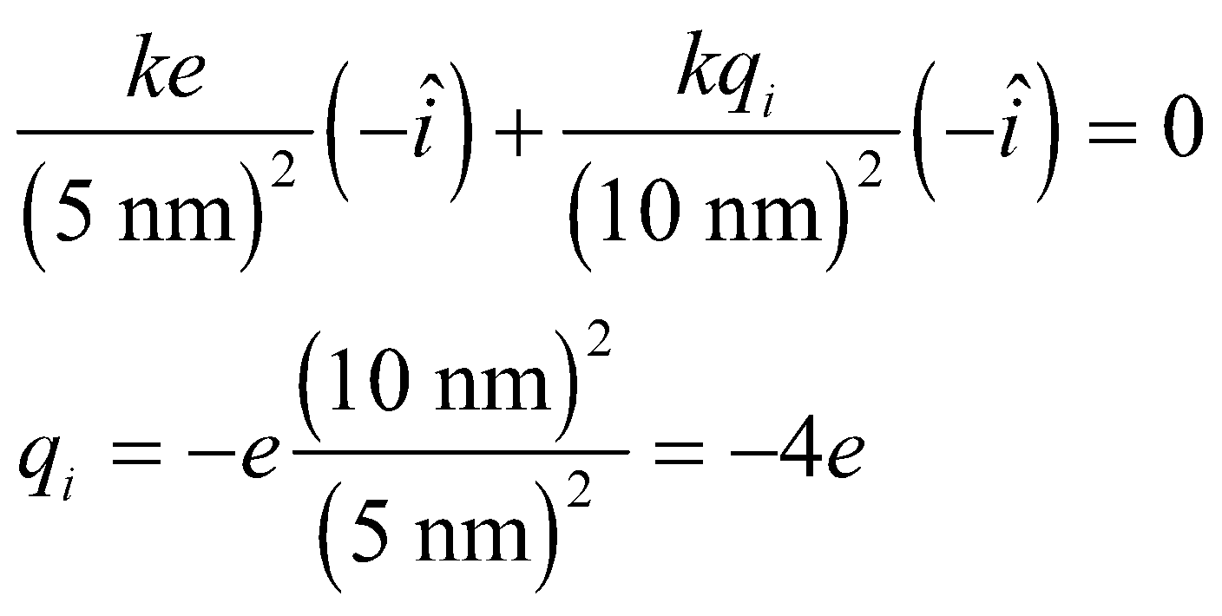

**Assess** Note that the field due to the ion was defined for a positive charge, so the final charge is negative, as indicated.

**48. Interpret** Coulomb’s law applies here. The two source charges *q* are positioned on the *x* axis, and we use the superposition principle to find the field strength at a point on the *y* axis.

**Develop** As in Example 20.2, we apply the symmetry argument to show that the *x* components of the electric field due to both charges cancel, and the net electric field points in the +*y* direction.

**Evaluate** **(a)** Since electric field is the force per unit charge, from Example 20.2, we obtain

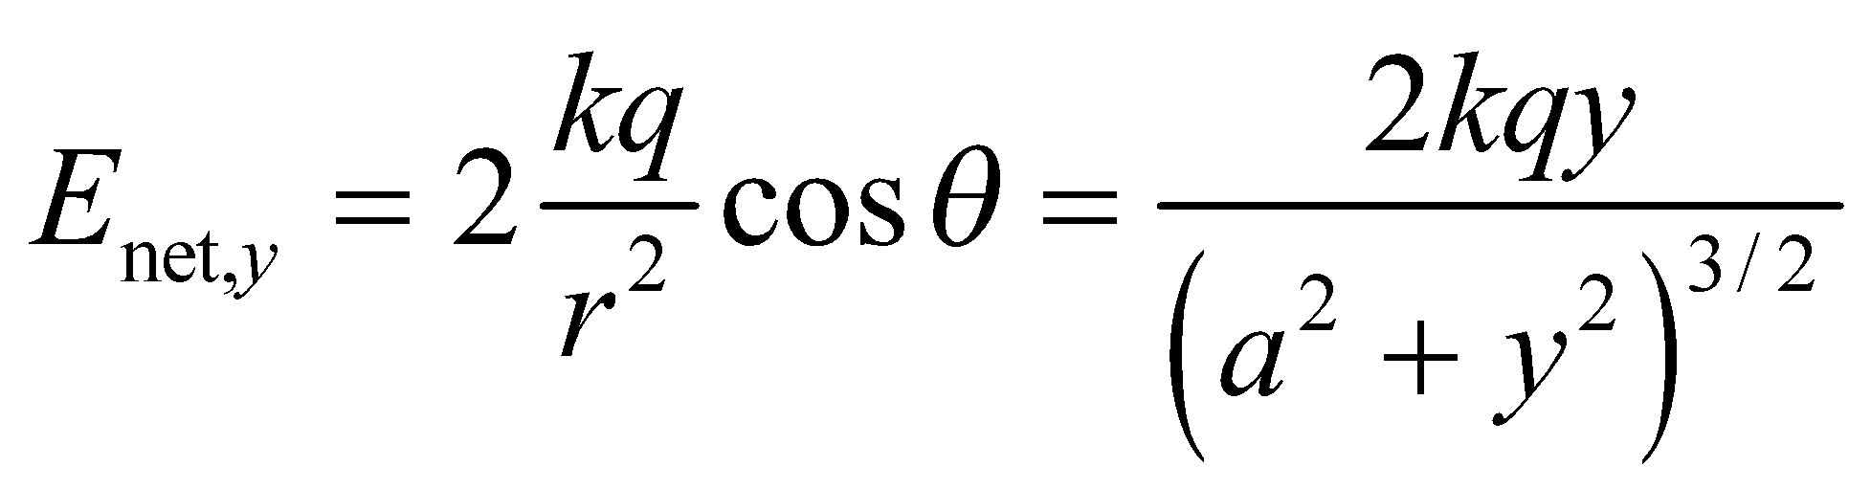

**(b)** The magnitude of the field, a positive function, is zero for y = 0 and 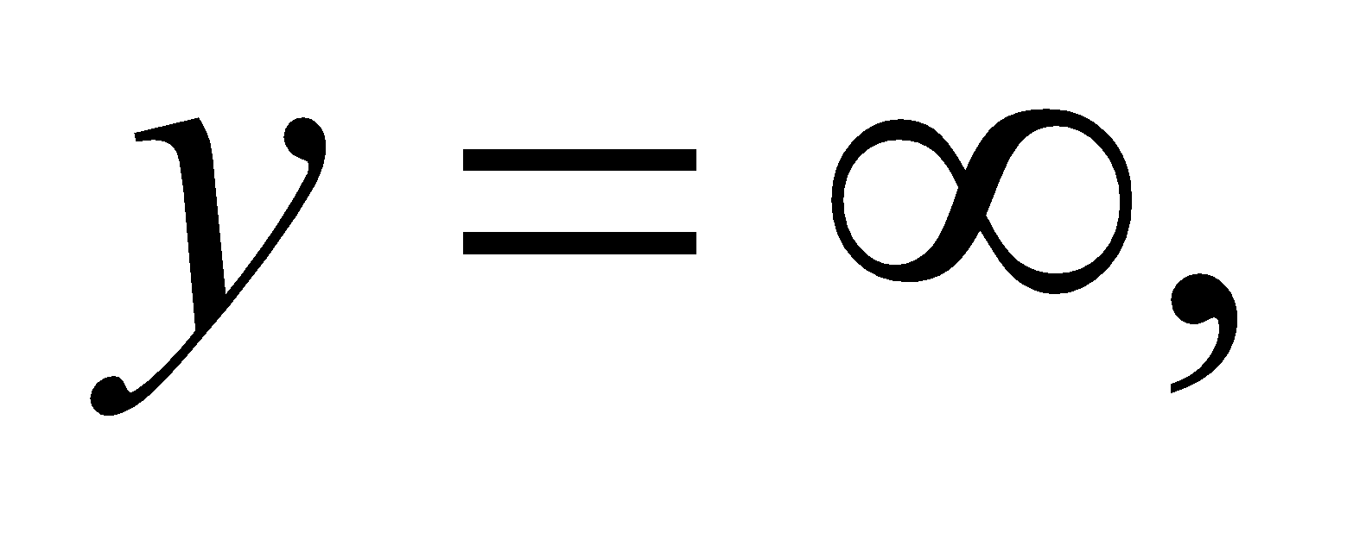 hence it has a maximum in between. Setting the spatial derivative of the electric field equal to zero, we find

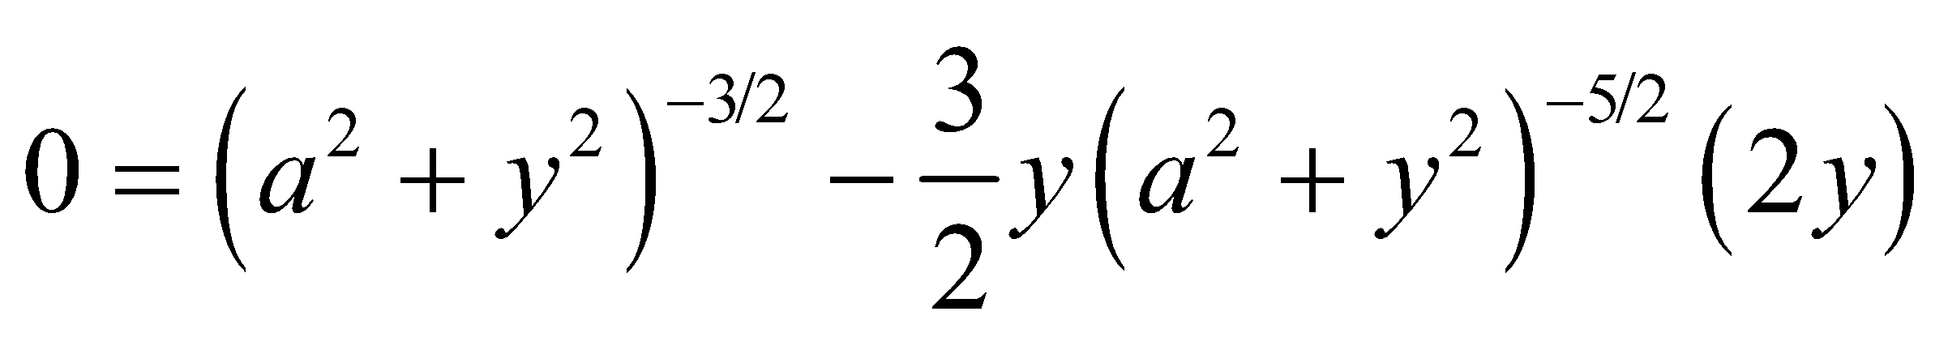

or 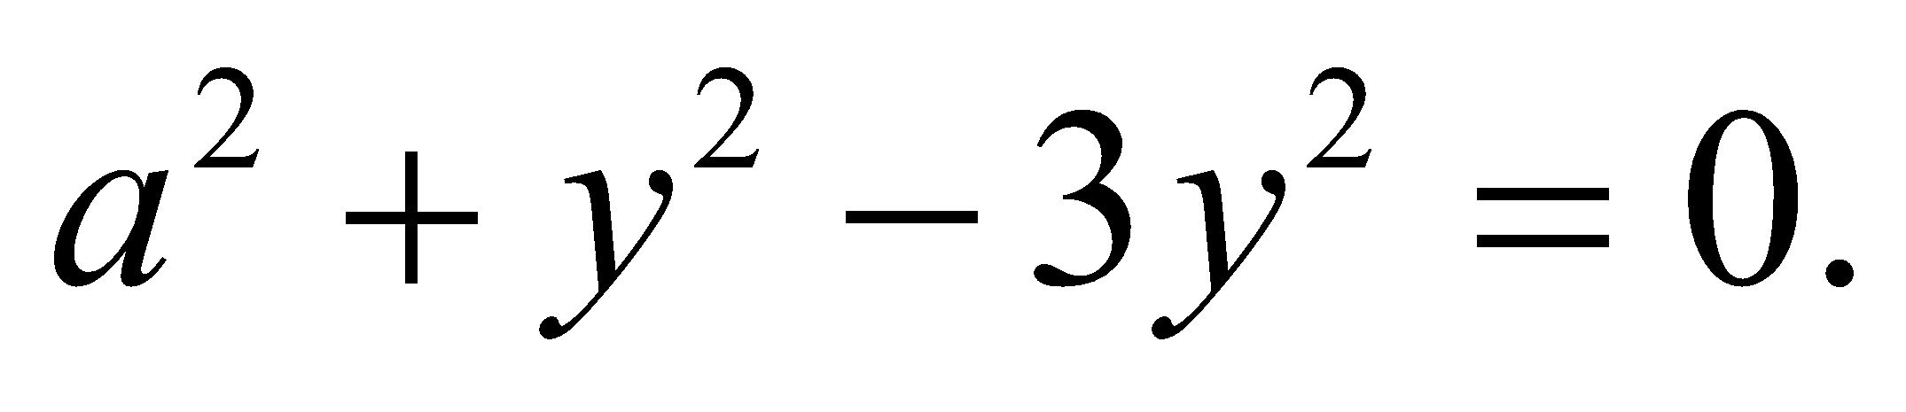 Thus, the field strength maxima are at 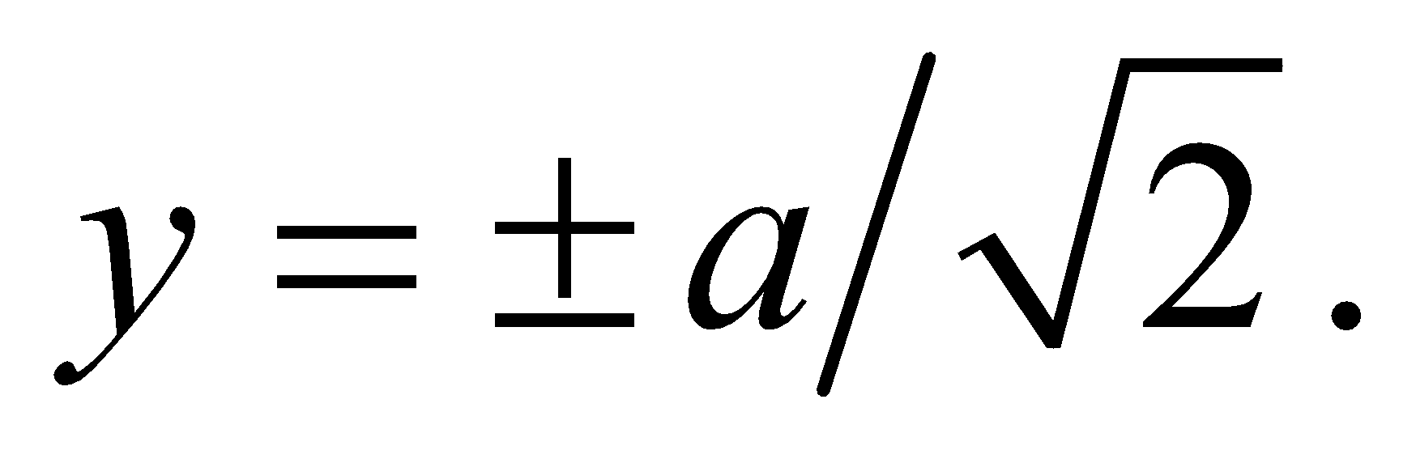

**Assess** By symmetry, we expect the directions of the electric field at 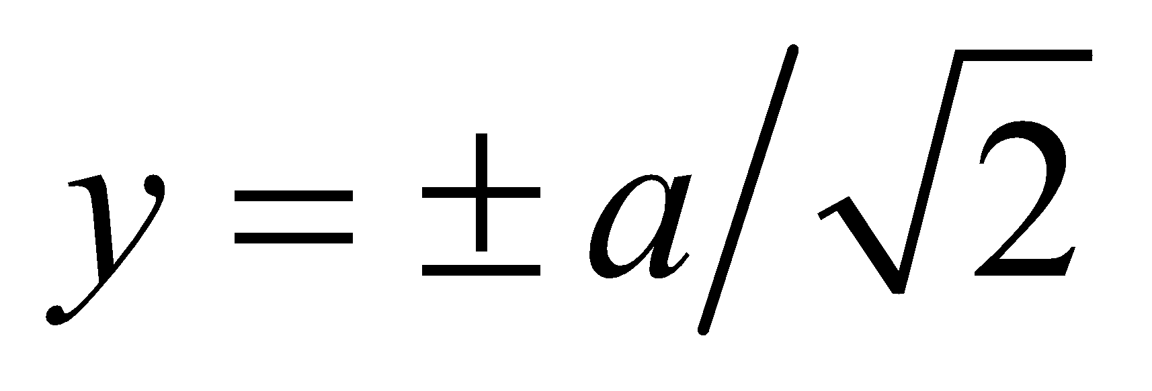 to be opposite.

**49.** **Interpret** This problem is that same as Example 20.5, except that it is rotated by 90°. There are two source particles: a proton at (0, 0.60 nm) and an electron at (0, −0.60 nm), so the system is dipole.

**Develop**  We can use the result of Example 20.5, with *y* replaced by *x*, and *x* by −*y* (or, equivalently, 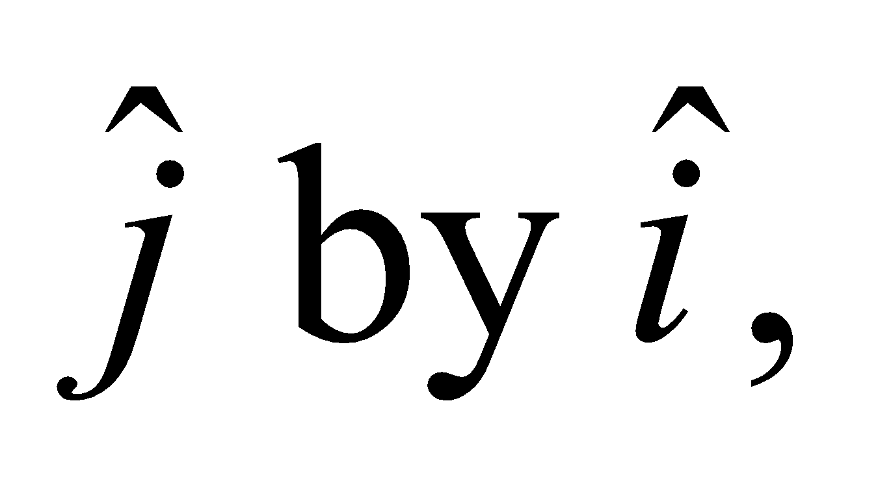 and 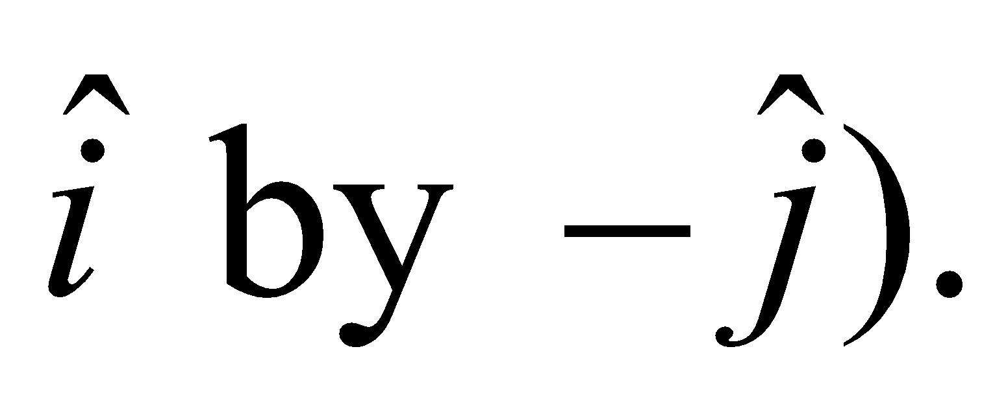 The electric field on the *x* axis is then

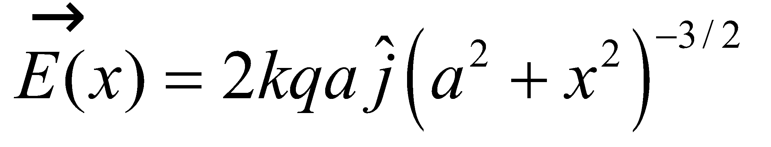

where 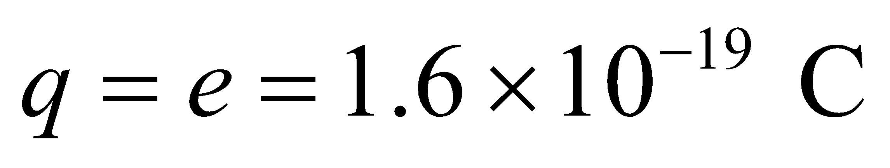 and *a* = 0.60 nm (see Figure 20.12 rotated 90° clockwise). The constant 

**Evaluate** (**a**) Midway between the two charges (at *x* = 0), the electric field is

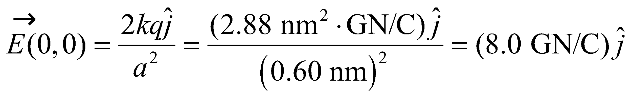

(**b**) for *x* = 2 nm,



(**c**) For *x* = 20 nm,



to two significant figures.

**Assess** For part (c), because *x*  *a*, we can apply Equation 20.6a, which gives

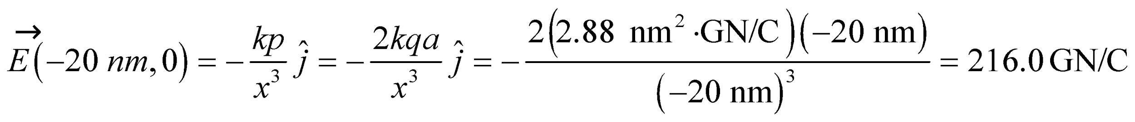

which differs by only 0.1% from the more precise result of part (c).

**50. Interpret** We find the electric field on the axis of a dipole, and show that Equation 20.6b is correct. To do this we will use the equation for electric field.

**Develop** The spacing between the + and – charges is *2a*. We will use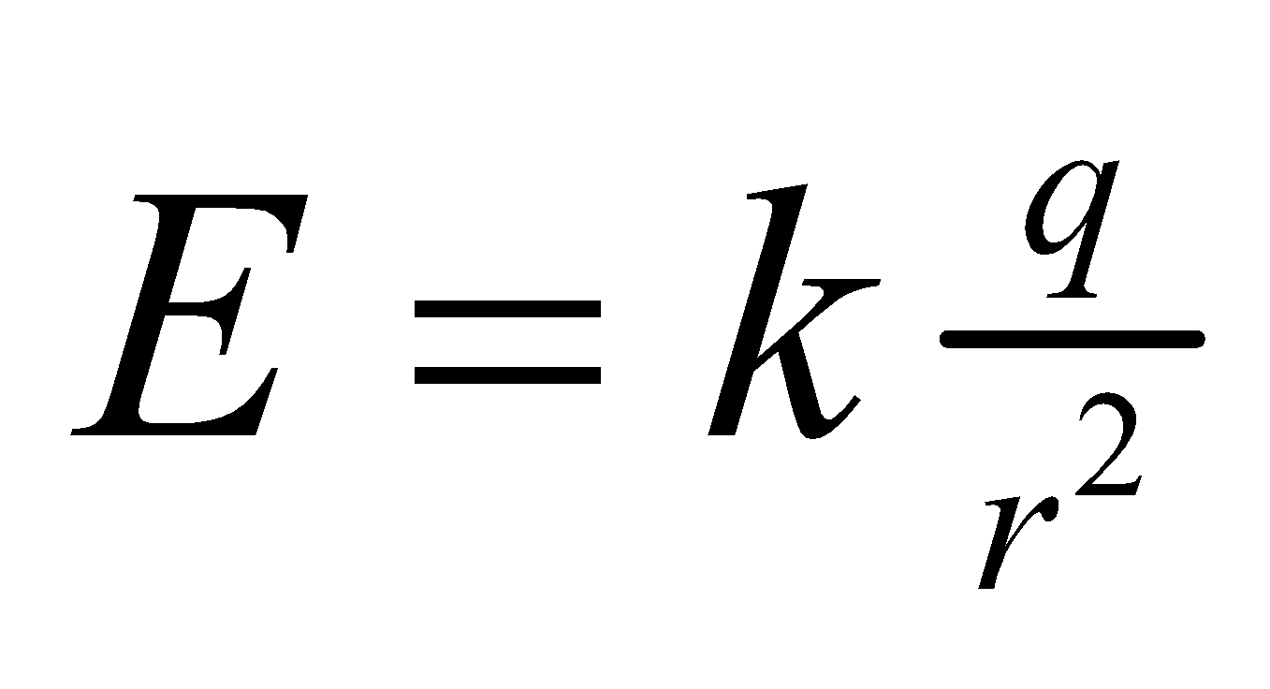for each charge to find the total field at a point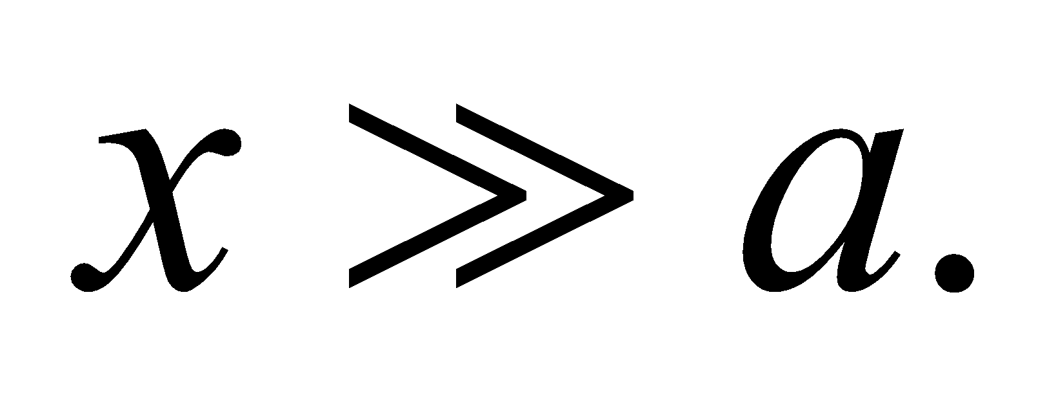

**Evaluate**

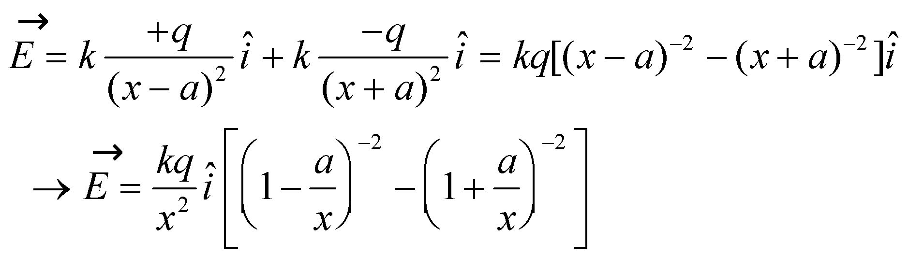

For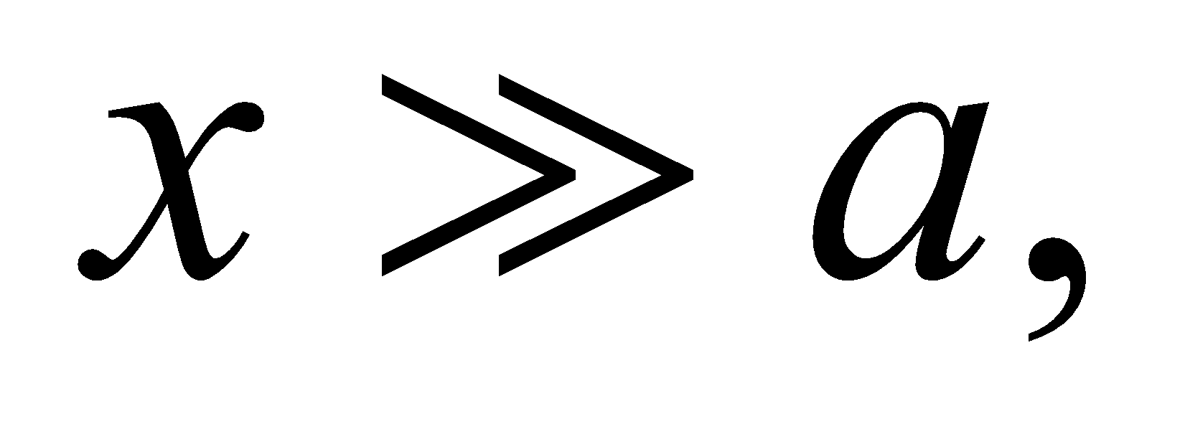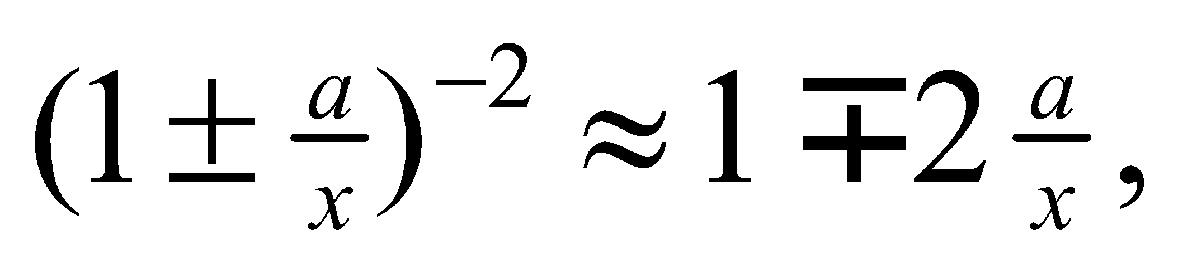so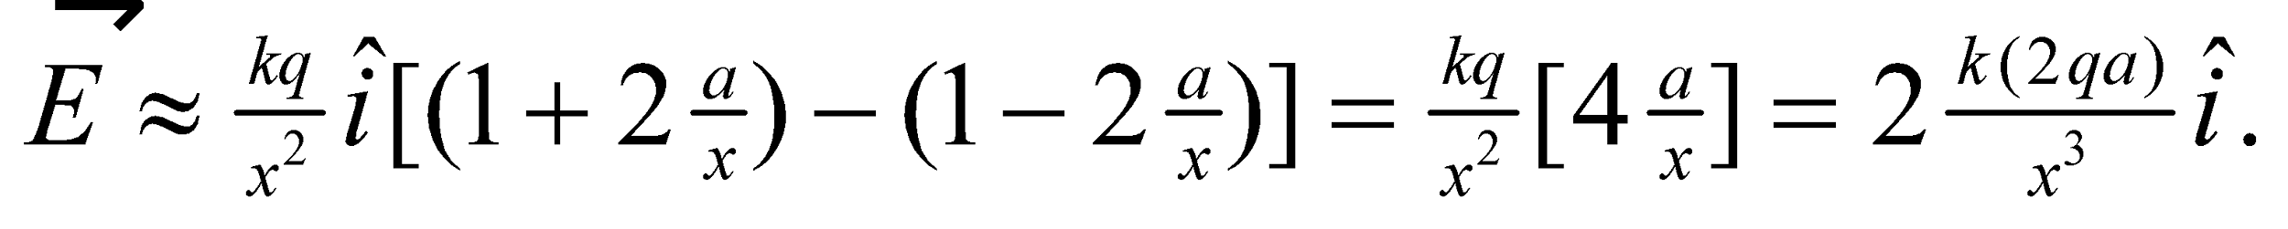But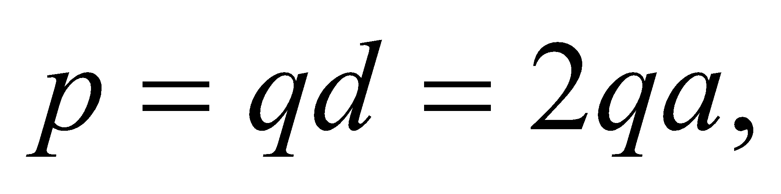so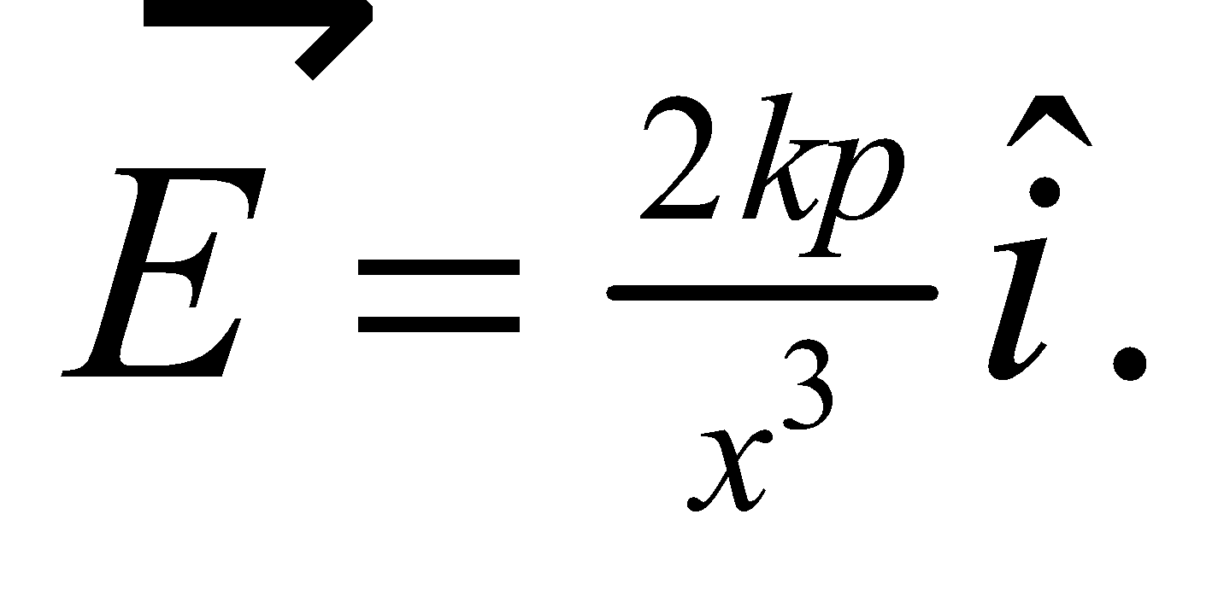

**Assess** We have shown what was required.

**51.** **Interpret** This problem involves finding the net charge or an unknown charge distribution. We are given the behavior of the electric field as a function of distance from the charge, for distances much, much greater than the size of the charge distribution.

**Develop** Taking the hint, we suppose that the field strength varies with an inverse power of the distance, 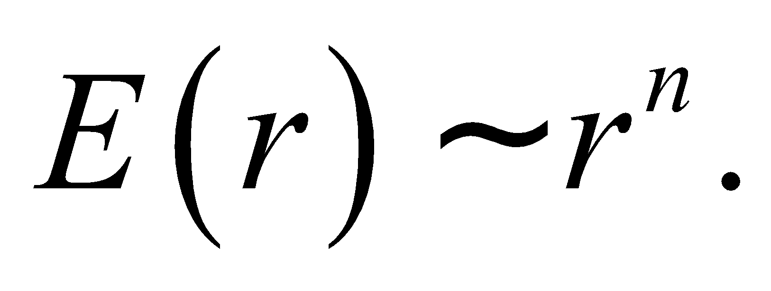 Under this hypothesis, 282/119 = (1.5/2.0)*n*, or *n* = ln(282/119)/ln(0.75) = −3.0.

**Evaluate** A dipole field falls off like 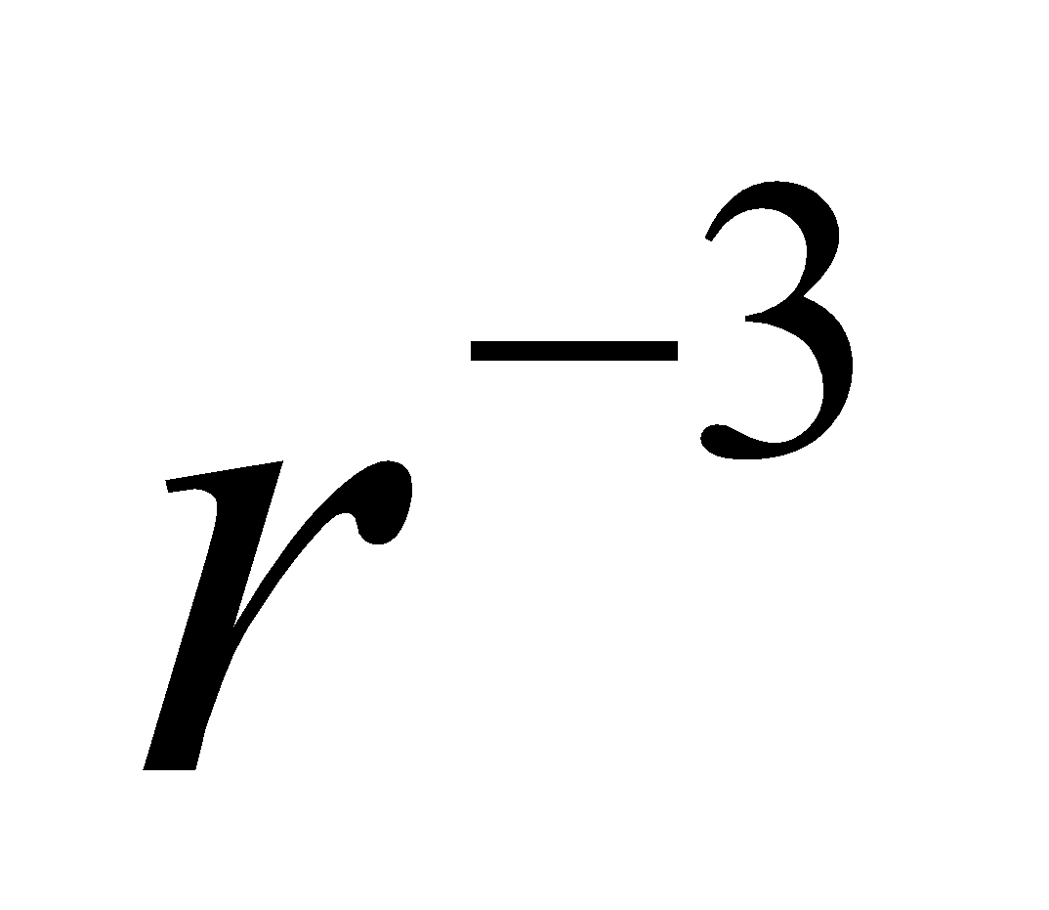 for 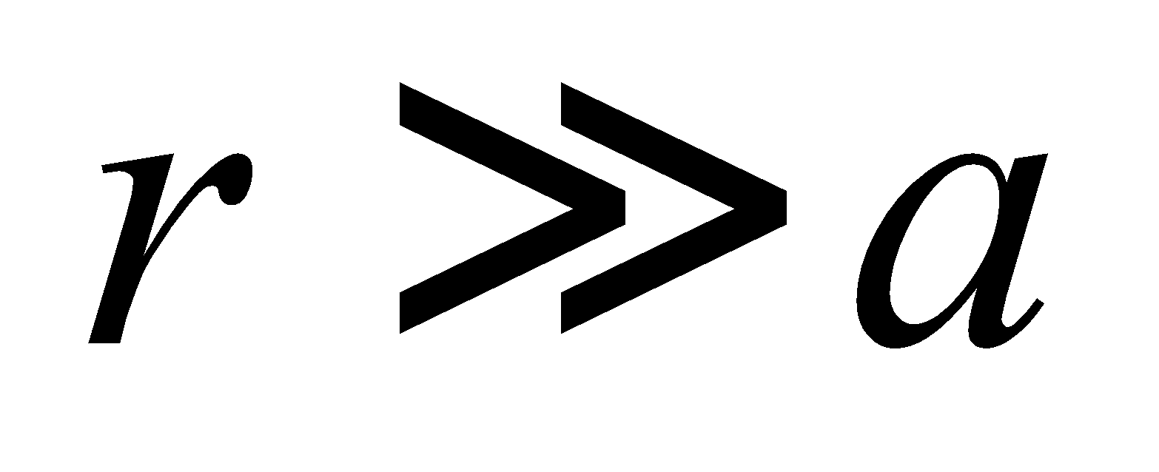, so the charge distribution must be a dipole, whose net charge is zero.

**Assess** Note that this result is only valid if the dipole separation *a*  1 m. Because this is normally the case, the result is appears valid.

**52. Interpret** Coulomb’s law and the principle of superposition applies here. There are three source charges, and we are to find the field strength at a point on the *y* axis above the upper-most charge.

**Develop** Make a sketch of the situation (see figure below). The electric field on the *y* axis (for 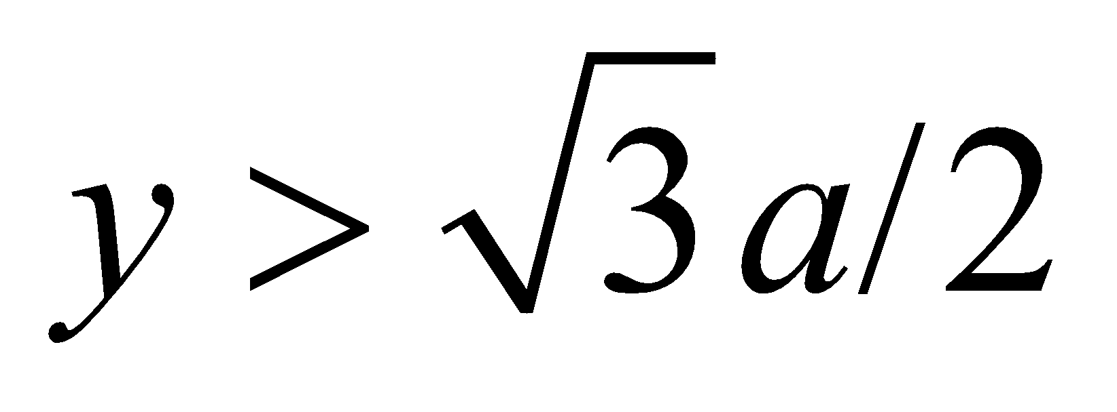) due to the two charges on the *x* axis follows from Example 20.2. The only difference is that in this problem, the charges on the x axis are separated by *a* instead of 2*a*. Thus,

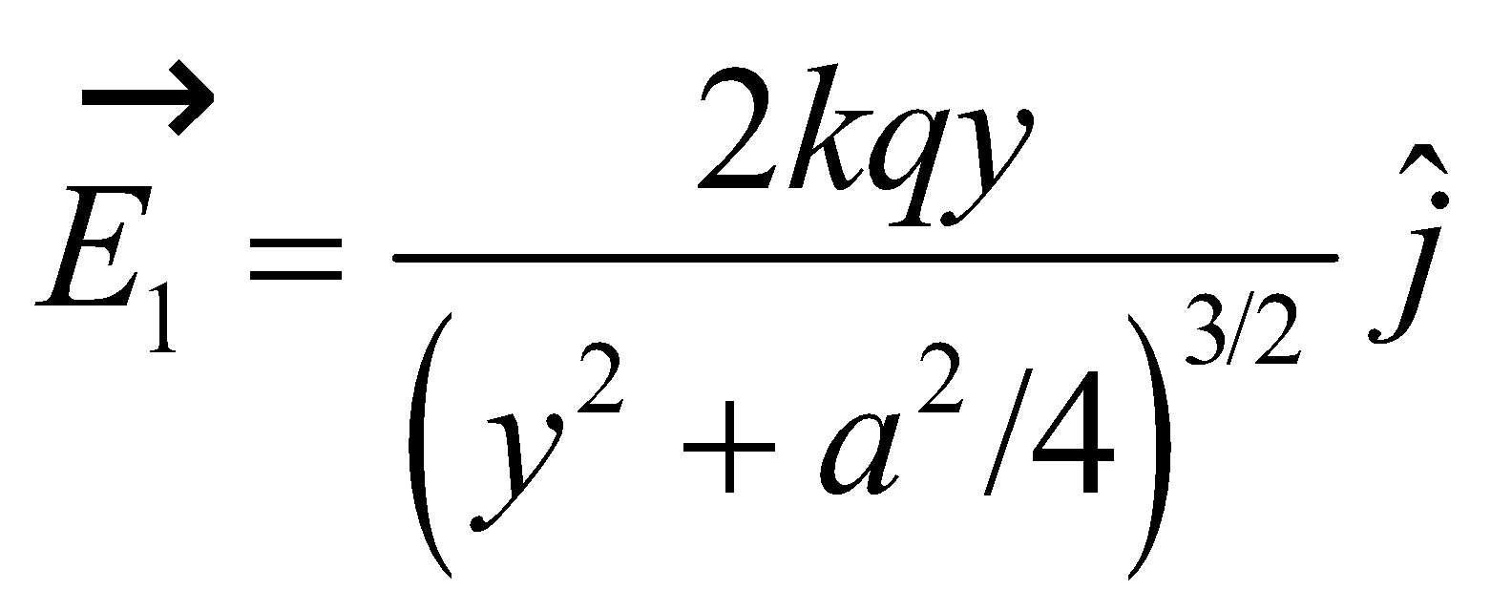

On the other hand, using Equation 20.3, we find the electric field due to the charge on the *y* axis for  is

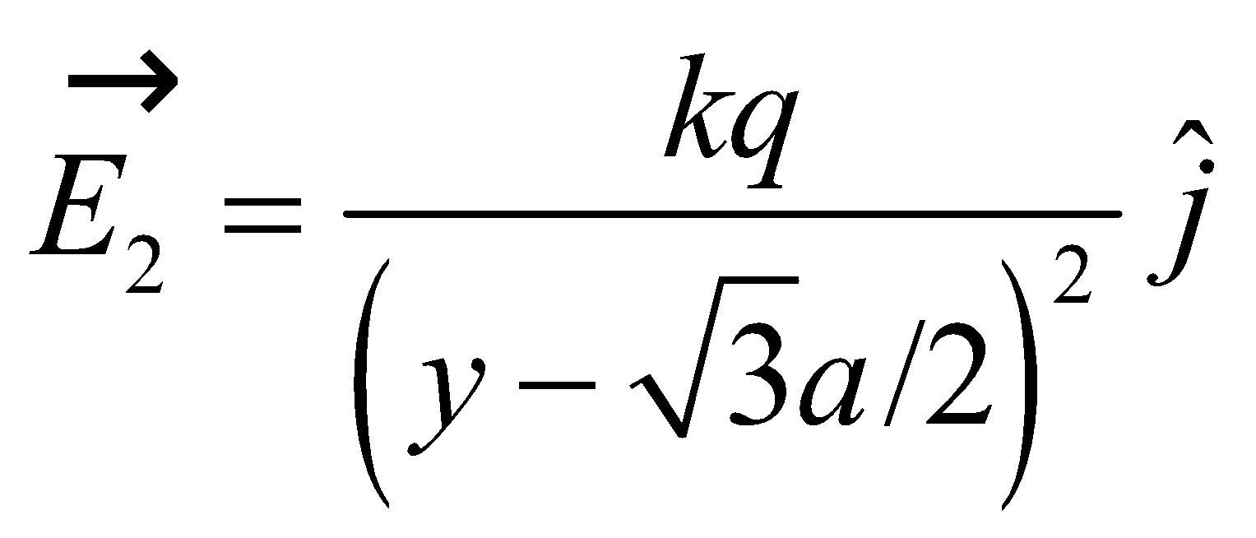

Using the principle of superposition, the total field for  is the sum of 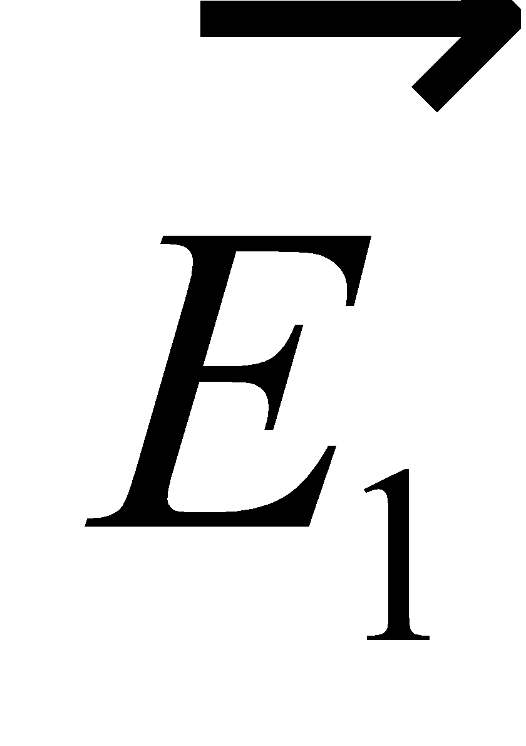 and 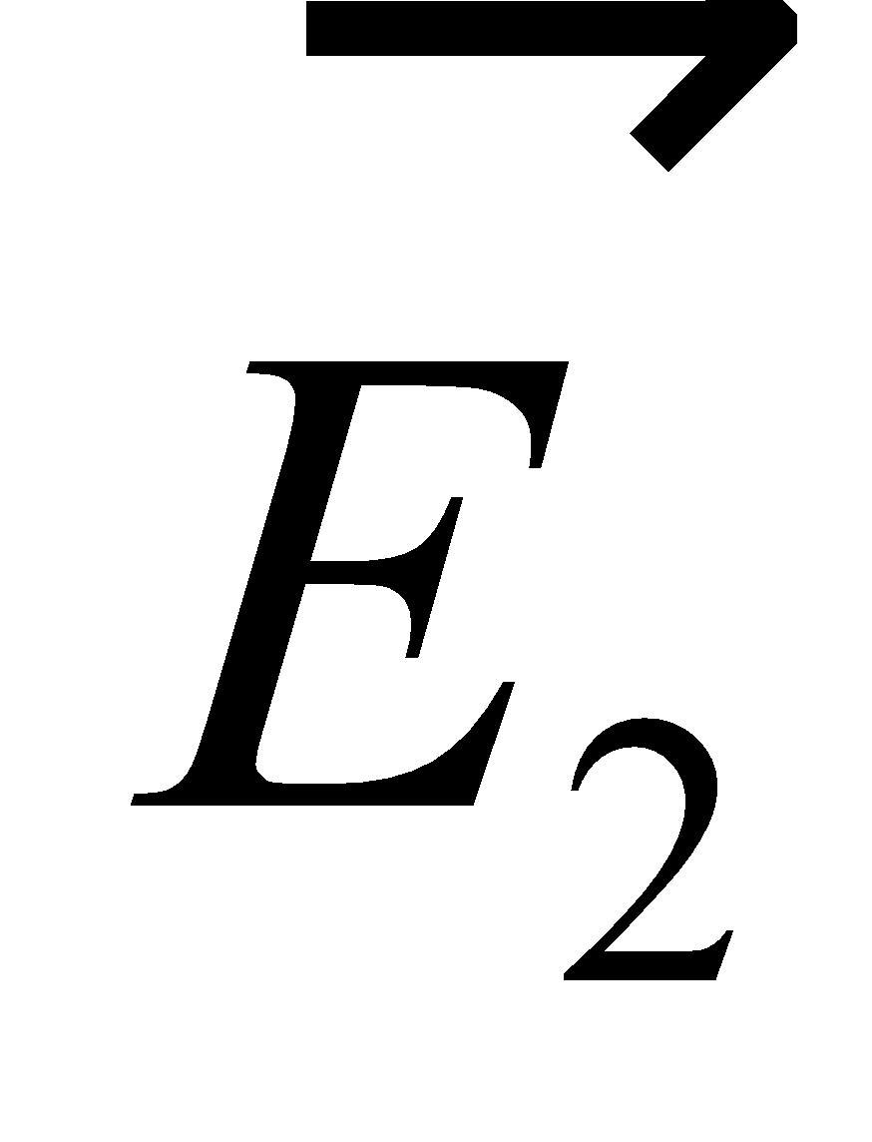.



**Evaluate** **(a)** For 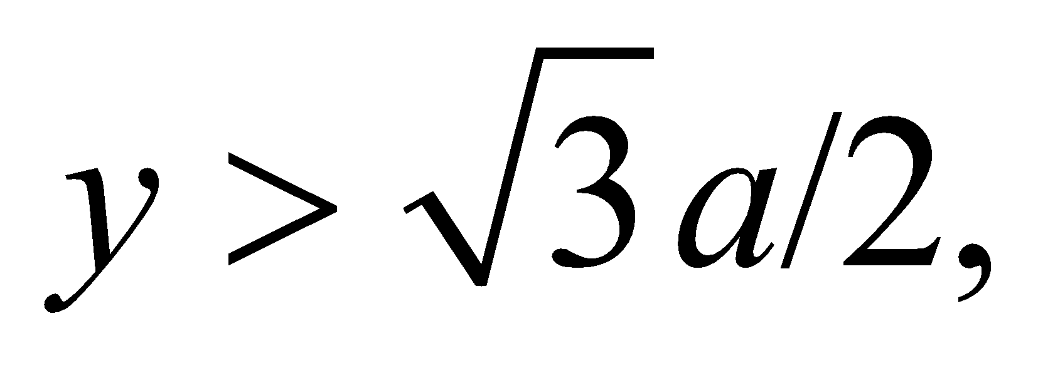 the total field is simply the sum of both terms:

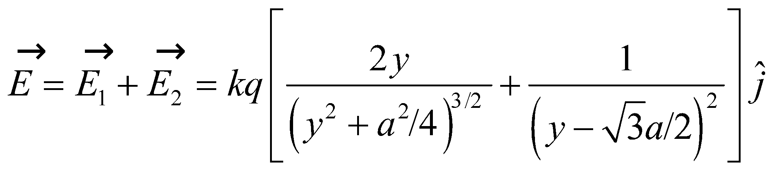

**(b)** For 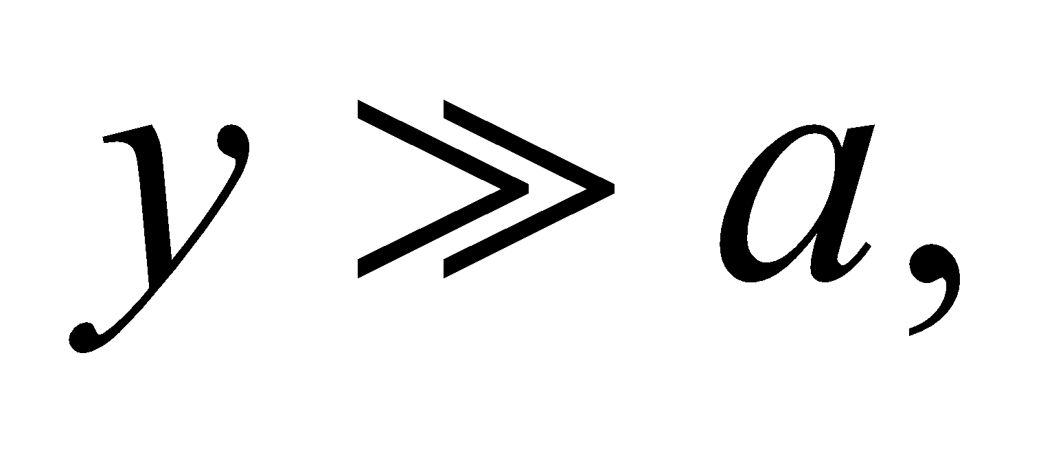 the electric field may be approximated as

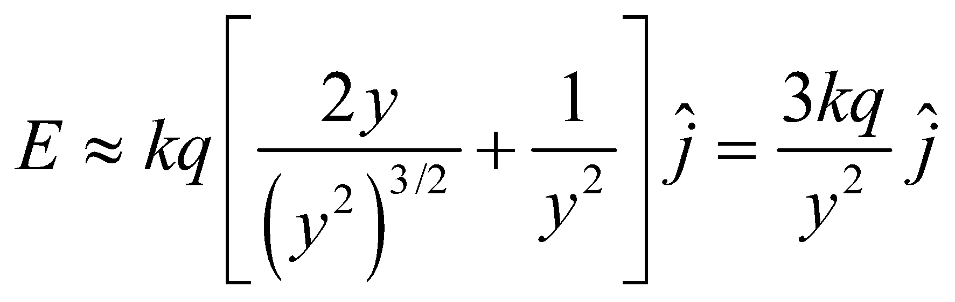

which is like that due to a point charge of magnitude 3*q*.

**Assess** At large distances much, much greater than *a*, the charge distribution looks like a point charge located at the origin with charge 3*q*.

**53.** **Interpret** This problem involves Coulomb’s law, which generates the given forces between two charged metal spheres. The spheres initially experience an attractive force, but when the charge on the spheres is equilibrated, the force becomes repulsive.

**Develop** The charges initially attract, so *q*1 = −*q*2, and, by Coulomb’s law (Equation 20.1), we have

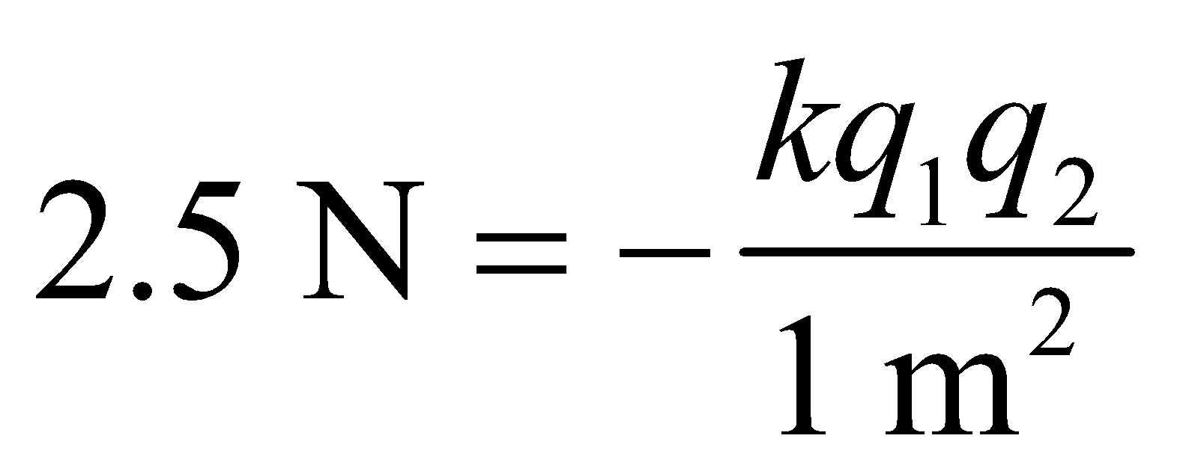

When the spheres are brought together, they share the total charge equally, each acquiring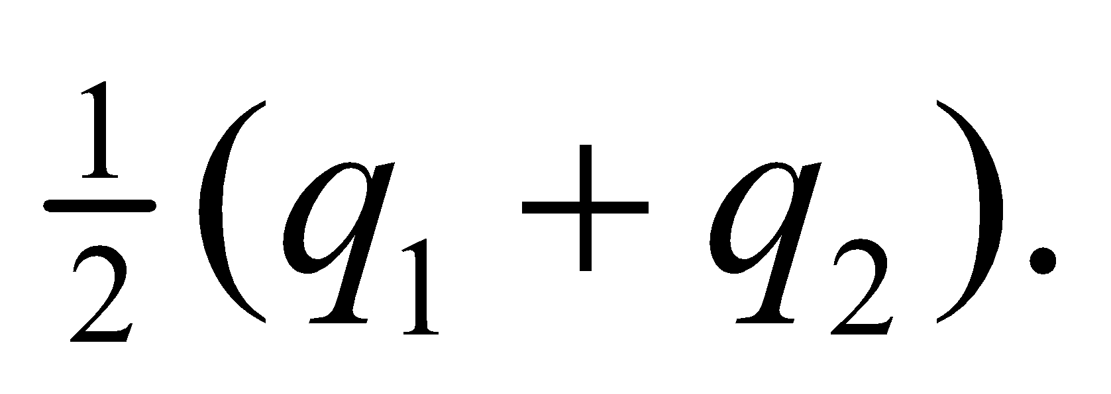The magnitude of their repulsion is

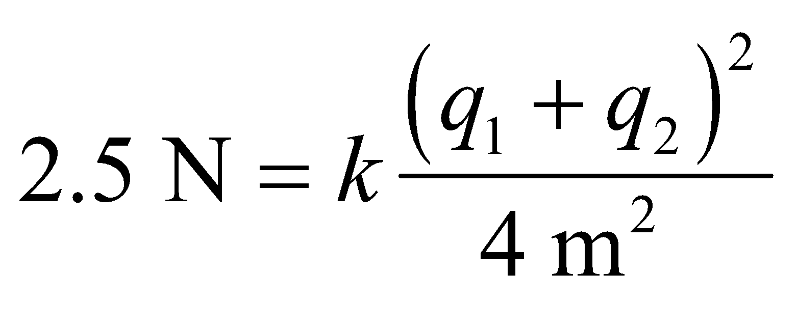

Because the forces have the same magnitude, we can equation them to find the original charges *q*1 and *q*2.

**Evaluate** Equating these two forces, we find a quadratic equation 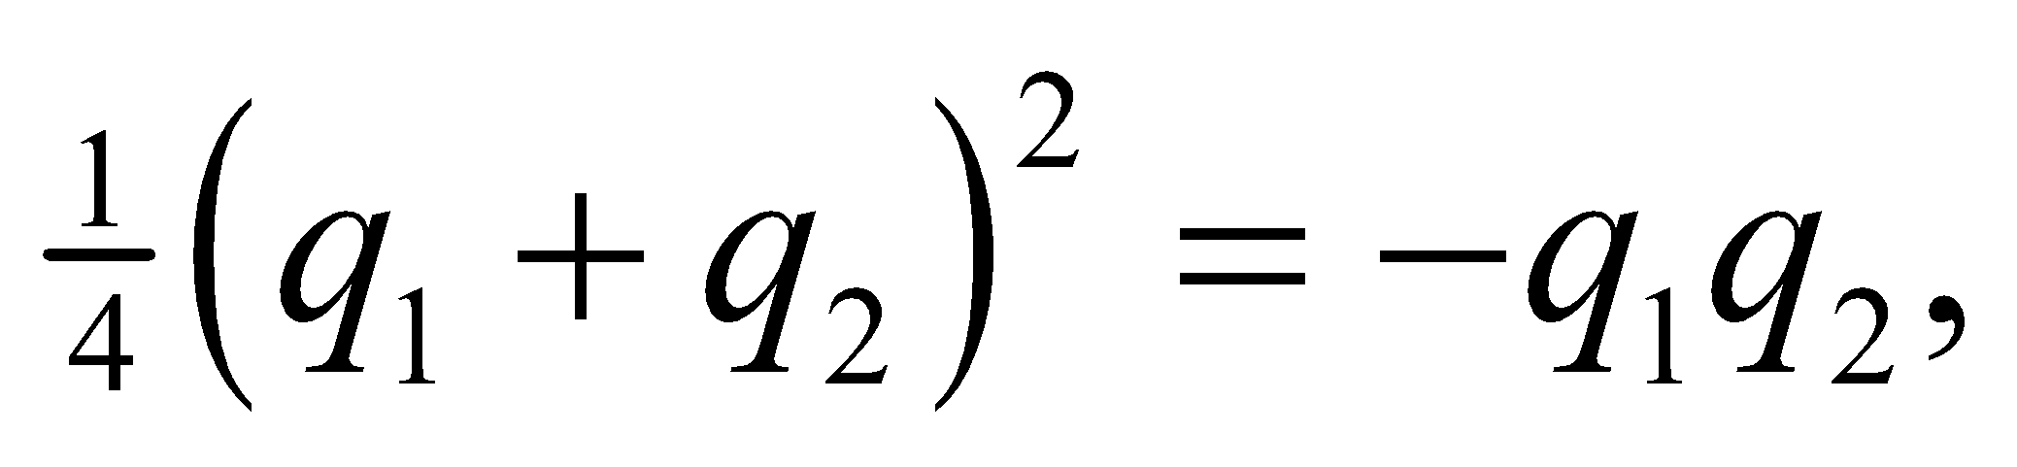 or 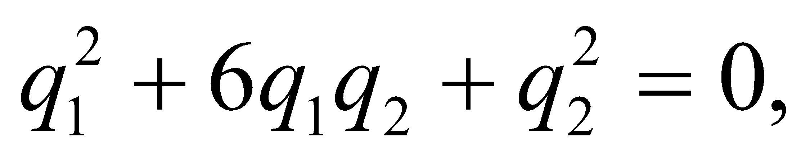 with solutions 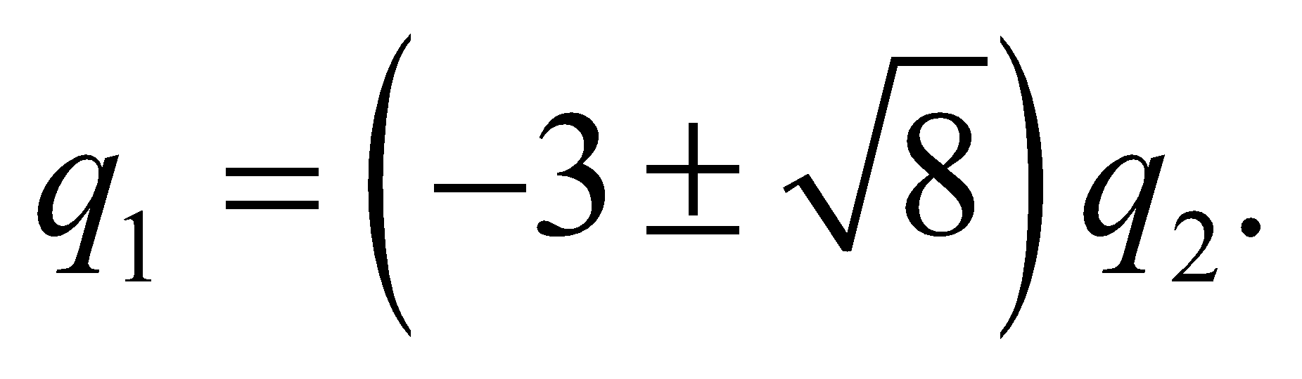 Both solutions are possible, but since 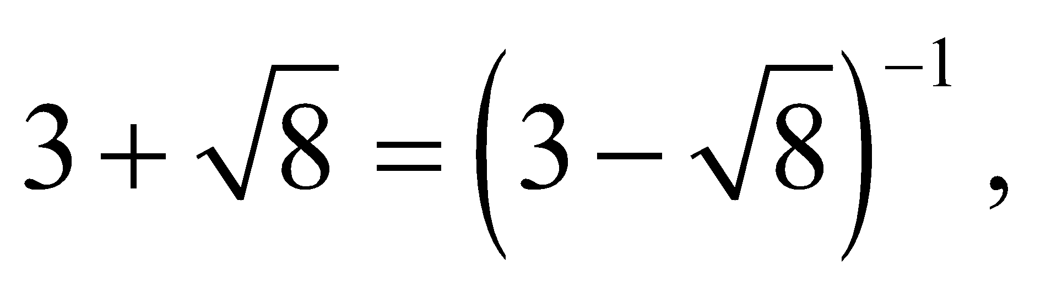 they merely represent a relabeling of the charges. Since , the solutions are 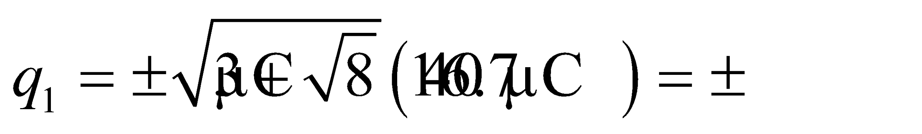 and 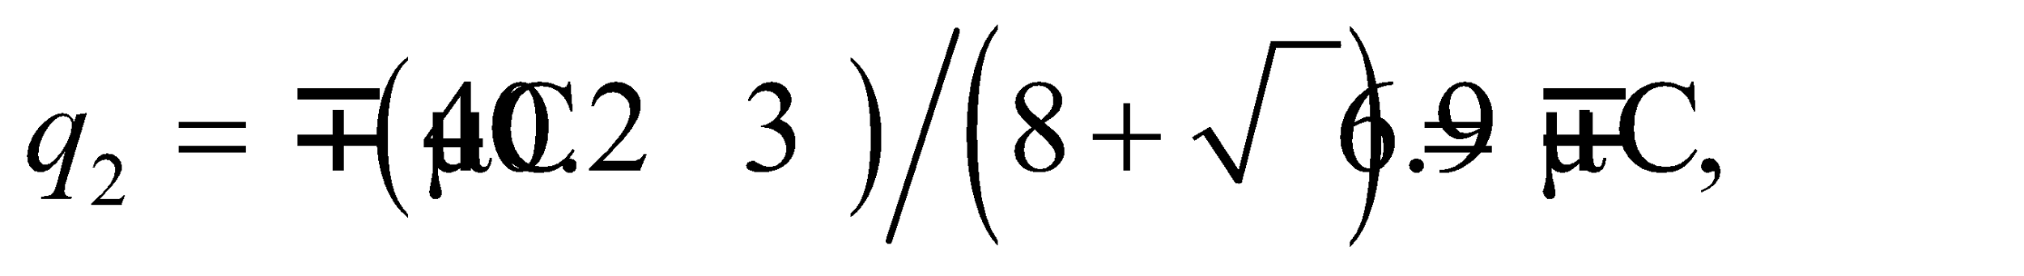 or the same values with *q*1 and *q*2 interchanged.

**Assess** The results are reported to two significant figures, which is the precision to which the data is known.

**54. Interpret** Two forces are involved in this problem: the Coulomb force and the spring force. The spring is stretched due to the Coulomb repulsion between the charges, and we are to find by how much the spring stretches.

**Develop** The Coulomb force is given by Equation 20.1 and the spring force is given by Equation 4.9, *F*s = −*kx*, where *x* is the displacement from equilibrium of the spring. We assume that the Coulomb repulsion *Fe* is the only force stretching the spring. When balanced with the spring force, 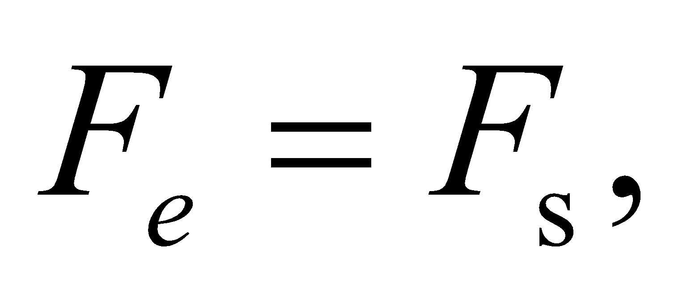 or

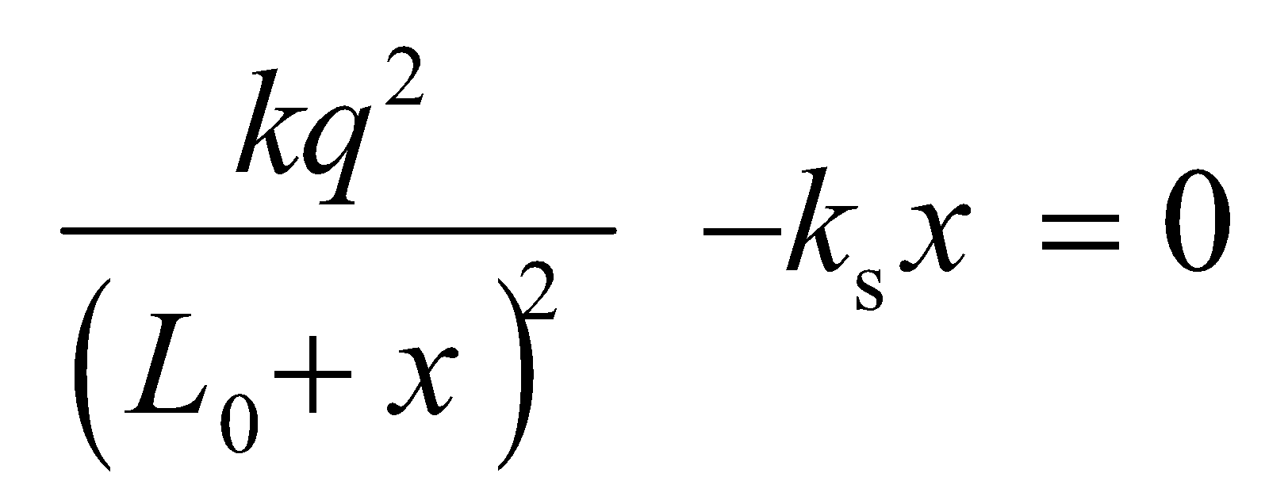

where 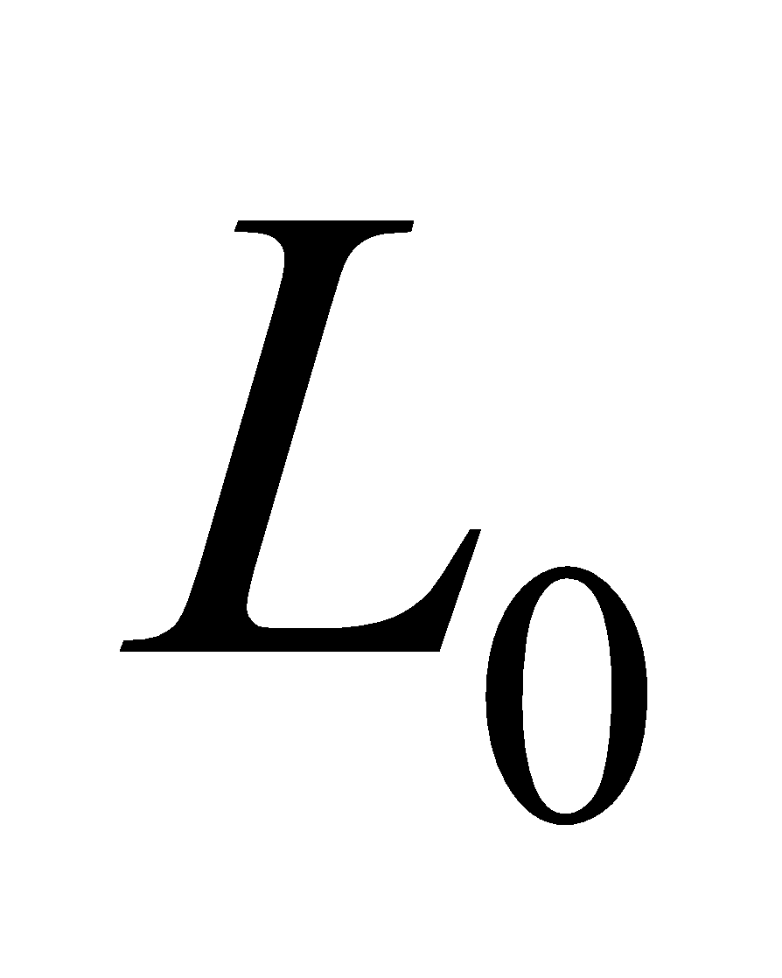 is the equilibrium length. This cubic equation can be solved by iteration or by Newton’s method.

**Evaluate** Substituting the values given in the problem statement gives

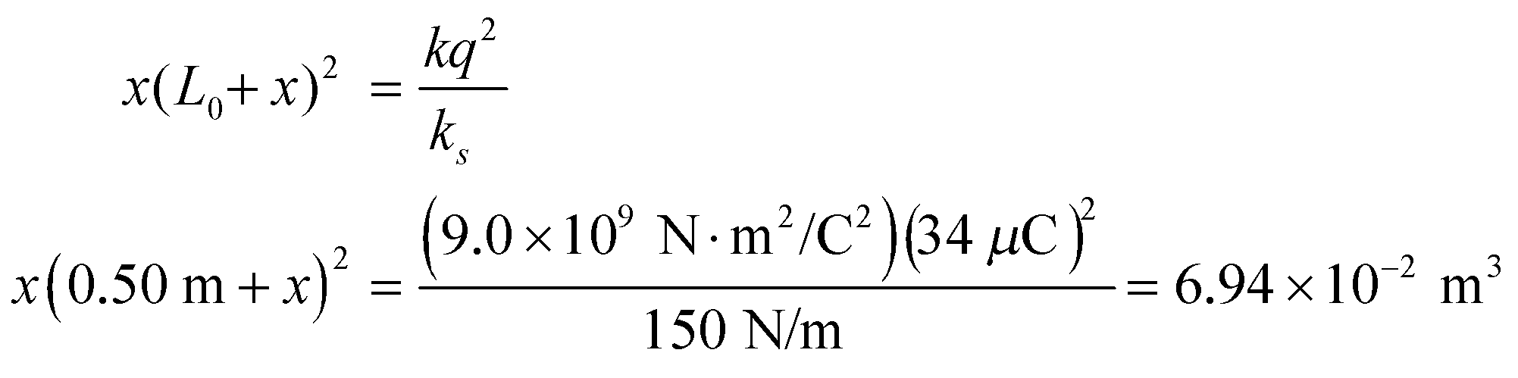

Newton’s method yields *x* = 16 cm, to two significant figures.

**Assess** Our result makes sense because the amount stretched is seen to decrease with increasing spring constant *k*s and increase with the magnitude of the charge *q*.

**55. Interpret** We will calculate the electric field magnitude a distance *x* from either end of a uniformly charged rod of charge *Q* and length *L*.

**Develop** We will use the integral form for electric field, Equation 20.7: 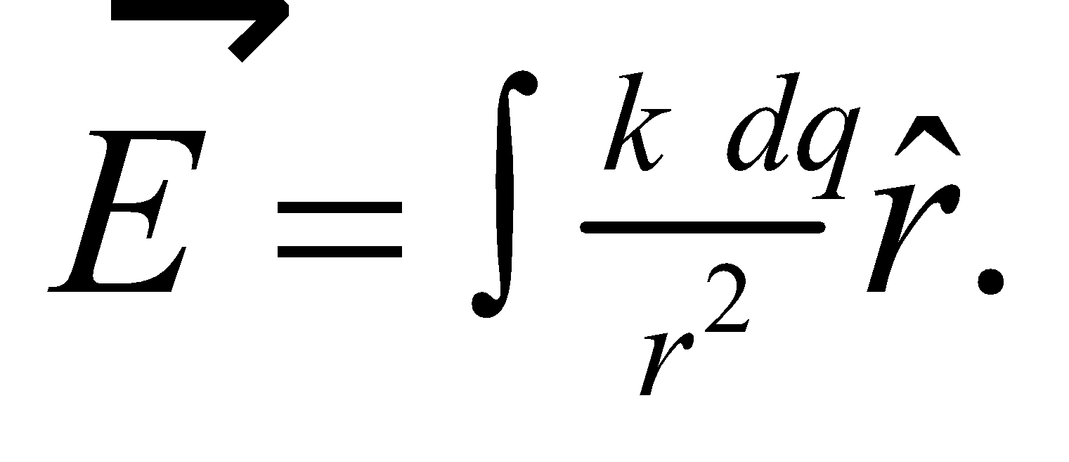 Because the charge is distributed uniformly along the length, the differential charge element is 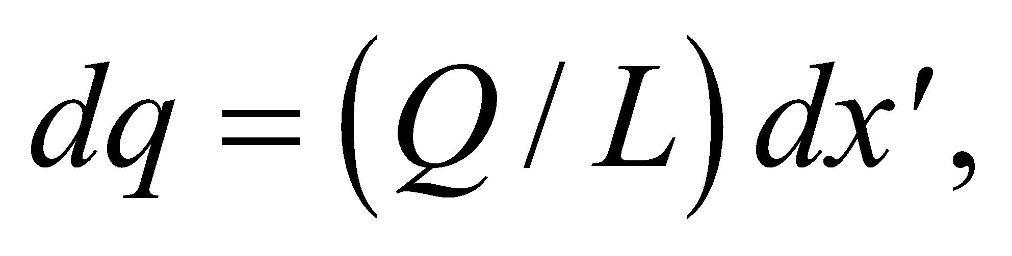where 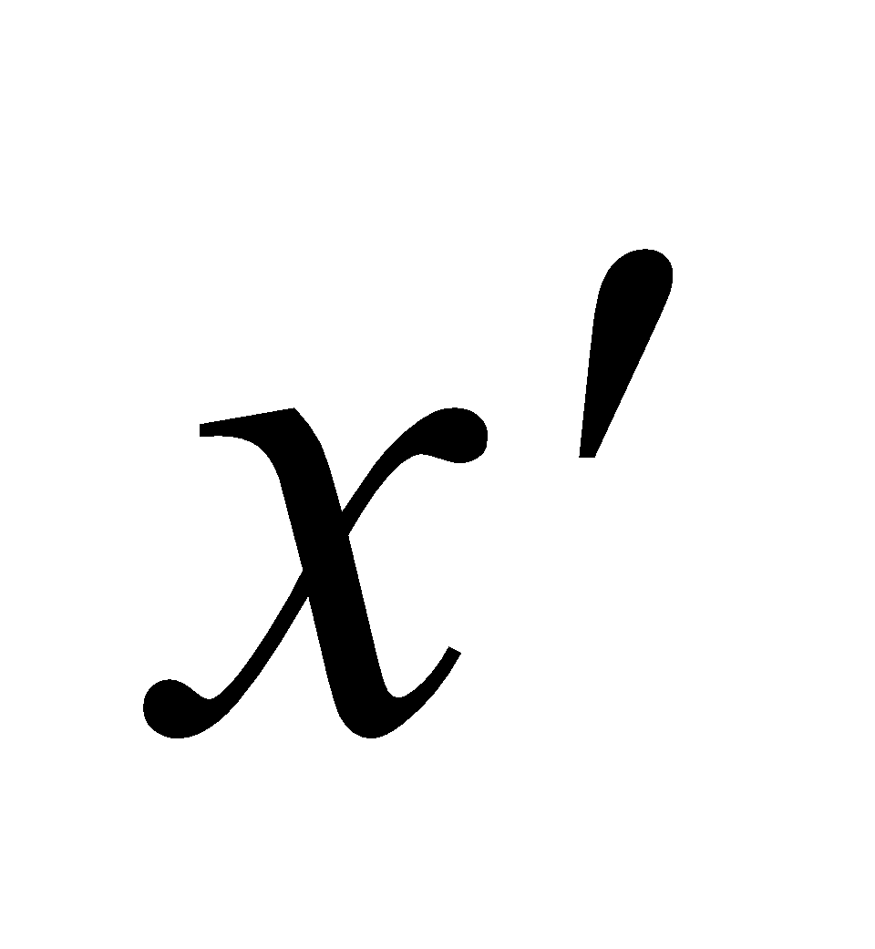is the location of this charge along the rod, see figure below.



We are only interested in the electric field along the *x*-axis at points with 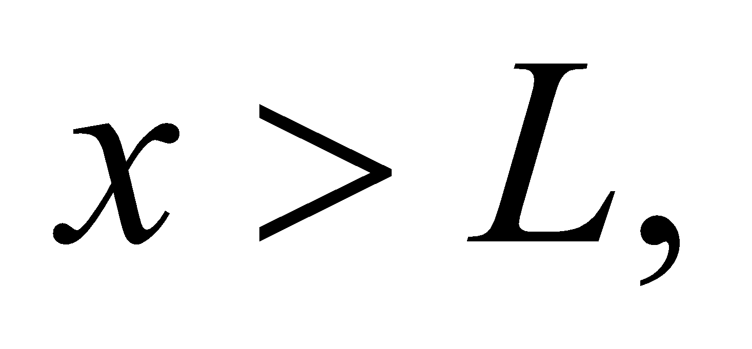in which case the distance to 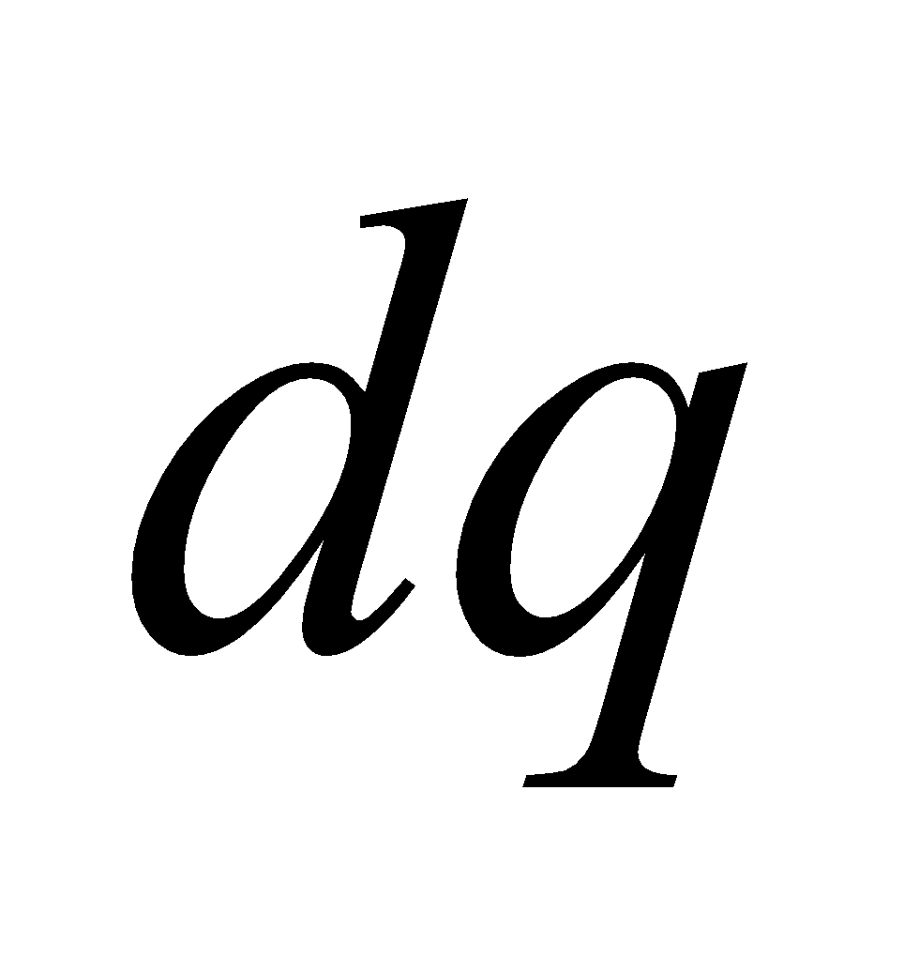 is just 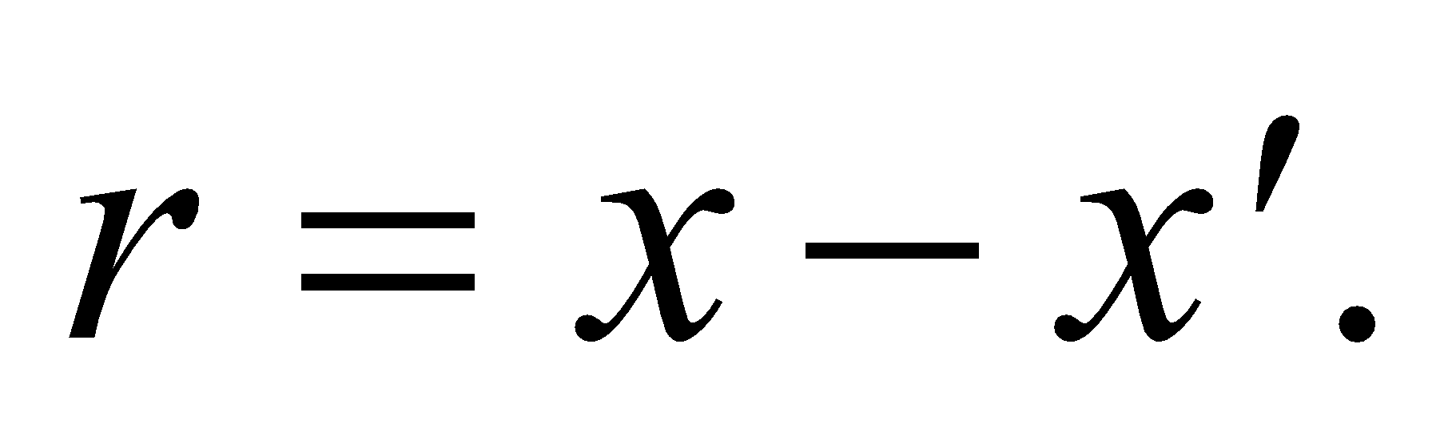

**Evaluate** The integral for the electric field strength is

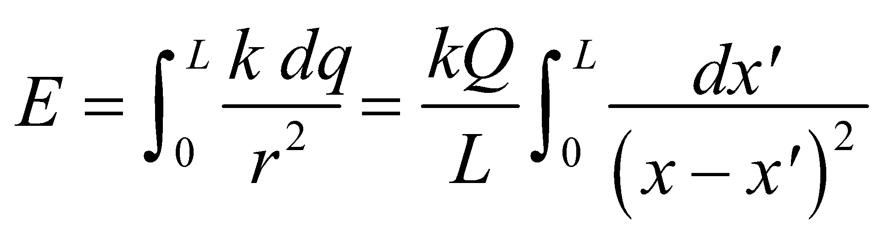

We can change variables: 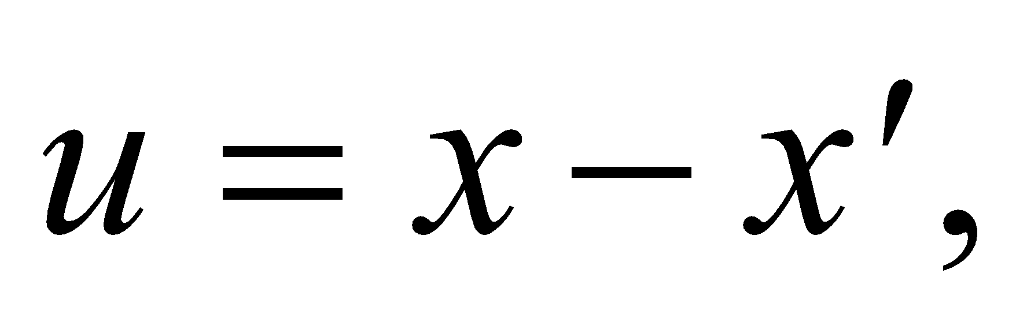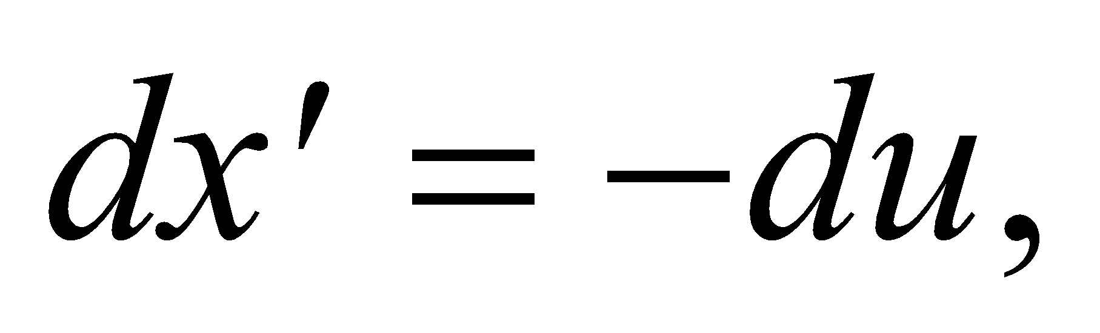 so the integral becomes

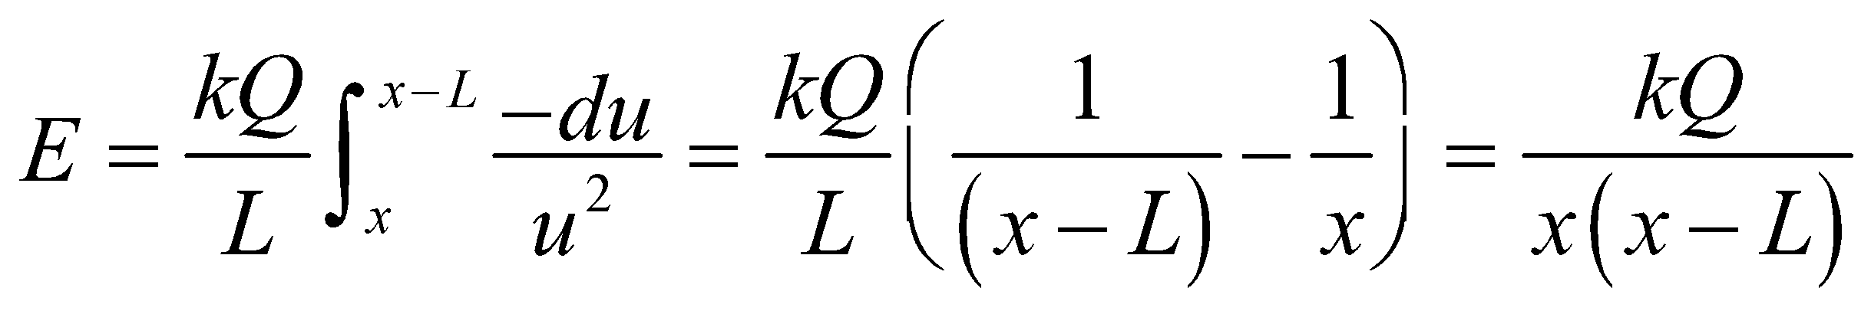

**Assess** For 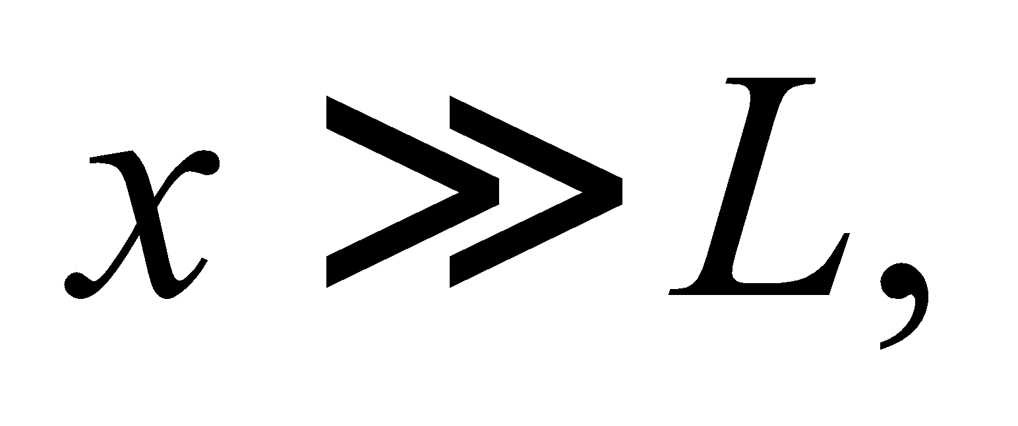the electric field reduces to 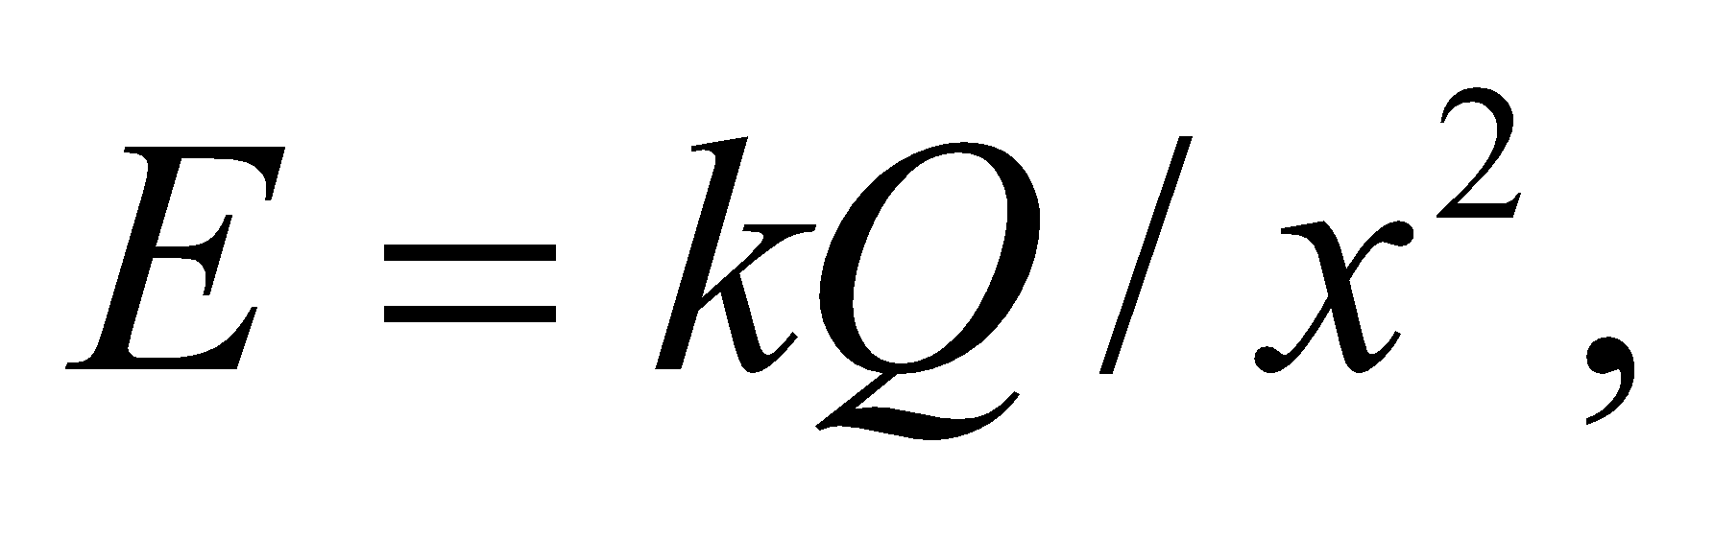which is what we'd expect since the rod will appear as a point charge from a great distance.

**56. Interpret** The electron undergoes circular motion where the centripetal force (Chapter 3) is provided by the Coulomb force in the form of an electric field around a long current-carrying wire.

**Develop** The electric field of the wire is radial and falls off like 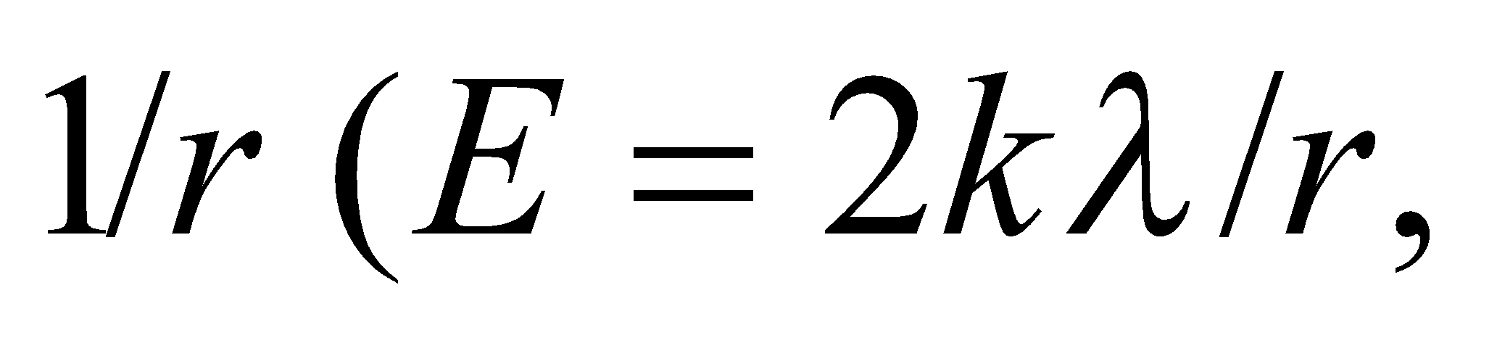 see Example 20.7). For an attractive force (negative electron encircling a positively charged wire), this is the same dependence as the centripetal acceleration (see Equation 3.9, *a*c = *v*2/*r*). For circular motion around the wire, the Coulomb force provides the electron’s centripetal acceleration. Thus, applying Newton’s second law gives

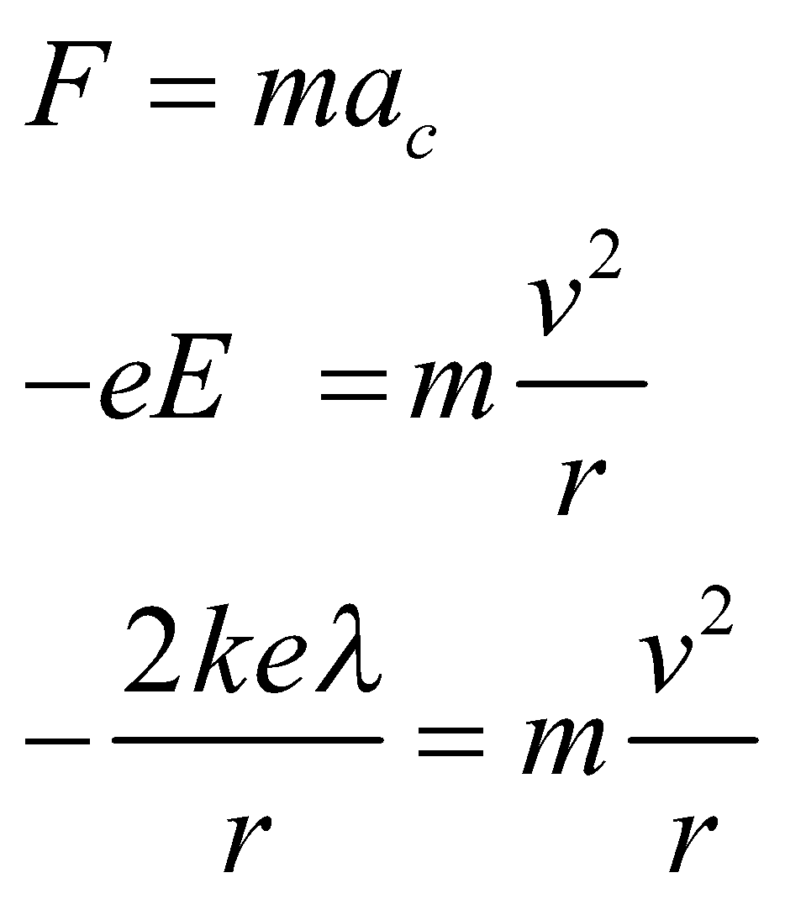

The equation can be used to deduce the tangential speed *v* of the electron.

**Evaluate** Substituting the values given, we find the speed to be

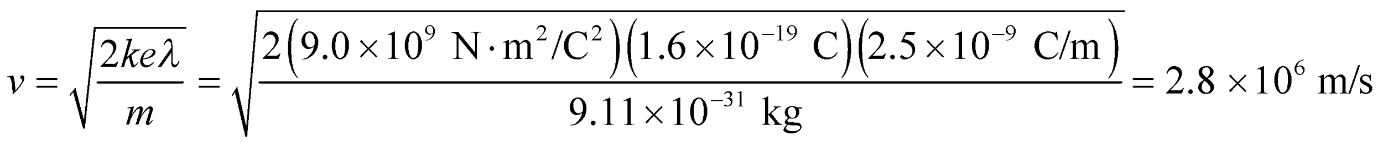

**Assess** The speed of the electron is independent of *r*, the radial distance from the long wire. This is because both the electric field and the centripetal acceleration fall off as 1/r, so the *r*-dependence cancels out.

**57. Interpret** You want to check if a patent for an isotope separator will work. Since different isotopes have the same charge but different mass, the device can work if it discriminates between objects with different charge-to-mass ratios.

**Develop** You can assume the accelerating field, 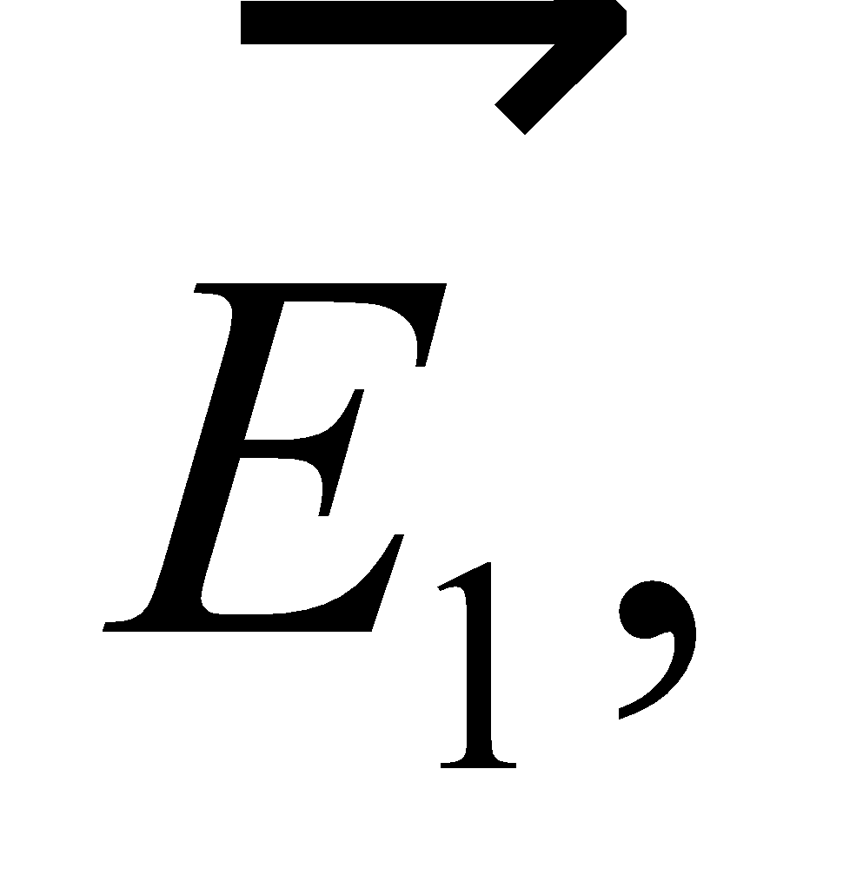 is constant and that the plates in the figure are separated by a distance *x*. Therefore, if an atom stripped of its electrons starts at rest at the bottom plate, it will be accelerated by the field to a final speed of

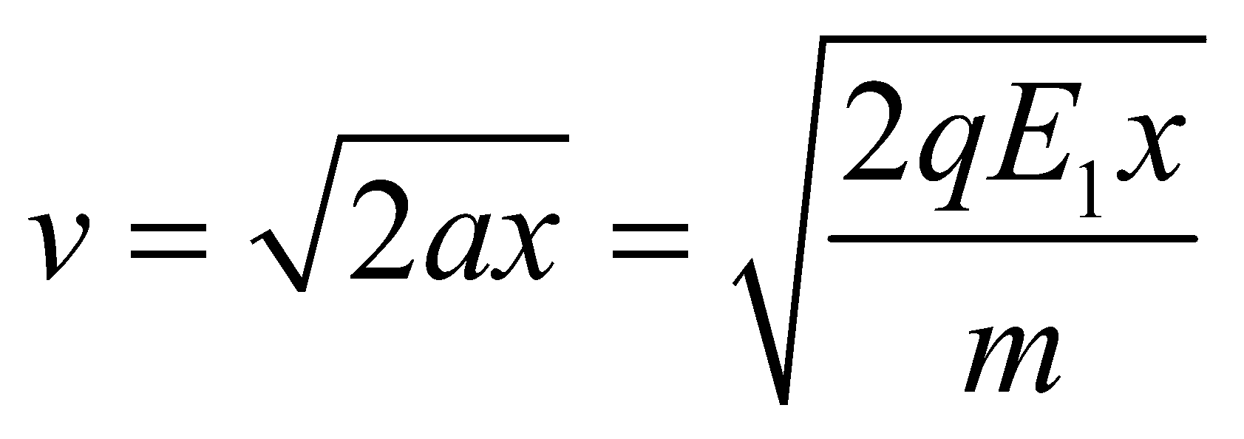

So, it is true that isotopes of different charge-to-mass rations 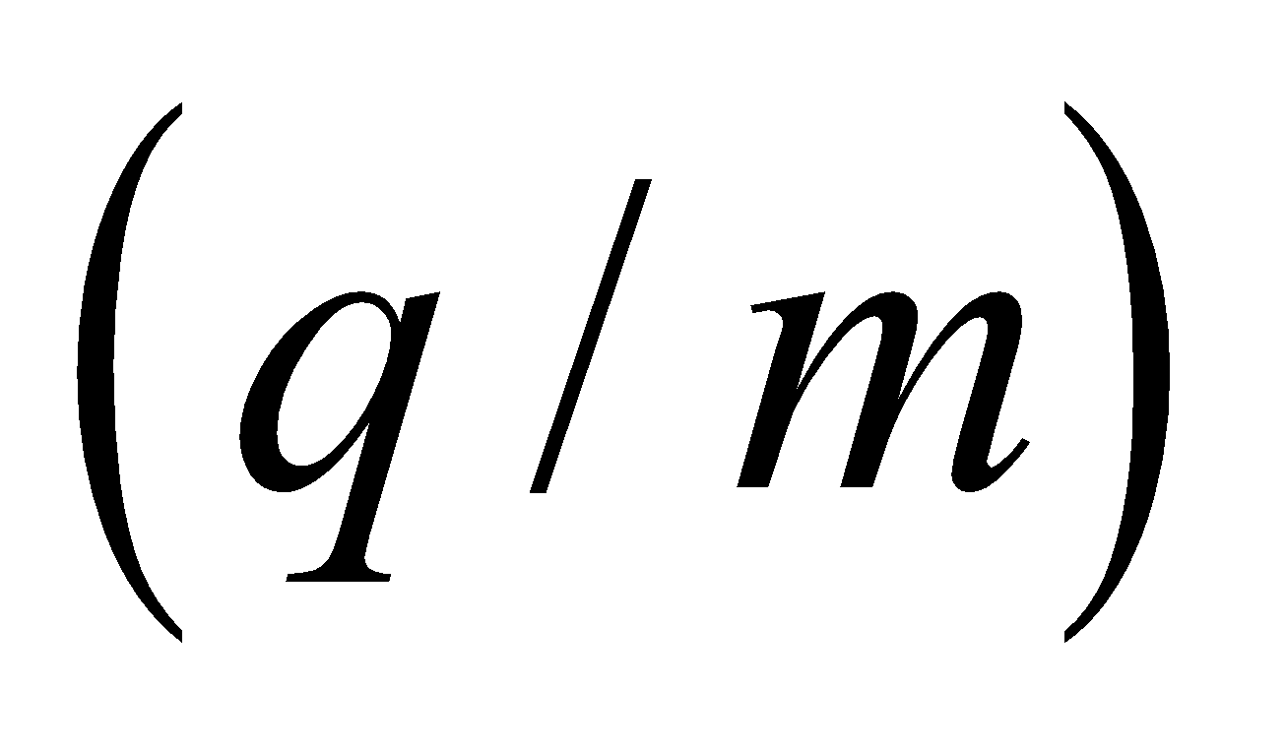will leave the first half of the device with different speeds. For example, an isotope with a relatively large charge-to-mass ratio will attain a higher speed in the accelerating field than another isotope with a lower charge-to-mass ratio. But the question is: can the second half of the device select just one of these speeds so that only one type of isotope emerges?

**Evaluate** The second half of the device is an electrostatic analyzer, as described in Example 20.8. It has a curved field, 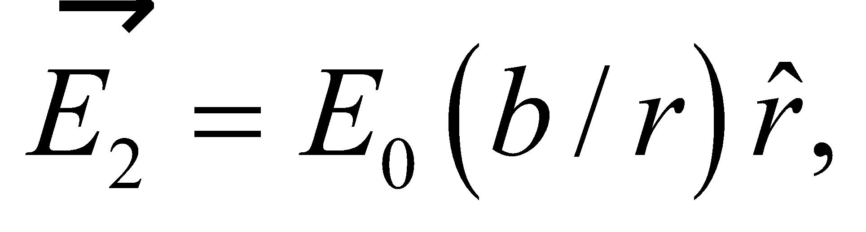 which points toward the center of curvature. The parameters 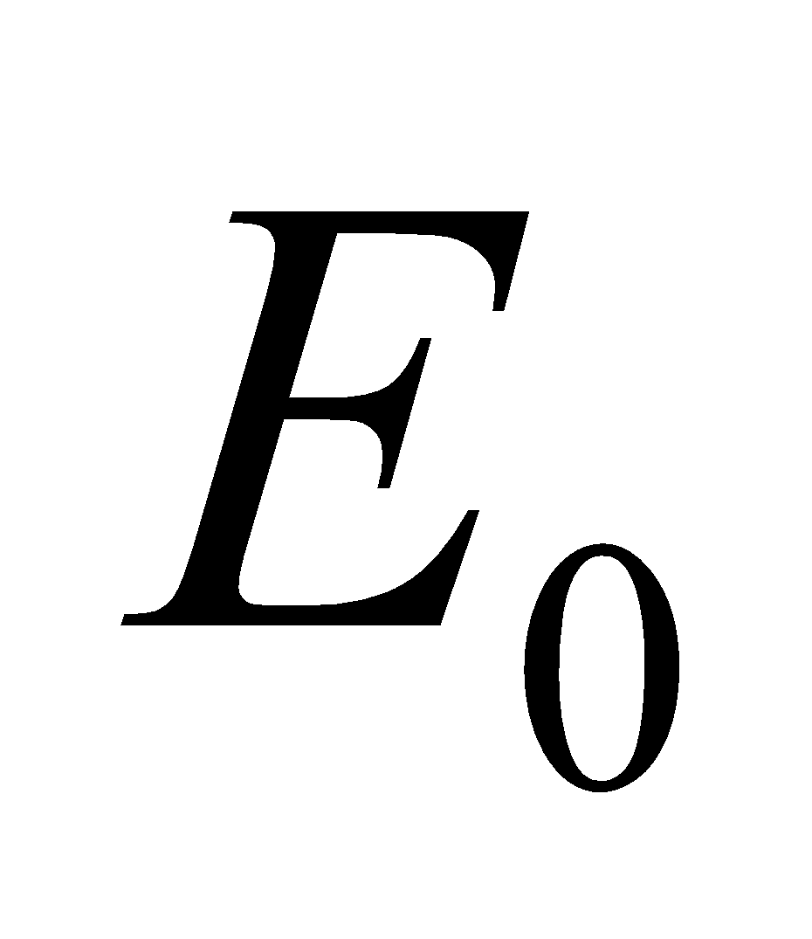 and 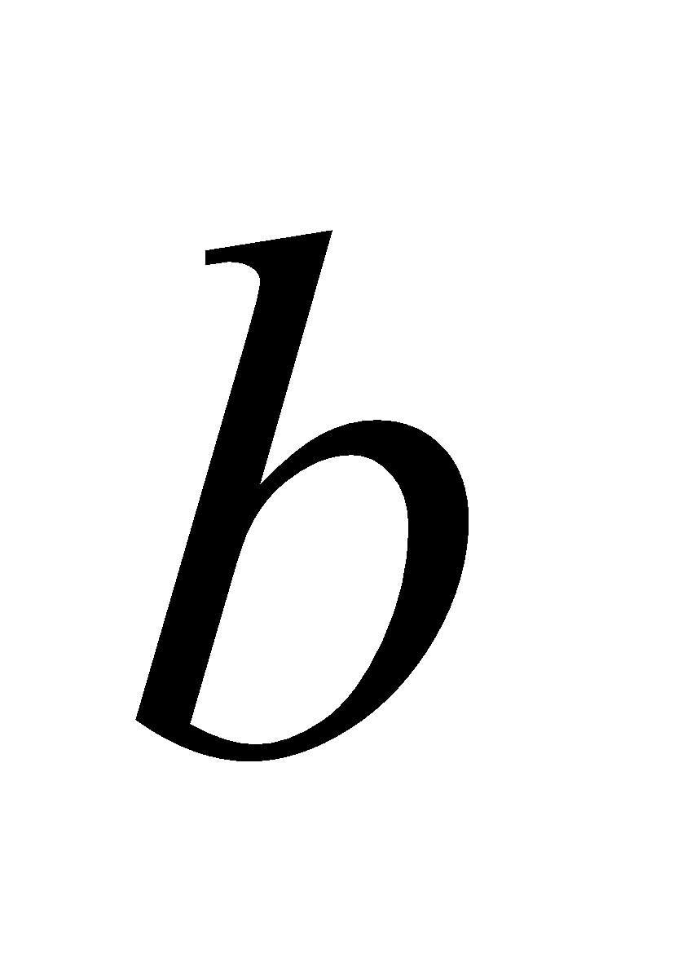 are constants with units of electric field and distance, respectively. It was shown in the text that particles entering the device from below will only emerge from the horizontal outlet if their speed satisfies:

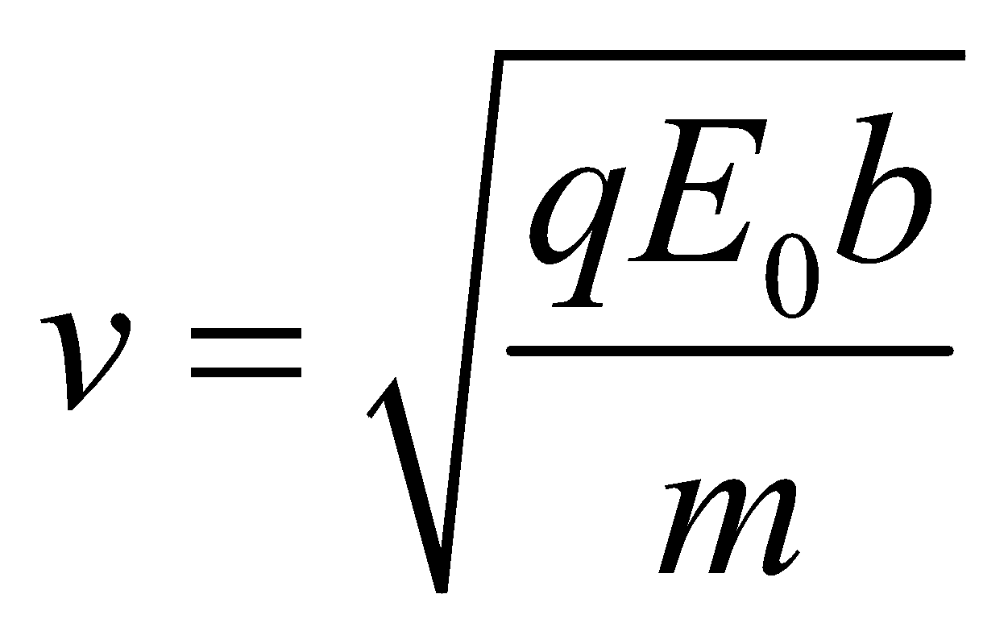

If you equate this speed with the speed from the accelerating field, you find that the charge-to-mass ratio cancels out. This means there's no discrimination between isotopes. If one type of isotope can emerge, then they all can. The device doesn't work.

**Assess** The problem with this device is that both the accelerating field and the curving field depend on the charge-to-mass ratio in the same way. One way to get around this is to accelerate the isotopes by heating them to high temperature. The speeds in this case won't depend on the charge. Another way is to use a magnetic field to curve the path of the isotopes. In this case, the charge-to-mass ratio doesn't cancel out, as we'll see in Example 26.2.

**58. Interpret** The problem asks us to find the electric field near a strand of DNA.

**Develop** We're looking for the electric field at a distance, 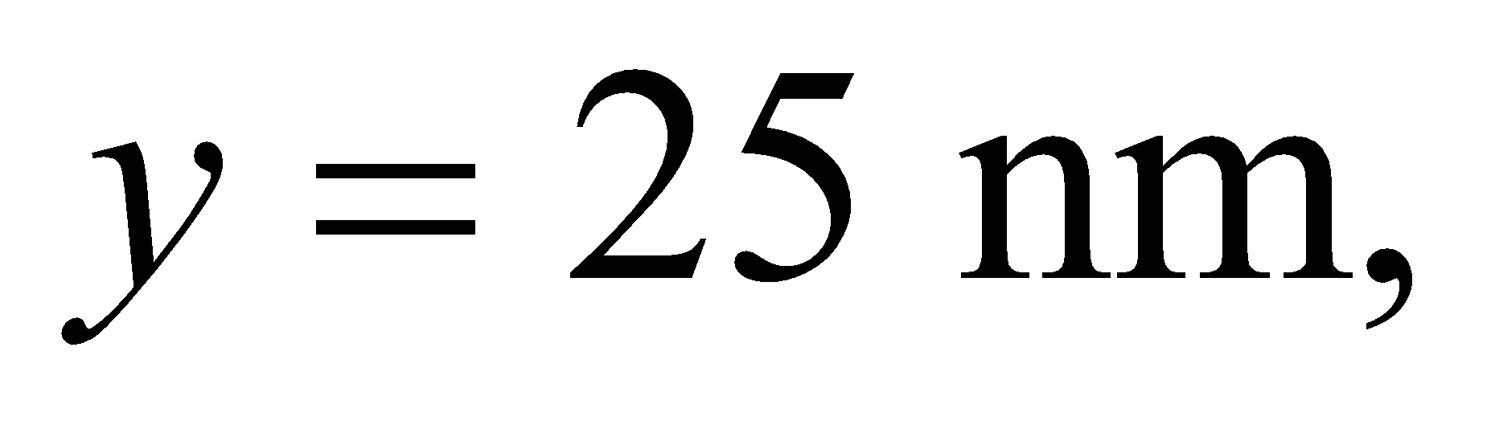from a strand of DNA that has length, 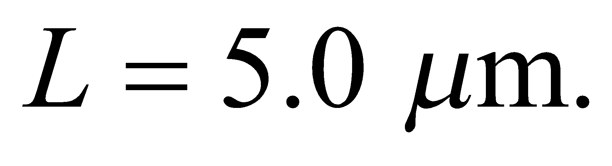 Since the point we're considering is not near either end of the strand and since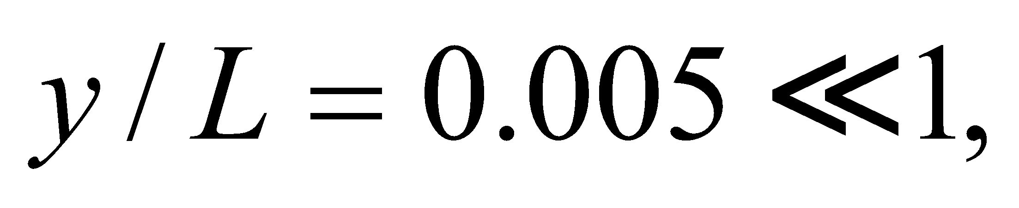the situation is approximately the same as for an infinite wire. In Example 20.7, it was shown that the electric field at a distance *y* from an infinite wire has magnitude 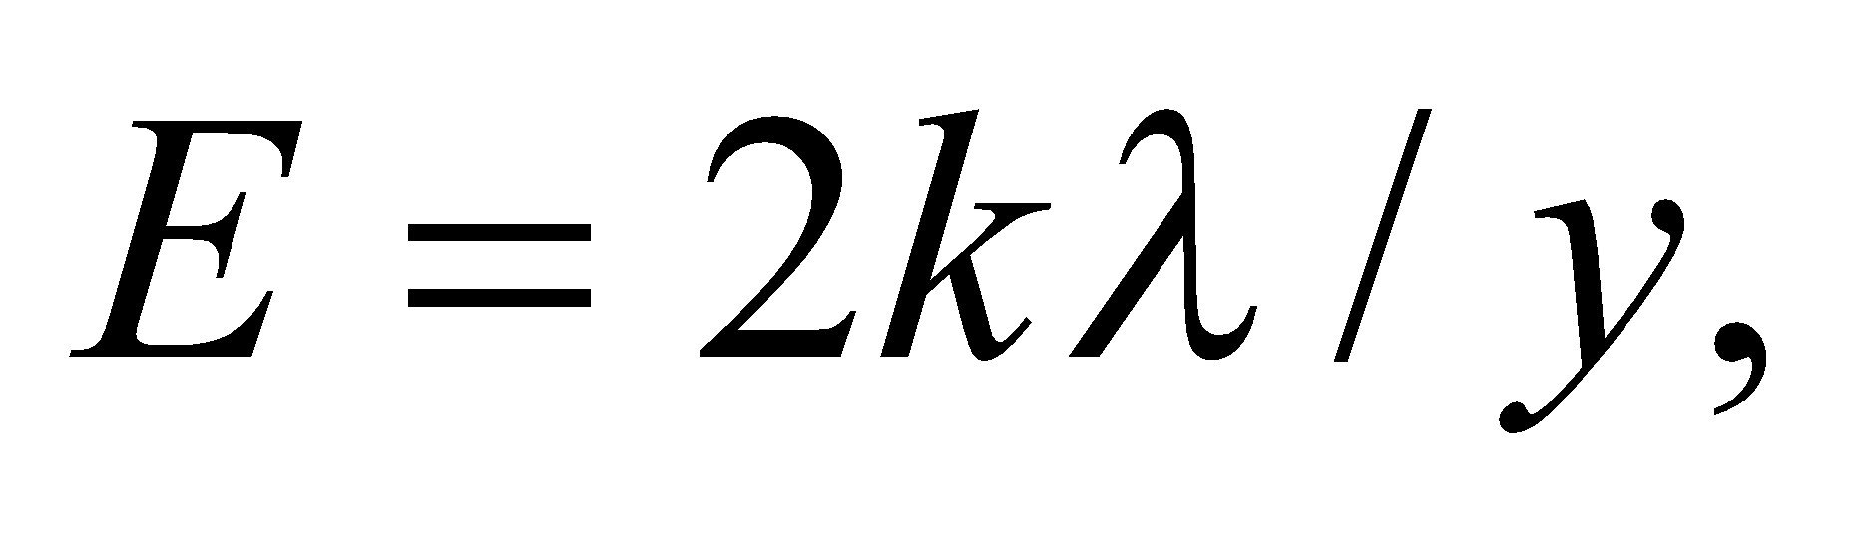where 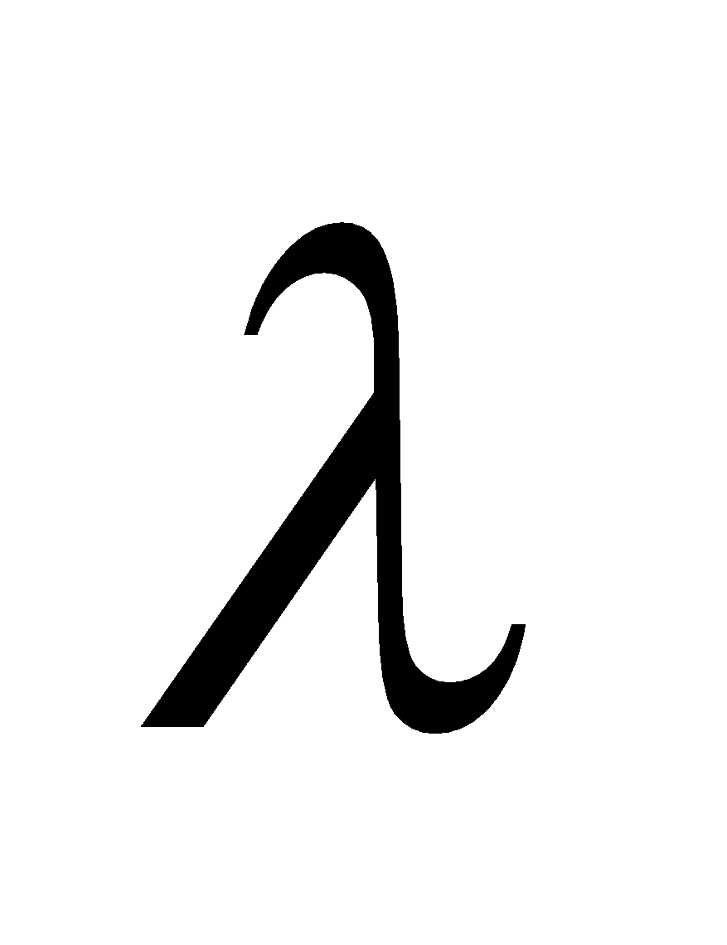 is the charge per unit length.

**Evaluate** We're told that the DNA carries 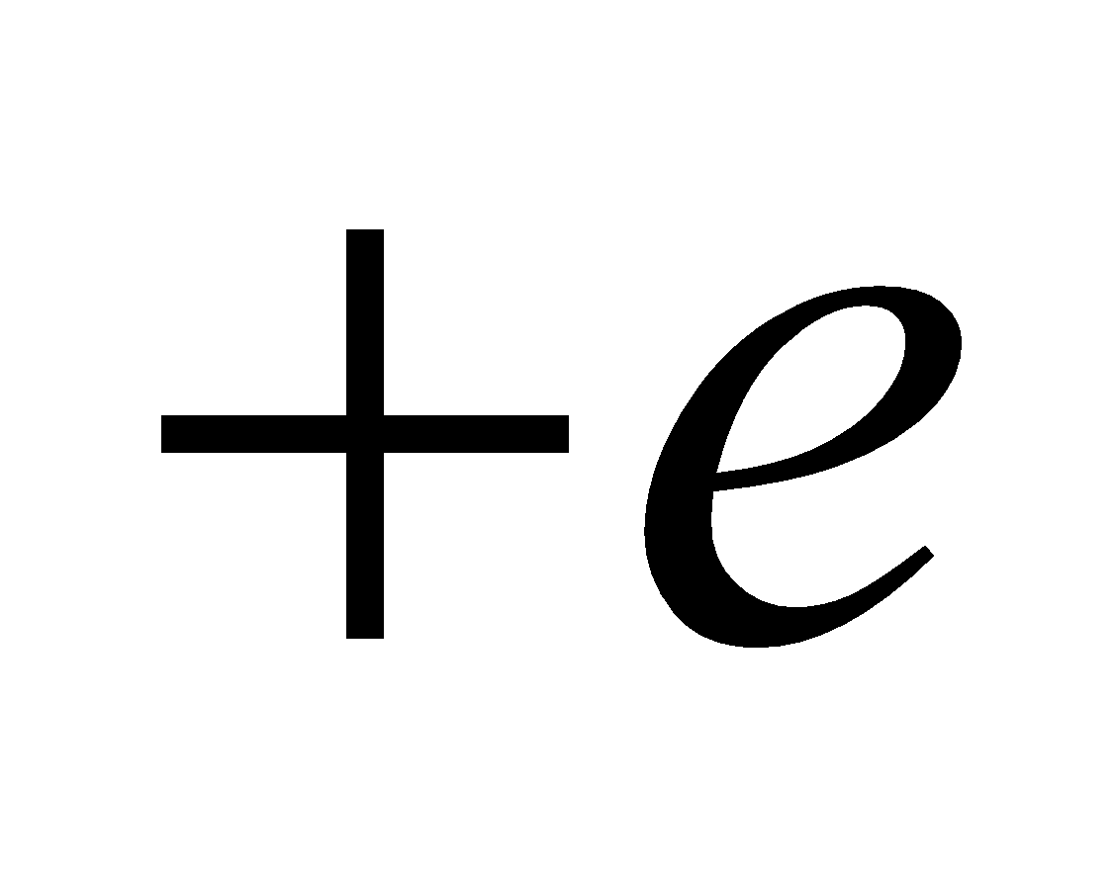of charge for every nm of length, so 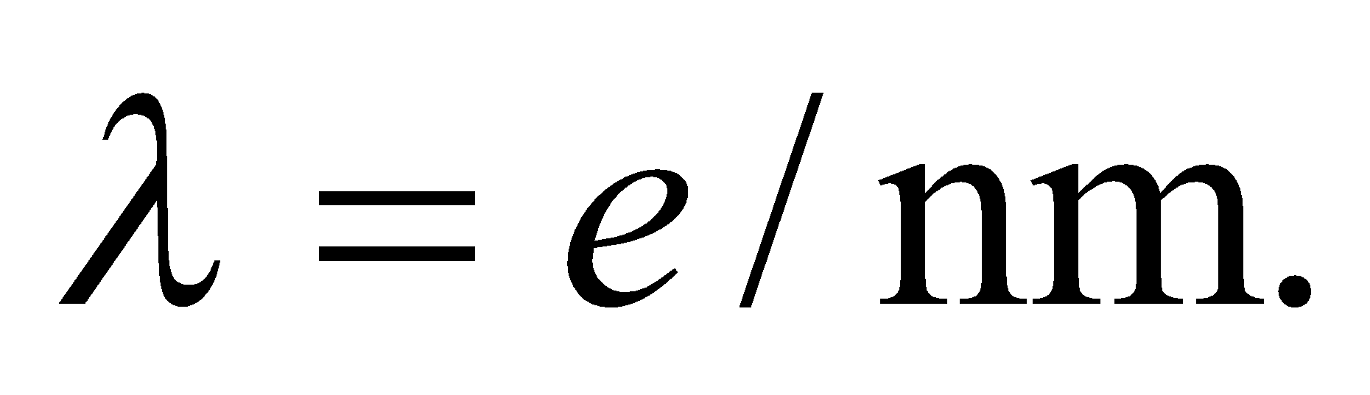Using the above formula:

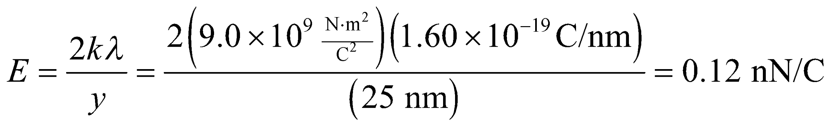

**Assess** Since the charge per unit length is positive, the electric field will point outward from the DNA strand, as in Figure 20.17. The actual field will deviate from this picture near either end. But we often can get away with treating a wire or a sheet as infinite, as long as we only consider points that are short distances away.

**59. Interpret** The charge orbiting the wire undergoes circular motion, and the centripetal force (Chapter 3) is provided by the Coulomb force. We are asked to find the line charge density, given the particle’s orbital speed. This problem is similar to Problem 20.56.

**Develop** The electric field of the wire is radial and falls off like  see Example 20.7). For an attractive force (positive charge encircling a negatively charged wire), this is the same dependence as the centripetal acceleration (Equation 3.9, *a*c = *v*2/*r*). For circular motion around the wire, the Coulomb force provides the centripetal acceleration. Thus, Newton’s second law gives

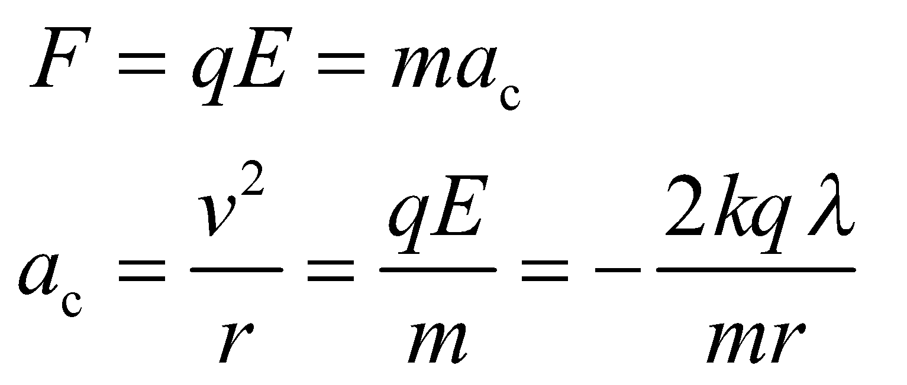

The equation can be used to deduce the line charge density *λ* give the speed.

**Evaluate** The above equation gives

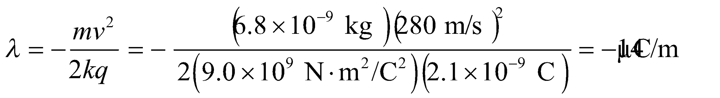

**Assess** For the force to be attractive, the line charge density must be negative.

**60.** **Interpret** For this problem, we are to find the torque on the given dipole placed at 30° with respect to a linear electric field (similar to what is shown in Figure 20.20). We are also to find the work done by the electric field in orienting the dipole so that it is antiparallel to the field.

**Develop** The torque on the dipole is given by Equation 20.9,

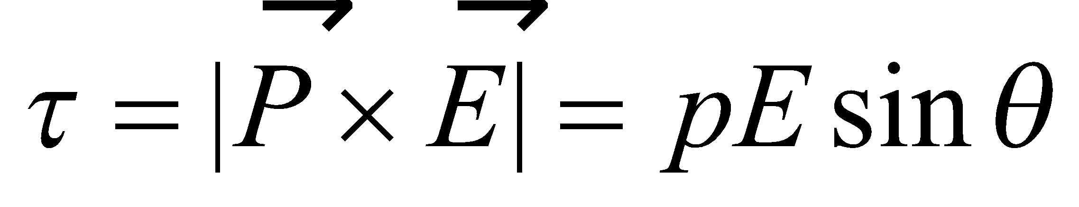

The work done in orienting the dipole antiparallel to the field is the change in the potential energy from the initial to the final states, where the potential energy of a dipole in an electric field is given by Equation 20.10. Thus,

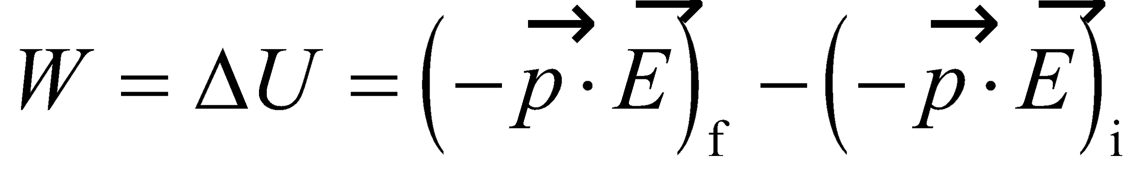

**Evaluate** (**a**) Evaluating the expression for torque gives



(**b**) Evaluating the expression for work gives



**Assess** When the dipole is oriented antiparallel to the field, the torque is also zero, but this is an unstable equilibrium because the slightest perturbation will allow the dipole to reverse its orientation in the electric field.

**61. Interpret** This problem is about an electric dipole aligned with an external electric field. We are to find the dipole moment given the electric field and the amount of work needed to reverse the dipole’s orientation.

**Develop** Using Equation 20.10, the energy required to reverse the orientation of such a dipole is



**Evaluate** Using the equation above, the electric dipole moment is

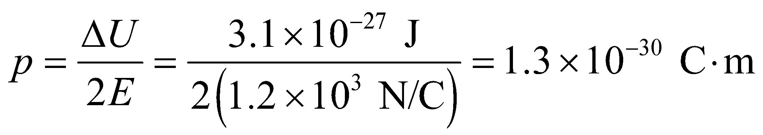

**Assess** An electric dipole tends to align itself in the direction of the external electric field. Thus, energy is required to change its orientation.

**62.** **Interpret** This problem involves 4 source charges, arranged as two dipoles. The dipoles are oriented parallel and on the same line. We are to find the expression for the force between the two dipoles, so Coulomb’s law and the principle of superposition will apply.

**Develop** Make a sketch of the situation (see figure below). The right-hand dipole has charges +*q* at *x* + *a*/2, −*q* at *x* − *a*/2, each of which experiences a force from both charges of the left-hand dipole, which are +*q* at *a*/2 and −*q* at −*a*/2. The Coulomb force on a charge in the right-hand dipole due to a charge in the left-hand dipole is

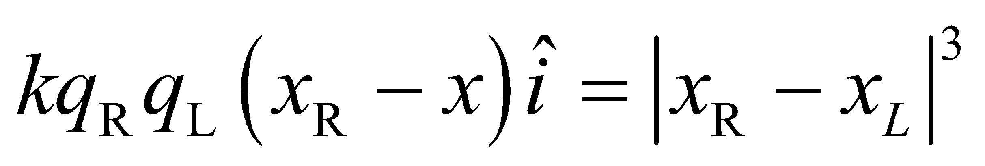

(see solution to Problem 15), so the total force on the right-hand dipole is

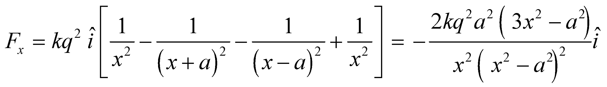

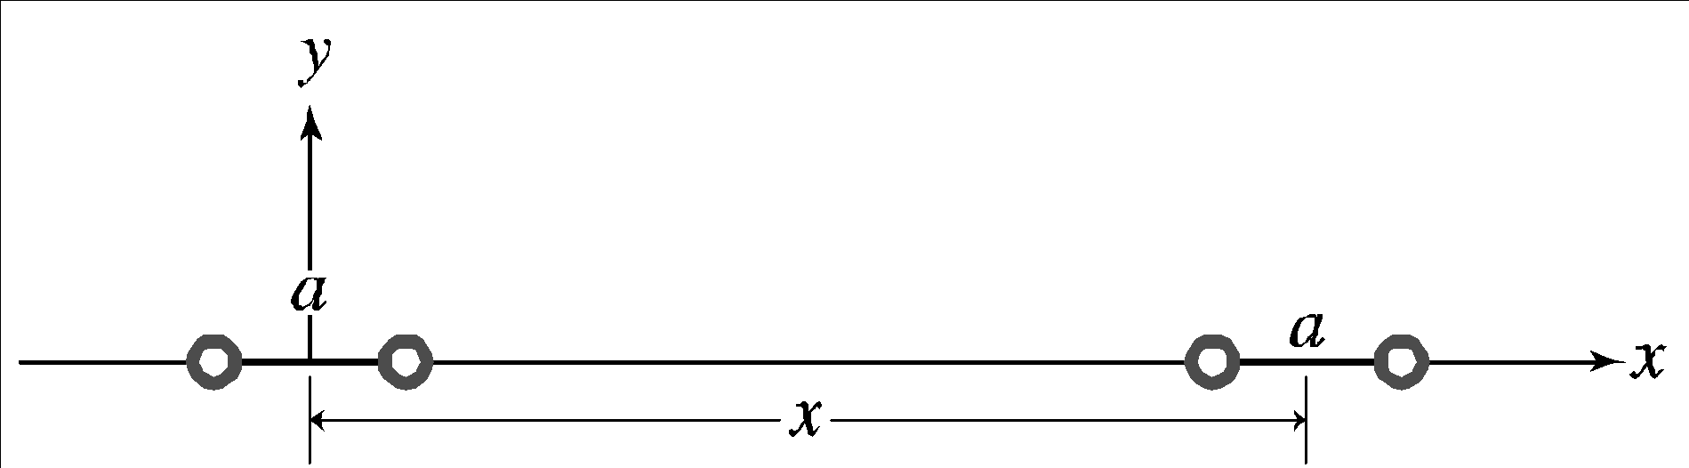

**Evaluate** **(a)** In the limit 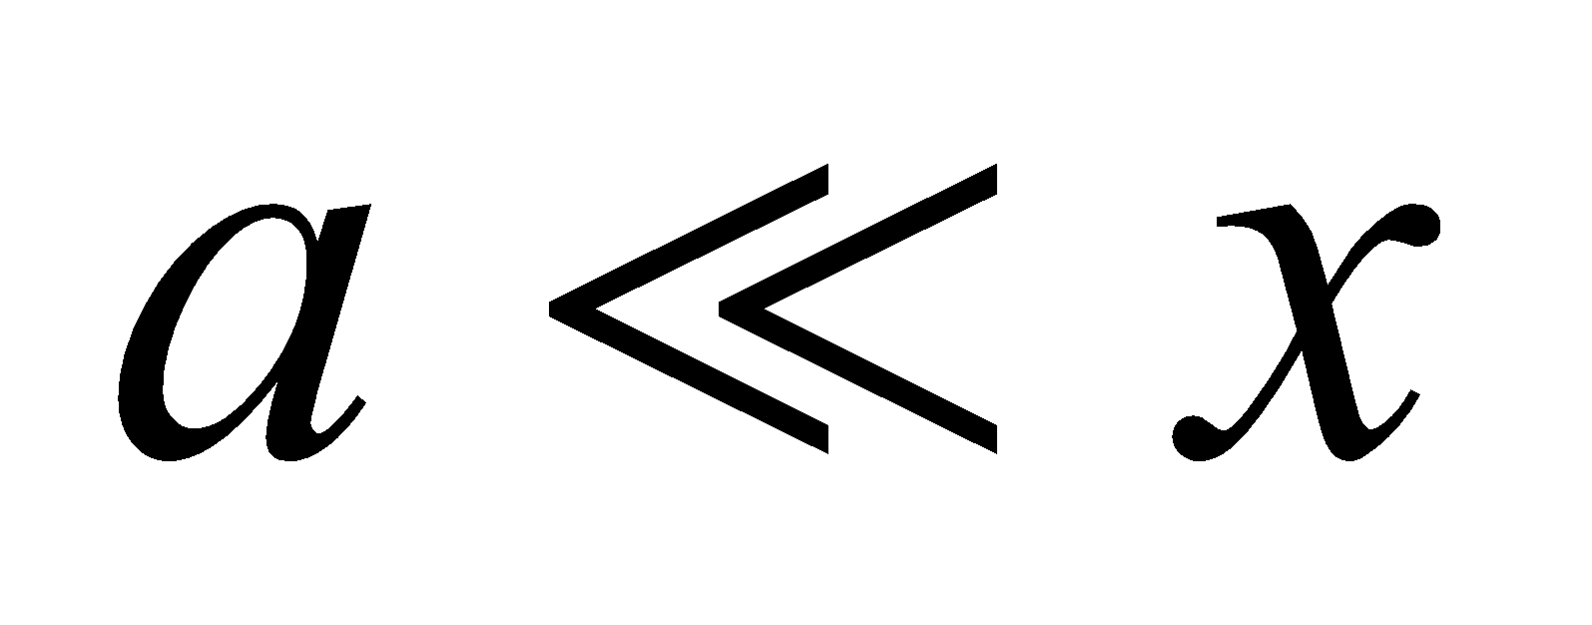

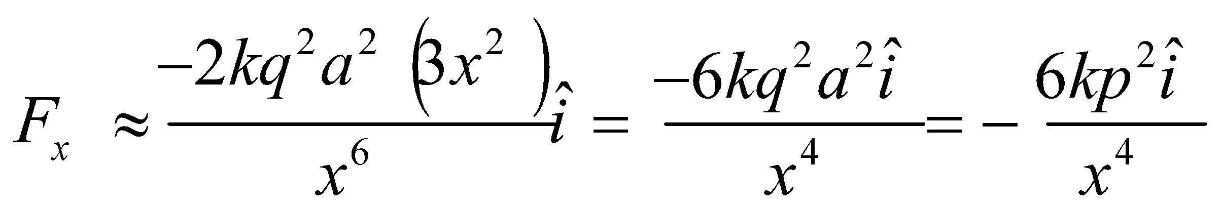

where *p* = *qa* is the dipole moment of both dipoles.

**(b)** The force on the right-hand dipole is in the negative *x* direction, indicating an attractive force.

**Assess** By Newton’s third law, each dipole experiences a force of equal magnitude but in the opposite direction.

**63. Interpret** This problem is about the interaction between a dipole and the electric field due to a source charge.

**Develop** With the *x* axis in the direction from *Q* to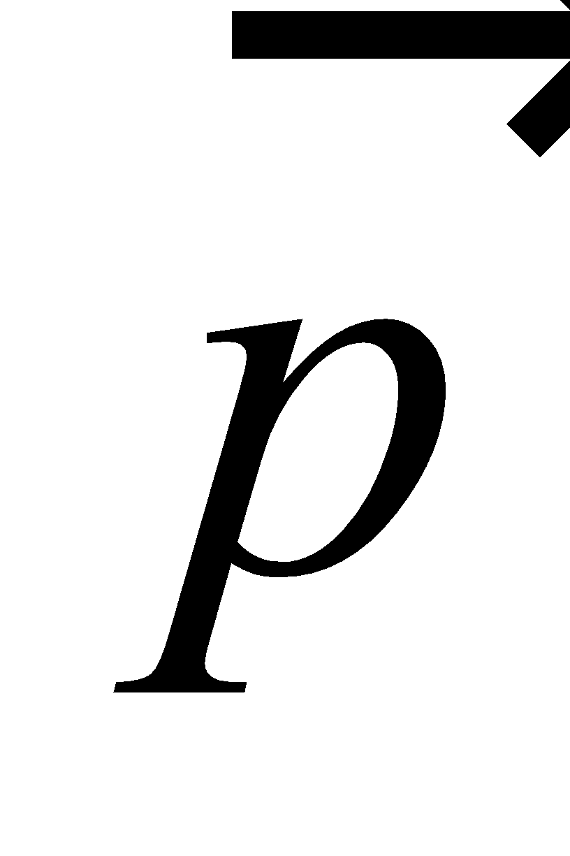and the *y* axis parallel to the dipole in Figure 20.30, we have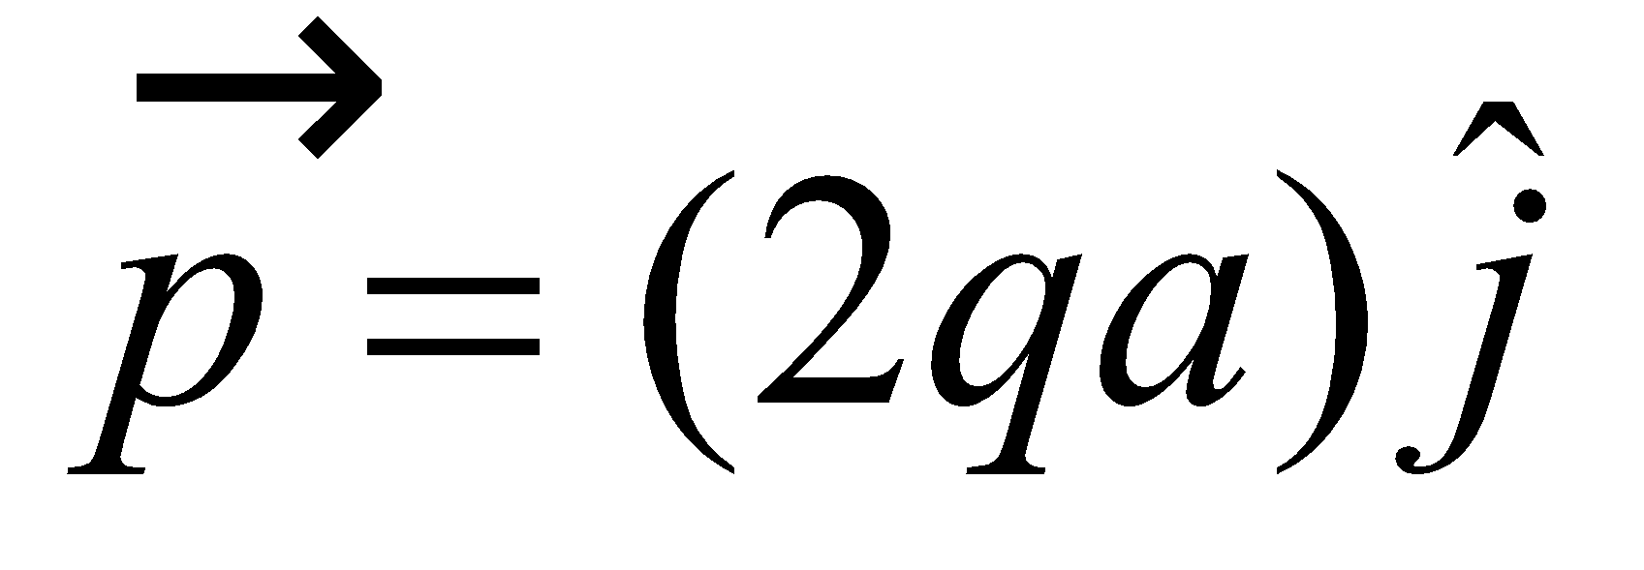and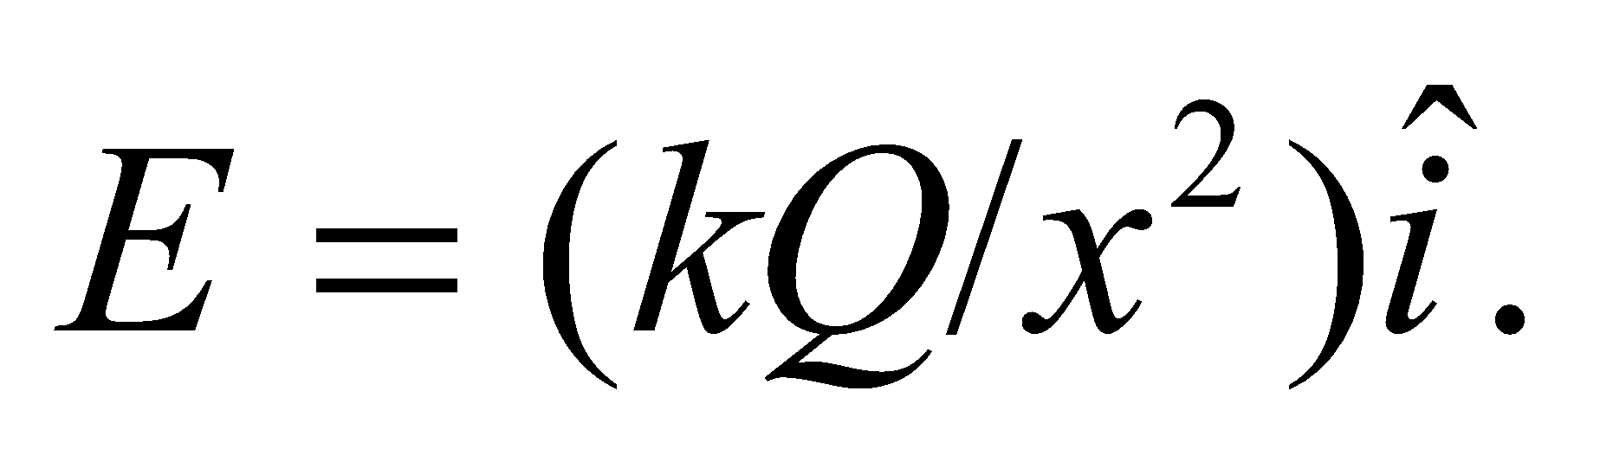In the limit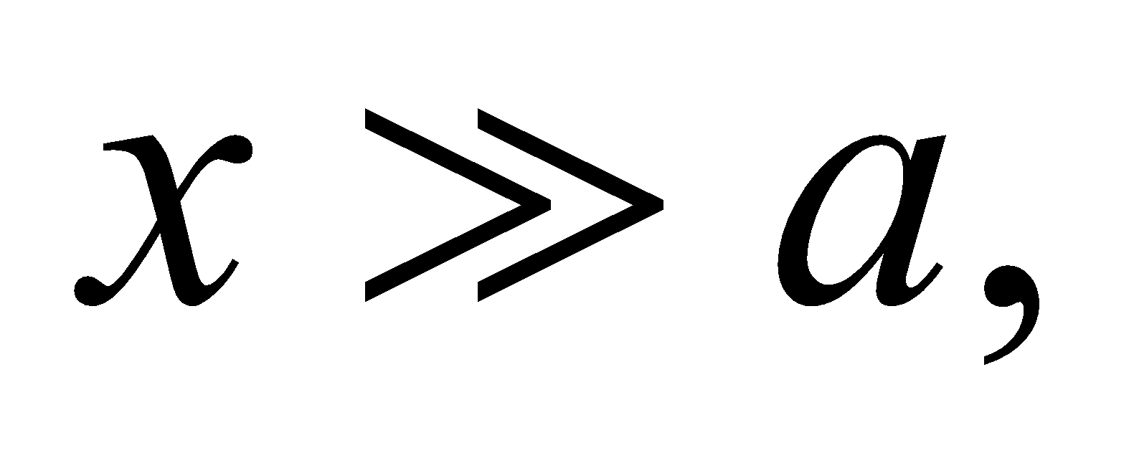the torque on the dipole is given by Equation 20.9,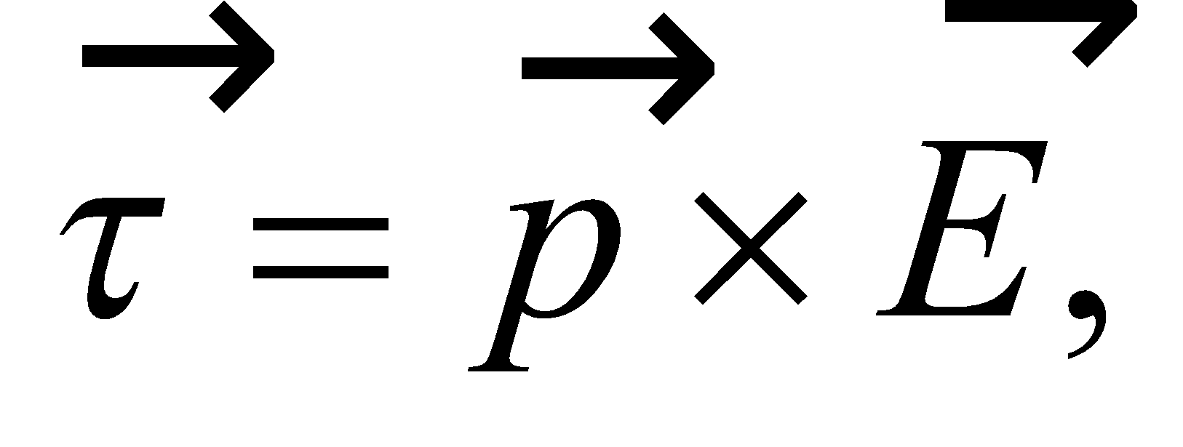 where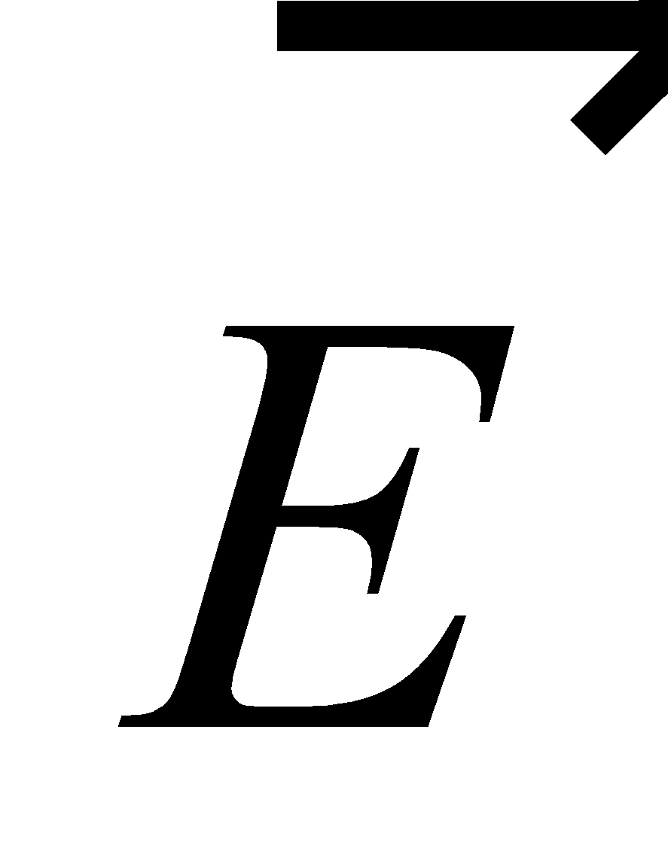is the field from the point charge *Q*, at the position of the dipole.

**Evaluate** **(a)** Using Equation 20.9, we find the torque to be

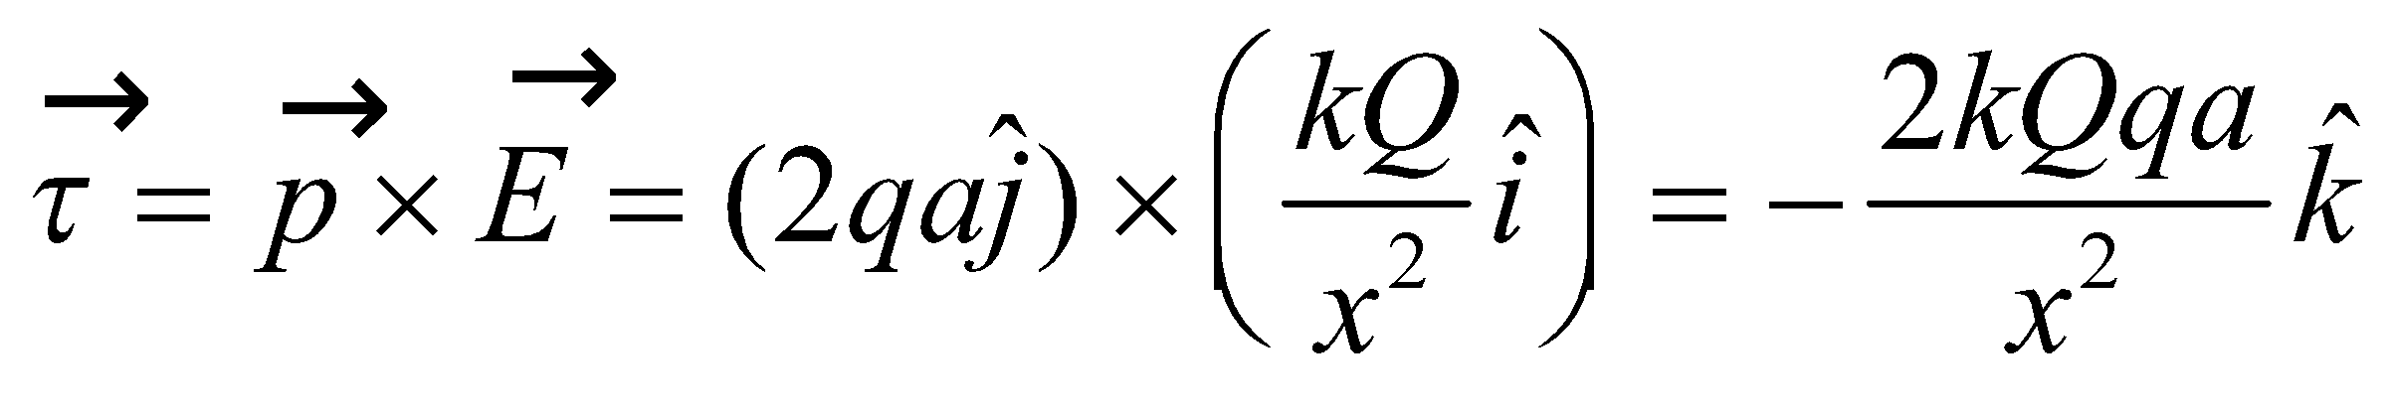

The direction is into the page, or clockwise, to alignwith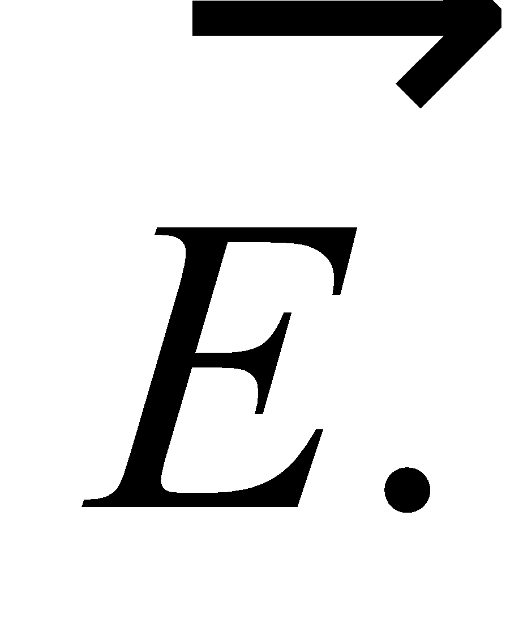

**(b)** The Coulomb force obeys Newton’s third law. The field of the dipole at the position of *Q* is (Example 20.5 adapted to new axes)

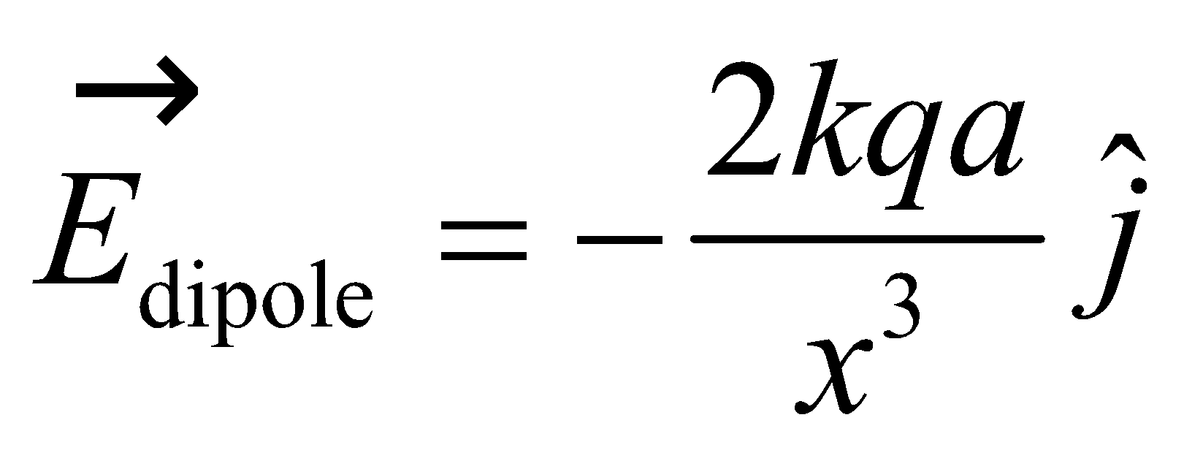

Thus, the force on *Q* due to the dipole is

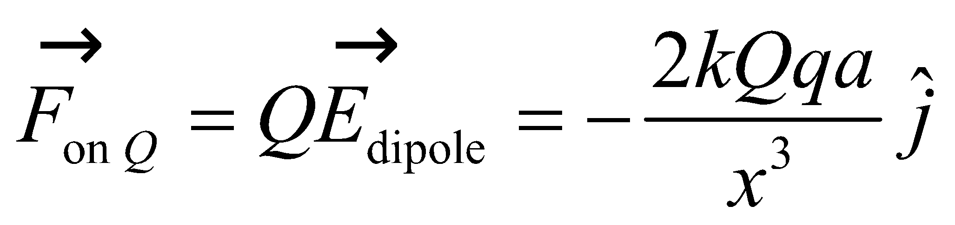

The force on the dipole due to *Q* is the opposite of this:

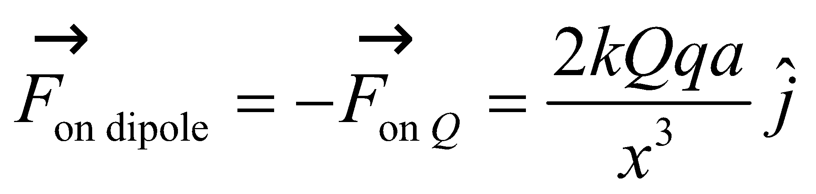

The magnitude of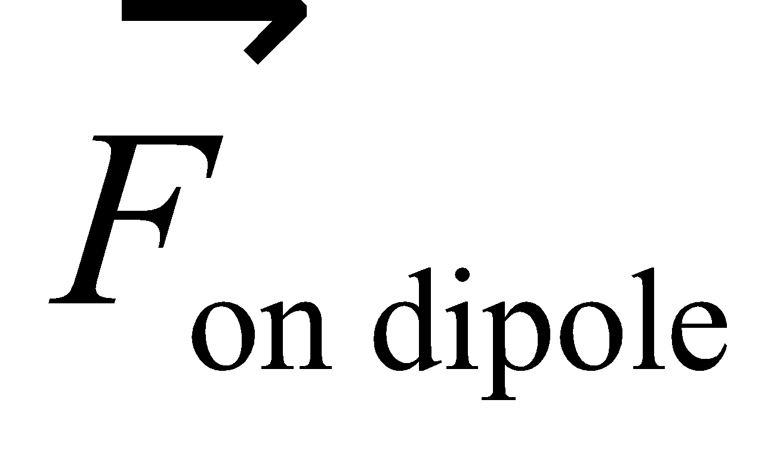is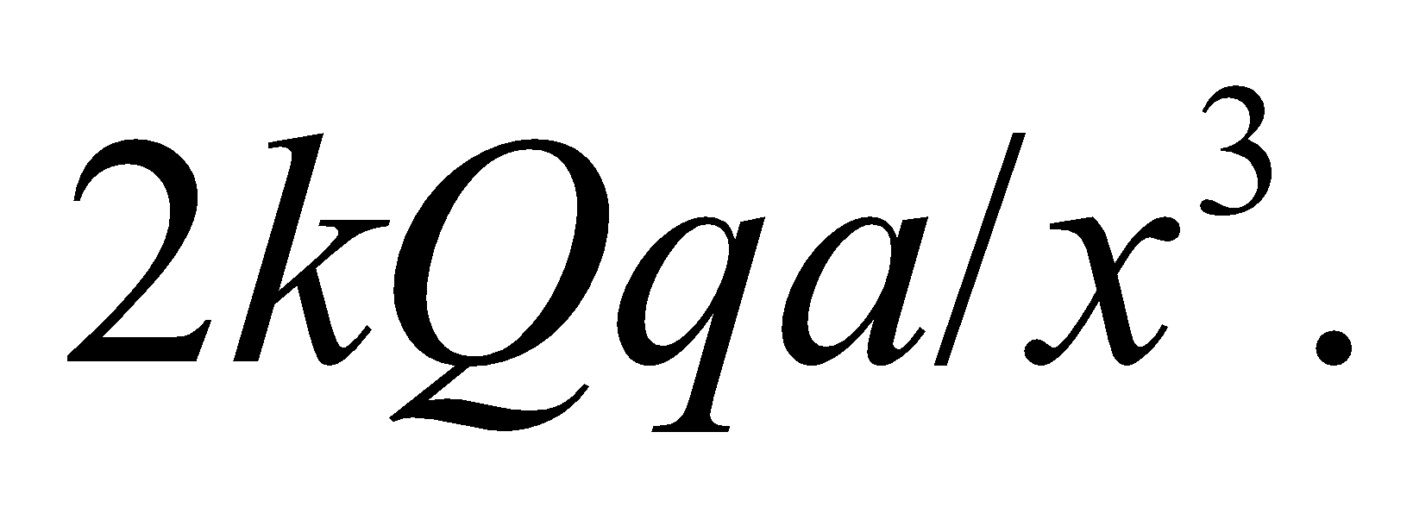

**(c)** The direction ofis in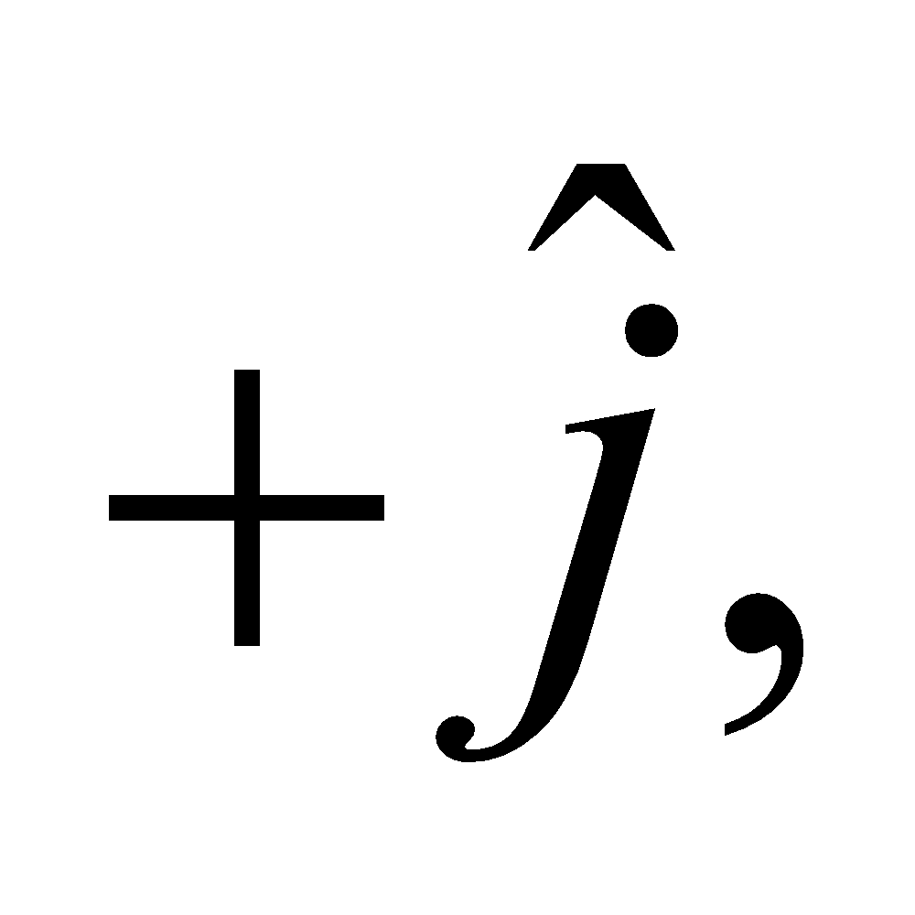or parallel to the dipole moment.

**Assess** The net forcewill cause the dipole to move in the 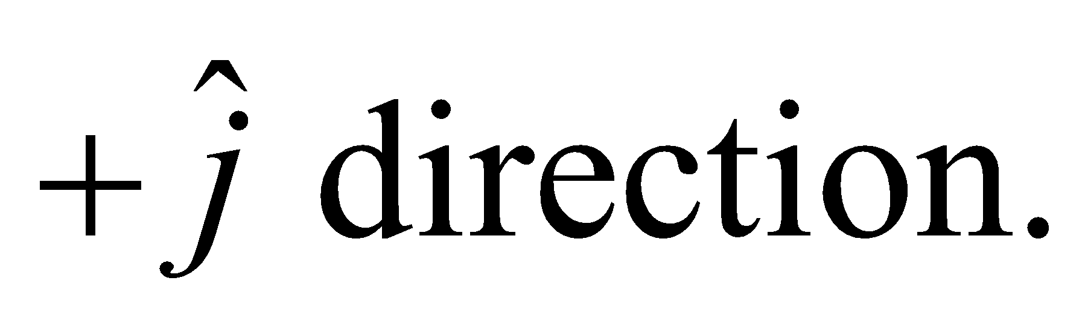In addition, there is a torque that tends to align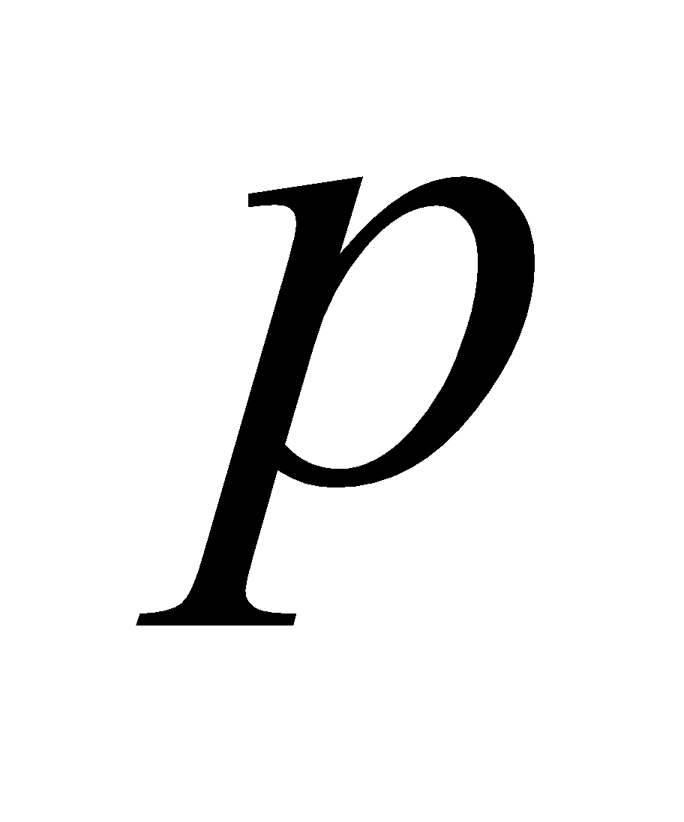with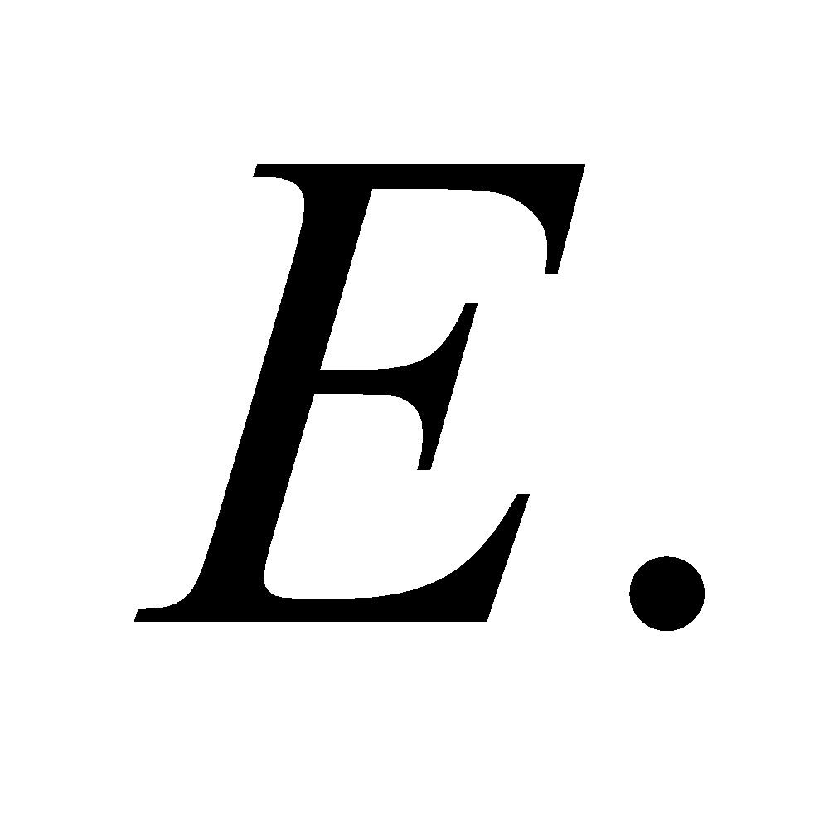So, the motion of the dipole involves both translation and rotation.

**64. Interpret** This problem gives the position of two source charges, and we are to find a position at which the electric field is zero.

**Develop** The electron’s field is directed toward the electron (a negative charge) and the ion’s field is directed away from the ion (a positive charge). Therefore, the fields can cancel only at points on the negative *x* axis (*x* < 0) since the directions are opposite and the smaller charge is closer. The field from a point charge is

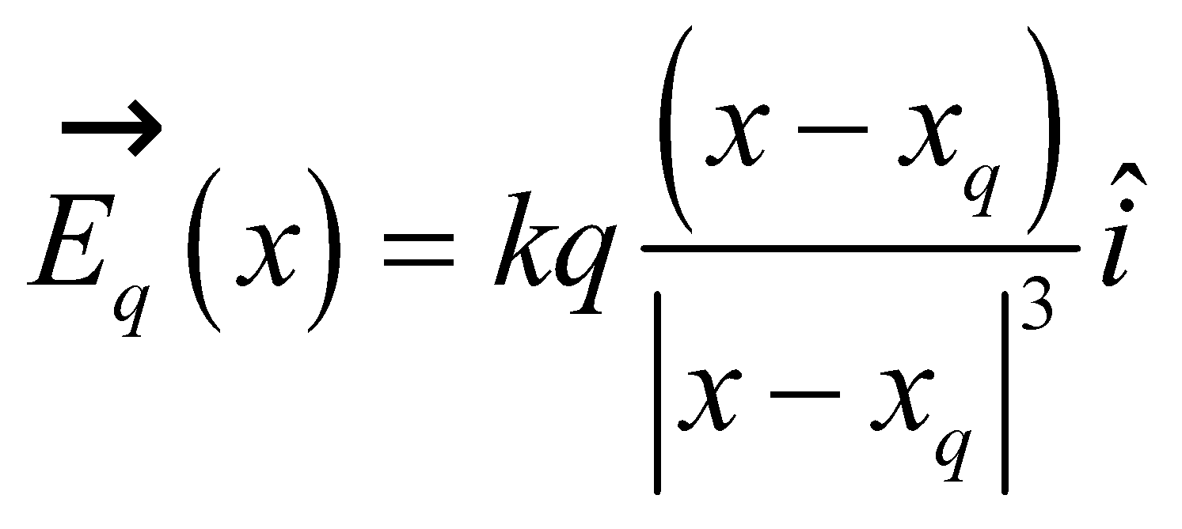

where *q* = −*e* and *xq* = 0 for the electron, and *q* = 5*e* and *xq* = 10 nm for the ion. Setting the total field to zero gives

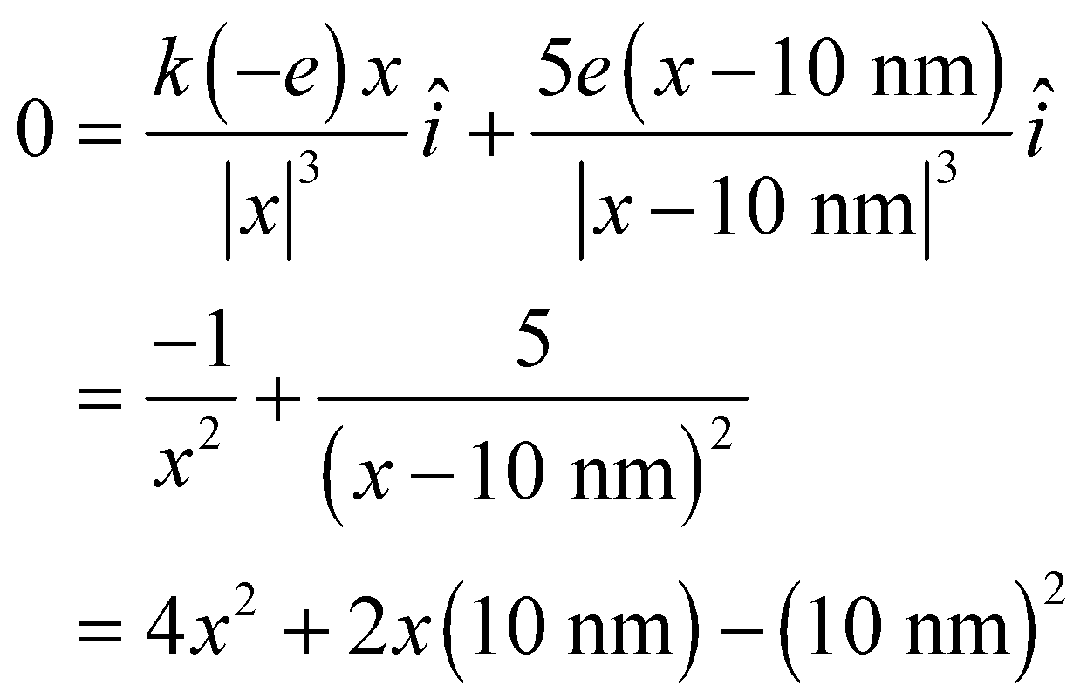

which we can solve for *x*.

**Evaluate** The negative solution to this quadratic is

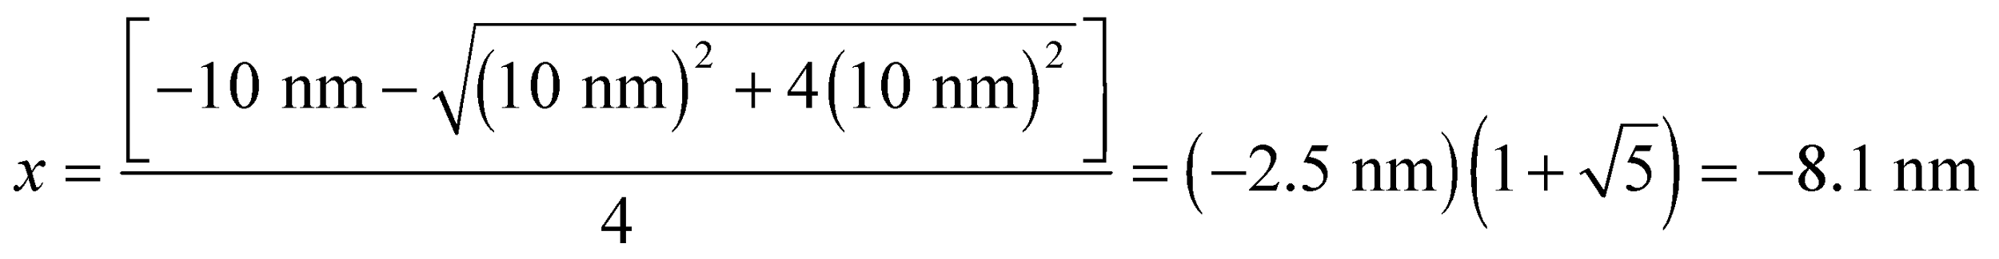

**Assess** Thus, if we label the distance between the two charges as *a*, the field goes to zero not far from −*a* from the smaller charge.

**65. Interpret** You're asked to estimate the charge distribution on two different molecules given their dipole moments.

**Develop** Your given the dipole moment, *p*, for H2O and CO in debyes. A debye (D) is a unit with dimensions of "charge" times "distance." You can look in an outside reference and see that 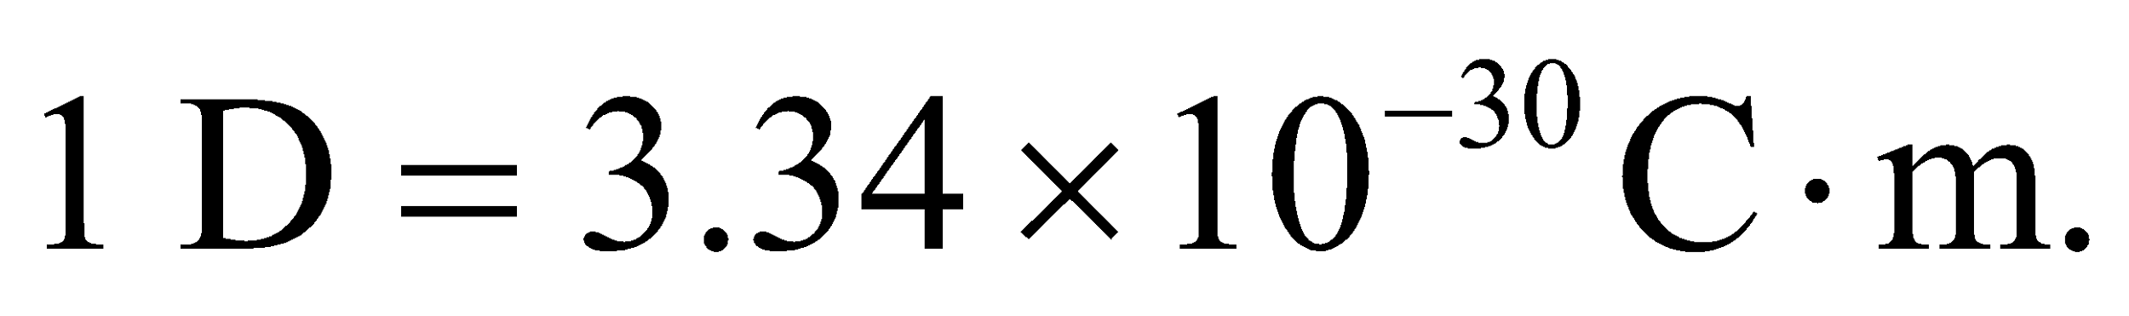 You can model these dipole molecules as two opposite charges, 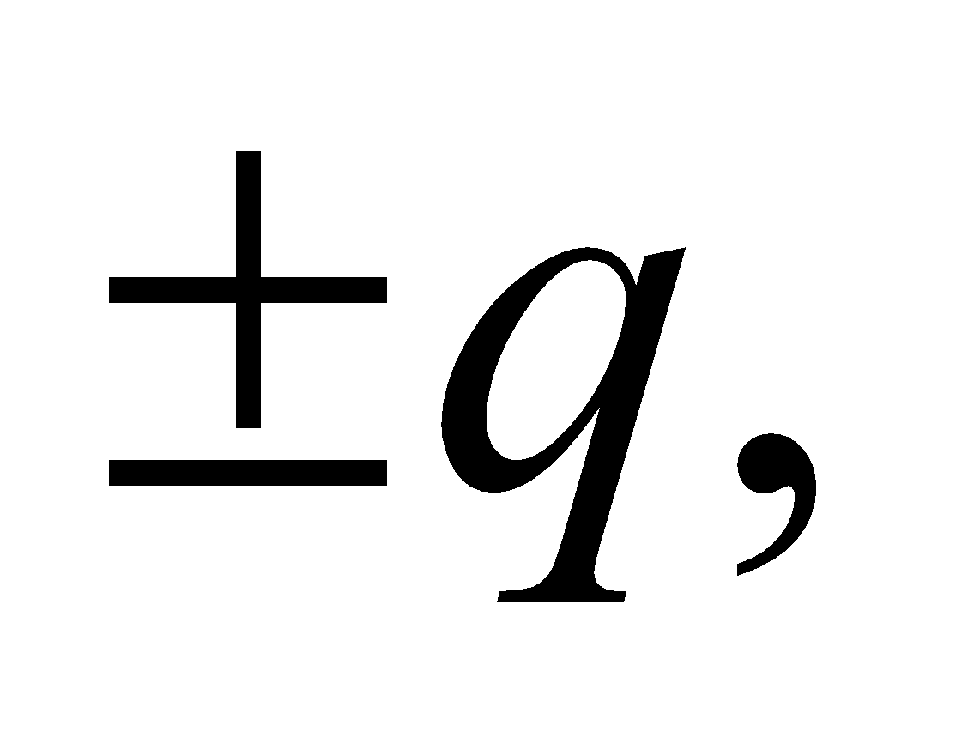 separated by a distance *d*. Since the atomic separation for many molecules is about an Angstrom 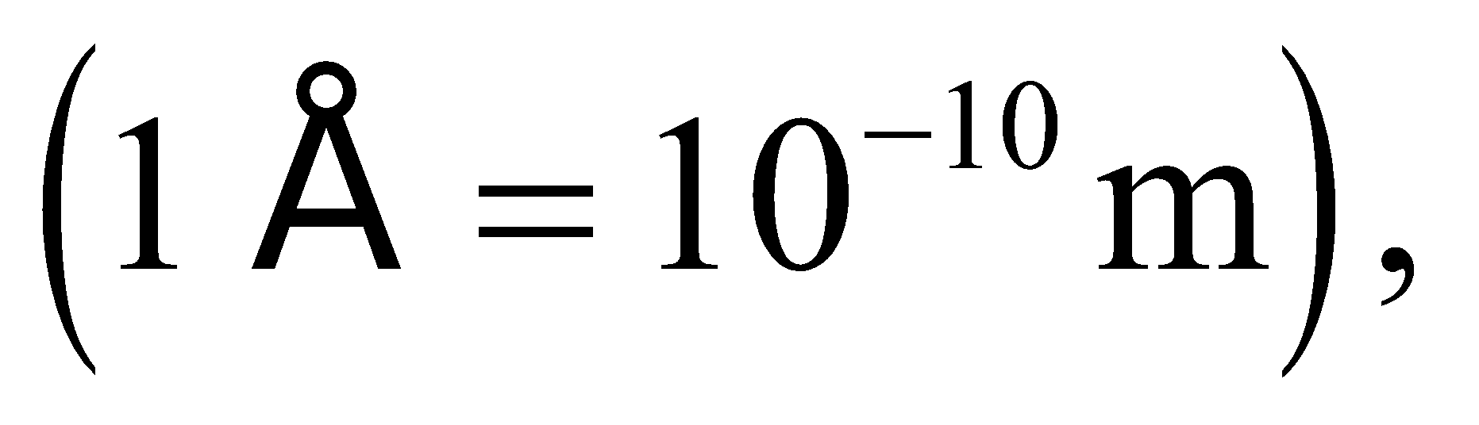we can estimate how the charge is distributed on each molecule: 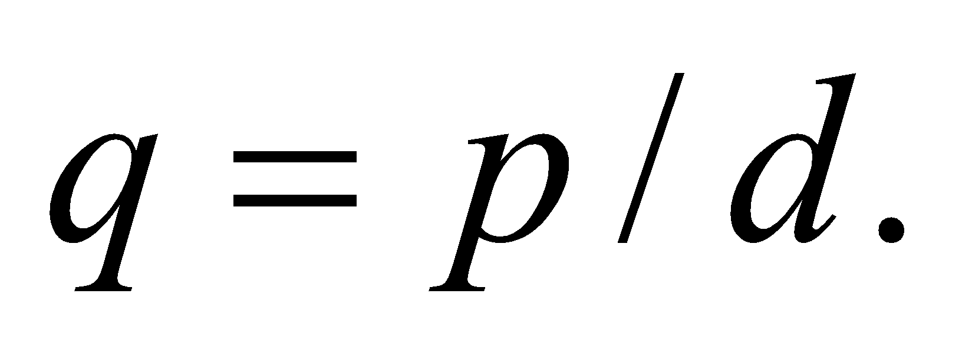

**Evaluate** Let's first convert the dipole moments to SI units:

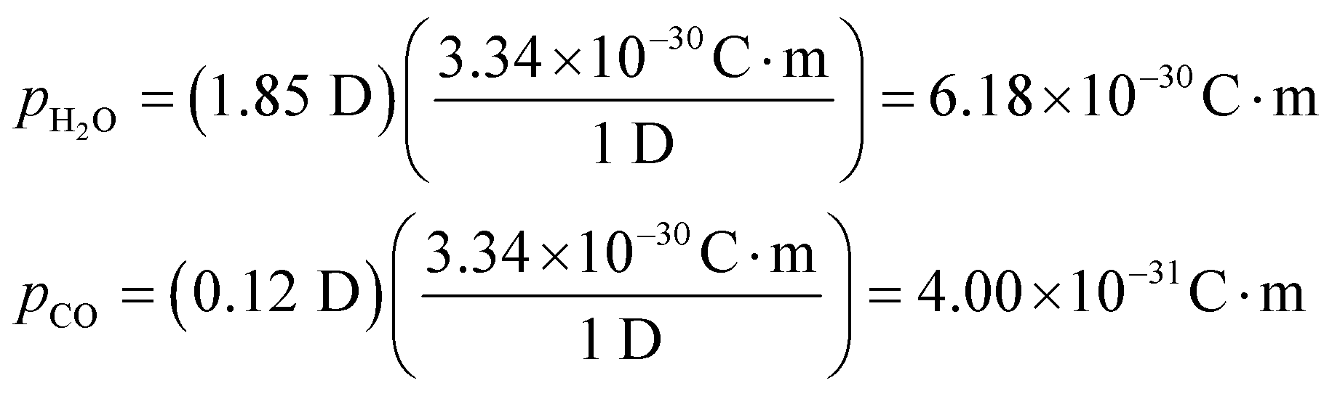

Assuming the atoms in the molecules are separated by about 1 Angstrom, the amount of charge on each "atom" is  
 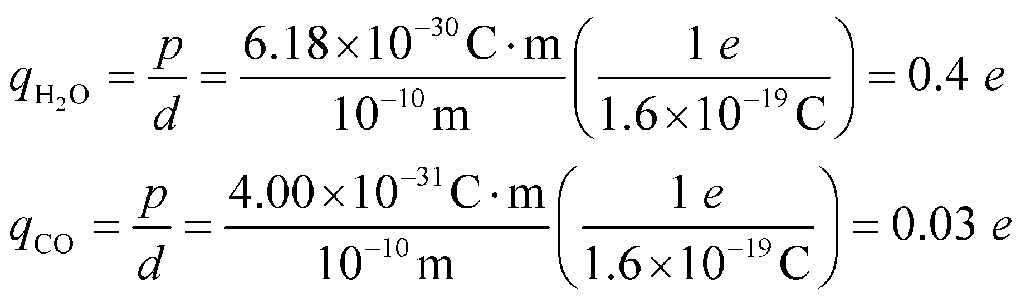

We've written the result in terms elementary charge.

**Assess** In the case of water, the oxygen atom partially "steals" the electrons from the hydrogen atoms. That results in a negative fractional charge 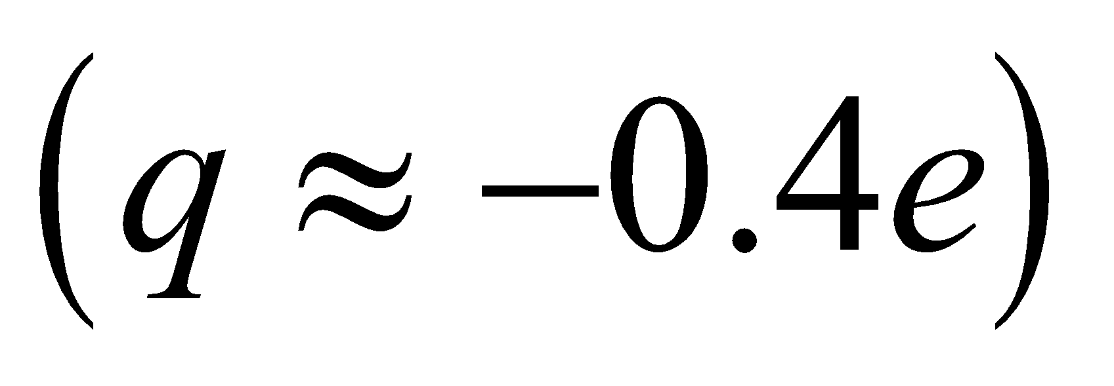on the oxygen atom, and a correspondingly positive fractional charge on the hydrogen atoms. A similar situation occurs with carbon monoxide, but this time the carbon atom is the more electrophilic ("electron-loving") species in the covalent bond, so it will have the negative fractional charge and the oxygen atom will have the positive one.

**66. Interpret** This problem is about the electric field due to a charged ring. We are to find the ring’s radius and the total charge on the ring, given the magnitude and direction of the electric field at two locations on the axis of the ring.

**Develop** The electric field on the axis of a uniformly charged ring of radius *a* is calculated in Example 20.6. The result is

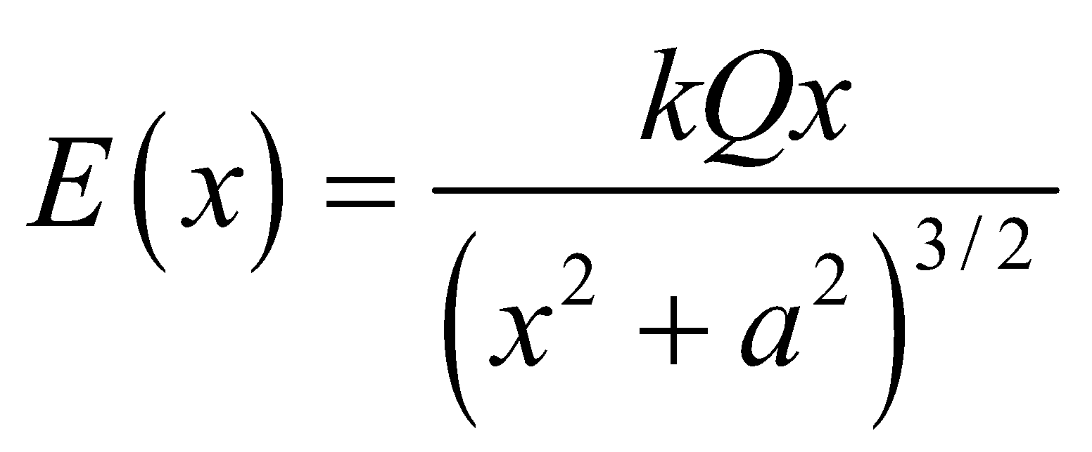

Knowing the field strengths at two different values of *x* allows us to deduce *a* and *Q*.

**Evaluate** (**a**) The data given in the problem statement imply

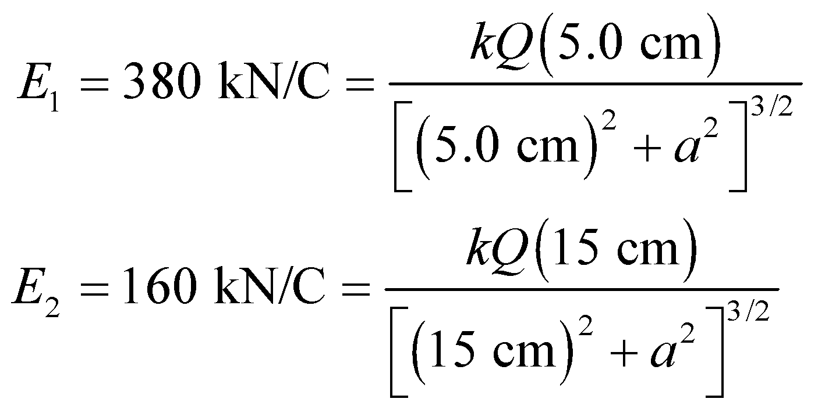

Dividing these two equations and taking the 2/3 root gives

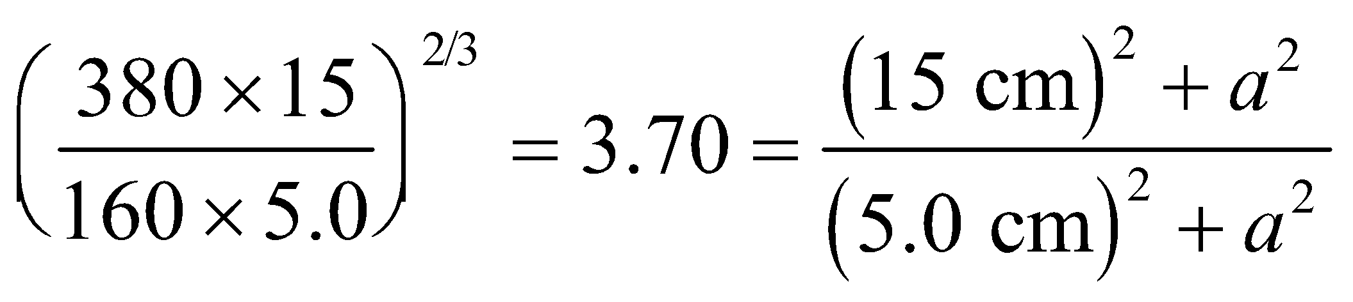

which, when solved for the radius *a*, gives

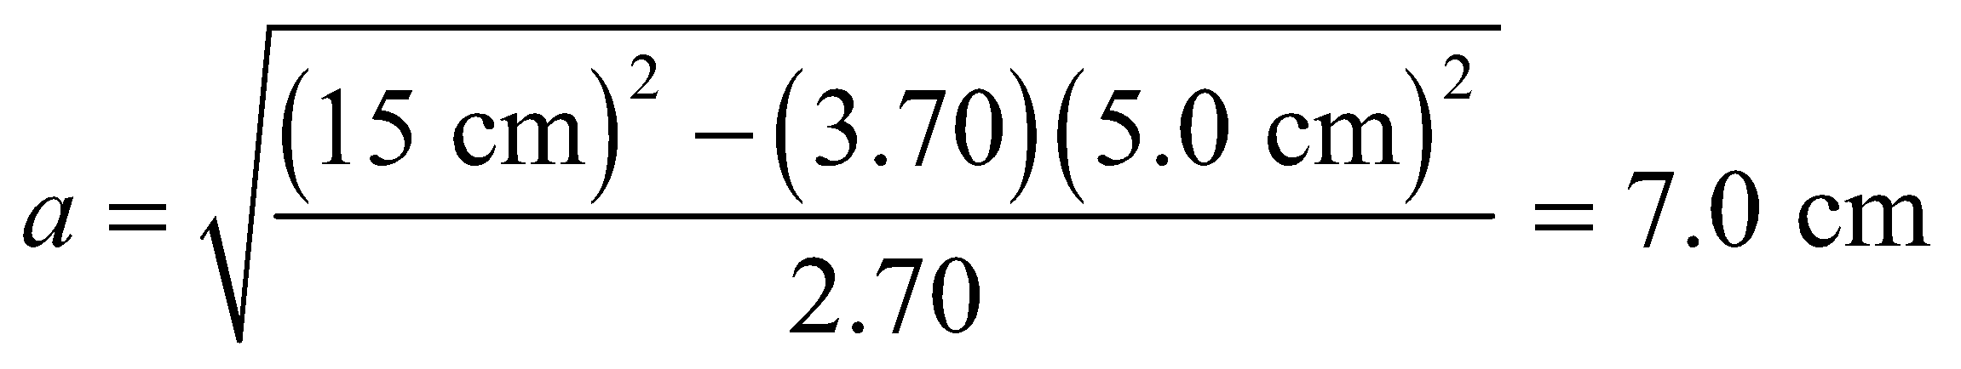

(**b**) To calculate *Q*, we substitute the result for *a* into either one of the field equations above. This leads to

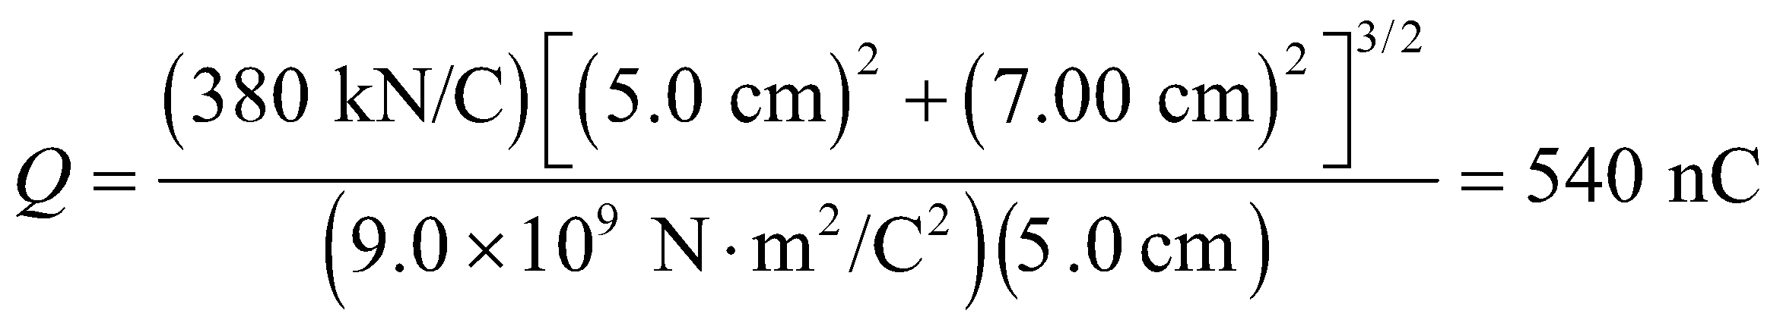

to two significant figures.

**Assess** To check that our results are correct, we may substitute the values obtained for *a* and *Q* into the field equation to calculate *E*1 and *E*2 at *r*1 = 5.0 cm and *r*2 = 15 cm. Note that the field strength decreases as *x* is increased. For example, the equation for E2 gives

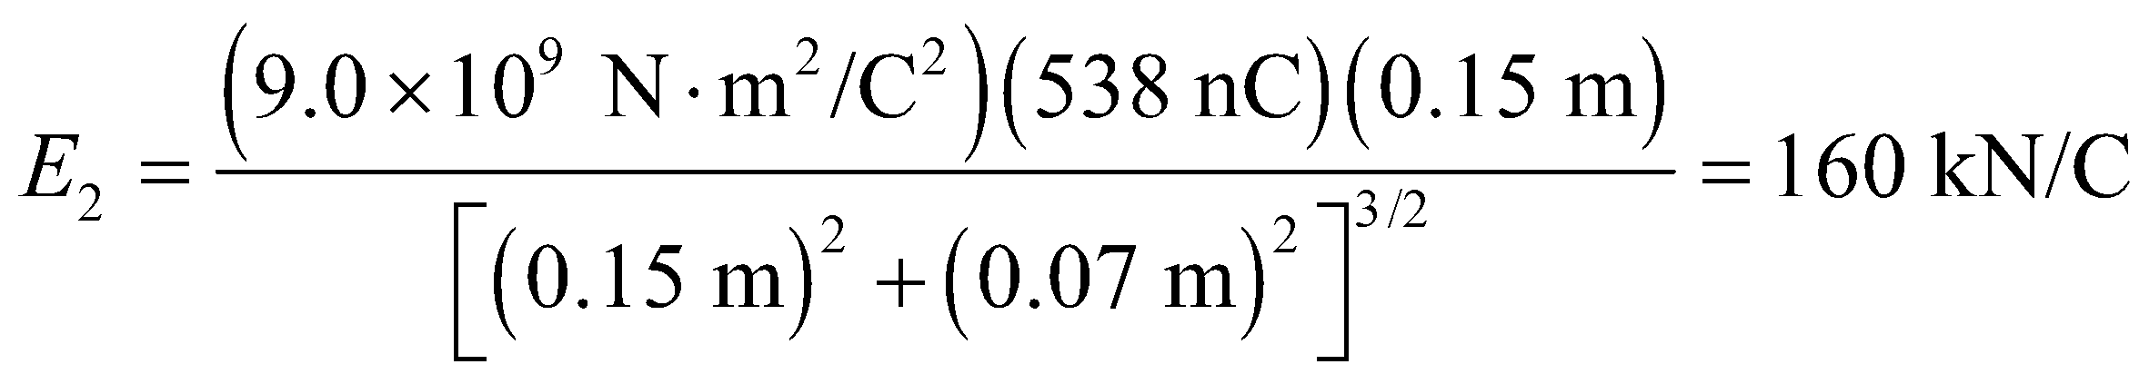

which agrees with the initial value.

**67. Interpret** This problem involves three source charges positioned on a line. We are to find the electric field on this line to the right of the right-most charge and show that this expression reduces to *κ*/*x*4 for *x*  *a*, where *κ* is a constant and *a* is the characteristic size of the source-charge distribution.

**Develop** The electric field of a single charge is give by Equation 20.3. Apply the principle of superposition to find the electric field due to three charges. This gives

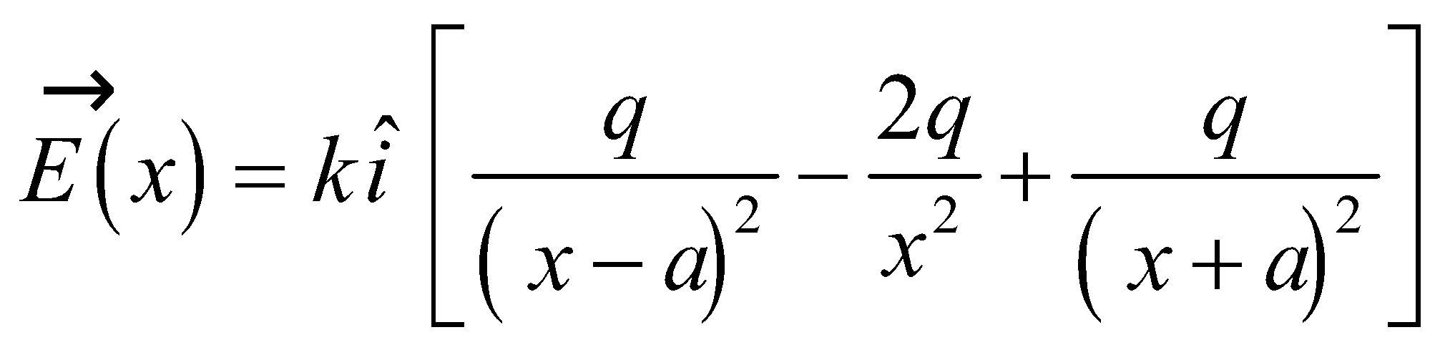

**Evaluate** (a) Simplifying the expression above for the electric field gives

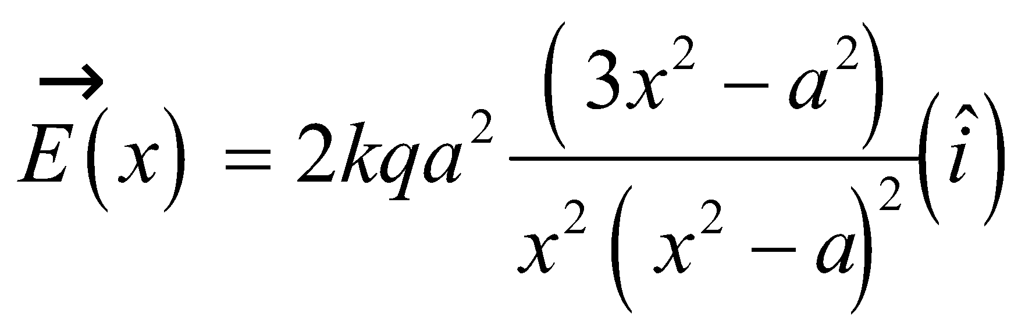

(b) For *x*  *a*, we can neglect the *a* compared to *x*2. This gives

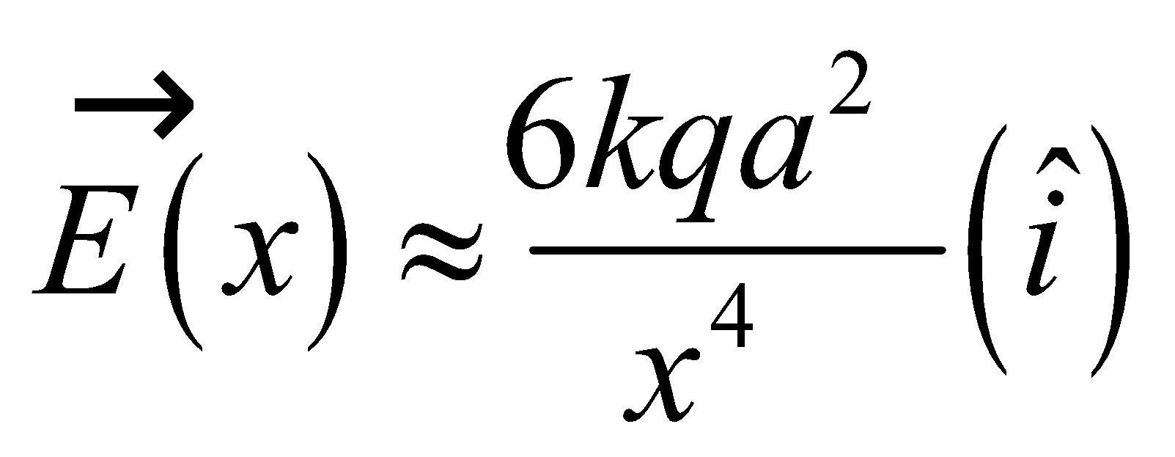

**Assess** The quadrupole moment of this “linear quadrupole” is 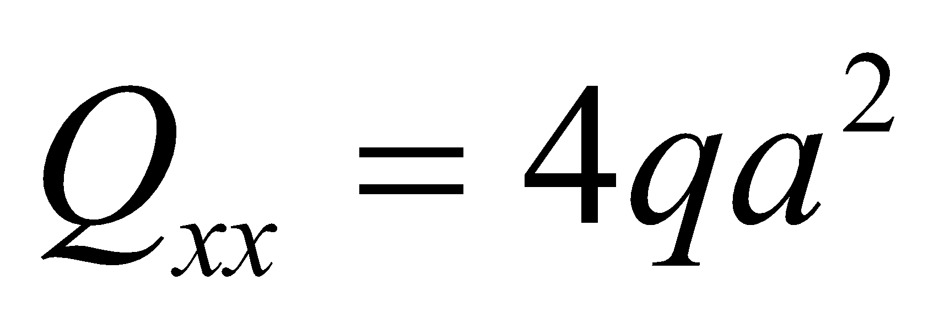.

**68. Interpret** We're asked to calculate the field from a dipole at a point located 45° from the dipole axis.

**Develop** We will place the dipole on the *x*-axis as in Example 20.5, with the 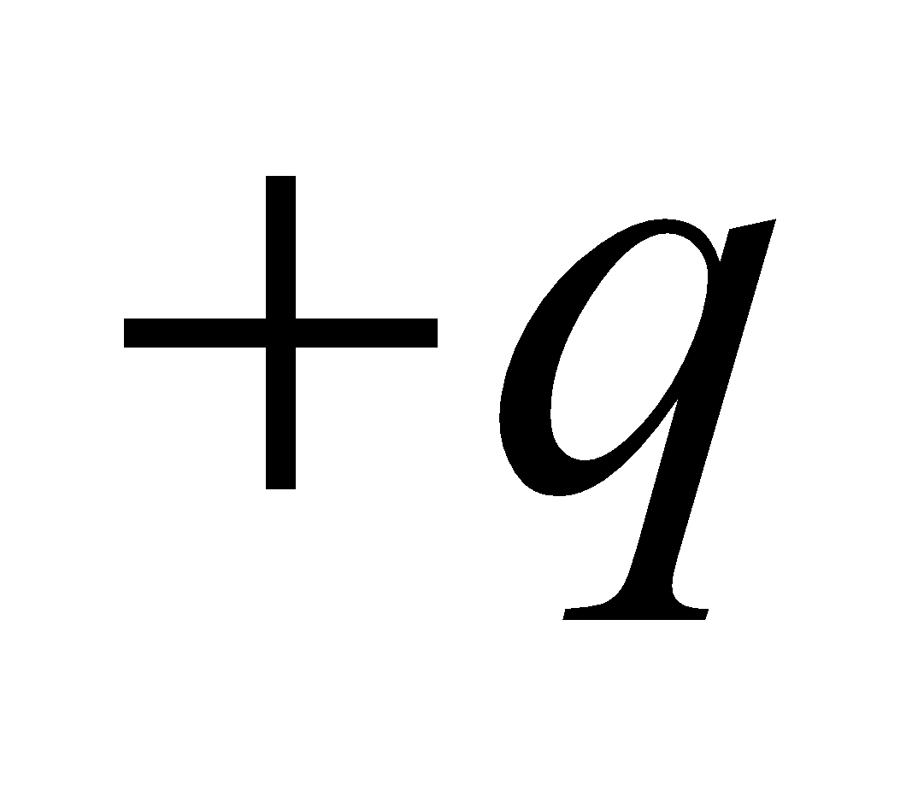charge at 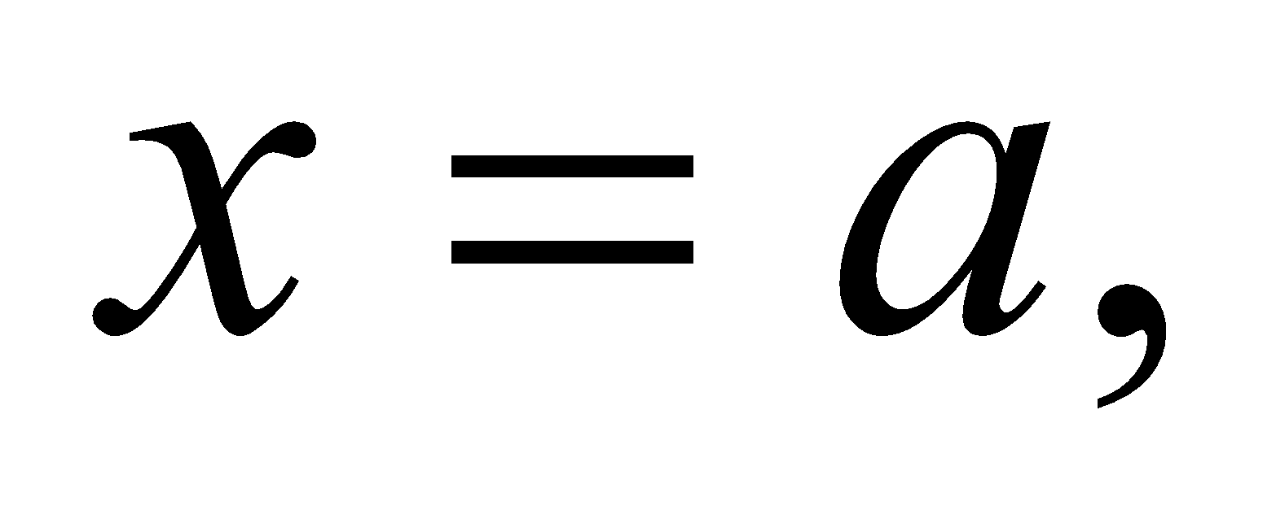 and the charge at 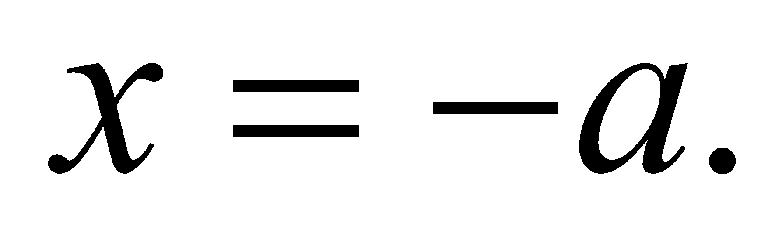 We identify 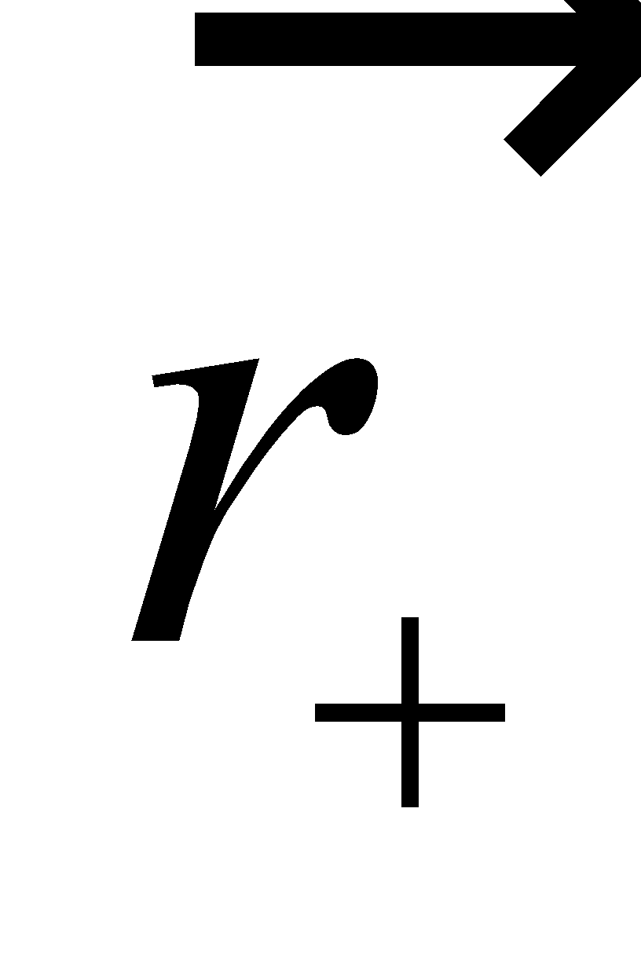and 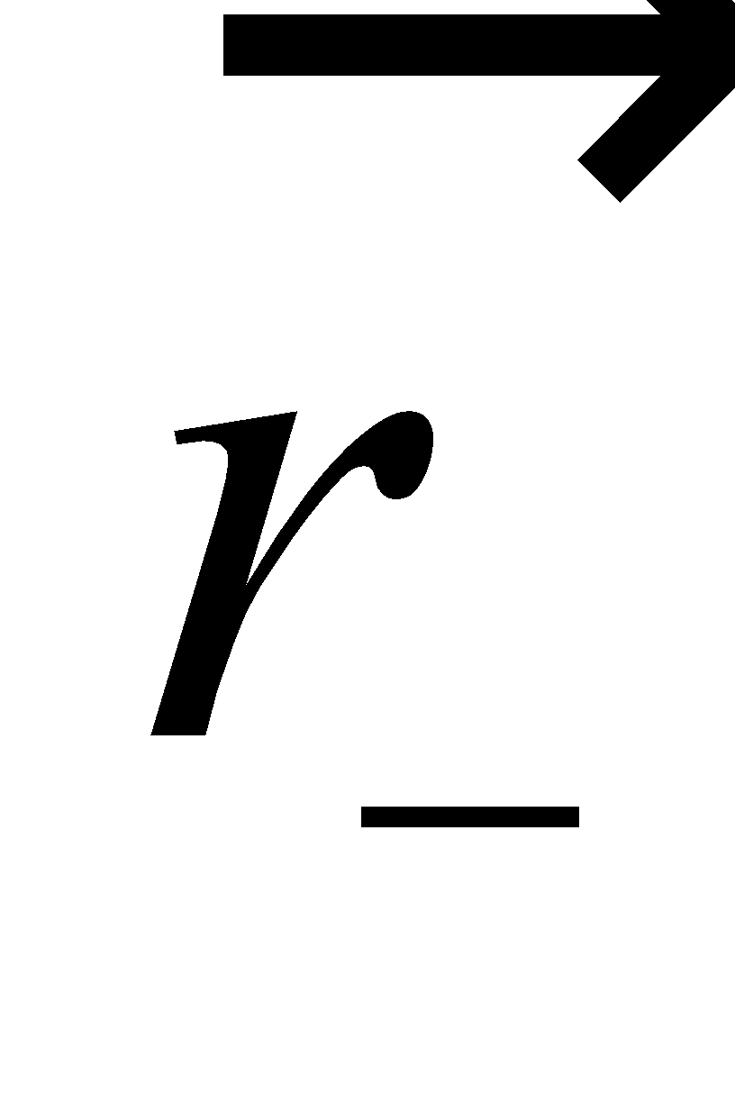 as the distance vectors from each charge to the field point, which is a distance r from the origin and an 45° from the *x*-axis. See the figure below.



From the figure it's clear what the component forms of and  are:

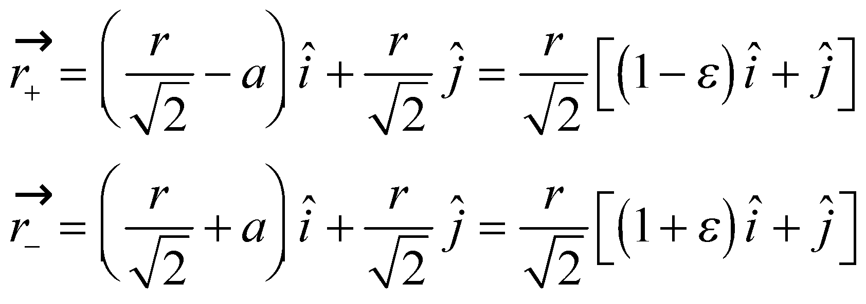

where we have simplified the expressions by using 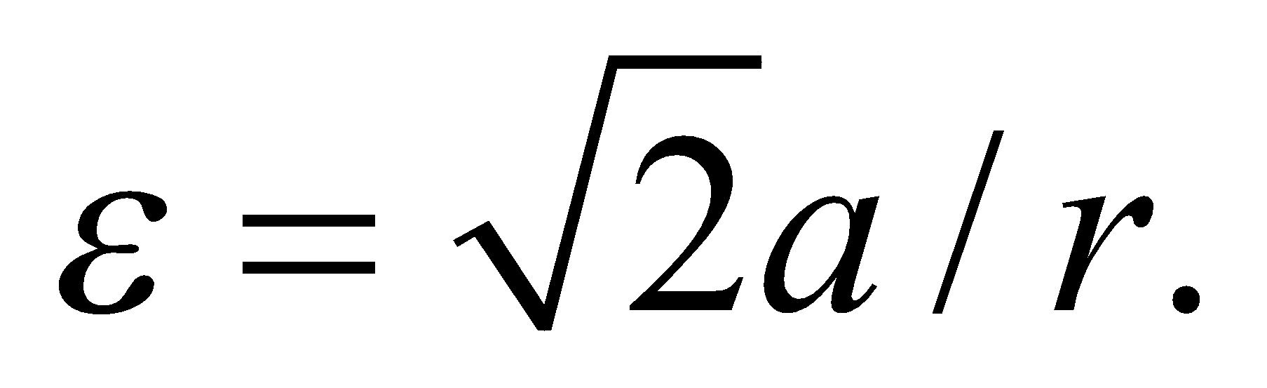 The magnitudes of these vectors are: 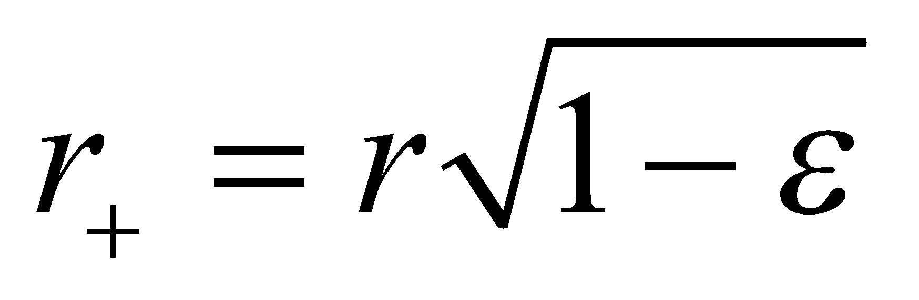 and 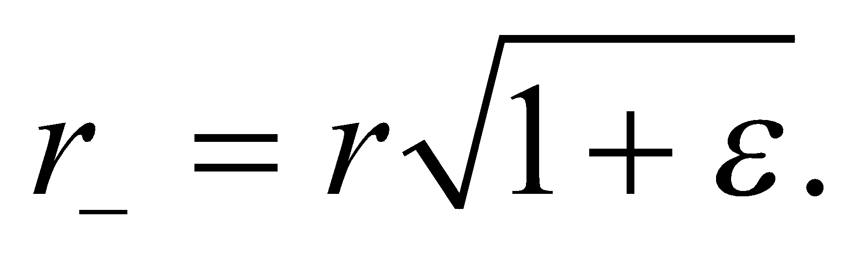 We have neglected terms of order 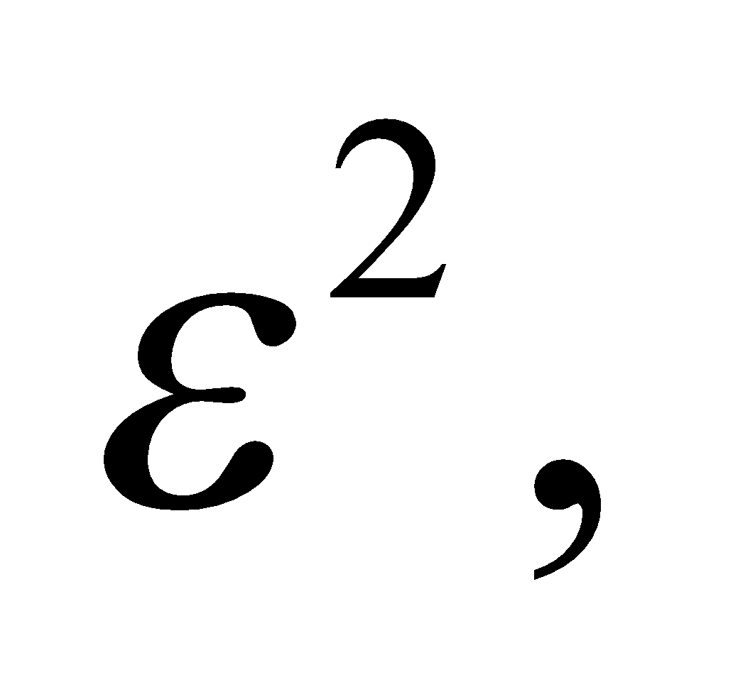 since 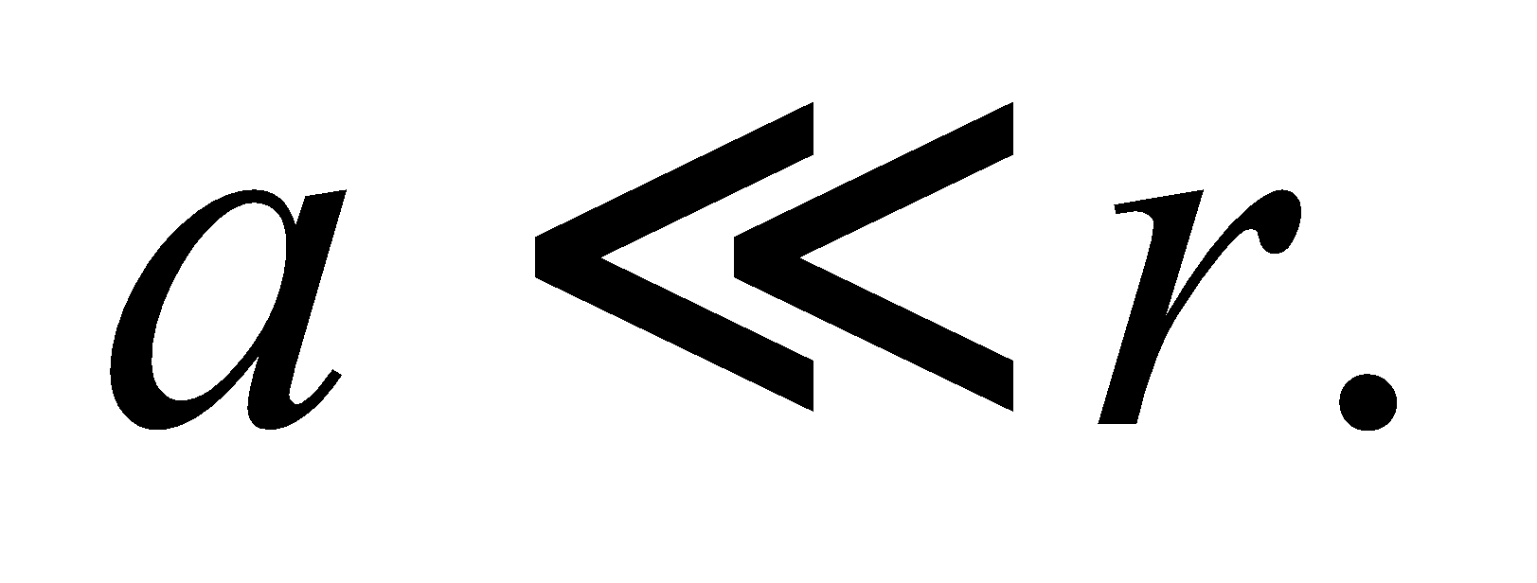 These variables can be plugged into Equation 20.3 in order to find the electric field contributions from each charge.

**Evaluate** The electric field from each charge is:

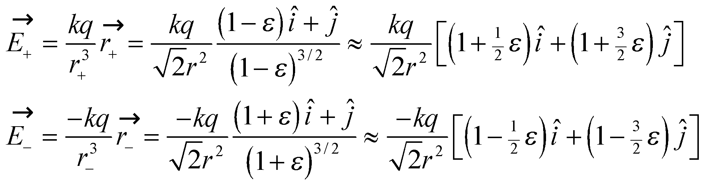

Here, we have used the binomial approximation: 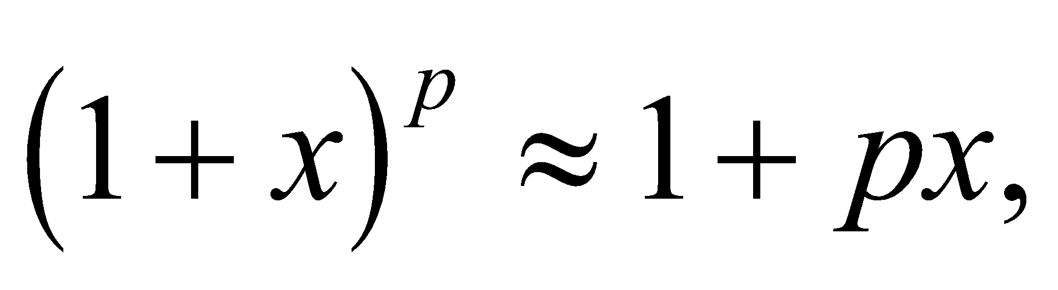for 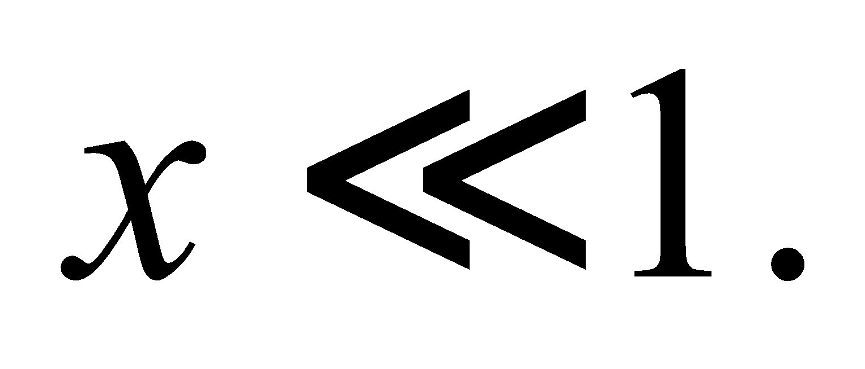Summing these together gives the net electric field from the dipole:

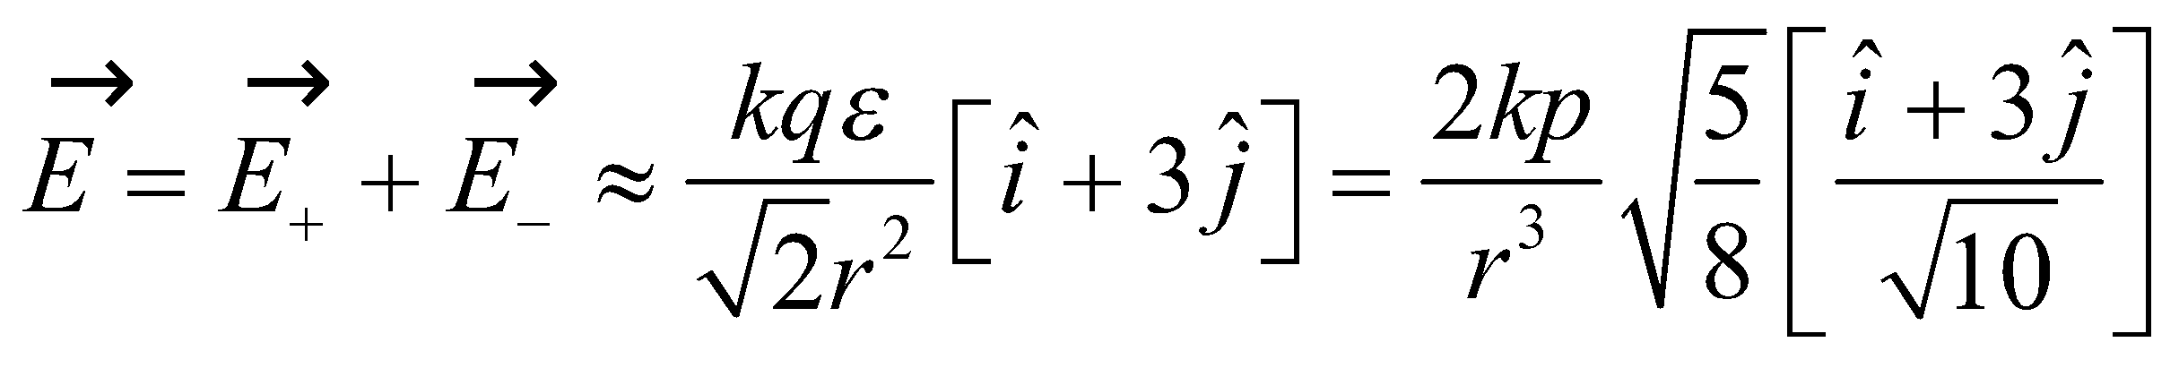

We've used the electric dipole moment, 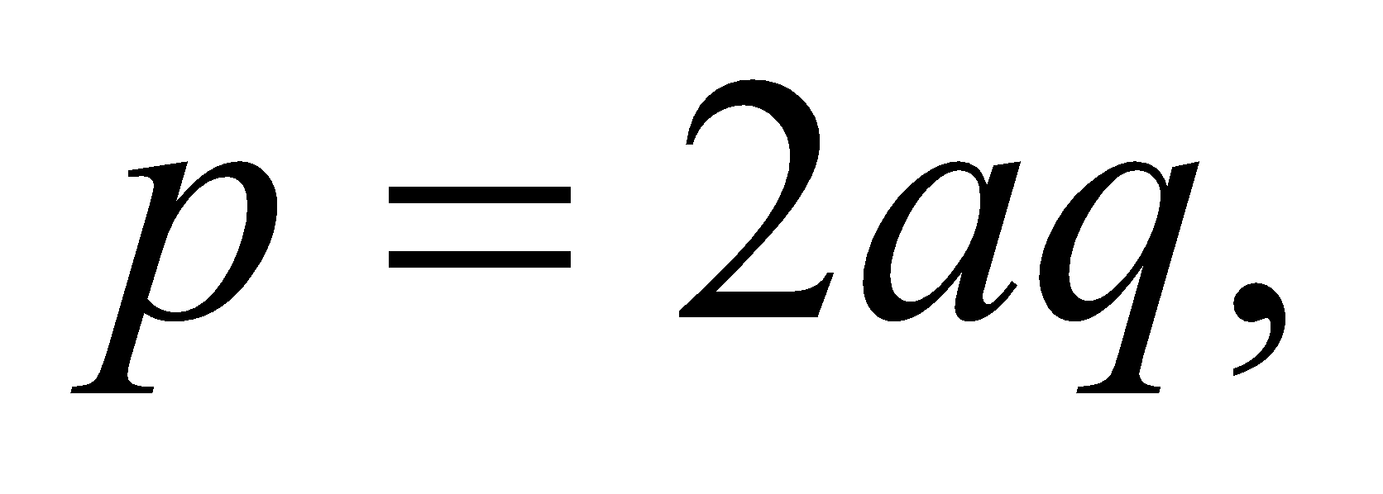and written the vector components as a unit vector. We can compare this to the electric field on the dipole axis at the distance, 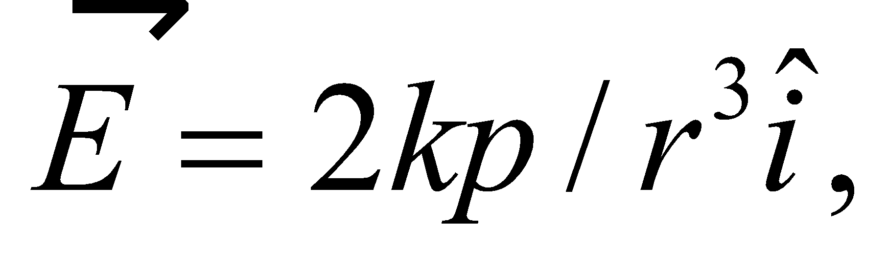 from Equation 20.6b. The magnitude of the electric field at a 45° angle to the dipole axis is reduced by a factor of 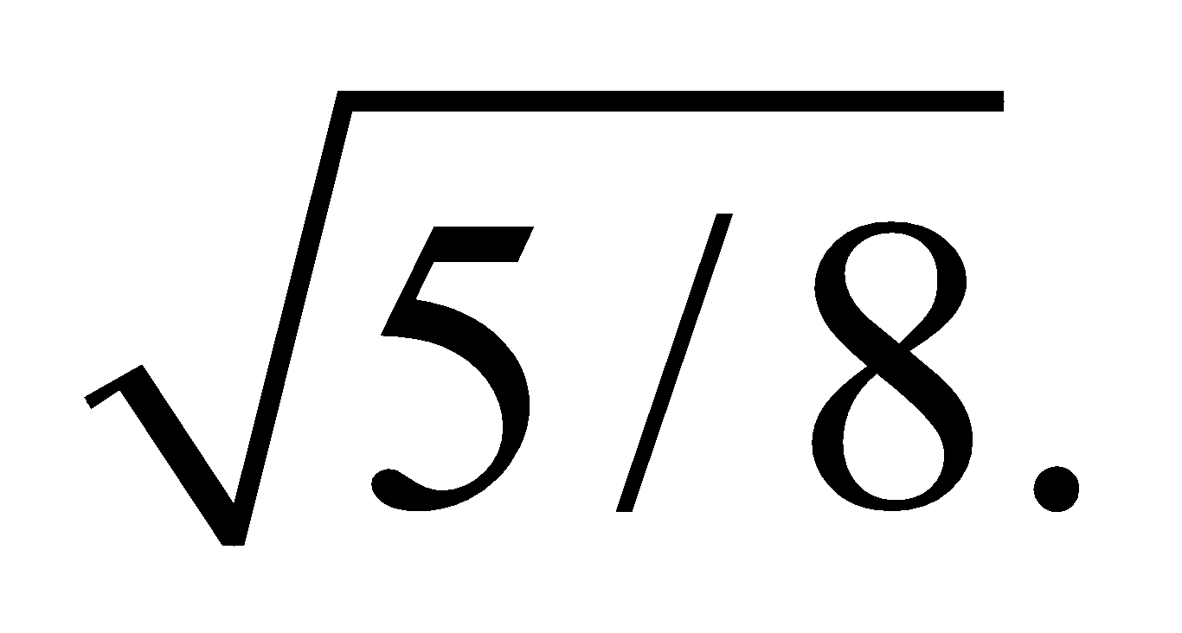

**Assess** For a given distance, the dipole field is largest on dipole axis. That's because this position maximizes the difference between and 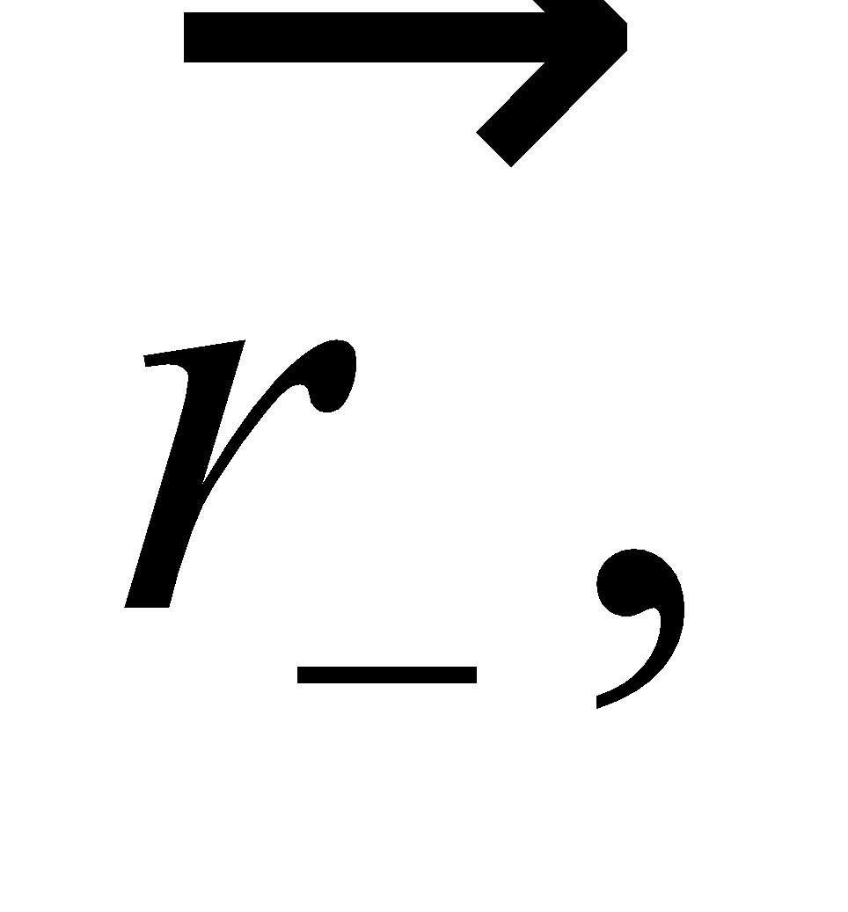 which in turn maximizes the difference between 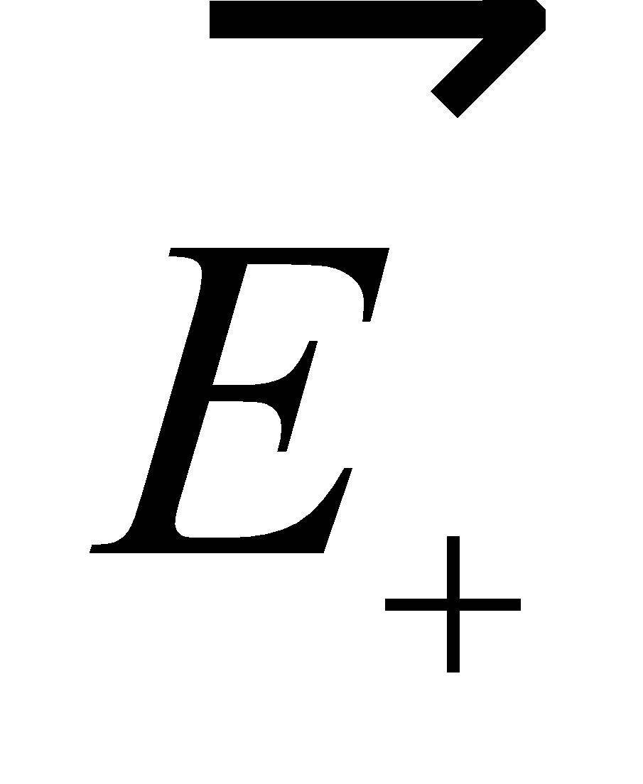and 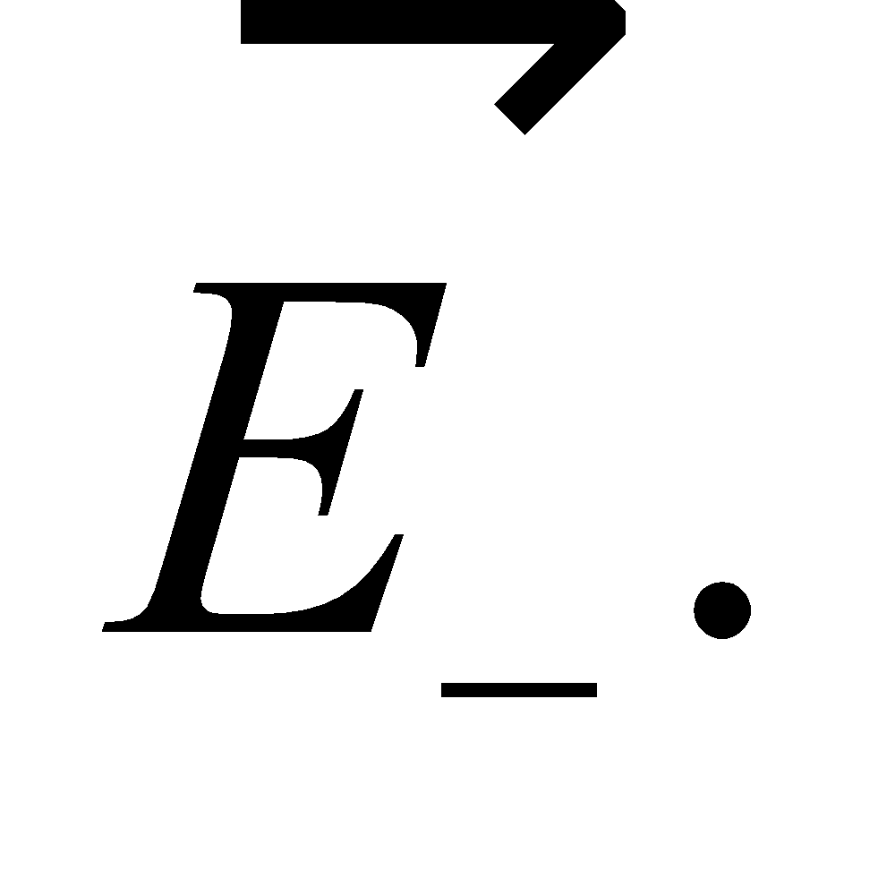

**69. Interpret** This problem is about the electric field due to a 10-m-long straight wire, which is our source charge.

**Develop** For a uniformly charged wire of length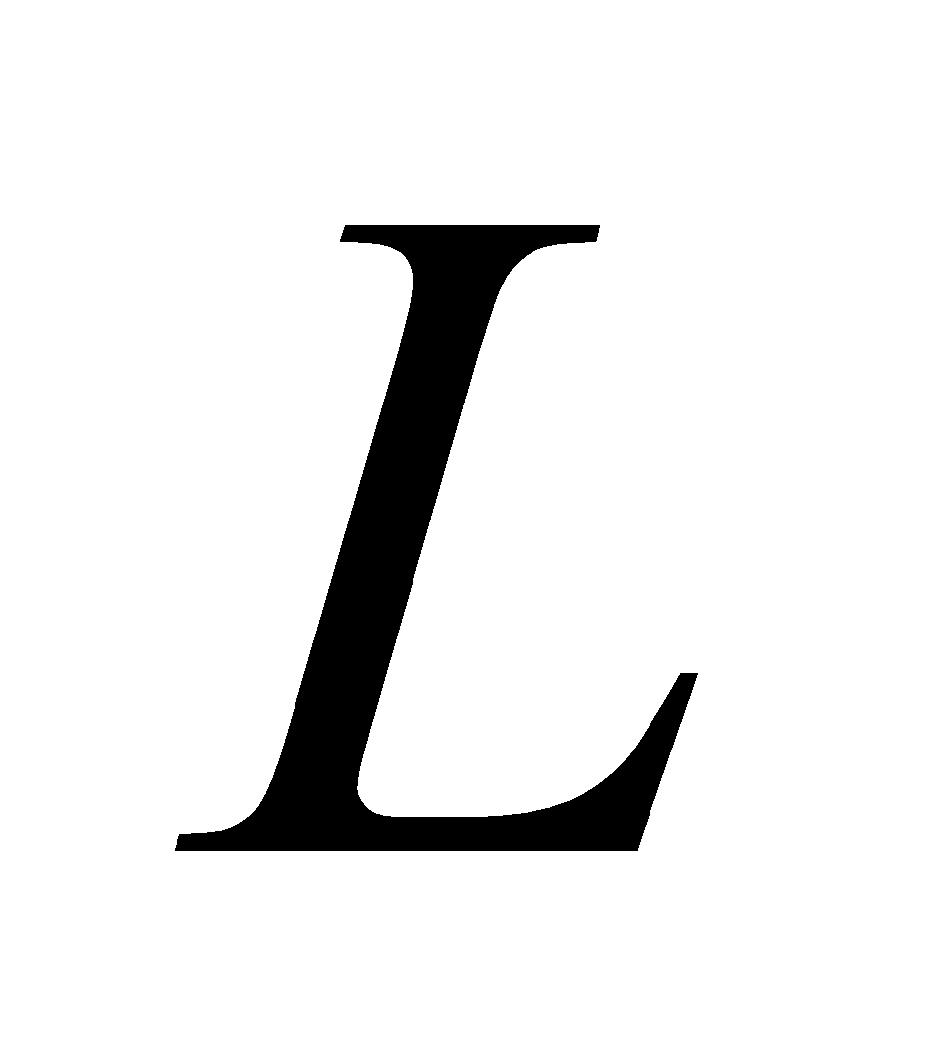and charge *Q*, the line density is 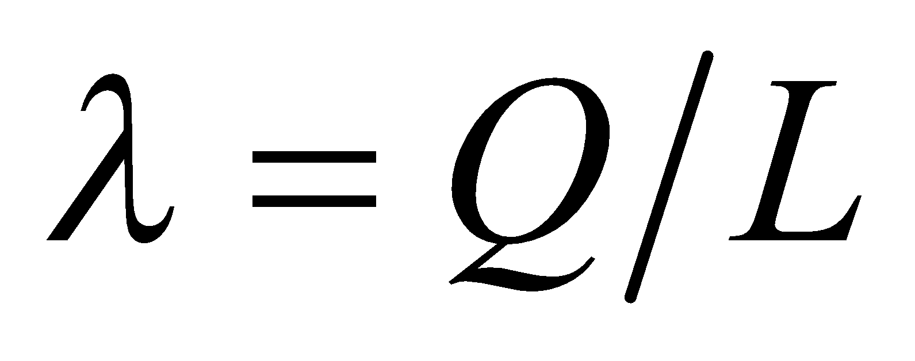.Approximating the wire as infinitely long, the electric field due to the line charge can be written as (see Example 20.7)

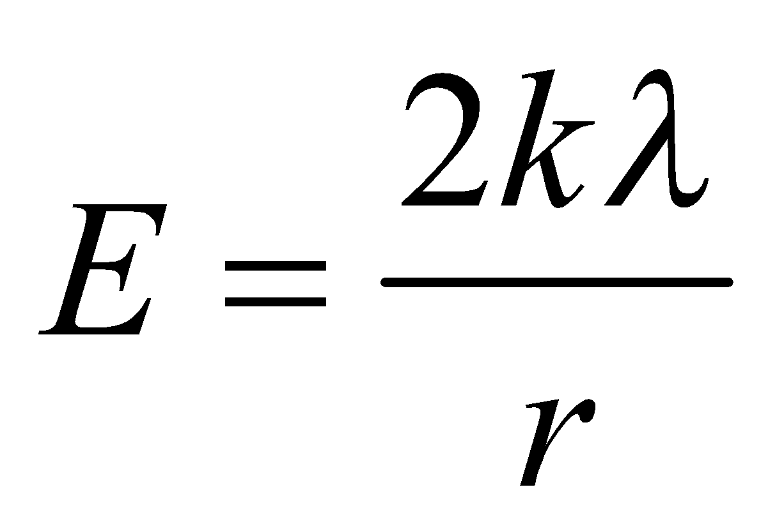

**Evaluate** **(a)** The charge density is

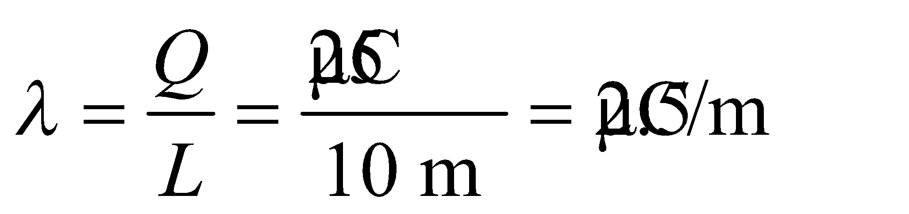

**(b)** Since 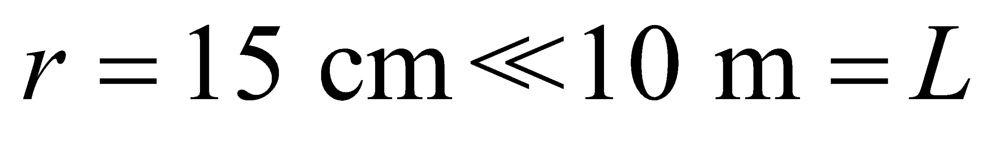 and the field point is far from either end, we may regard the wire as approximately infinite. Then Example 20.7 gives

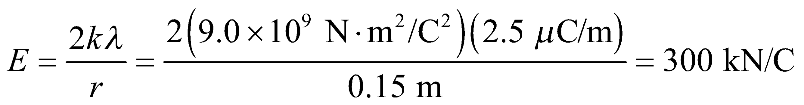

**(c)** At 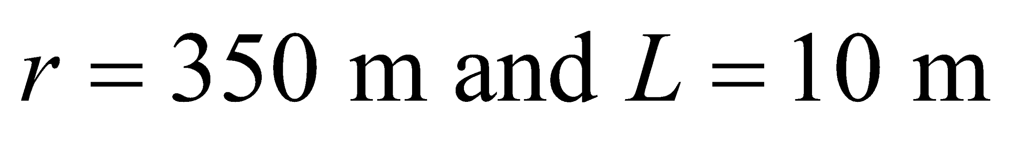, the wire behaves approximately like a point charge, so the field strength is

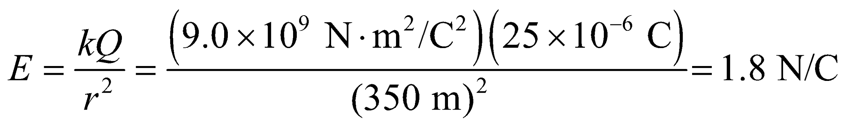

**Assess** The finite-size, line charge distribution looks like a point charge at large distances.

**70. Interpret** We're considering the electric field from a thin rod at a point on the rod's perpendicular bisector.

**Develop** We will approach this problem in the same way as was done in Example 20.7 for an infinite line of charge.

**Evaluate**  (a) The line charge density is just the total charge divided by the length: 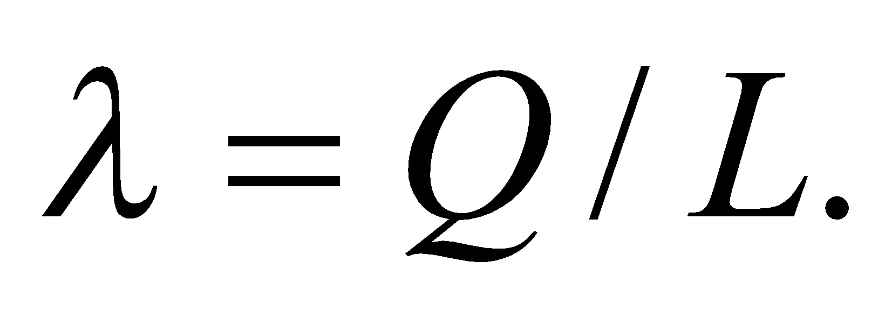

(b) The charge distribution is symmetrical with respect to the rod's perpendicular bisector. Therefore, all horizontal components of the electric field in the *x*-direction will cancel each other out, as in Figure 20.16. The result is an electric field that points along the *y*-axis.

(c) To find the magnitude of the electric field on the bisector, we follow the same development as in Example 20.7. Due to the symmetry, the infinitesimal electric field component, 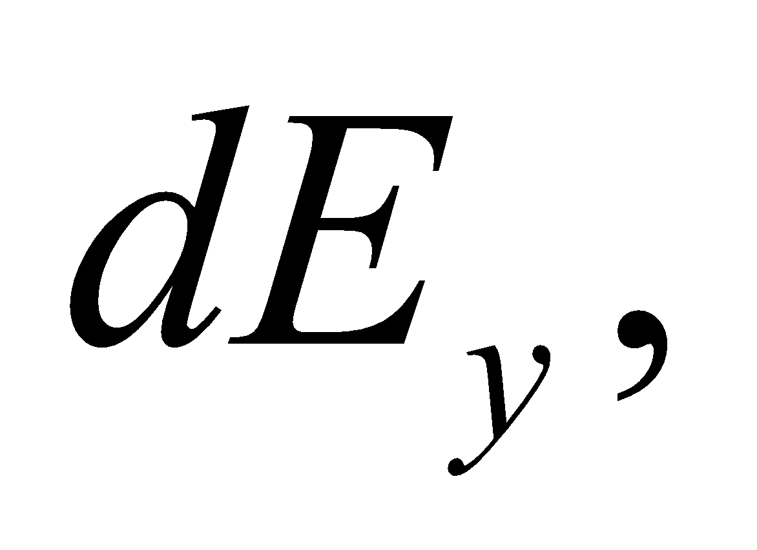will be the same, but the limits of integration not be infinity, but instead 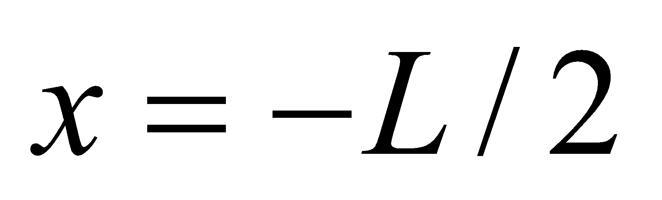 to 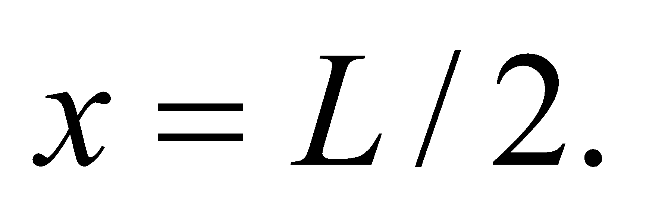

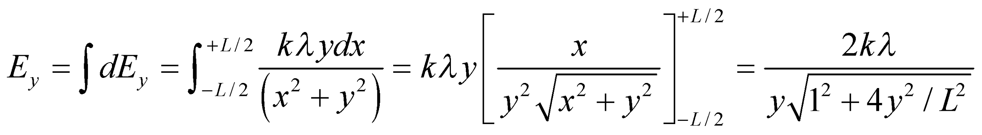

**Assess** For 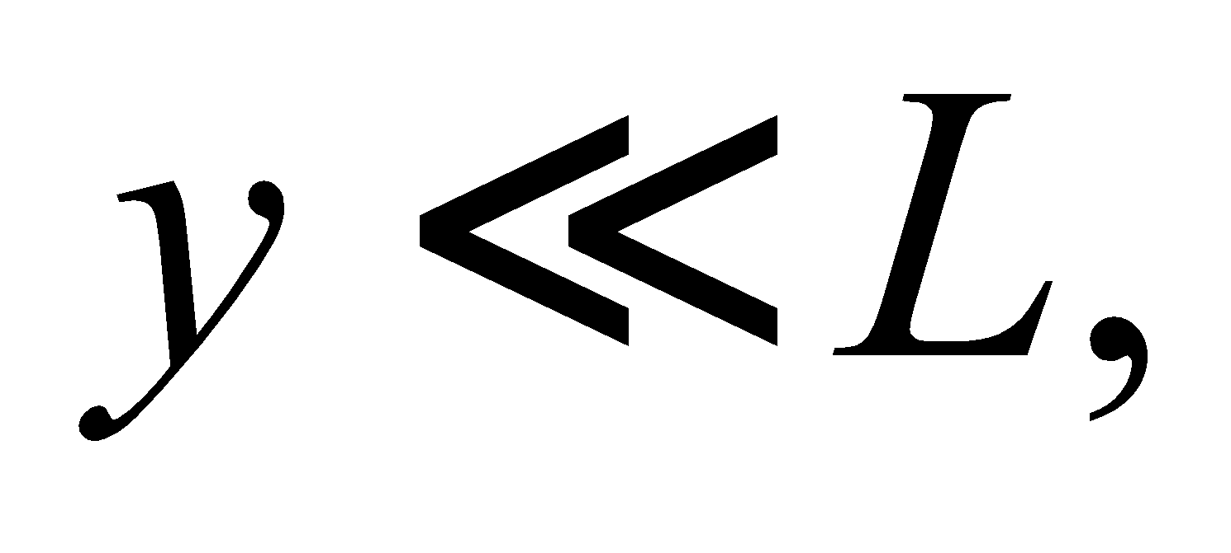the electric field reduces to the result for an infinite wire, 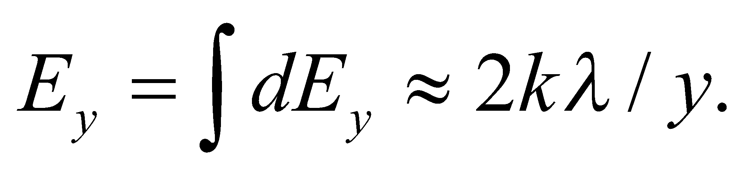 And conversely, if 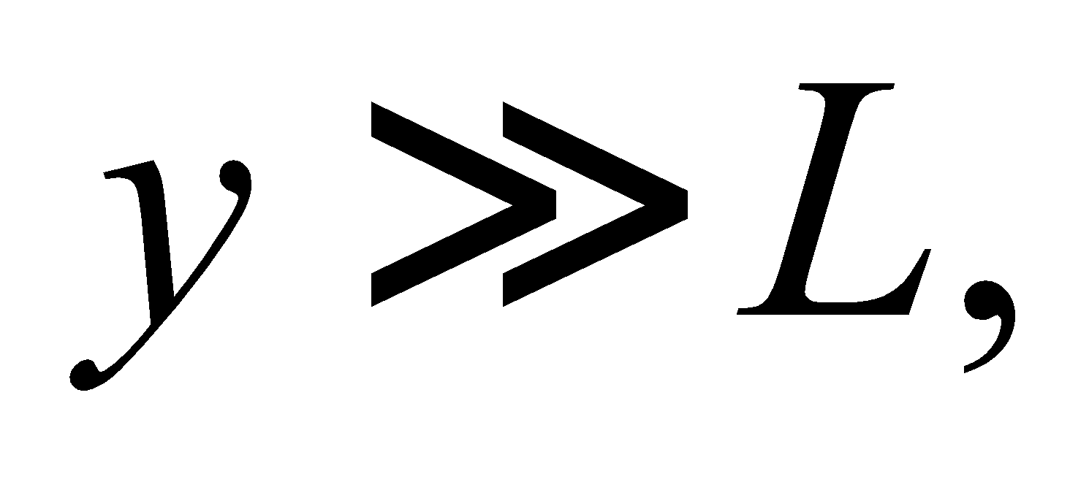the field becomes: 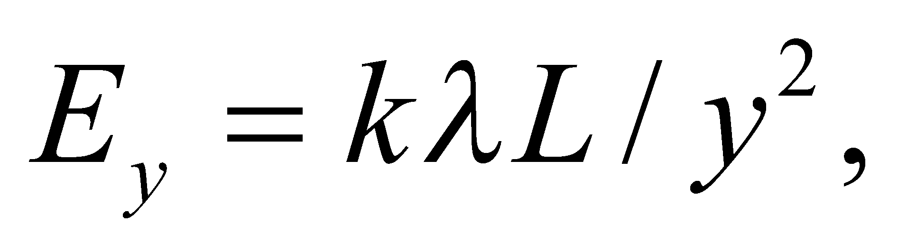which is the field from a point charge 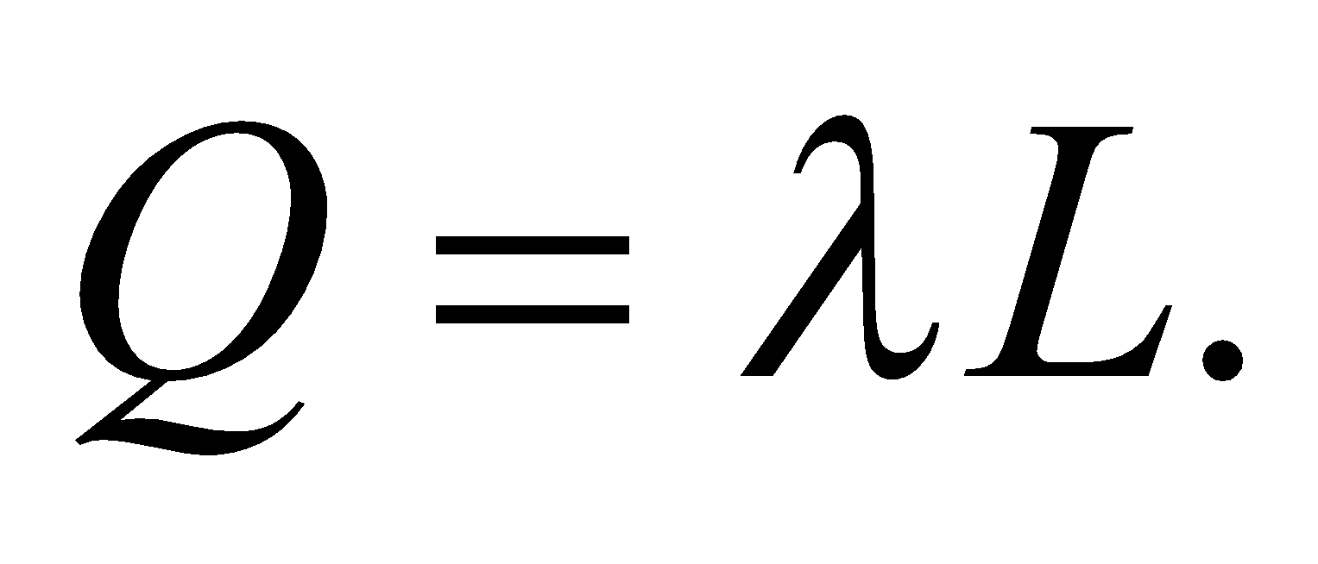This makes sense: from very far the rod should behave like a point charge.

**71. Interpret** In this problem we want to find the electric field due to a uniformly charged disk of radius *R*.

**Develop** We take the disk to consist of a large number of annuli. With uniform surface charge density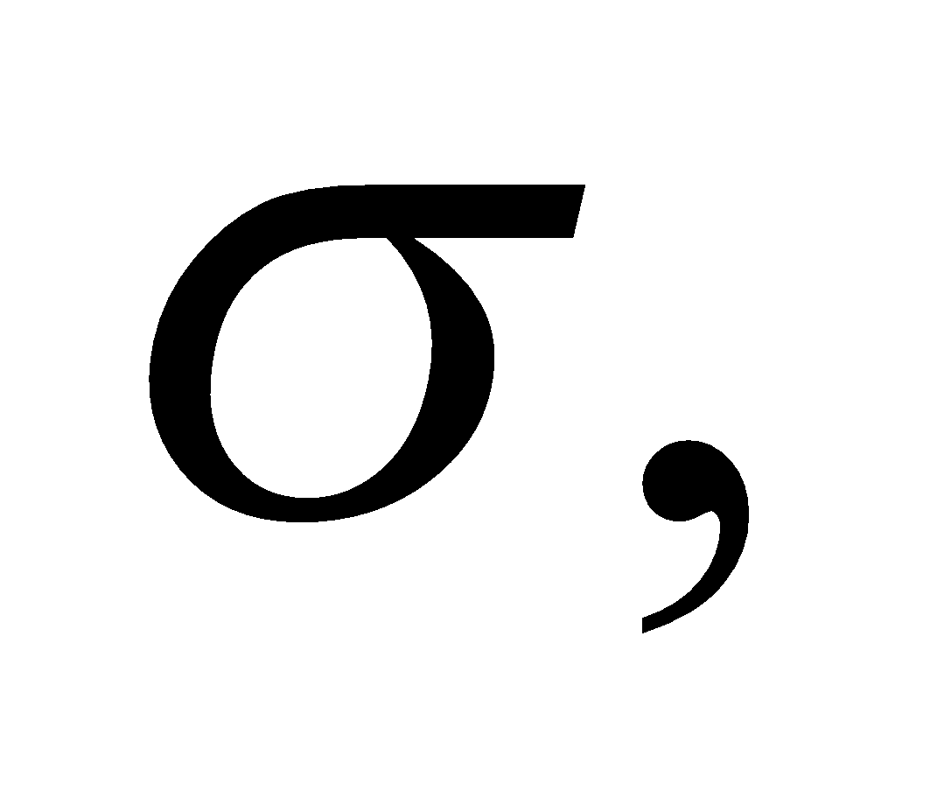 the amount of charge on an area element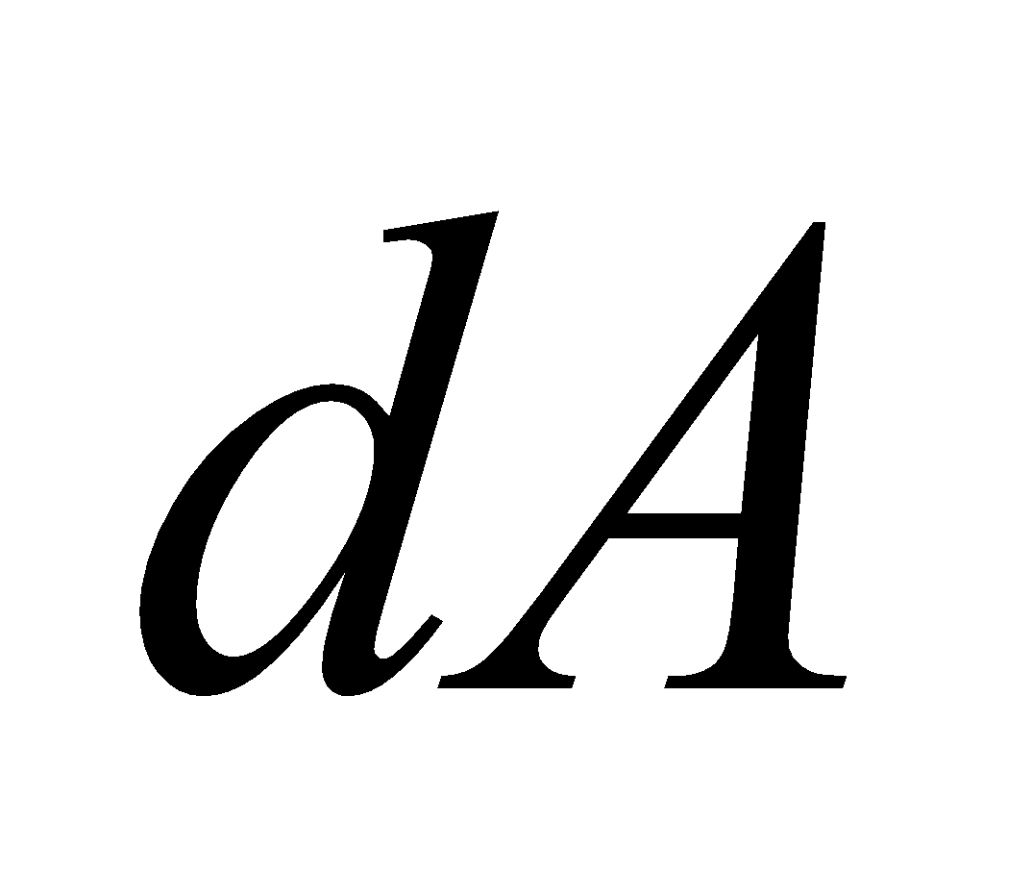is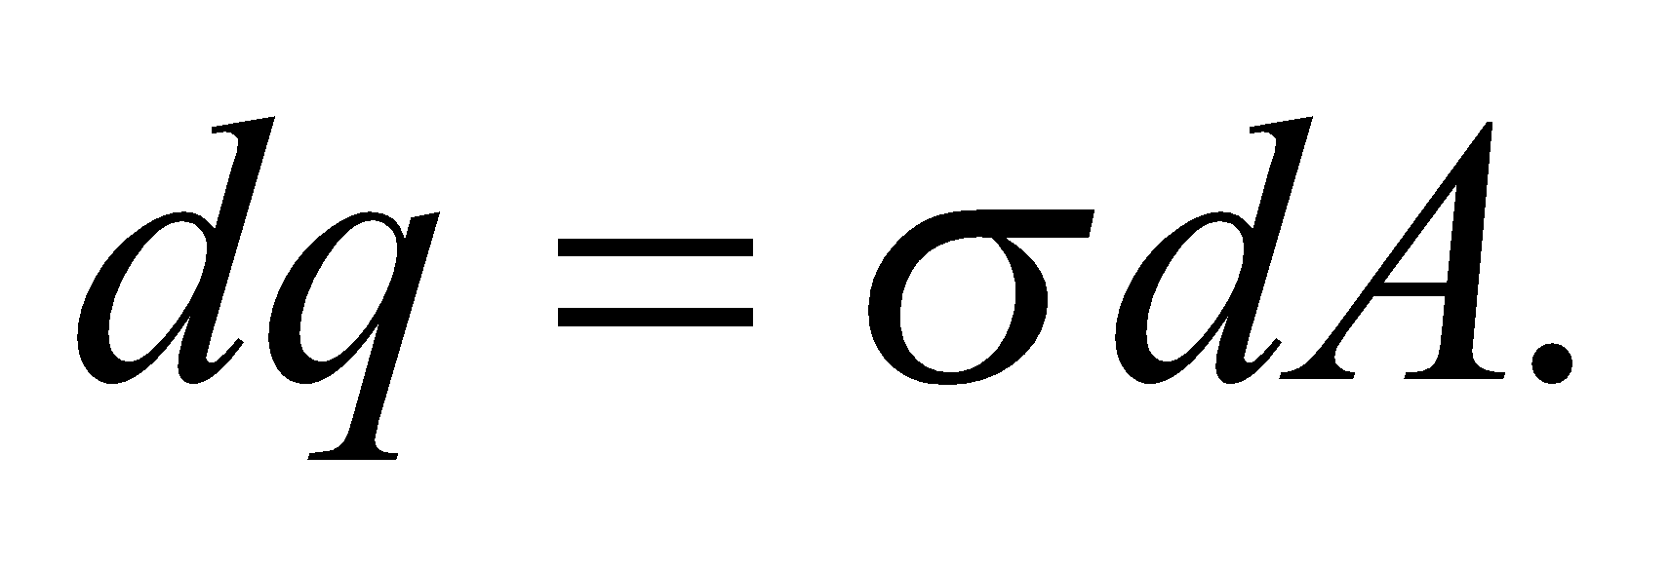Our strategy is to first calculate the electric field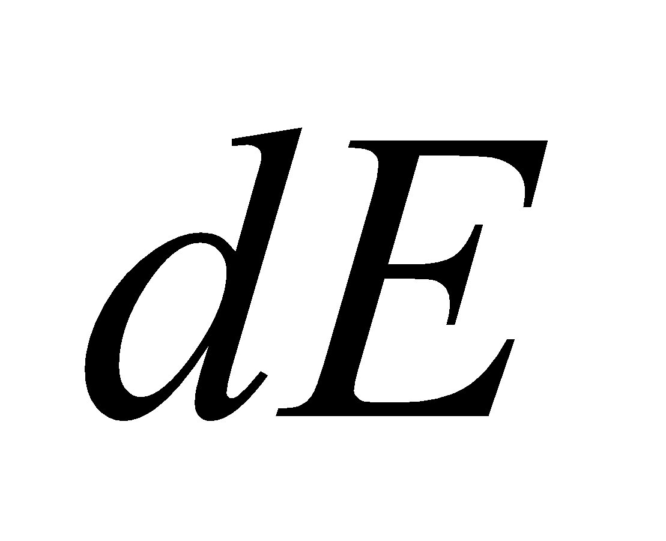due to at a field point on the axis, simplify with symmetry argument, and then integrate over the entire disk to get *E*.

**Evaluate (a)** The area of an annulus of radii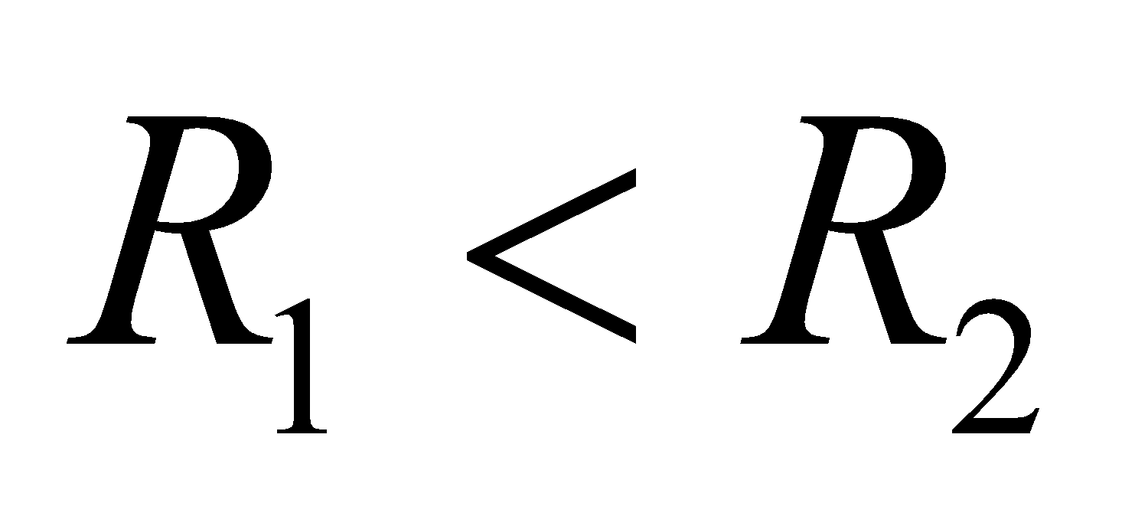is just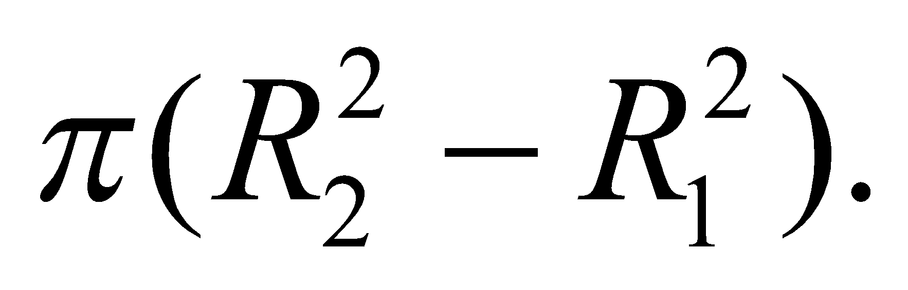For a thin ring,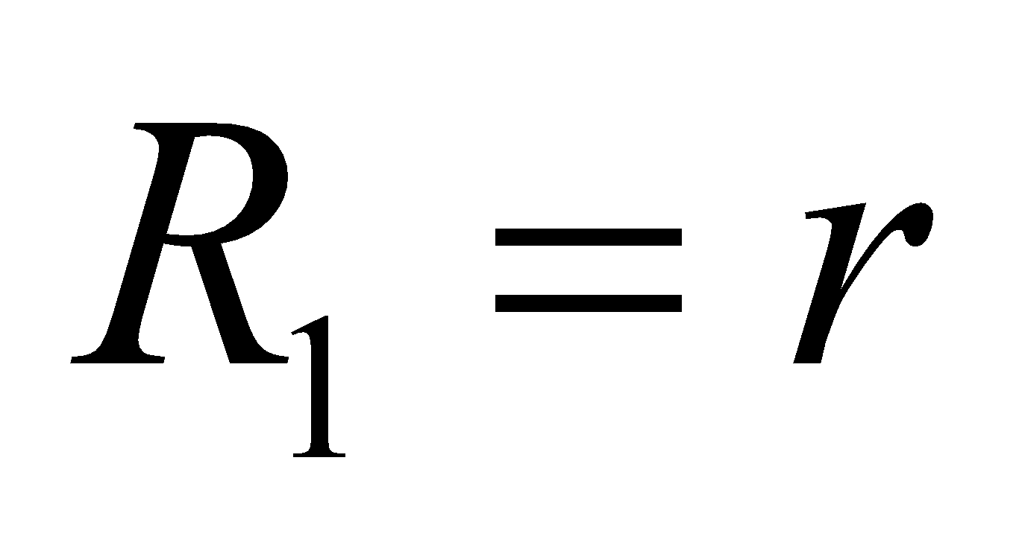and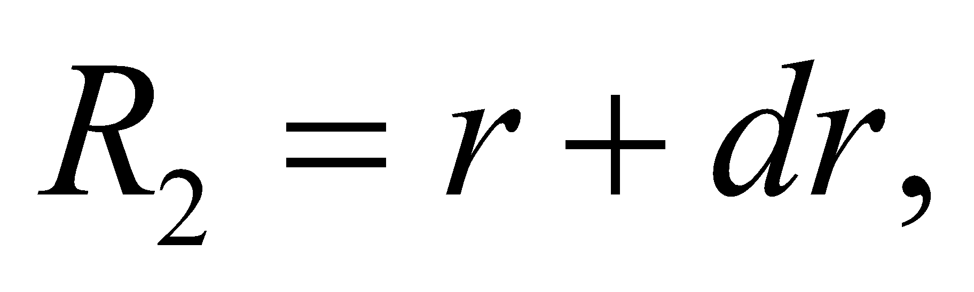 so the area is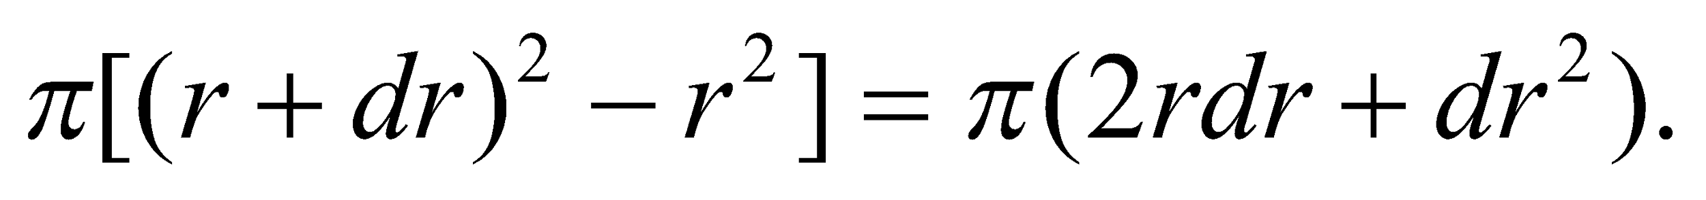When *dr* is very small, the square term is negligible, and (This is equal to the circumference of the ring times its thickness.) **(b)** For surface charge density  **(c)** From Example 20.6, the electric field due to a ring of radius *r* and charge *dq* is

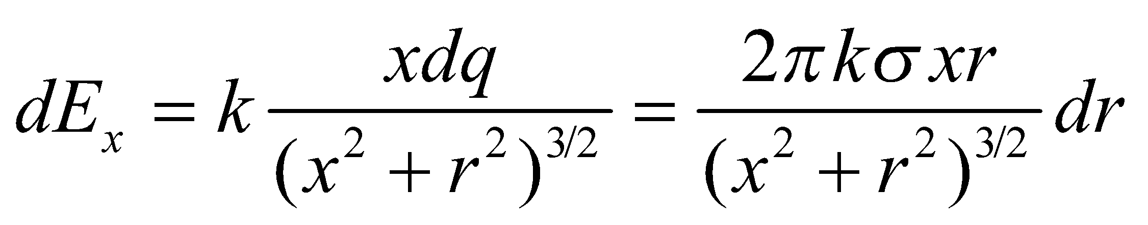

which holds for *x* positive away from the ring’s center. **(d)** Integrating from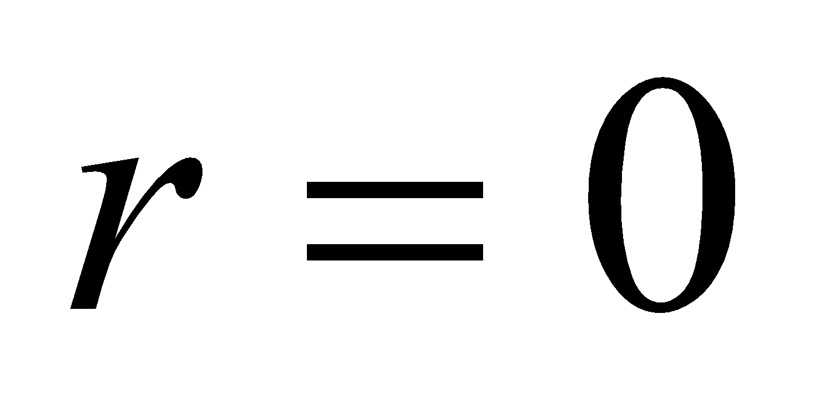to *R*, one finds



For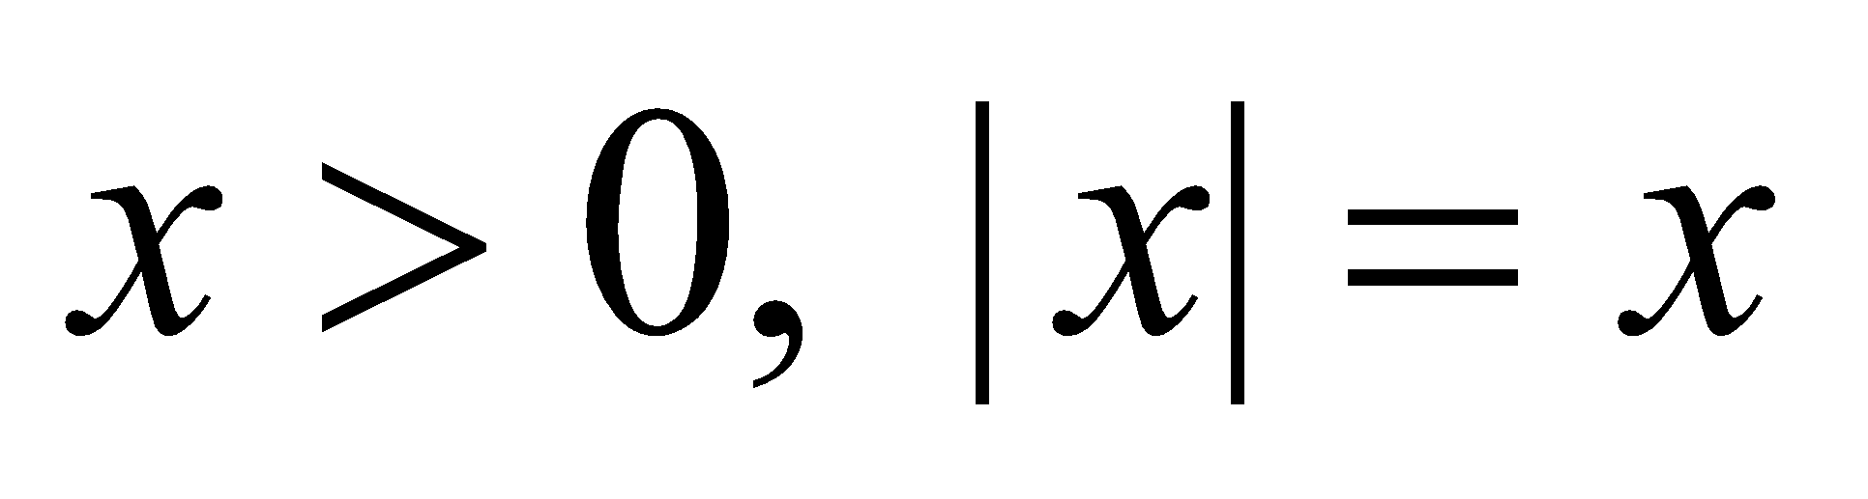and the field is

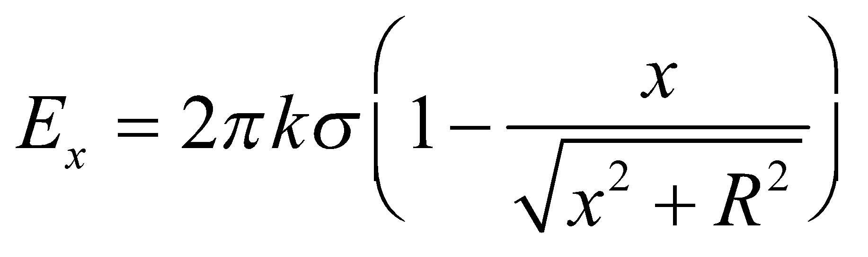

On the other hand, forthe electric field is



This is consistent with symmetry on the axis, since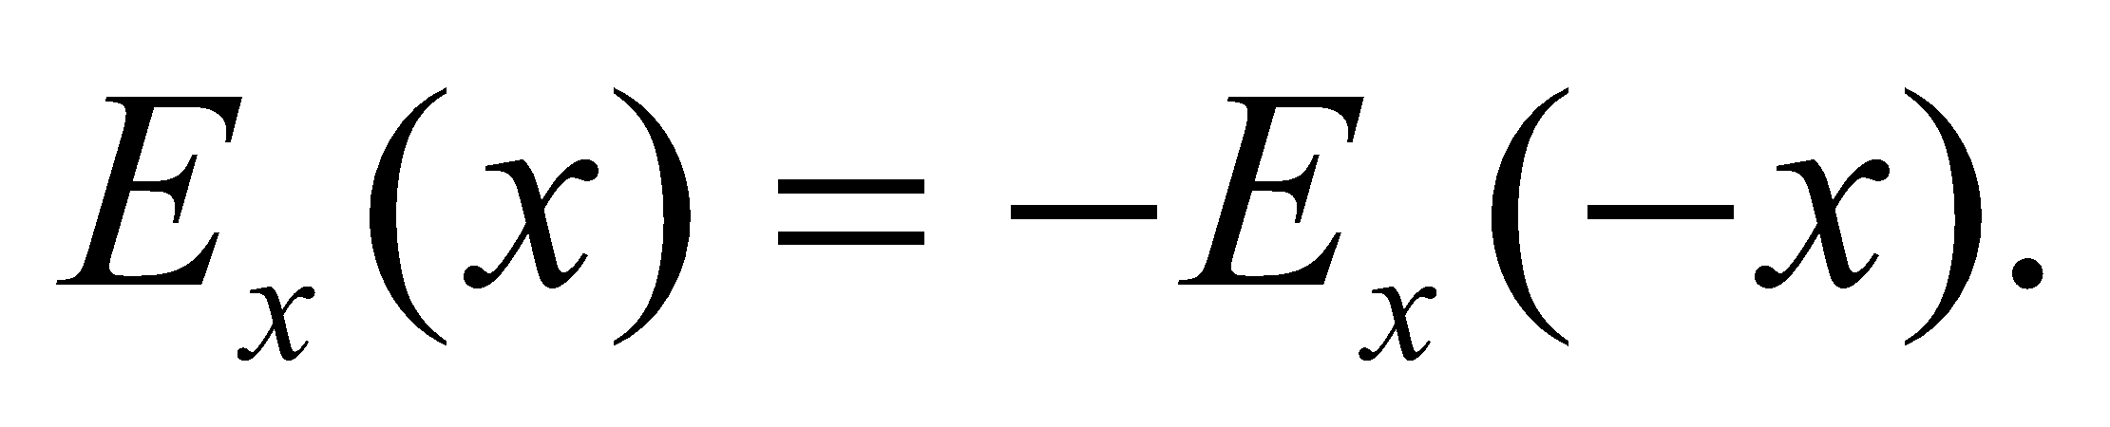

**Assess** One may readily verify that (see Problem 71), for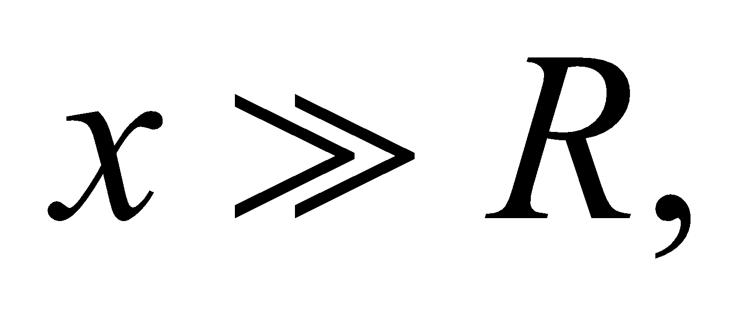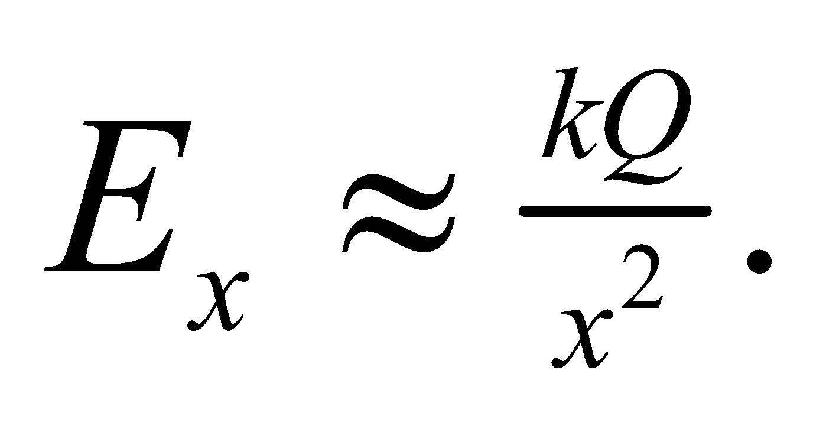In other words, the finite-size charge distribution looks like a point charge at large distances.

**72. Interpret** We will find the electric field from an infinite sheet.

**Develop** An infinite flat sheet is the same as an infinite flat disk (the shape is irrelevant when the dimensions extend to infinity). Thus, we can find the magnitude of the electric field from a uniformly charged infinite flat sheet by letting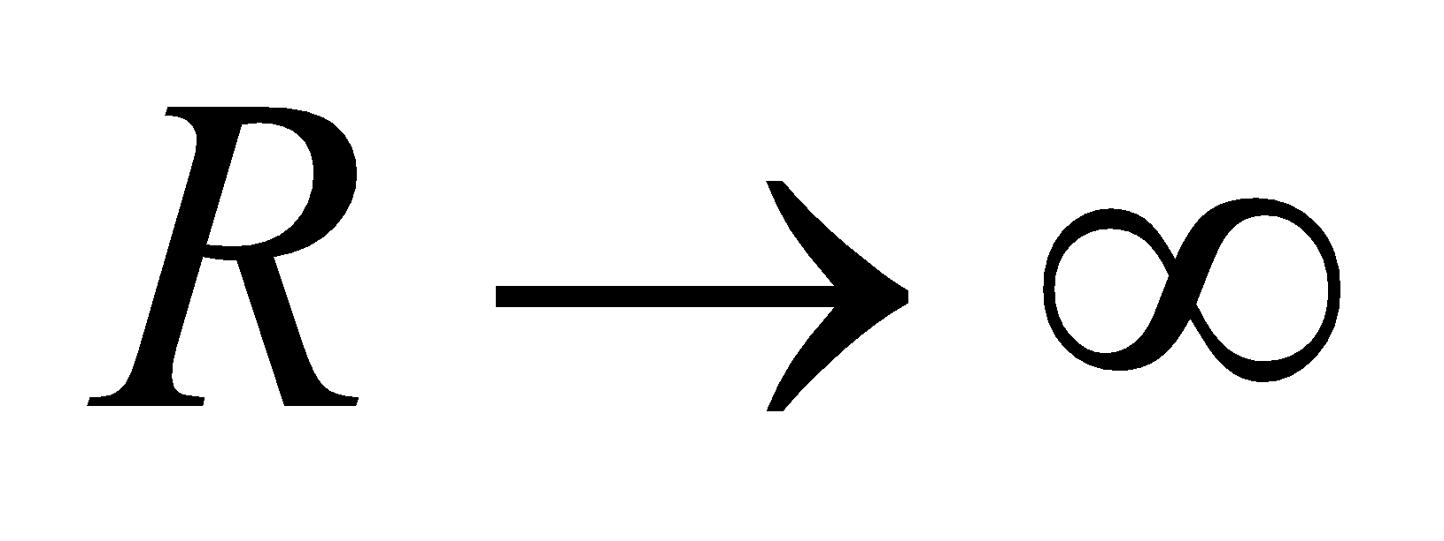in the result of Problem 20.71.

**Evaluate** As was shown in the previous problem, a charged disk centered at the origin and perpendicular to the *x*-axis will generate an electric field along the x-axis with magnitude:



Where  is the charge density per unit area. If then the second term in the parentheses goes to zero, and we're left with:

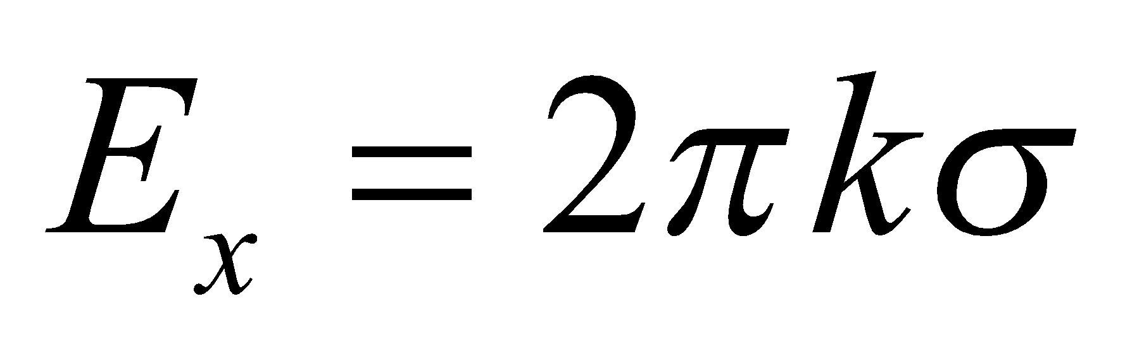

**Assess** Strikingly, this result no longer depends on x, the distance from the sheet. The field is uniform, whether you are a nanometer or a light-year away. If the charge on the sheet is positive, the field points away from the sheet on both sides, and the opposite if the charge is negative.

**73. Interpret** In this problem we want to show that at large distances, the electric field due to a uniformly charged disk of radius *R* reduces to that of a point charge.

**Develop** The result of Problem 71 for the field on the axis of a uniformly charged disk, of radius *R*, at a distance *x* > 0 on the axis (away from the disk’s center) is



For 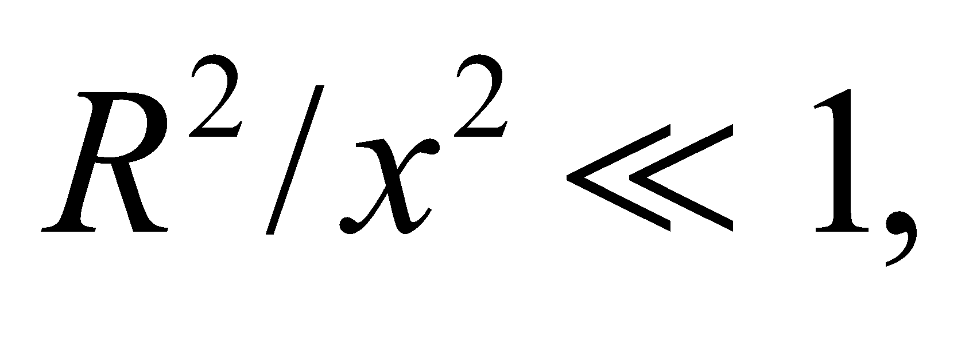 we use the binomial expansion in Appendix A and write

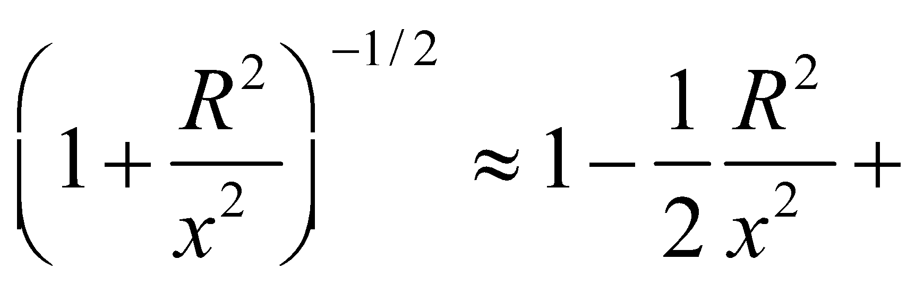

**Evaluate** Substituting the above expression into the first equation, we obtain

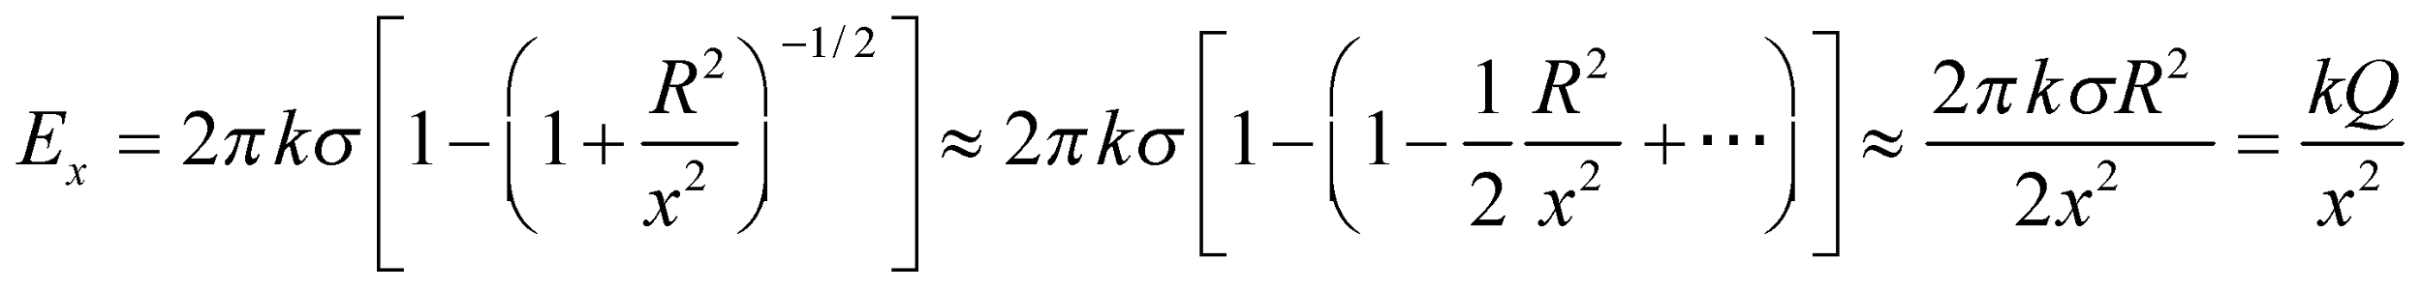

which is the field from a point charge 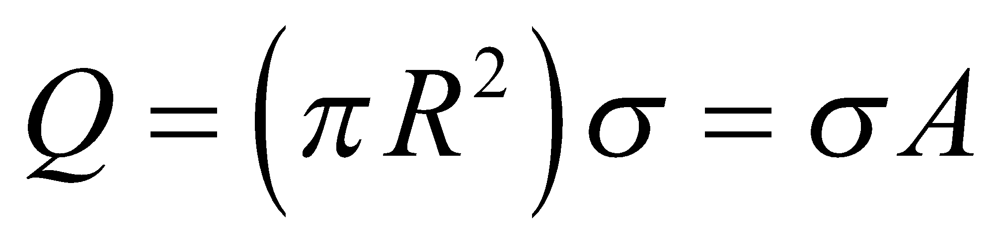 at a distance *x*.

**Assess**The result once again demonstrates that any finite-size charge distribution looks like a point charge at large distances.

**74.** **Interpret** For this problem, we are to find the electric field at the center of a semicircular loop.

**Develop** Begin by establishing a coordinate system (see figure below) with origin at point *P*, vertical *y* axis, and horizontal *x* axis. Then each charge element *dq* creates an electric field of magnitude  in the direction 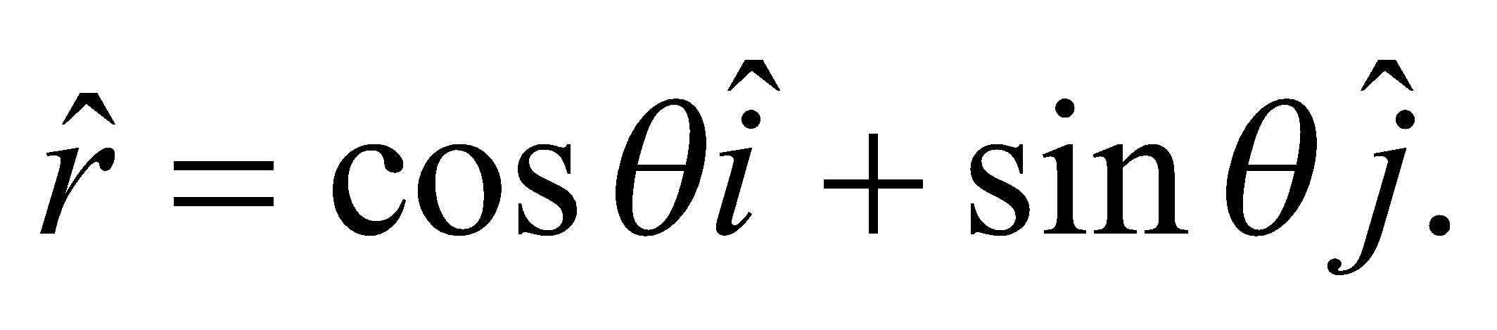 The total electric field at *P* is then 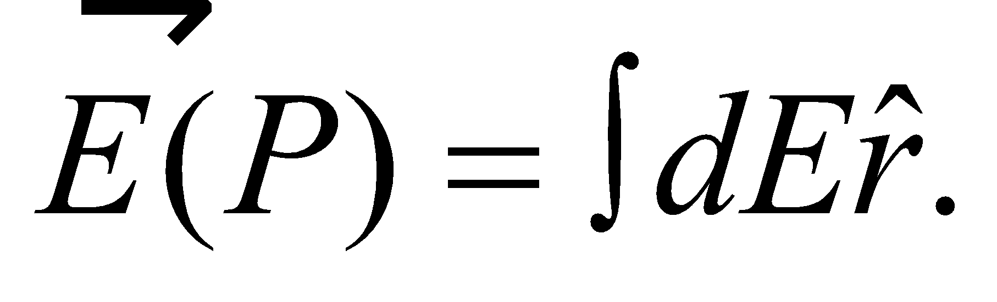 The loop has a uniform charge *Q* along its length of *πa*, so its linear charge density is 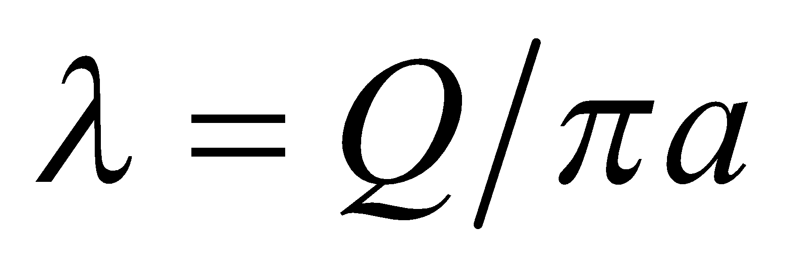 and we can write  Expressing the line element as  we have 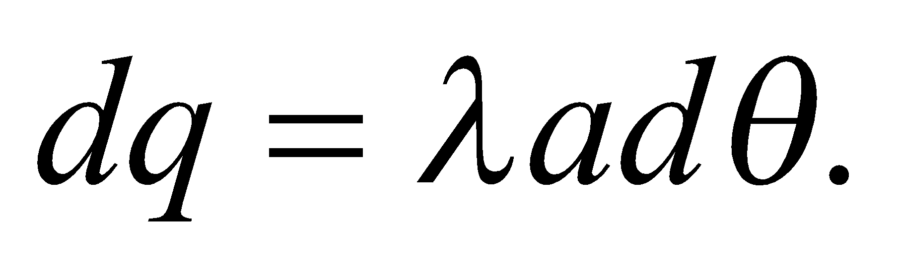 We can now formulate the integral for the total electric field in terms of *θ* starting with 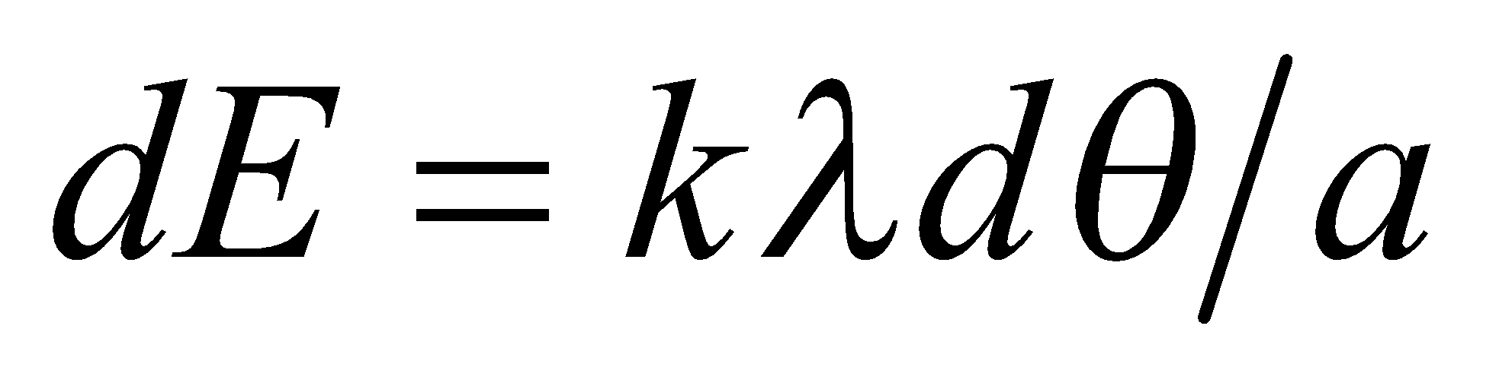:

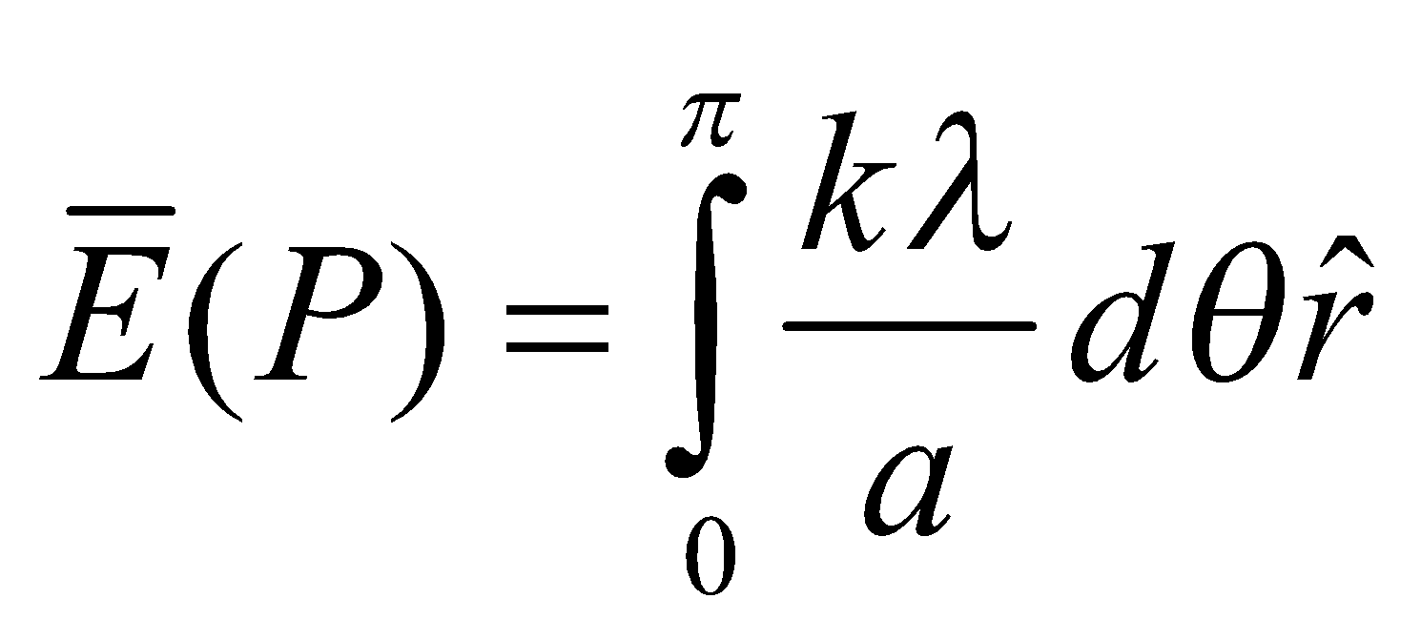

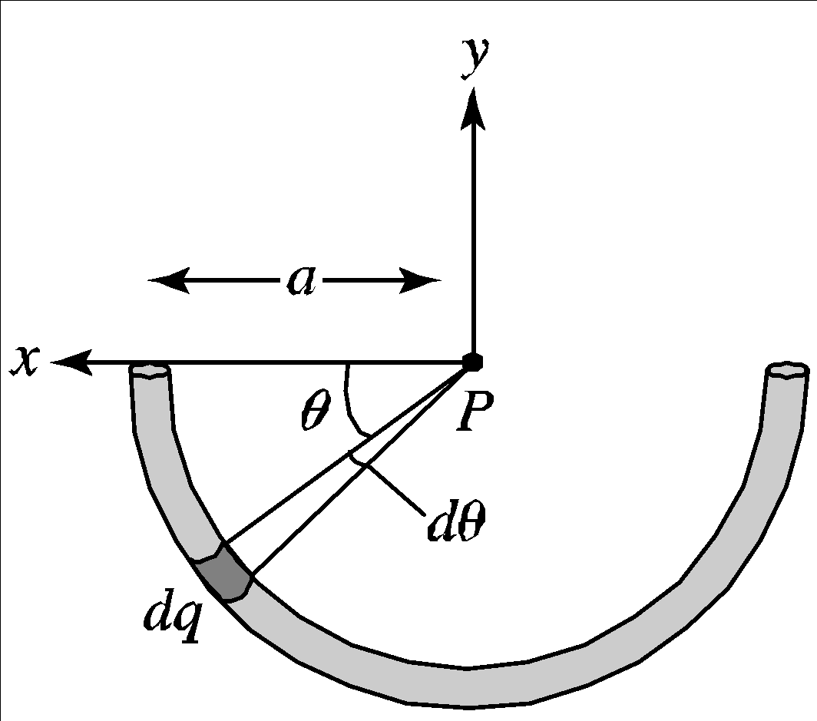

**Evaluate** Performing the integration gives

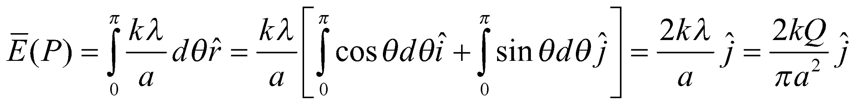

**Assess** The field decreases as 1/*a*2, and increases proportional to the total charge *Q*.

**75. Interpret** We are to find the position of the charge *Q* in Example 20.2 for which the force is a maximum. At large distances, the force will be small because of the inverse-square nature of the force. At close distances, the net force will be small because the forces from the two charges tend to cancel. Somewhere between near and far will be a maximum.

**Develop**  The equation for force is found in the example, so we will differentiate to find the value of *y* where force is a maximum. We are given the equation for force:

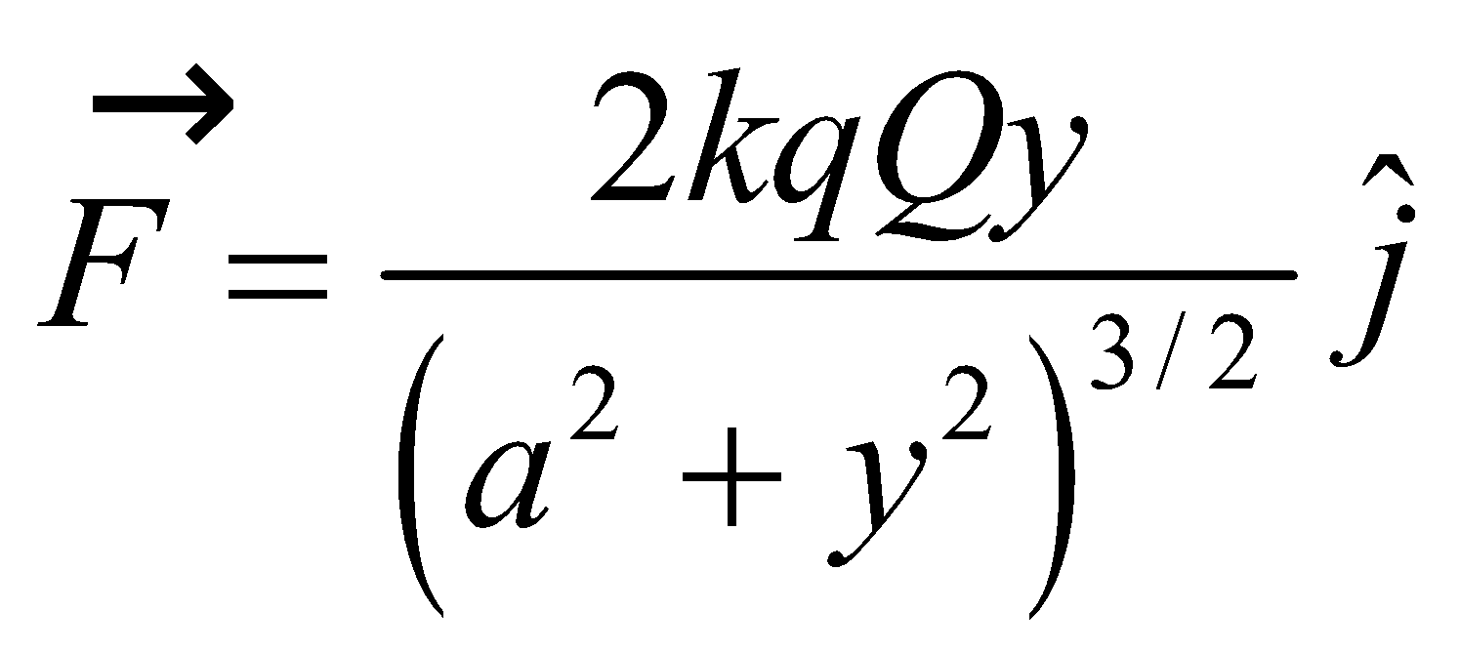

We find the value of *y* at which this force is a maximum by setting *dF*/*dy* = 0.

**Evaluate**

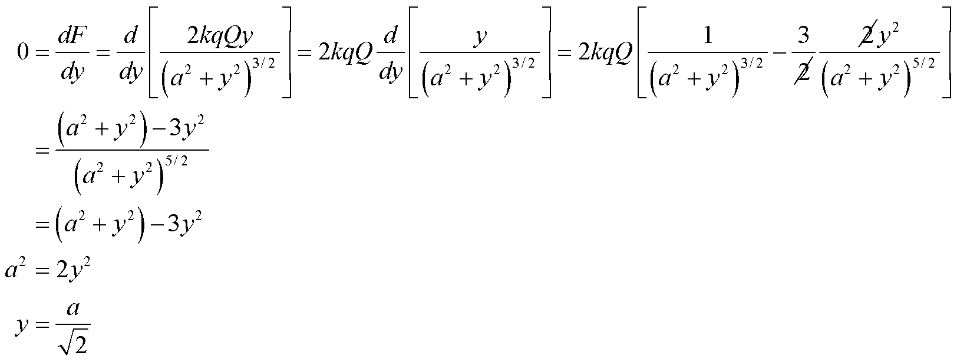

**Assess** This is a bit less than one and a half times the distance from the center to one charge.

**76. Interpret** We are to find the electric field at any point (*x*, *y*) due to a uniformly charged rod of length *L* and charge *Q*. We will check our answer by showing that the result matches the special cases of Problem 71 and Problem 55. This is an electric field problem, which we will solve by direct integration.

**Develop** We will find the field at point 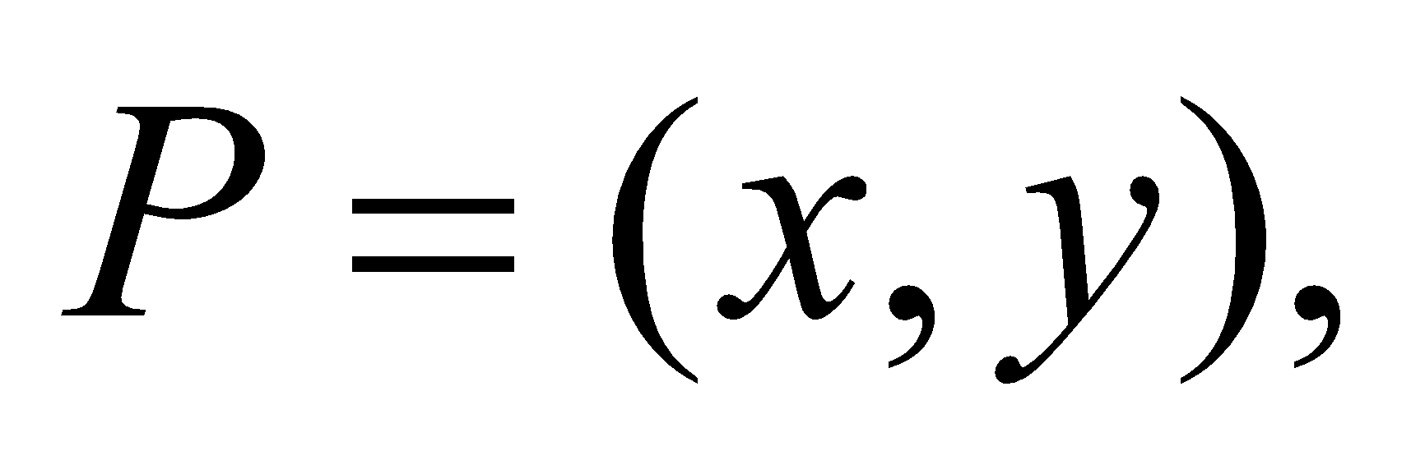 and for the integration variable we’ll use *x*′. The infinitesimal charge *dq* is the charge per unit length times the length *dx*′, so 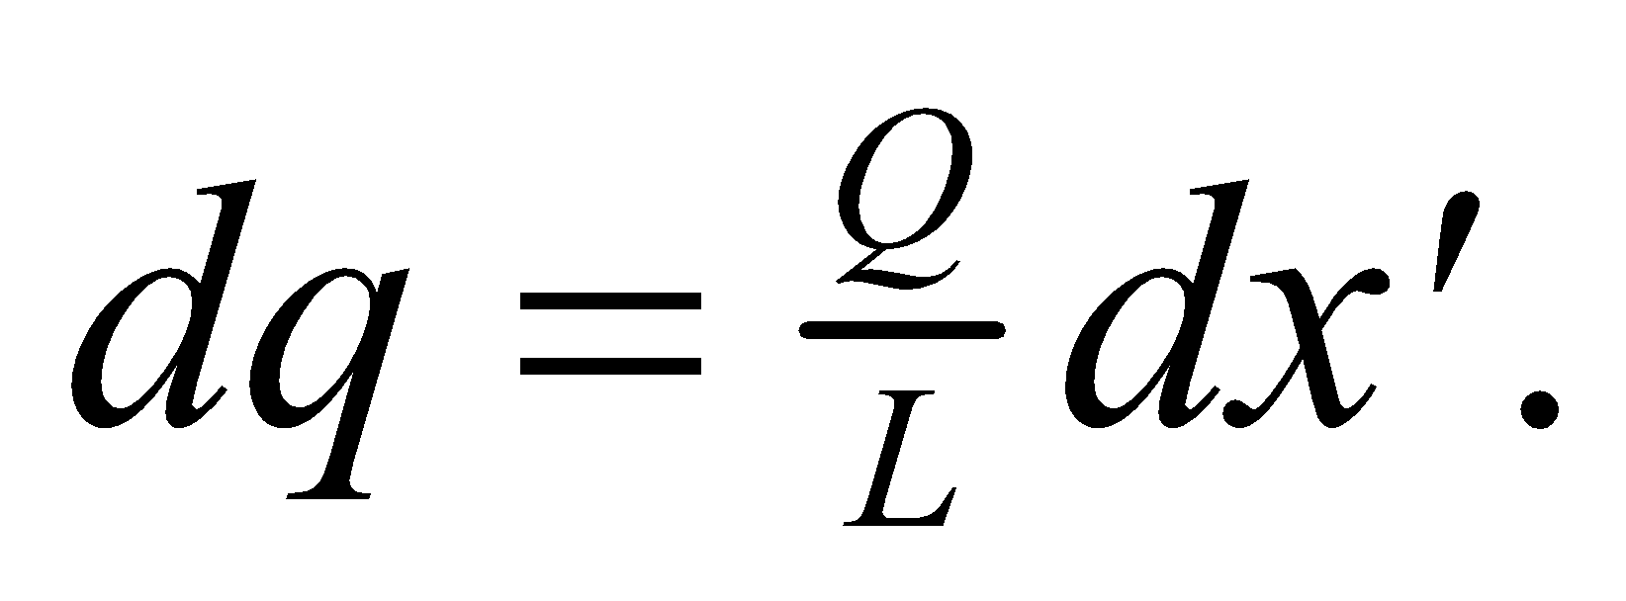The distance from each bit of charge to the point (*x*, *y*) is 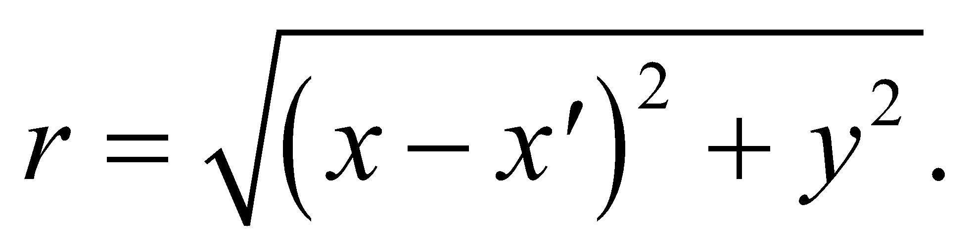 The unit vector in the direction of *r* is

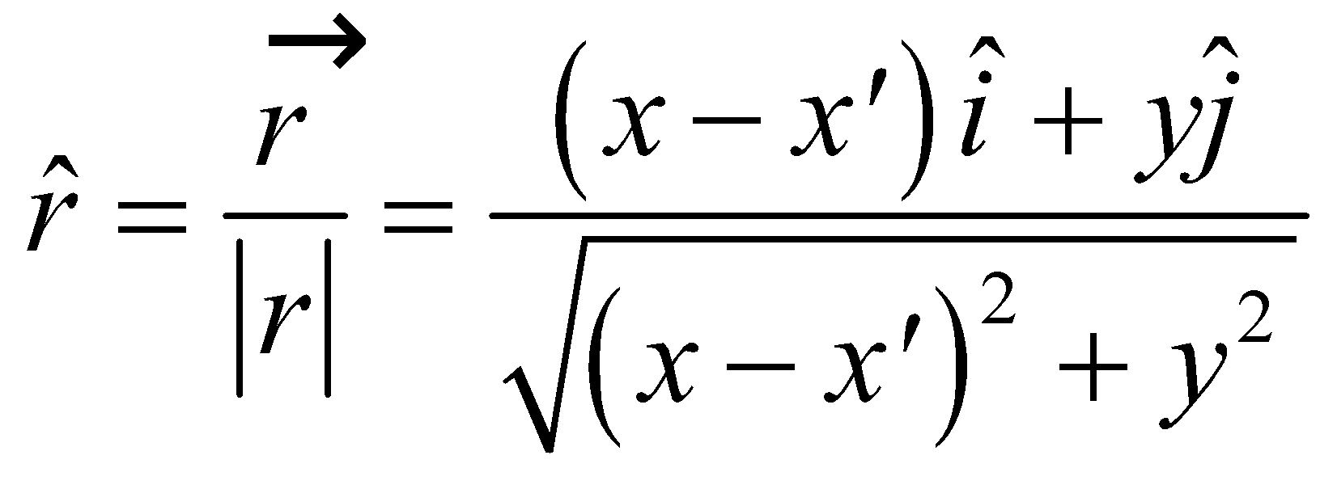

We will find the electric field by integrating 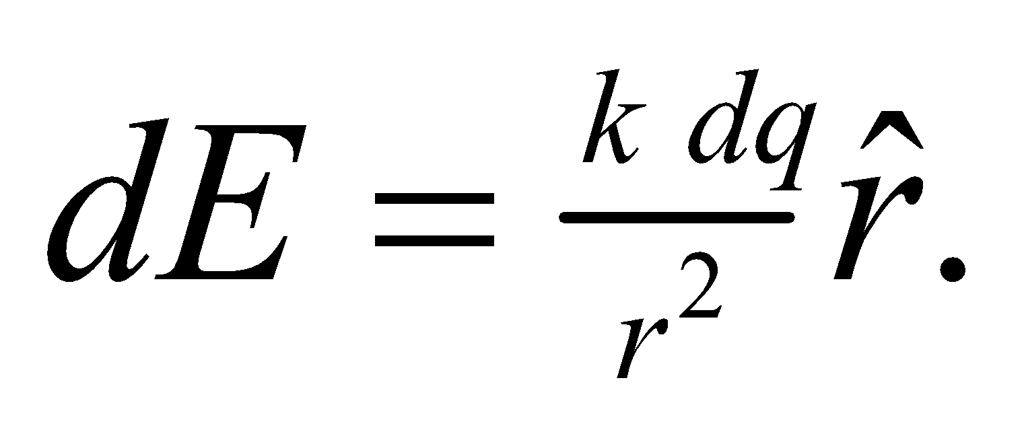

**Evaluate**

**(a)**

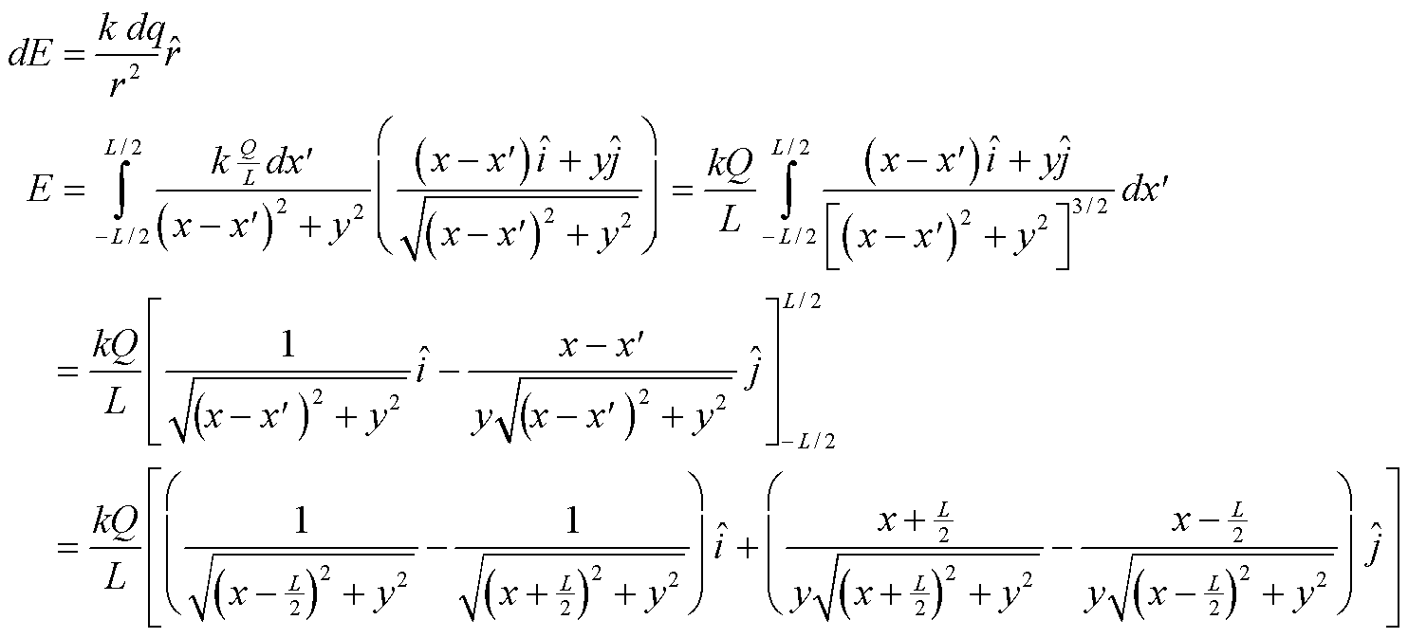

When the electric field reduces to



**(b)** When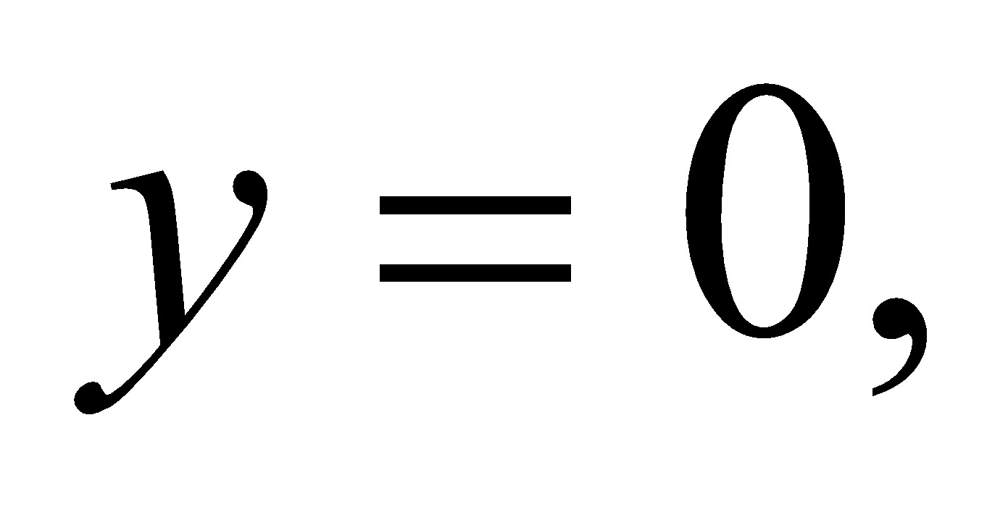the electric field reduces to

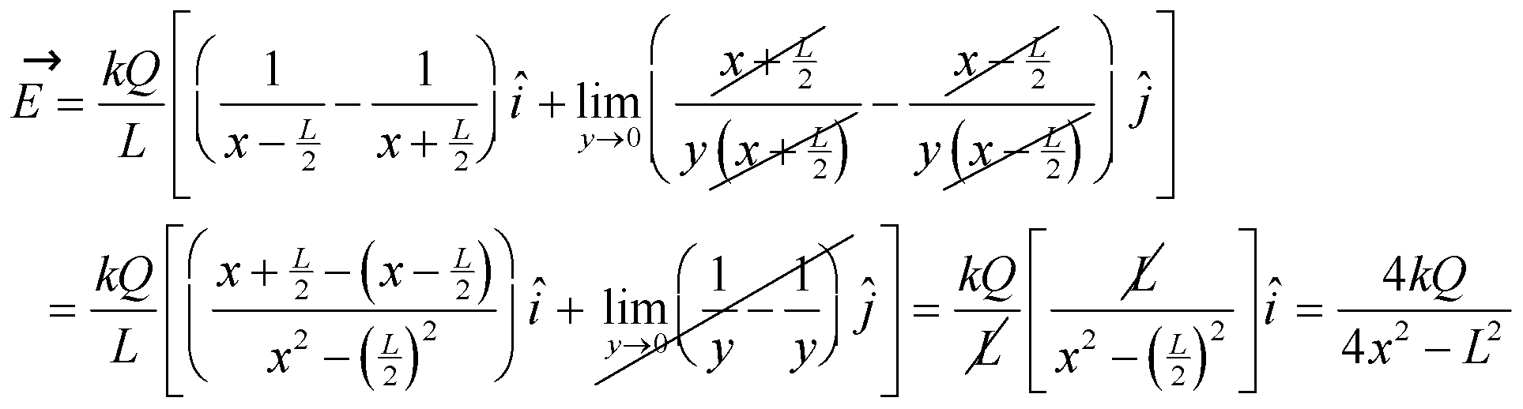

**Assess** The electric field in part **(a)** is not simple, but we have shown that for some simple cases it reduces to simpler forms.

**77. Interpret** We are to find the electric field near a line of *non-uniform* charge density. This is an electric field calculation, and we will integrate to find the field.

**Develop** The rod has charge density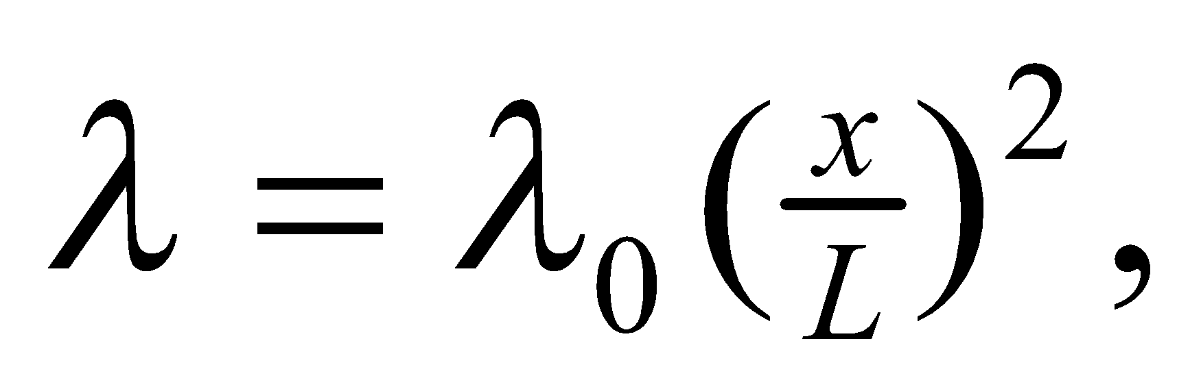 and extends from *x* = 0 to *x* = *L*. We want to find the electric field at *x* = −*L*. We will use  with 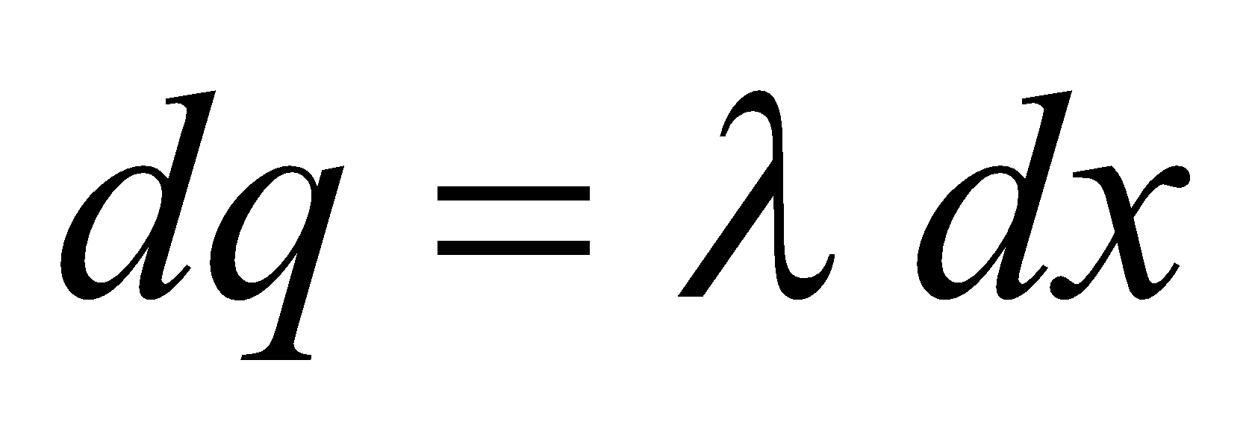 and 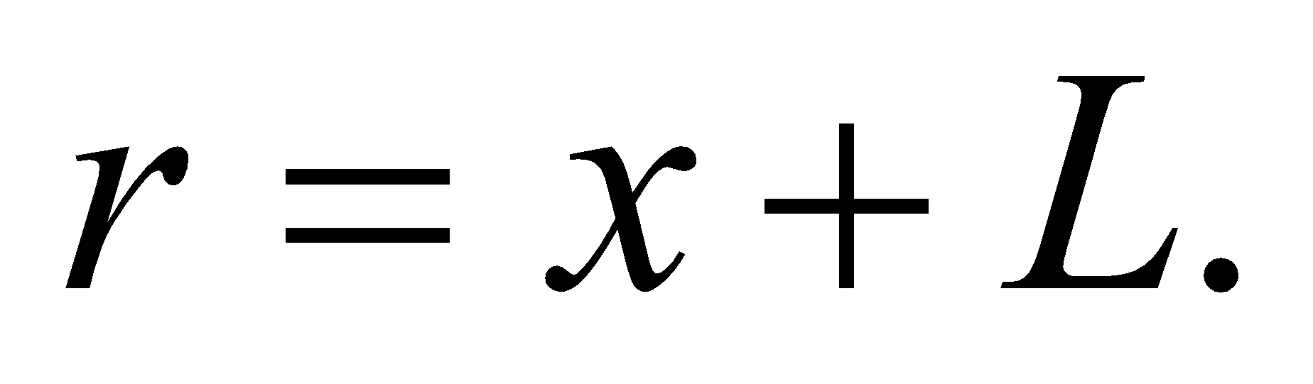

**Evaluate**



**Assess** Since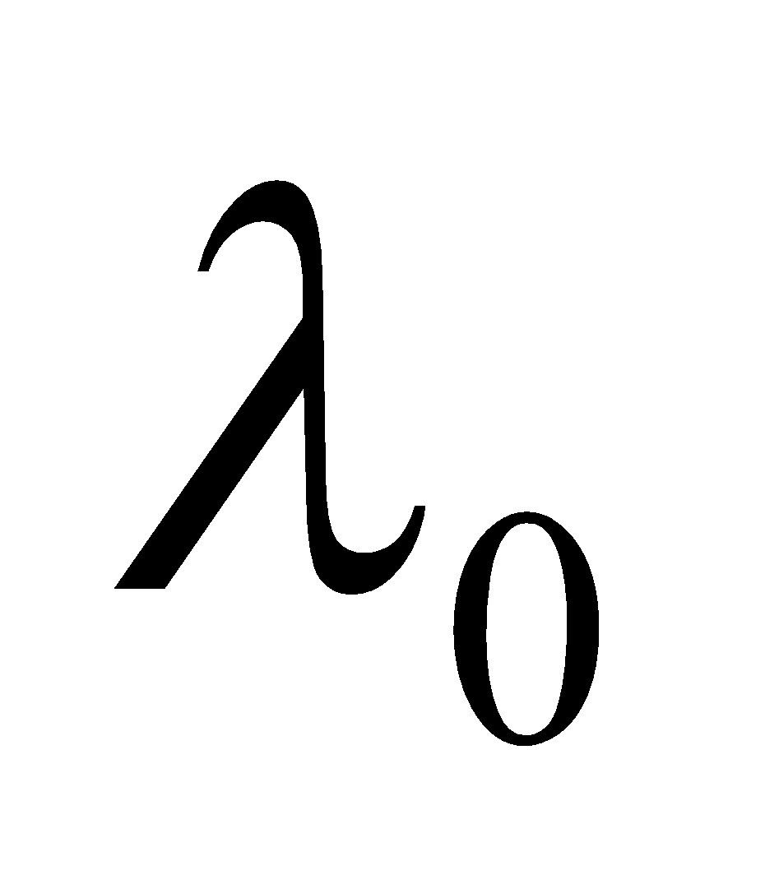is charge per length, the units are correct.

**78. Interpret** We are to find the electric field at points along the axis of a rod carrying *non-uniform* charge density. This is an electric field calculation, and we will integrate to find the field. We will also show that at large distances the field looks like that of a dipole, and we’ll find the dipole moment.

**Develop** The rod has charge 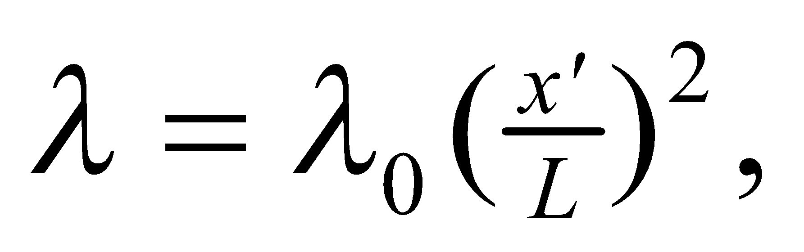 and extends from *x*′ = −*L* to *x*′ = *L*. We want to find the electric field at some point *x* > *L*. We will use 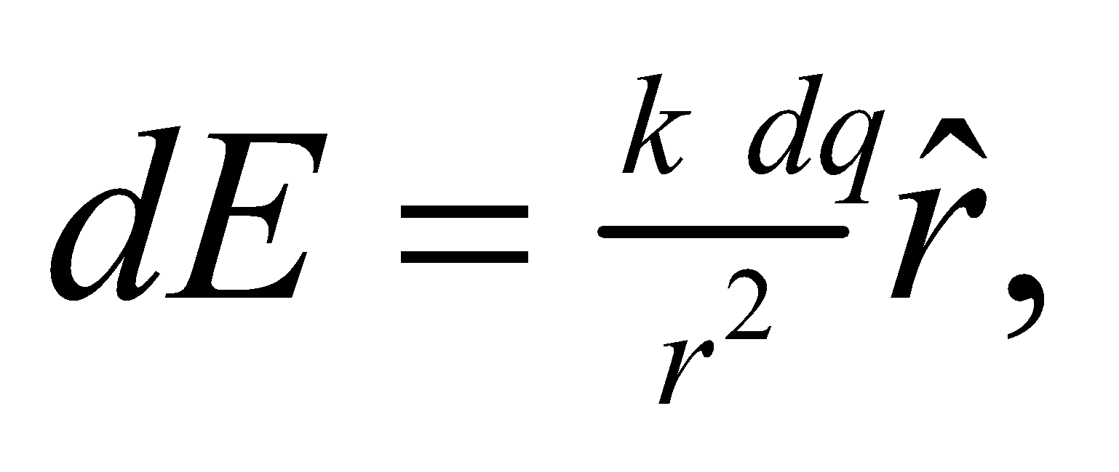 with 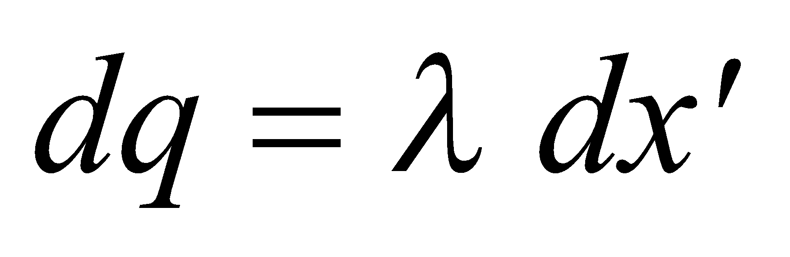 and 

**Evaluate** **(a)** We perform the integration to find

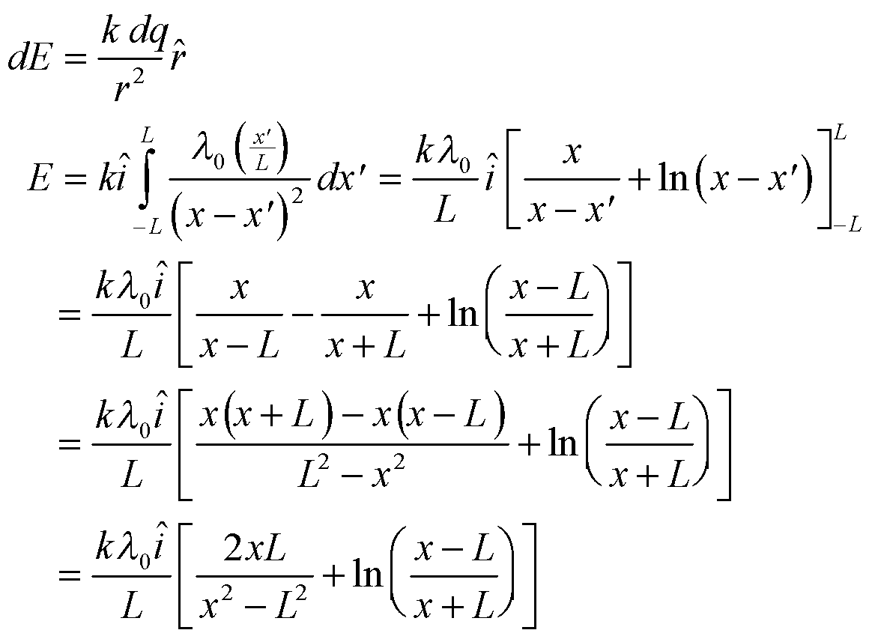

**(b)** For *x*  *L*,

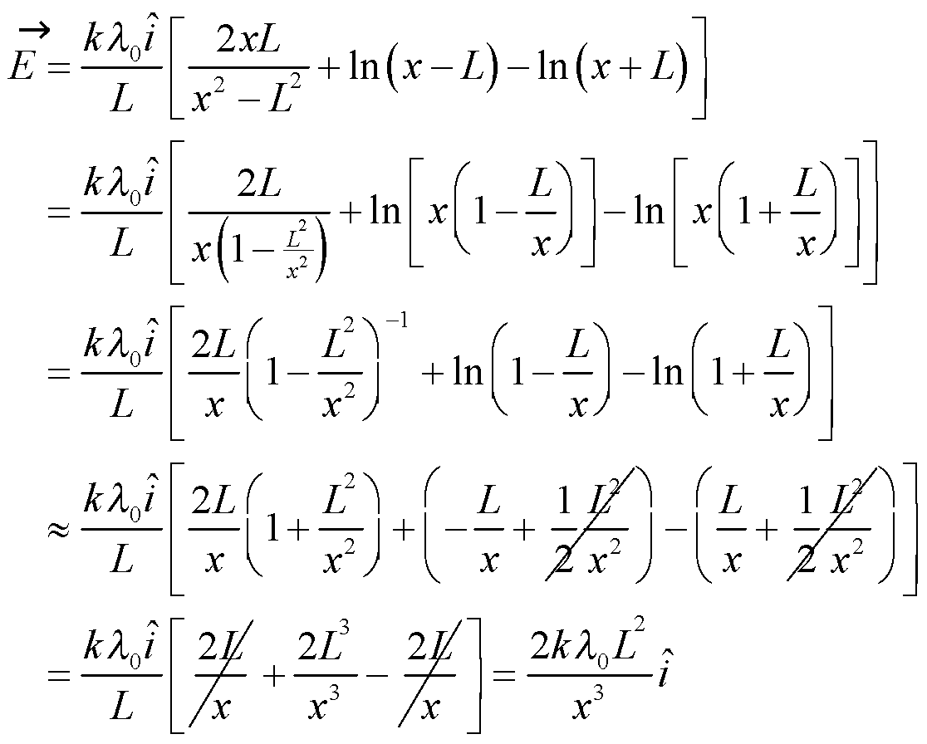

Comparing this with the field of a dipole in the same orientation, 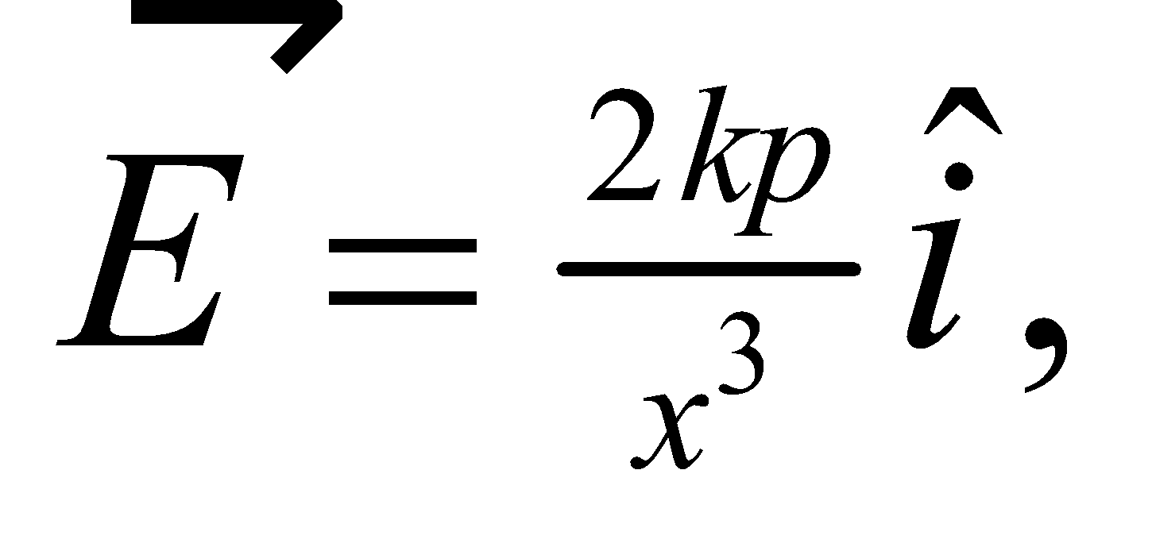 we see that the dipole moment of this charged rod is 

**Assess** We have shown what was required.

**79. Interpret** An electric field is used to deflect ink drops in an ink-jet printer. You need to find the maximum electric field for which the ink drops still can exit the deflection device. This is a problem of projectile motion where the dynamics are controlled by the electric force, not the gravitational force.

**Develop** The time that it takes the ink drop to traverse the field region in the Figure 20.35 is: 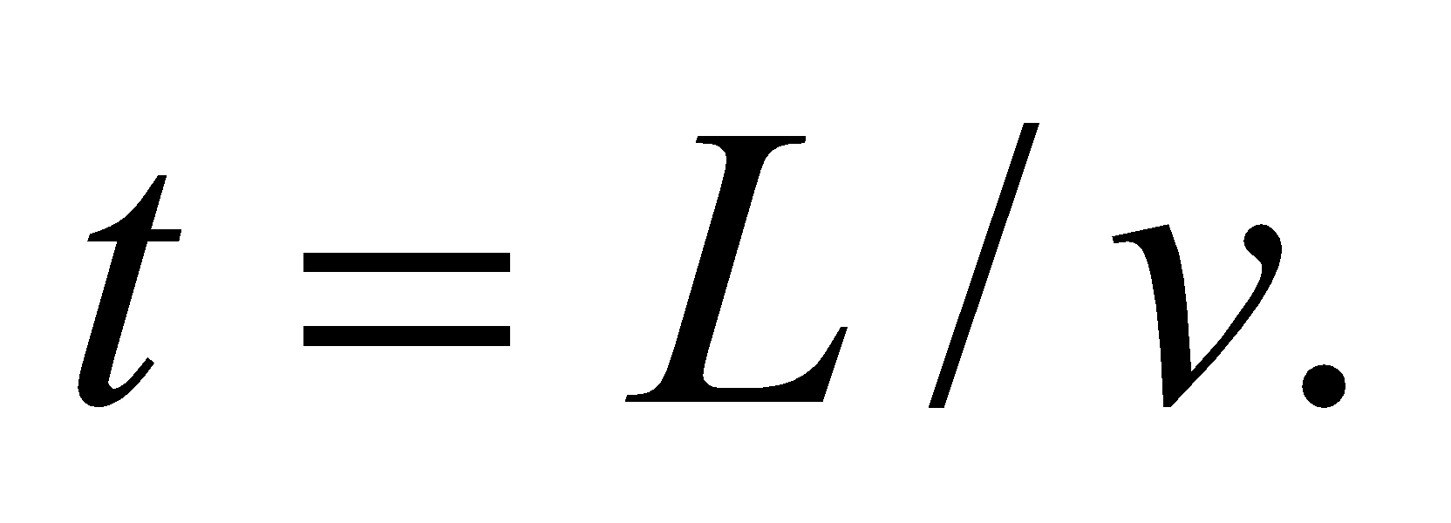 During that time it will undergo acceleration from the electric field: 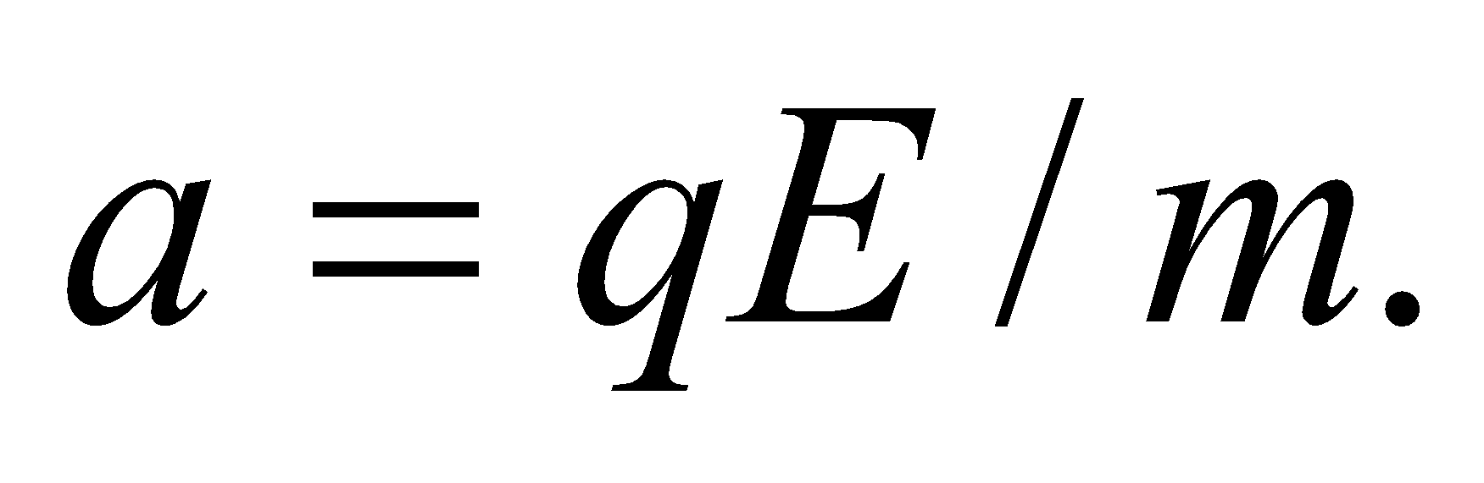 Since the field is uniform, this acceleration is constant, so the amount of vertical deflection will be: 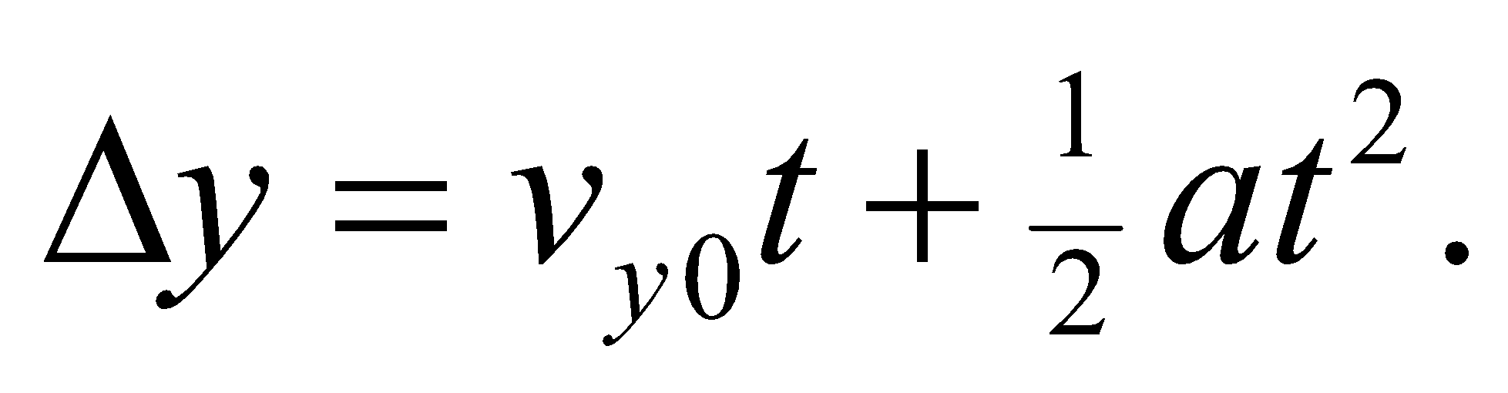The drop initially has no vertical velocity, so  The maximum field is that which deflects the drop by 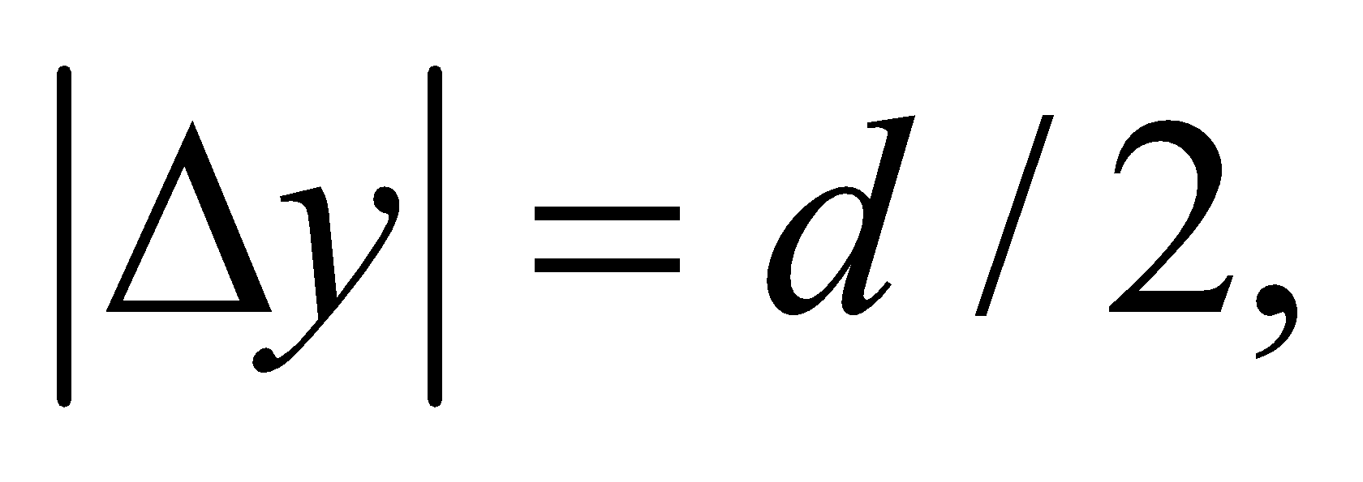since the drop starts off in the middle between the two plates.

**Evaluate** Solving for the maximum field magnitude,



**Assess** You can check that this has the right units:

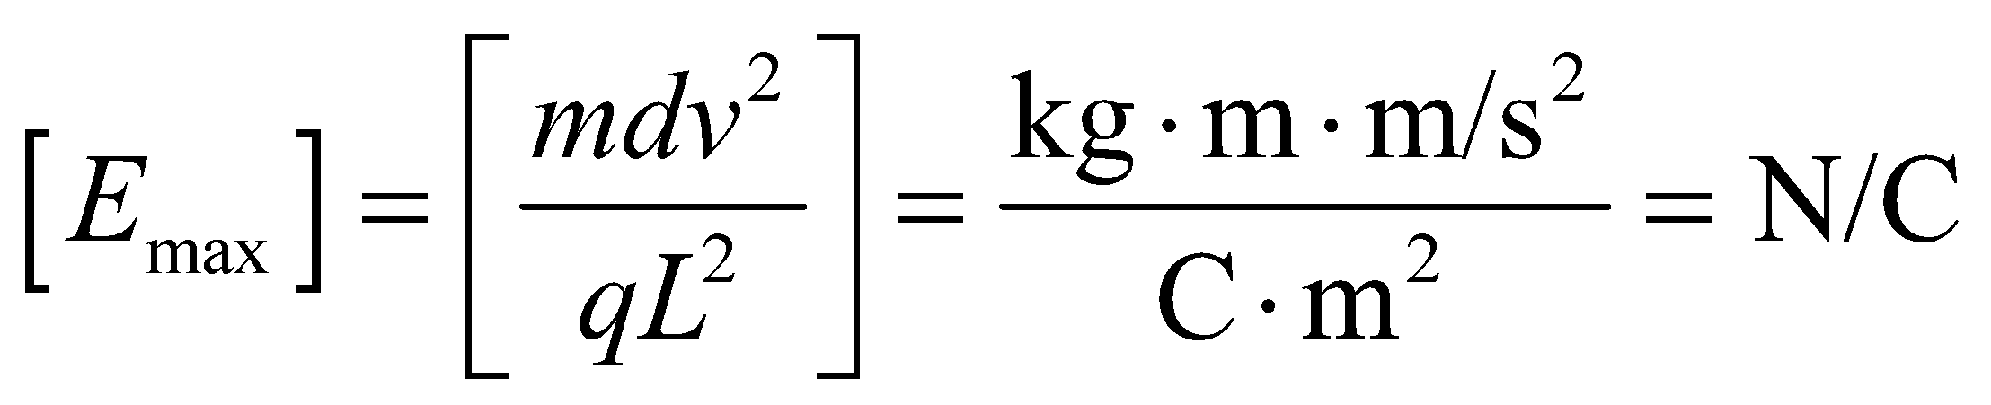

Indeed, these are the right units for an electric field.

**80. Interpret** We are considering the electric fields that operate in the heart muscle.

**Develop** In Equations 20.6a and 20.6b (as well as Problem 20.68), we see that the electric field from an electric dipole is proportional to one over the distance cubed,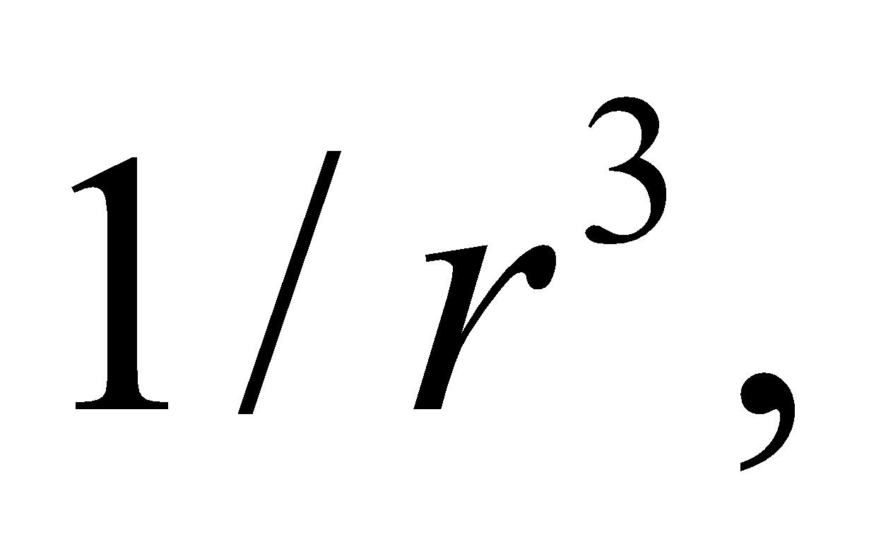for *r* much larger than the dipole's length: 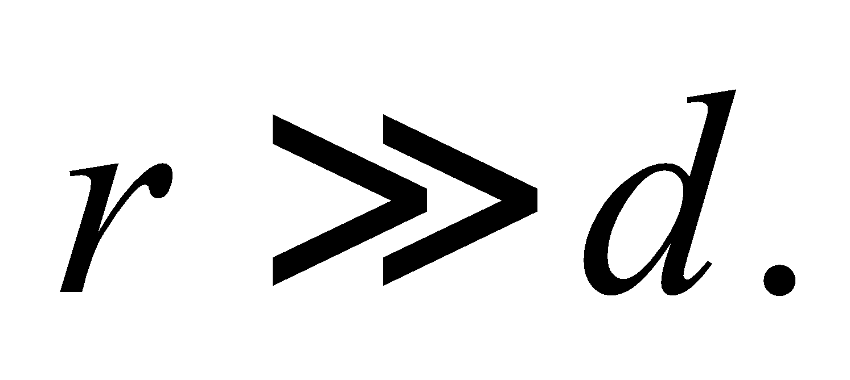

**Evaluate** The heart is composed of many electric dipoles, so the electric field will be a sum of dipole fields that all are proportional to the distance, 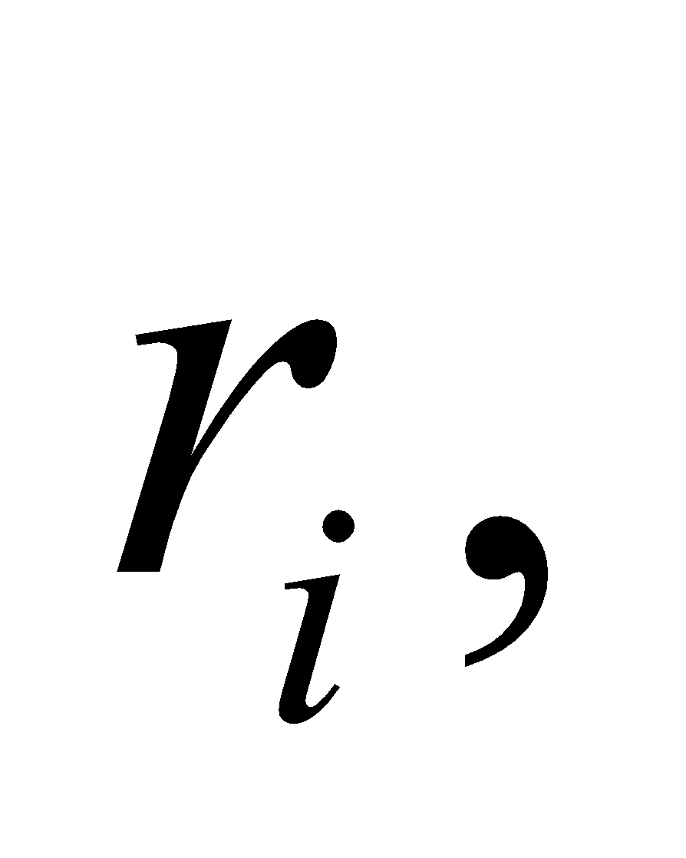 separating the dipole from the point of interest:

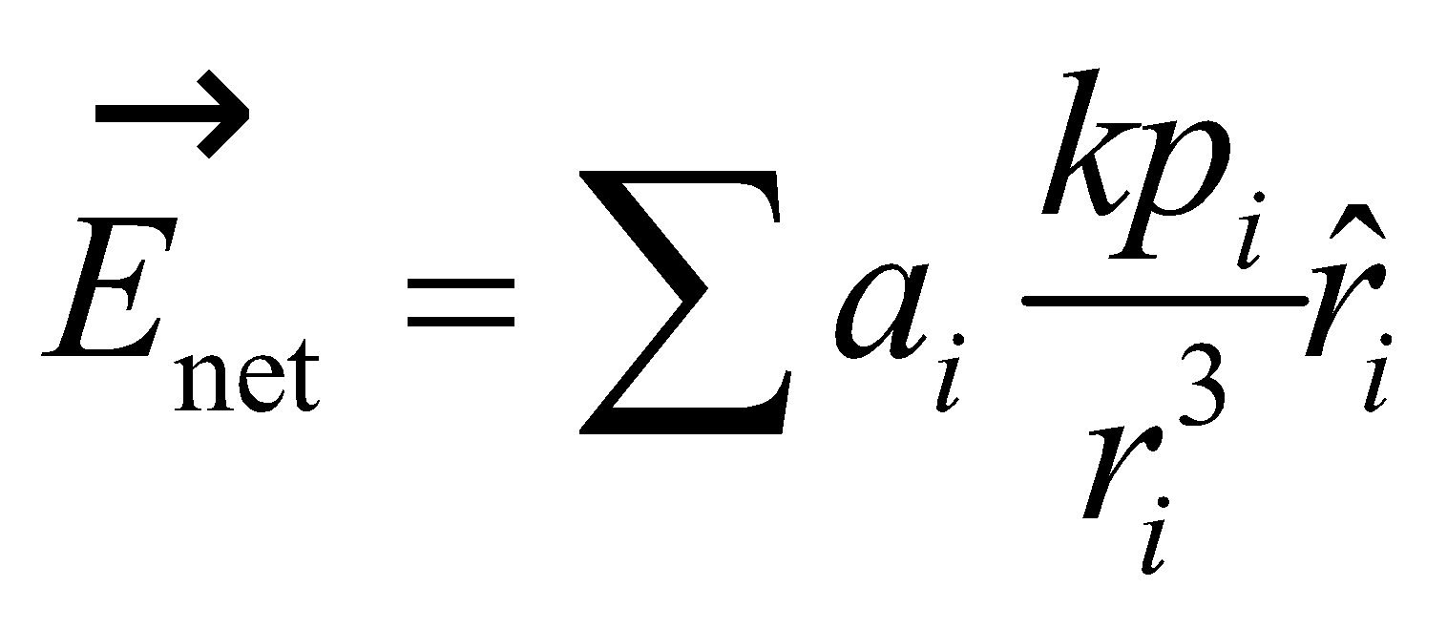

where 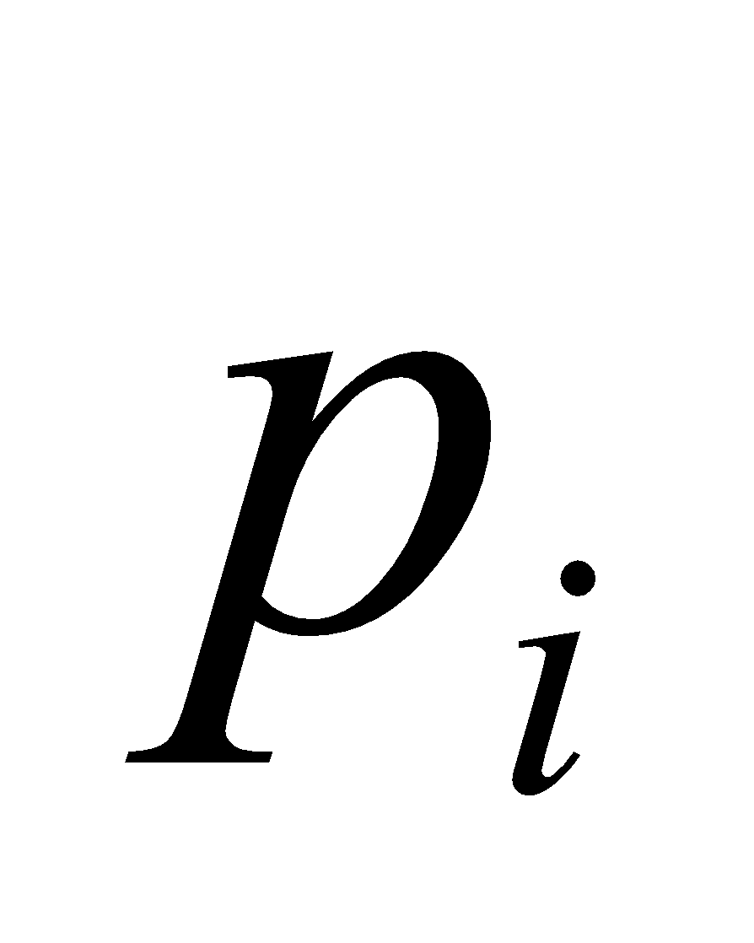 are the individual dipole moments, and 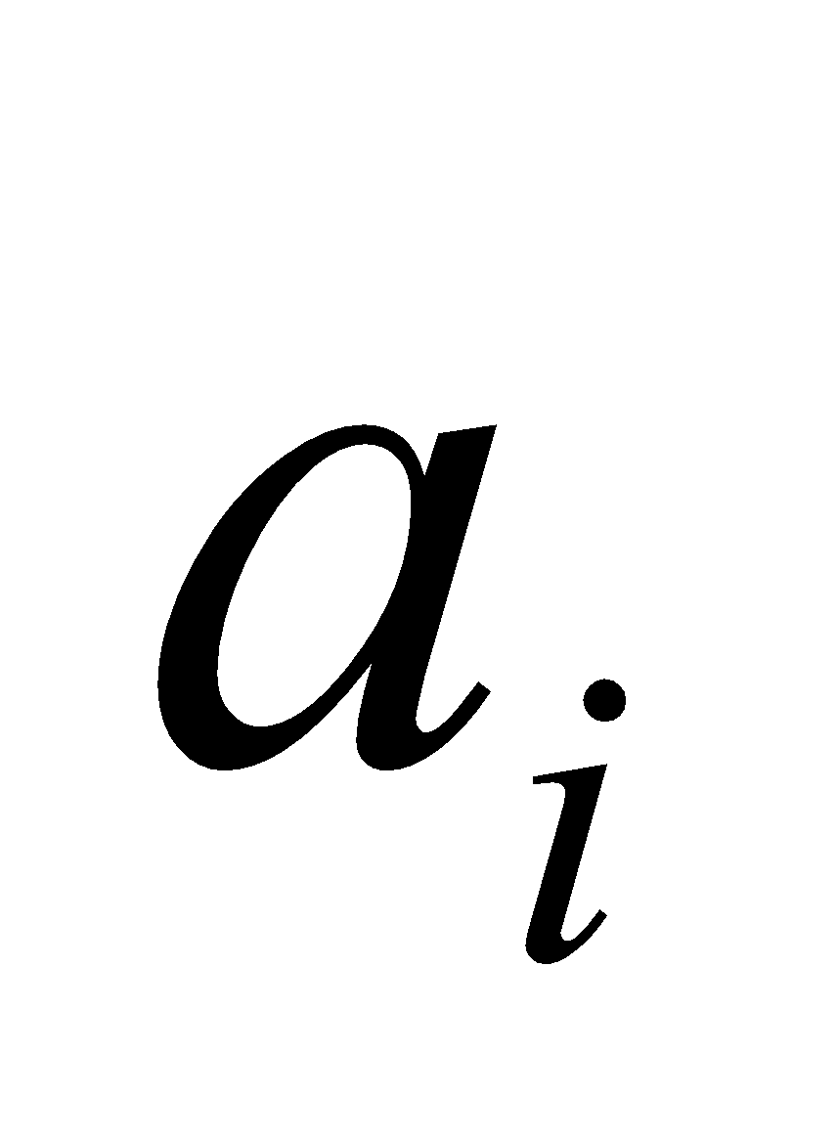are constants arising from the particular geometry. Far enough away from the heart, the individual distances will all be approximately equal to each other: 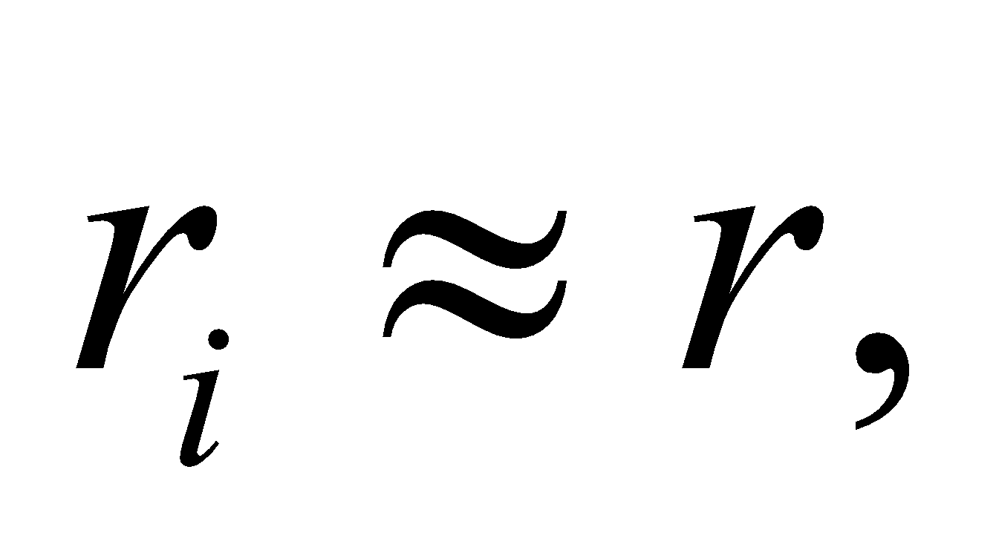so the magnitude of the net field will fall off as 

The answer is (c).

**Assess** If there were a net charge on the heart, then the field might fall off as But there apparently is a balance of positive and negative charges in the heart muscles, as shown in Figure 20.36a.

**81. Interpret** We are considering the electric fields that operate in the heart muscle.

**Develop** The magnitude of the dipole field on a line that bisects the dipole axis is from Equations 20.6a. Whereas, the magnitude of the dipole field along the dipole axis is 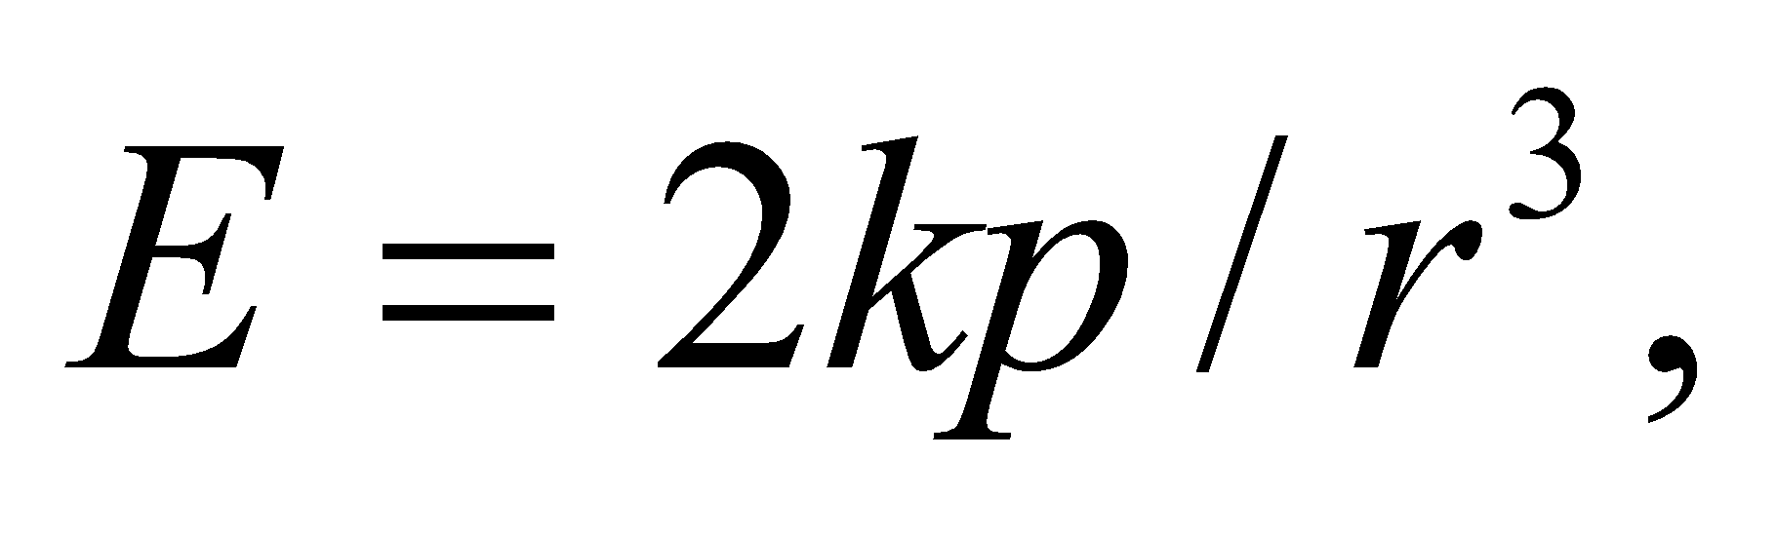from Equations 20.6b. So the field is twice as large along the dipole axis.

**Evaluate** The extension of the line in Figure 20.36c bisects the dipole axes of all the dipoles in the heart muscle. A line perpendicular to this one will approximately correspond to the axes of all the dipoles. So the field on the extension should be weaker than the field on the perpendicular.

The answer is (a).

**Assess** At the same distance from the heart, the field on the extension of the line in Figure 20.36c is the weakest compared to other directions. That's because the field contribution from the positive and negative charges are equal and approximately opposite.

**82. Interpret** We are considering the electric fields that operate in the heart muscle.

**Develop** The figures make it clear that the net charge is zero in Figures 20.36a and b.

**Evaluate** To form a dipole, there only needs to be a slight shift in the relative position of positive and negative charges (see, for example, Figure 20.23). There appears to be a slight shift in the balance of charges in Figure 20.36b.

The answer is (c).

**Assess** Note that a dipole is often not a stable arrangement of charge. There will be Coulomb forces between the positive and negative charges trying to pull them back into a configuration that has less of a dipole moment.

**83. Interpret** We are considering the electric fields that operate in the heart muscle.

**Develop** Equations 20.6b shows that the electric field on the dipole axis is parallel to the axis and points in the same direction as the dipole moment, i.e. in the direction from the negative charge to the positive charge.

**Evaluate** Inside the heart above and below the line in Figure 20.36c, the electric field should point in the same direction as the dipole moment.

The answer is (a).

**Assess** If we had been asked about the internal field of the dipoles, the answer would have been opposite the direction of the dipole moment (see Figure 20.24). But this would only comprise a small sliver of the heart area. The majority of the electric field points in the dipole moment's direction.